**BUSINESS CASE SCENERIO FOR CAR LOAN APPROVEMENT**

*Exploratory Data Analysis and RCA*

In this particular used case, we focus on to fetch out those customers who are following ideal conversion funnel

That is users who undergone all 4 steps while taking car loan

1. Login

2. Credit approved

3. Agreement Created

4. Disbursed

For this Below SQL Query like this:

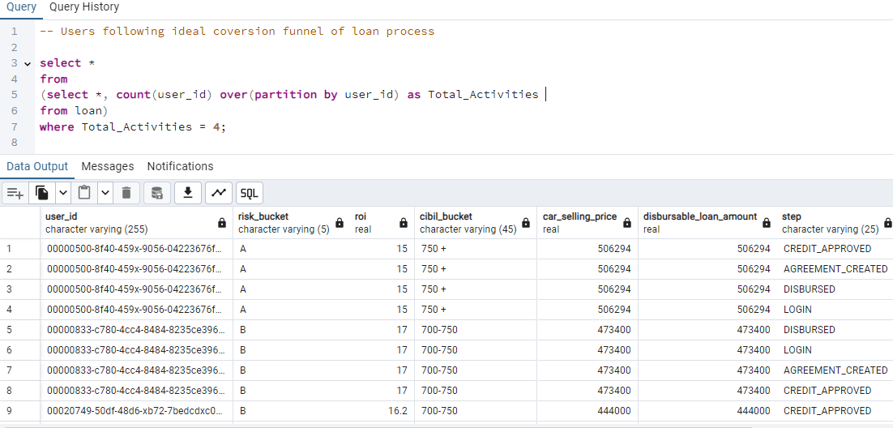

* Query for Total Number of Unique Customers following all 4 steps of loan Sanctioned.

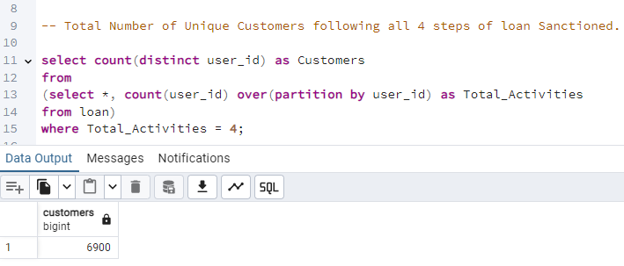

After this we want to find out total numbers of unique customers for those loan sanctioned is completed in all various months.

SQL Query as follow shown below :-

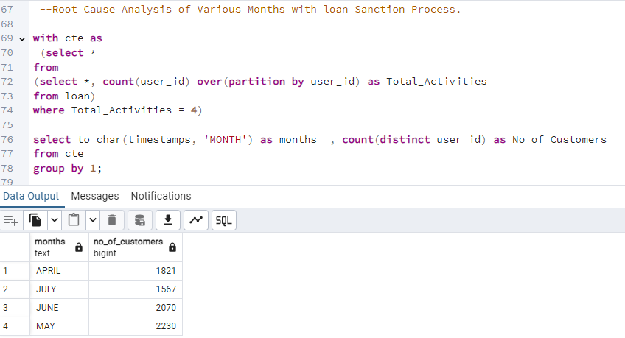

With Respect to above query:

We can conclude that Car Loan Sanctioned Process, is decreasing in the month of “JULY” as compare to other months, i.e. minimum in JULY

Hence these are following reason as follows:

1. ***Month v/s Risk Bucket***

By Using Pivot Table & Line chart we get to conclusion that Number of Customers for both “B” & “C” Risk Bucket is low in the month of JULY as compare to other months observe below query result

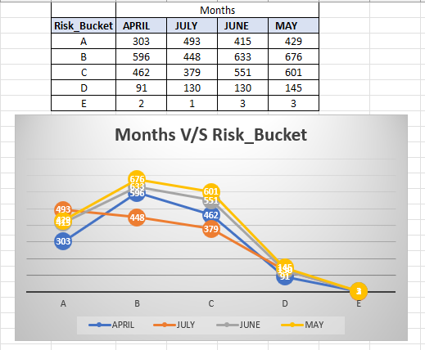

1. ***Months V/S CIBIL Score***

By Using Pivot Table & Stacked Column chart we get to conclusion that Number of Customers for both all Slabs, especially CIBIL Score greater than 700+ is very less in the month of JULY as compare to other months observe below query result

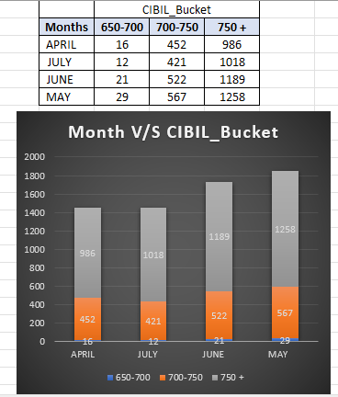

Due to above 2 main reasons, Total Selling Price & Loan of Cars Disbursed is also decreases for JULY Month than other 3 months in year 2024 as shown in below 2 SQL Query.

1. 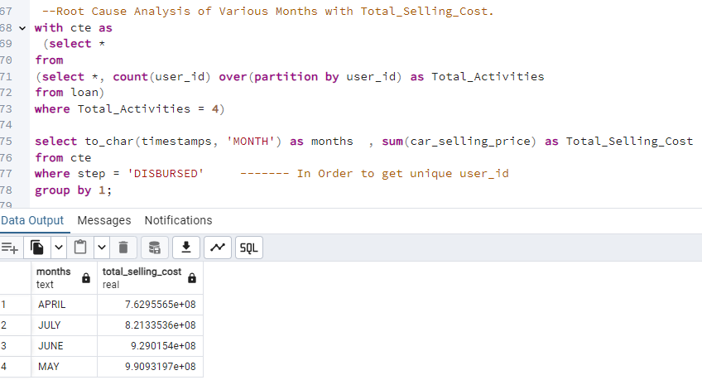

2. 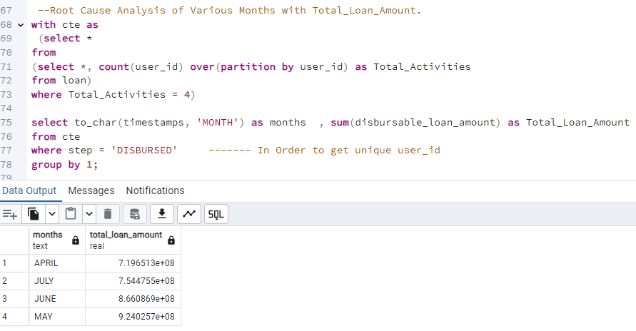

Note: For e.g. value 2.8231834e+09 mean 2.8 x 10^9 = 28231834000. So, therefore in both query for JULY Month value is less than JUNE & MAY.

*ROOT CAUSE ANALYSIS FOR CONVERSION RATE OF MONTH OVER PREVIOUS MONTHS*

SQL QUERY AS FOLLOWS FOR CONVERSION FUNNEL OF JULY AGAINST THE PREVIOUS MONTHS

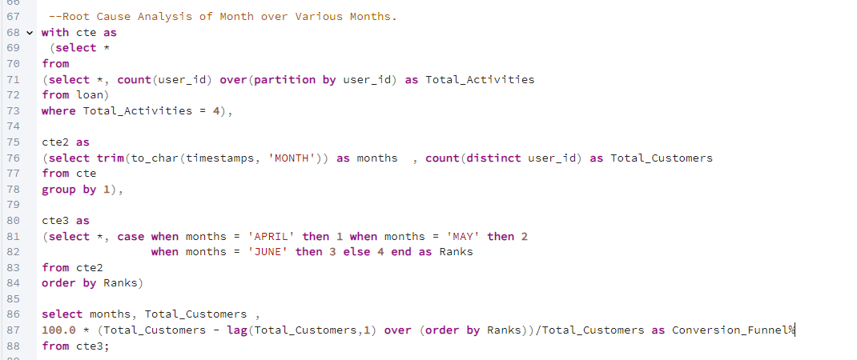

OUTPUT :

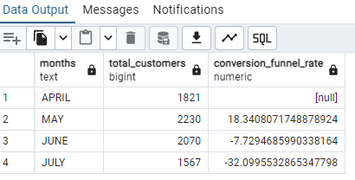

**Hence Proved: For JULY Month, Total Customers is decreased by 32% for Car loan Sanctioned Process.**

**MEANINGFUL & VALUABLE INSIGHTS**

**For MAY Month, Total Customers is Increased by 19% for Car loan Sanctioned Process.**

**Therefore, MAY & JUNE are the best months for purchasing Cars due to following reasons**

1. **High CIBIL Score mainly over 750-900.**
2. **High Quality of User Ranking mainly related to “A” Risk Bucket Slab**
3. **Reasonable ROI (Rate of Interest) lies.**
4. **High Number of Customers follows Ideal conversion funnel process.**

**RECOMMENDATIONS:**

**For July, Cost of Car Price should reduce or minimal by giving necessary discount at reasonable & genuine ROI offers just to attract & increase the number of customers.**