**Product Purchase and User Retention**

**QUESTION : 1**

**What are the top three products sold each month??**

**SQL QUERY**

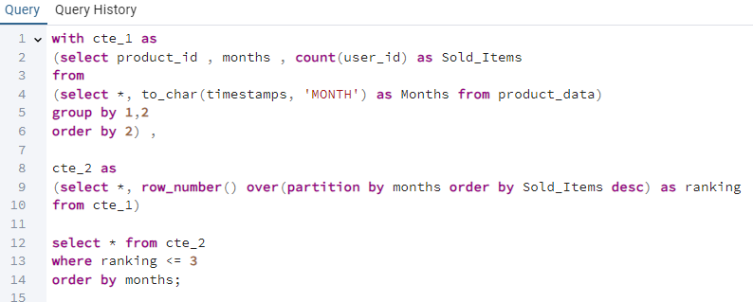

**QUERY OUTPUT**

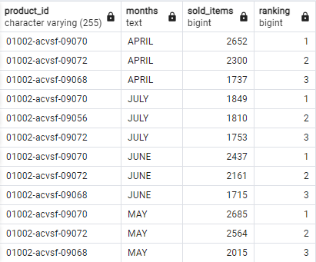

**QUESTION: 2**

**SQL Query For each month, that is the count of users who added an item to the cart & count of users who bought that item within 3 days of adding it to the cart??**

**SQL QUERY**

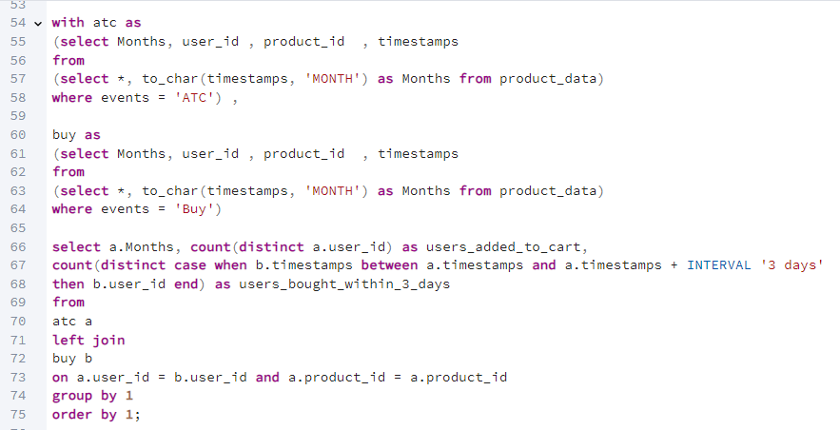

**QUERY OUTPUT**

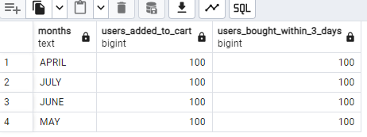

**Question 3.**

**For each month, what is the M1 retention of users after their first order. A user is considered as retained in M1 if they have purchased a product between 30 to 60 days of their first order??**

**SQL QUERY**

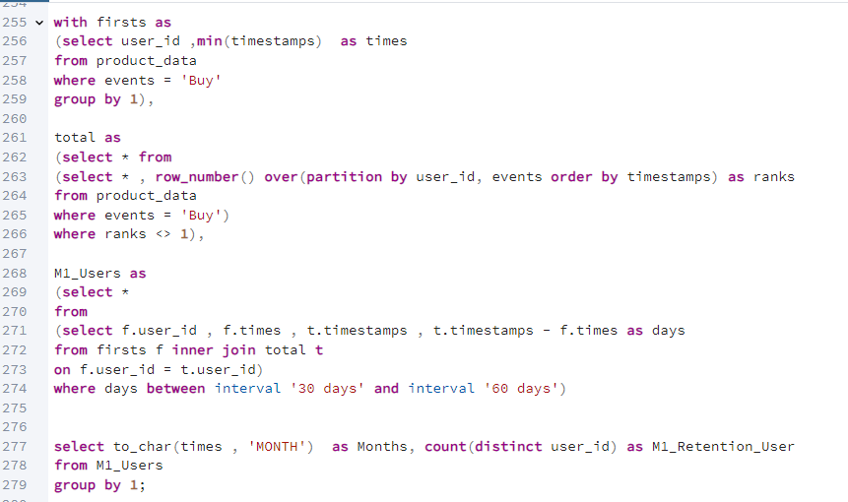

**QUERY OUTPUT**

