### DFD 01

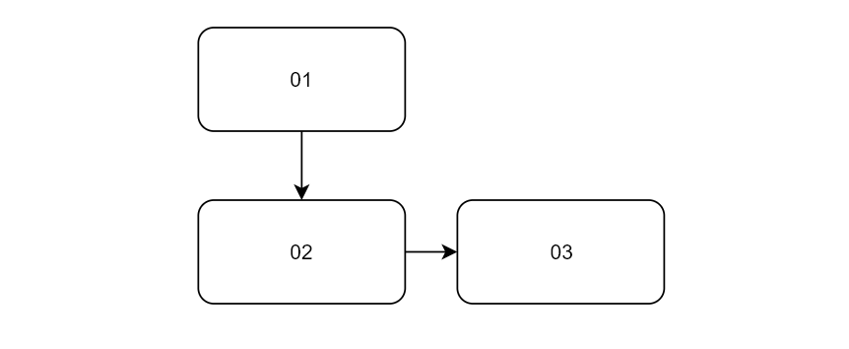

[DFD_02](./DFD_02.md)

./DFD_02.md

| DFD | DFD_01_01 |  |
| --- | --- | --- |
| Description | Title |  |
| Input | fsdfdsa |  |
| Output | fdsaf |  |

| DFD | DFD_01_02 |  |
| --- | --- | --- |
| Description | Title |  |
| Input | fsdfdsa |  |
| Output | fdsaf |  |

| DFD | DFD_01_03 |  |
| --- | --- | --- |
| Description | Title |  |
| Input | fsdfdsa |  |
| Output | fdsaf |  |

| TEST | TEST |
| --- | --- |
| 1234 | 4321 |
| 5678 | 8765 |

### DFD 02



| DFD | DFD_02_01 |  |
| --- | --- | --- |
| Description | Title |  |
| Input | fsdfdsa |  |
| Output | fdsaf |  |

| DFD | DFD_02_02 |  |
| --- | --- | --- |
| Description | Title |  |
| Input | fsdfdsa |  |
| Output | fdsaf |  |

| DFD | DFD_02_03 |  |
| --- | --- | --- |
| Description | Title |  |
| Input | fsdfdsa |  |
| Output | fdsaf |  |