1. **individual work**

Dataset of our group is Chicago Food Inspection. I choose recent 3 years’ data here.

plot 1: Distribution of Risk Level of Facilities in 2015-2017

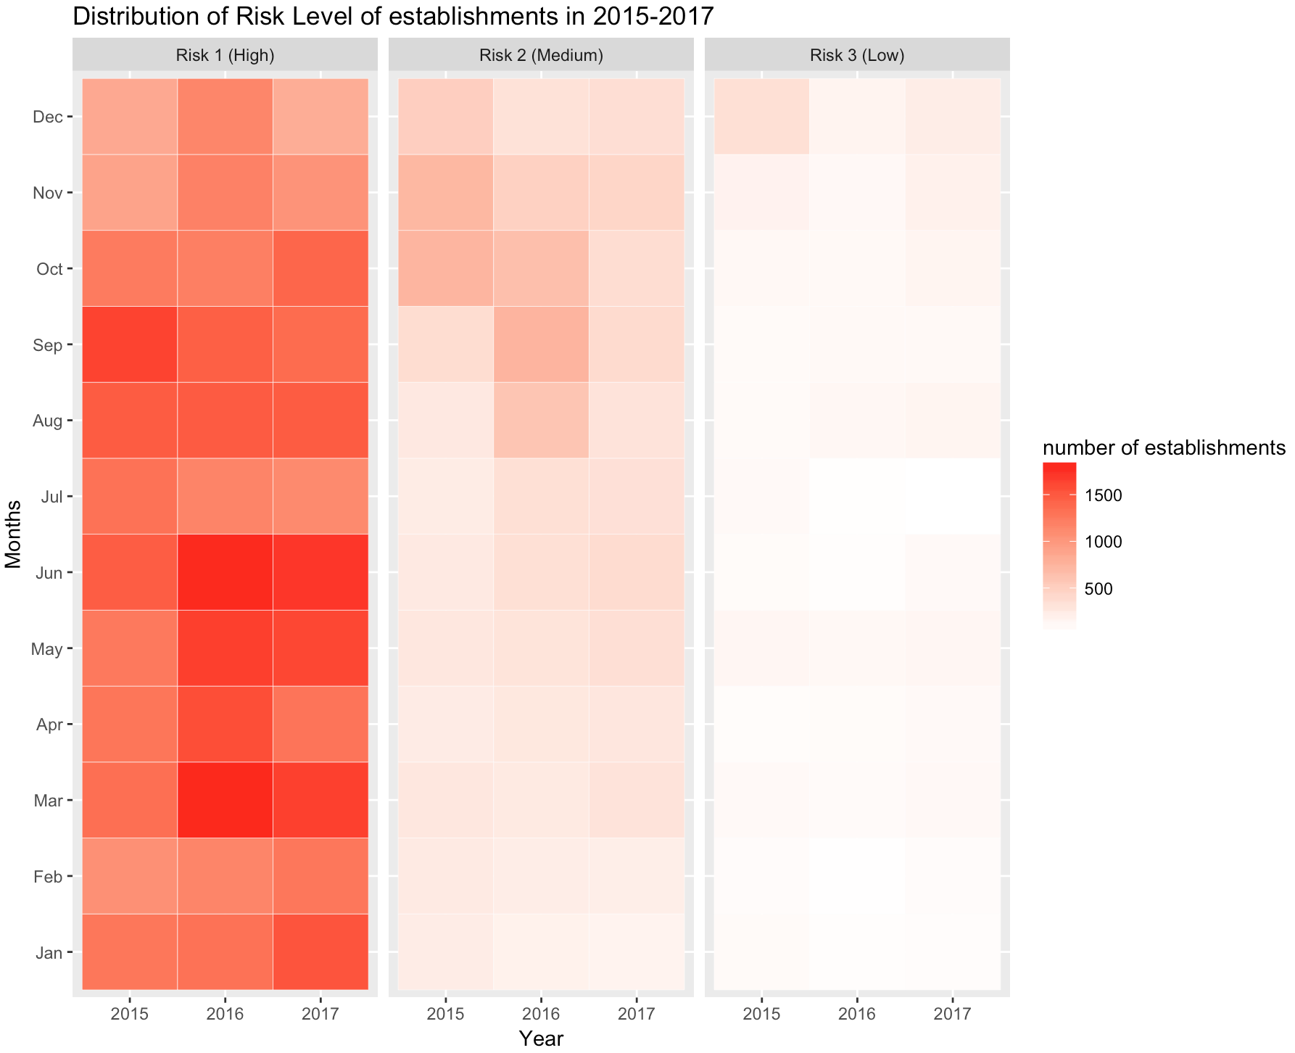

Through the graph, we can see that generally no matter in which year, the rank is Risk1 >Risk2>Risk3, and from the colors we can see that the number of establishment in high risk take a really big part. As for year, the number of establishments of medium risk and low risk are yearly reduced which is a good news anyway.

plot 2: Food Inspection Frequency in 2017



I use Tableau to map this overlay graph so even It looks clutter I can see each line individually and clearly.

Here we can get an interesting thing: inspectors seem would ‘take a break’ near every 5 days and inspection more happened in spring and winter and less in summer in general.

Besides, I create the time series interactive chart below which is easily to get 3-year information from without clutter.

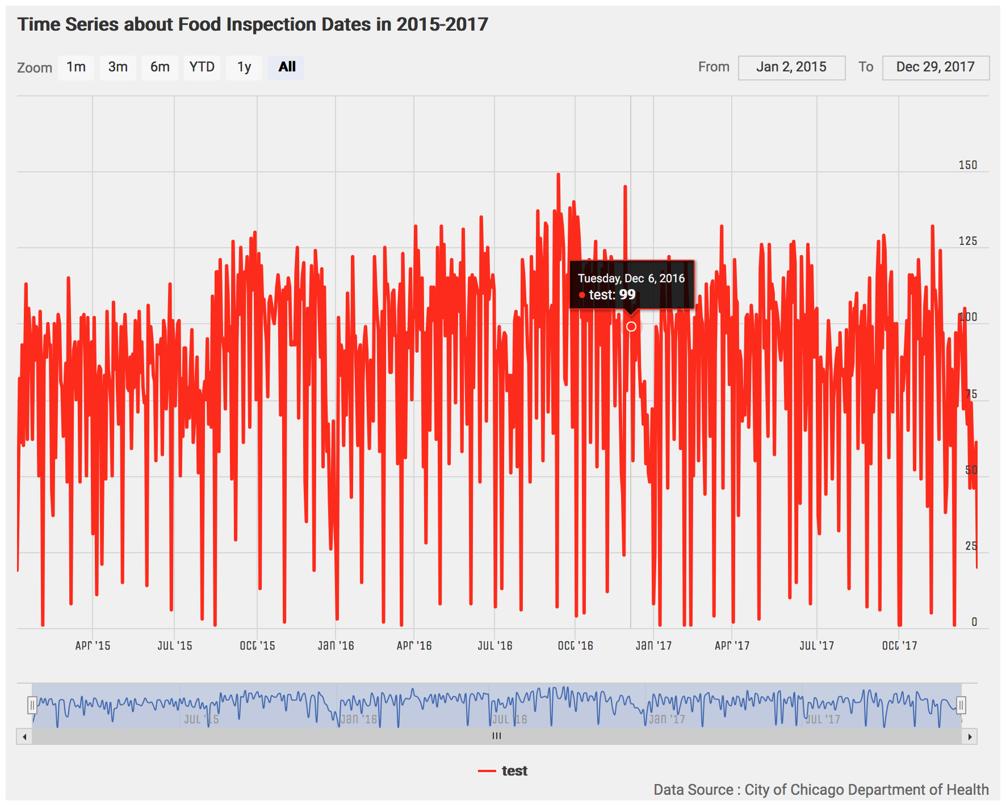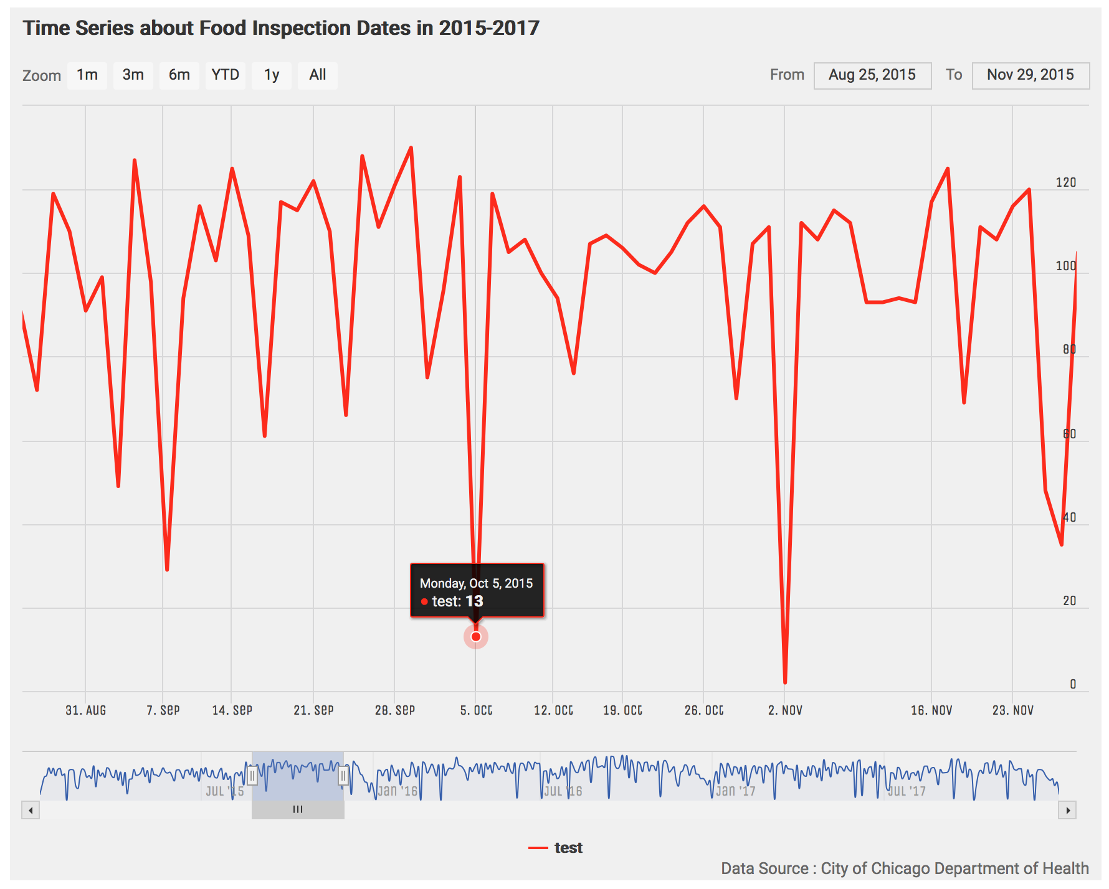

#1.Top Twenty most Common Words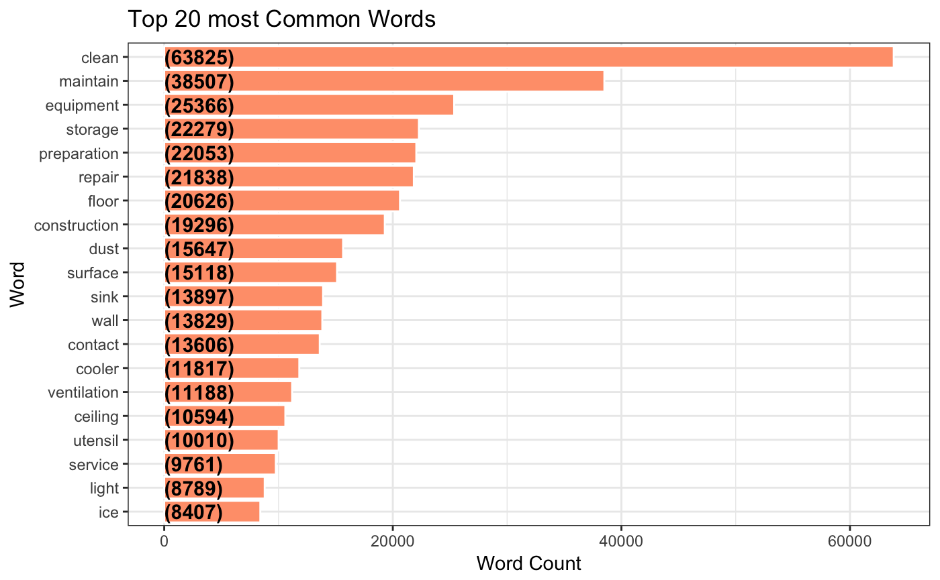

#2. WordCloud of the Common Words

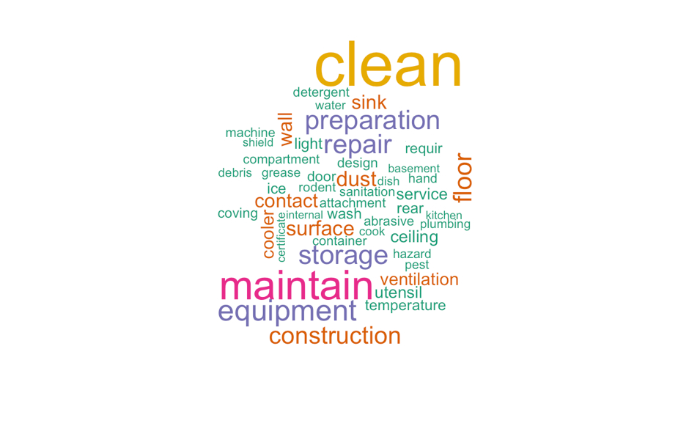

#Term Frequency of Words (TF)

