Workspace HLD

Contents
Introduction
Use Cases
Create workspace
Invite member to existing workspace
Bookmark workspace

Introduction

Use Cases

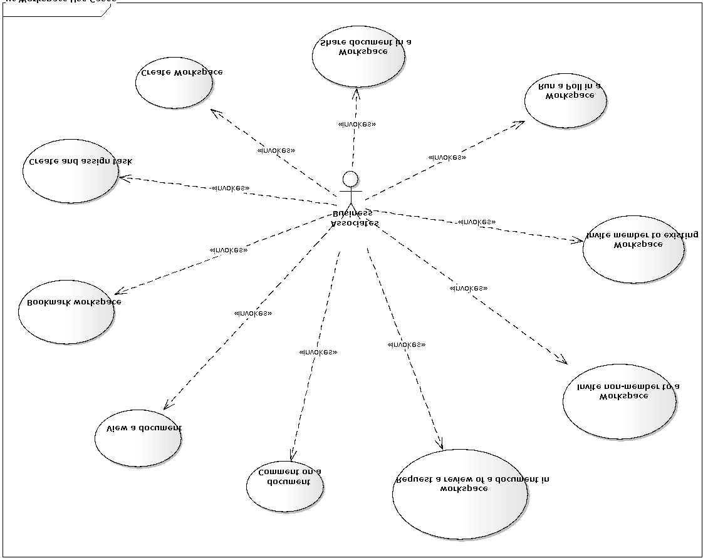
Figure: The use case diagram

Create workspace

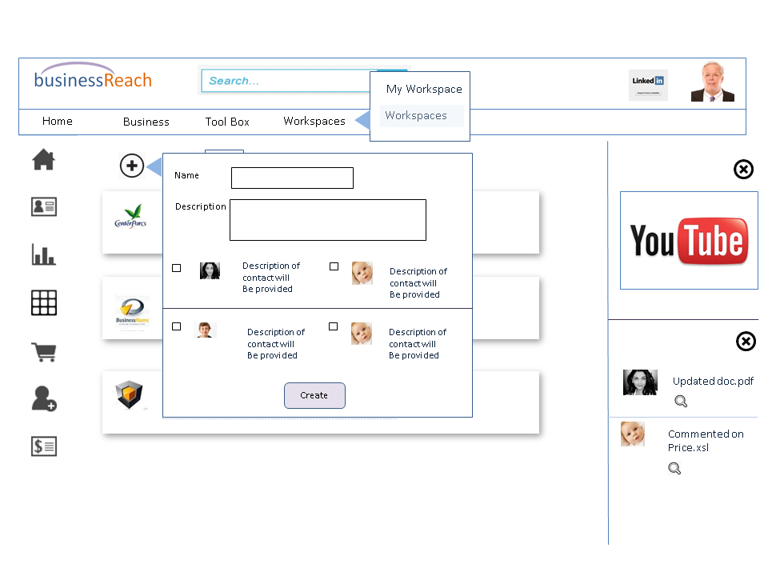
Figure: The mockup screen for creating a new workspace
- User by clicking “Workspaces” menu navigates to the above screen that shows list of all the workspaces the Business Associates has visibility
- User then may by clicking the add icon and system displays a dialog box with the list all contacts
- User selects one or more contacts, enters the workspace name and description then presses the “Create” button
- System creates a workspace and invites all the selected contacts to join the workspace
- Then system navigates to the following screen that displays the newly created workspace dashboard
- Initially the dashboard will only show the pending invites
- Once the invited members accept the invitation by clicking the link sent via email the dashboard will show notifications of acceptance
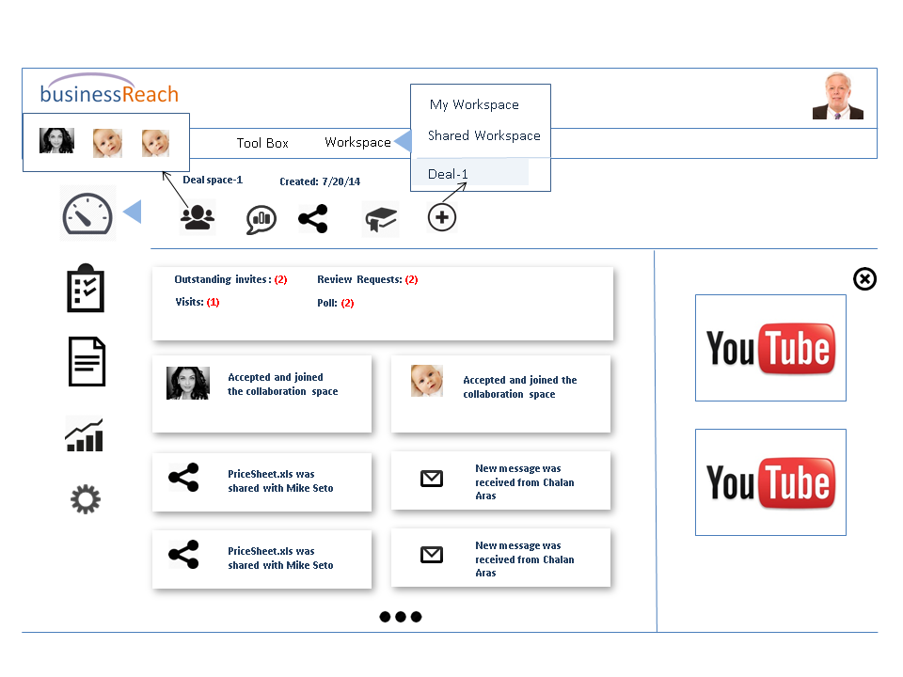
Figure: A workspace dashboard
The above screen shows a workspace dashboard. A workspace dashboard shows all the latest workspace related activities to provide a snapshot view of what is going on in a workspace. The right panel shows all the workspace related training videos. If user closes the right panel the screen expands to fills that space. Following are the activities shown in a workspace dashboard
- Pending invitation
- Invitation acceptance
- Document share
- New message
- Comment on a document shared in the workspace
- Document review request
- Document review response
- Poll request
- Poll response

Invite member to existing workspace
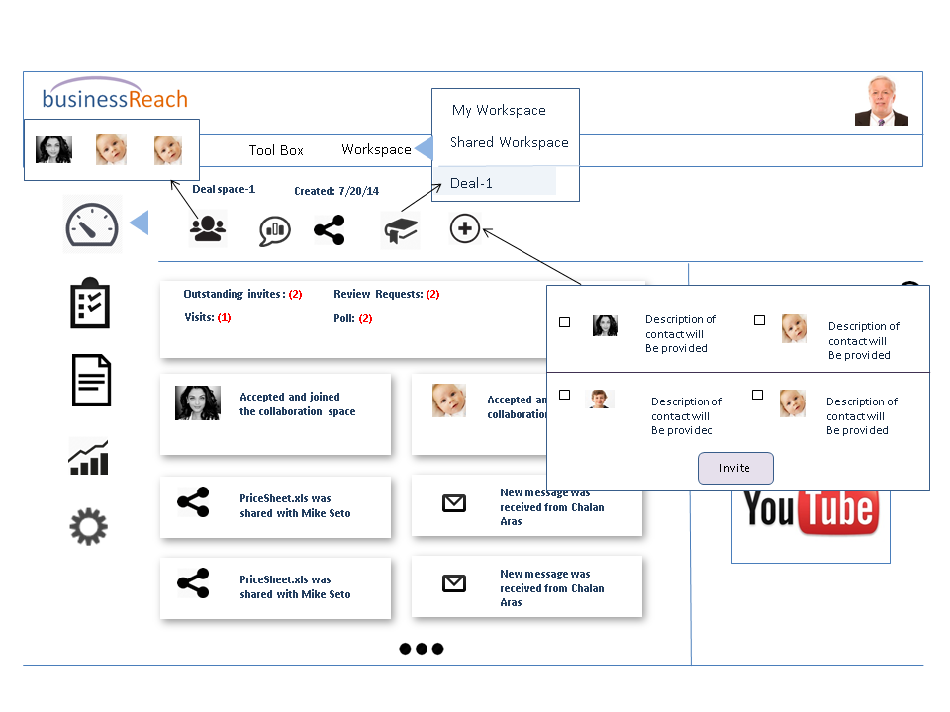
Figure: Invite members into an existing workspace
The above screen shows the flow of inviting a member who is not part of the workspace into the workspace.
- User clicks the “Add” button to bring up contact list
- The contact list should exclude the members already part of the workspace
- User selects one or more contacts and presses “Invite” initiate the invitation process that sends email with a link to accept the invitation to all selected contacts

Bookmark workspace

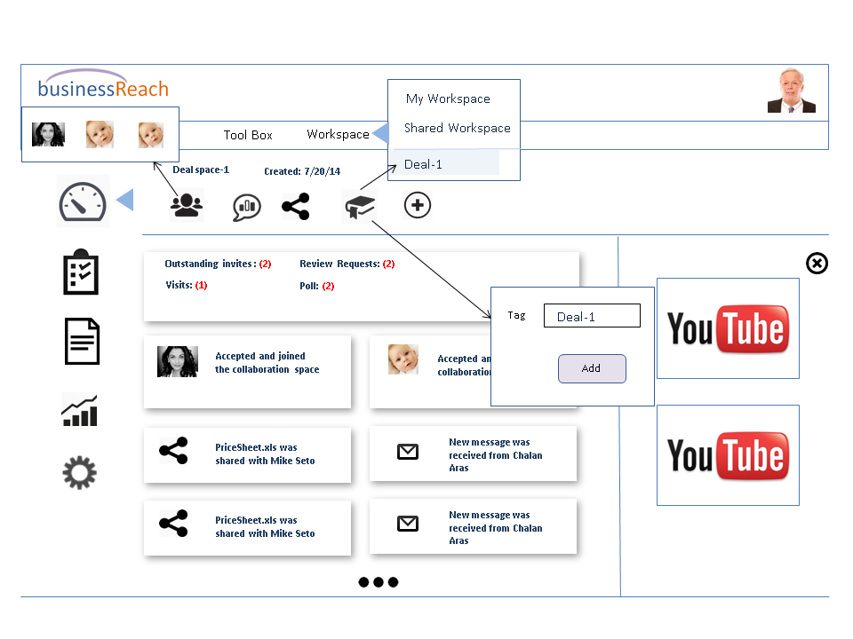
Figure: Bookmarking a workspace
Over time a user may participate in numerous workspaces. To keep track of the important ones the user might want to book mark a workspace for convenient navigation.
- User clicks on the bookmark icon and defines a bookmark tag in the popup dialog
- User clicks “Add” button
- System adds the workspace in bookmark list
- Then the tag shows up in workspace menu as shown in the above diagram
- User may click the menu item to navigate to the workspace

