Collaboration Workspace HLD

# Introduction

Workspace is a software infrastructure provided by BusinessReach for logical collaboration among business partners. This is ideal for processes span across business boundaries such as

* Collaboration on a deal among multiple partners
* Collaboration on partner training

A collaboration space can be created in an explicit or implicit way. In the following diagram user can press the “Add” sign on top tool bar to create a collaboration space.

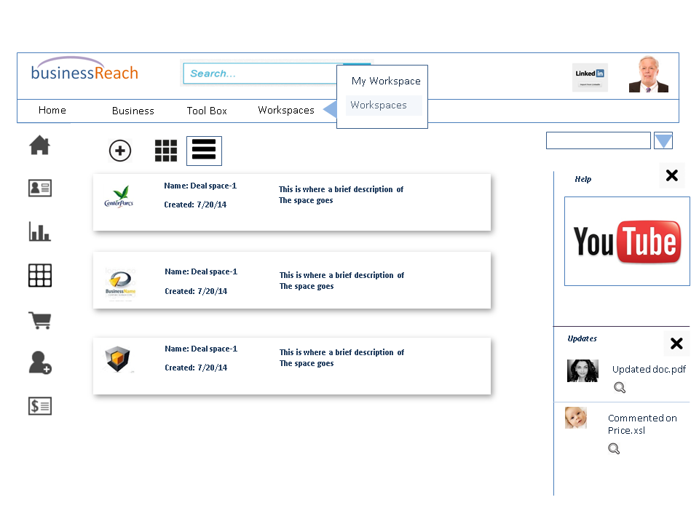

* Upon pressing “Add” sign a dialog box will appear with the list of business partners.
* User can search and select one or more such partners and press “Create”
* System will create a workspace and send invitation to each of the selected partners
* The email will contain “Join” button
* Upon clicking “Join” the partner will be redirected to the workspace page

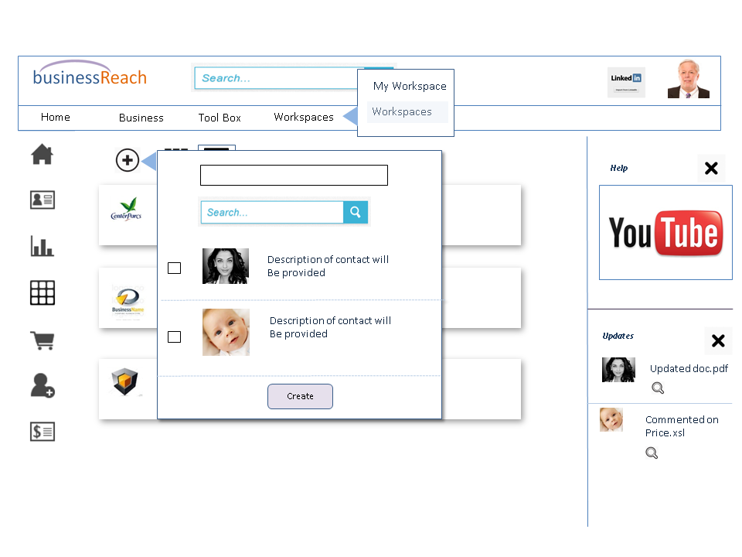

The following screen shows different views of workspace screen one list view and another tiled view.

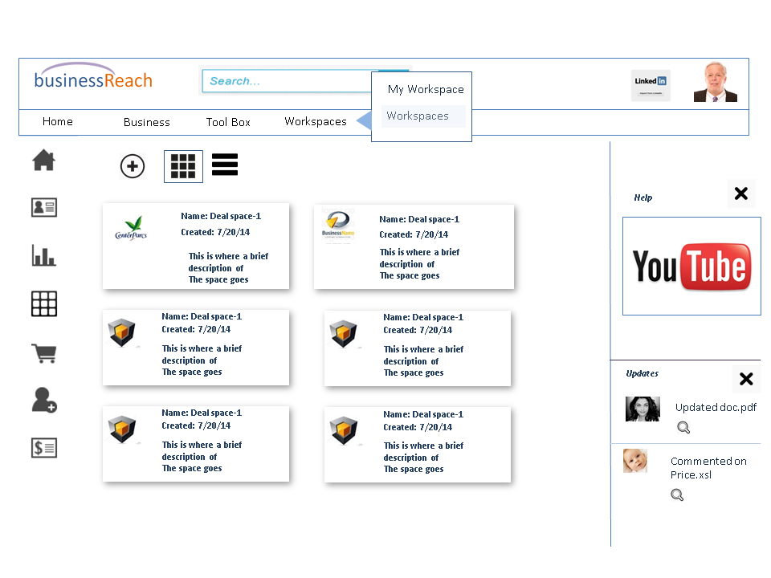

* User can click on one of the workspaces to view the details of that workspace as shown in the screen below
* The dash board provides a snap shot view of what is going on in a workspace such as new message, new document upload etc.
* In addition to the dash board workspace provides a view of all the documents shared in the workspace

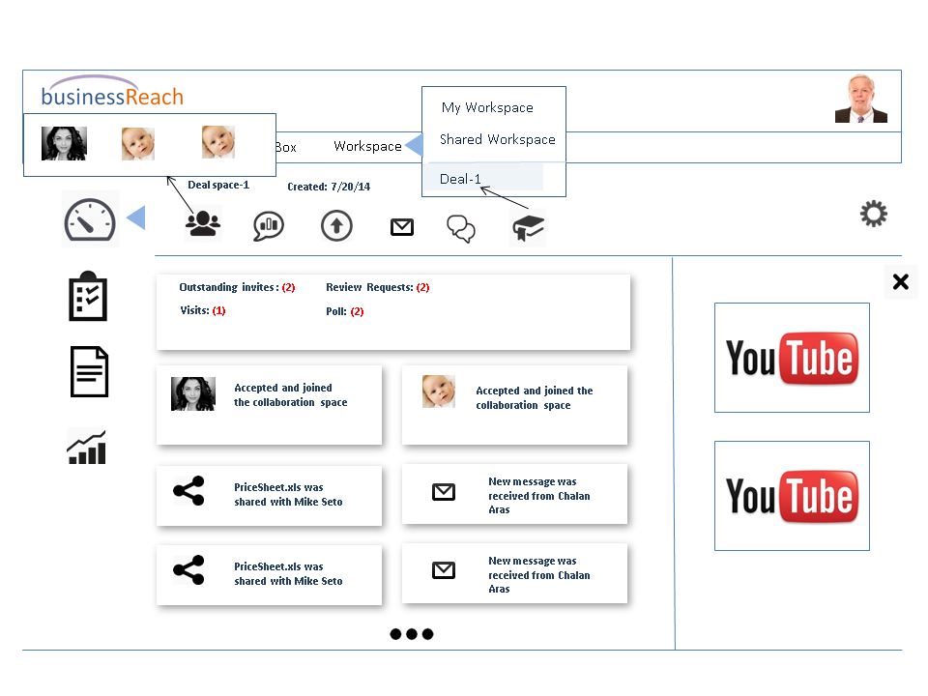

* This view shows details of a workspace
* A workspace can be bookmarked. Once bookmarked it will show as a menu item as shown
* Also clicking on the right most icon on top tool bar will show the list of participants

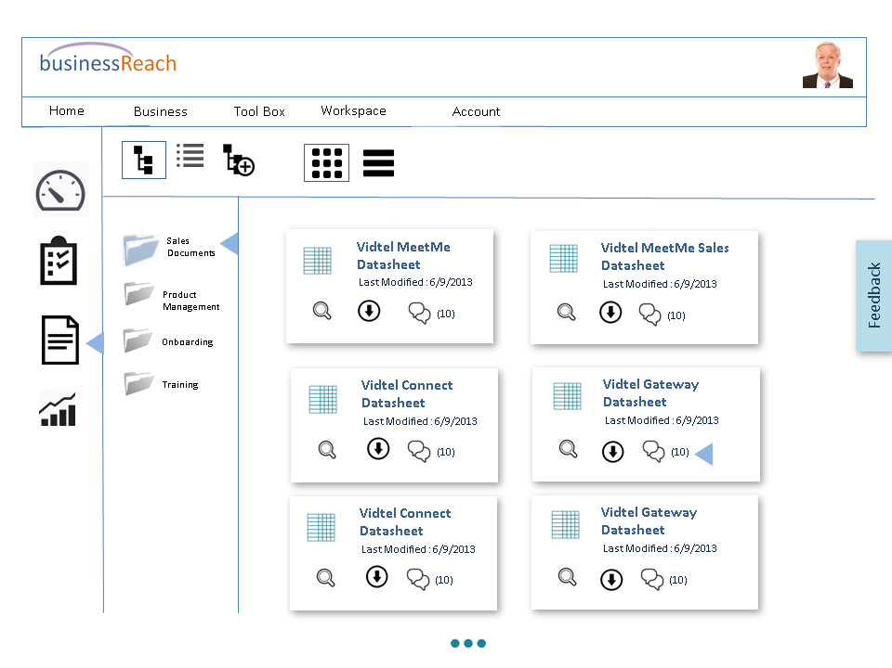

* This is the document screen of the workspace
* System automatically shows the documents in the first folder in a tiled view
* User can click on the magnifying glass button to see a specific document as shown in the next screen

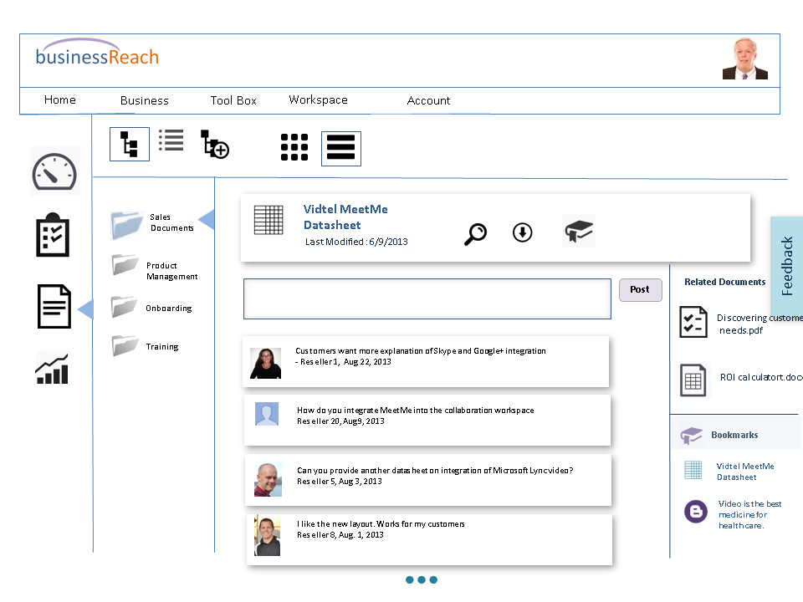

* The home page of a document has a wall that shows all the activities such as share, update and comment
* User can click on the magnifying glass to view the document in its thumbnail view as shown in the screen below
* In the screen below the user can click on a specific page and provide comment where the comment will be stored against the page as shown

