Steps –
CREATE custom;

create table if not exists temperature_data
(Date1 DATE, Zipcode Int, temperature Int)
row format delimited
fields terminated by ',';

LOAD DATA LOCAL INPATH '/home/acadgild/dataset.txt'
INTO TABLE temperature_data;

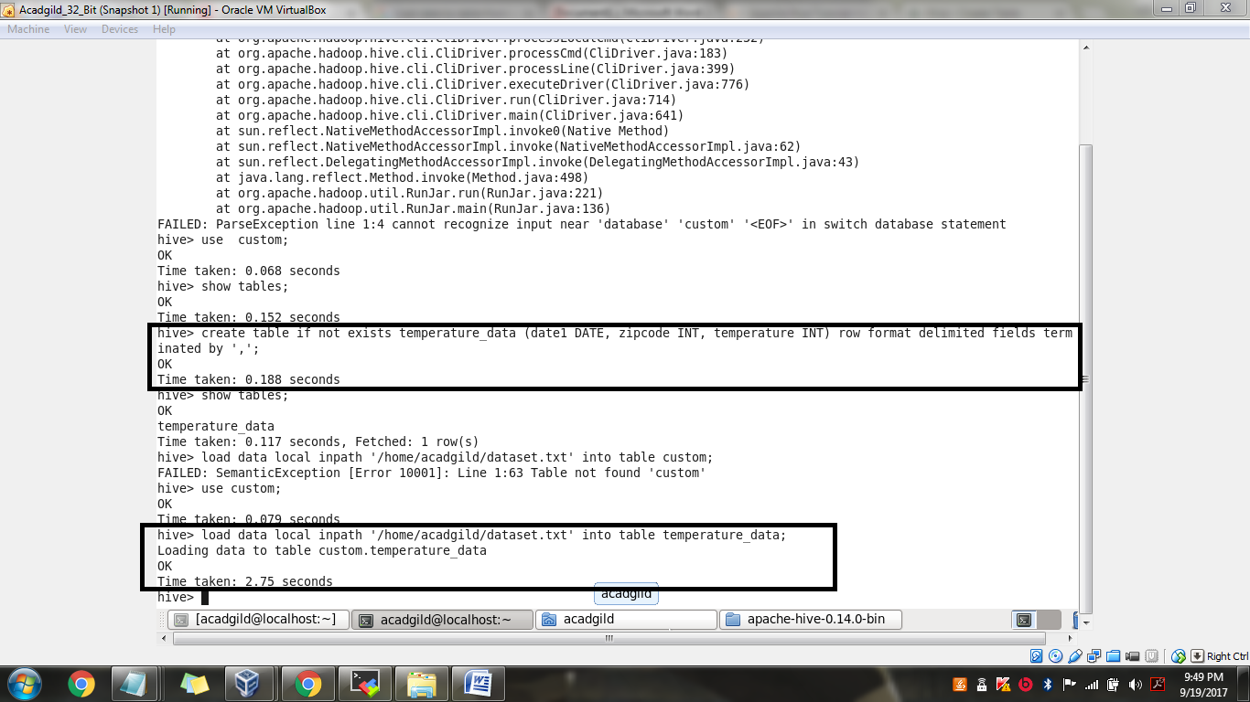

Verify if the data is loaded
