Introduction:
Hive is data warehouse software used for querying and managing large data sets residing in distributed storage. Hive language is similar to SQL language and is called HiveQL. Hive is designed to enable easy data summarization. It allows traditional map reduce programs to customize mappers and reducers when it is inconvenient or inefficient to execute the logic in HiveQL (User Defined Functions UDFS).Hive can easily be integrated with other data technologies by using Hive JDBC connections. Hive uses HDFS for storage, but stores all the meta information about the database and table in Derby or MySQL database.
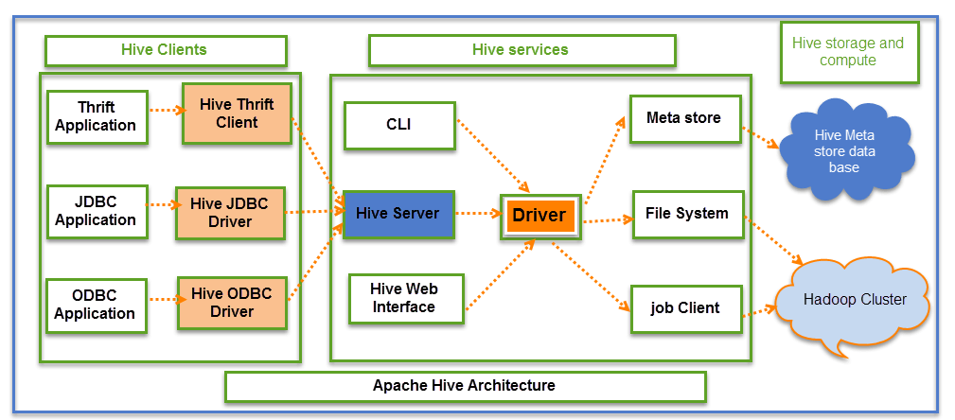
The above screenshot explains the Apache Hive architecture in detail
Hive Consists of Mainly 3 core parts
- Hive Clients
- Hive Services
- Hive Storage and Computing
Hive Clients:
Hive provides different drivers for communication with a different type of applications. For Thrift based applications, it will provide Thrift client for communication.
For Java related applications, it provides JDBC Drivers. Other than any type of applications provided ODBC drivers. These Clients and drivers in turn again communicate with Hive server in the Hive services.
Hive Services:
Client interactions with Hive can be performed through Hive Services. If the client wants to perform any query related operations in Hive, it has to communicate through Hive Services.
CLI is the command line interface acts as Hive service for DDL (Data definition Language) operations. All drivers communicate with Hive server and to the main driver in Hive services as shown in above architecture diagram.
Driver present in the Hive services represents the main driver, and it communicates all type of JDBC, ODBC, and other client specific applications. Driver will process those requests from different applications to meta store and field systems for further processing.
Hive Storage and Computing:
Hive services such as Meta store, File system, and Job Client in turn communicates with Hive storage and performs the following actions:
- Metadata information of tables created in Hive is stored in Hive "Meta storage database".
- Query results and data loaded in the tables are going to be stored in Hadoop cluster on HDFS.

HOW HIVE WORKS
Hive on LLAP (Live Long and Process) makes use of persistent query servers with intelligent in-memory caching to avoid Hadoop’s batch-oriented latency and provide as fast as sub-second query response times against smaller data volumes, while Hive on Tez continues to provide excellent batch query performance against petabyte-scale data sets.
The tables in Hive are similar to tables in a relational database, and data units are organized in a taxonomy from larger to more granular units. Databases are comprised of tables, which are made up of partitions. Data can be accessed via a simple query language and Hive supports overwriting or appending data.
Within a particular database, data in the tables is serialized and each table has a corresponding Hadoop Distributed File System (HDFS) directory. Each table can be sub-divided into partitions that determine how data is distributed within sub-directories of the table directory. Data within partitions can be further broken down into buckets.
Hive supports all the common primitive data formats such as BIGINT, BINARY, BOOLEAN, CHAR, DECIMAL, DOUBLE, FLOAT, INT, SMALLINT, STRING, TIMESTAMP, and TINYINT. In addition, analysts can combine primitive data types to form complex data types, such as structs, maps and arrays.

Different modes of Hive
Hive can operate in two modes depending on the size of data nodes in Hadoop.
These modes are,
- Local mode
- Map reduce mode
When to use Local mode:
If the Hadoop installed under pseudo mode with having one data node we use Hive in this mode
If the data size is smaller in term of limited to single local machine, we can use this mode
Processing will be very fast on smaller data sets present in the local machine
When to use Map reduce mode:
If Hadoop is having multiple data nodes and data is distributed across different node we use Hive in this mode
It will perform on large amount of data sets and query going to execute in parallel way
Processing of large data sets with better performance can be achieved through this mode
In Hive, we can set this property to mention which mode Hive can work? By default, it works on Map Reduce mode and for local mode you can have the following setting.

Components of HIVE:

UI – The user interface for users to submit queries and other operations to the system. As of 2011 the system had a command line interface and a web based GUI was being developed.

Driver – A Driver is the component that handles query submissions. It is responsible for orchestrating the life cycle of a query by invoking the components in the correct order to fulfill it. The Driver also spawns sessions and keeps track of session statistics.

Compiler – The component that parses the queries, does semantic analysis on the different query blocks and query expressions and eventually generates an execution plan with the help of the table and partition metadata looked up from the metastore. The compiler takes a HiveQL query and translates it into MapReduce jobs. A parser parses the query and builds an abstract syntax tree (AST). The AST is checked for types and semantic consistencies. Metadata from the metastore is used to achieve this step. The output of the checks is an operator DAG. A series of optimization transformations are then applied on the DAG. The transformations are chained, and the output is an optimized operator tree. Users are allowed to add their transformations by implementing the Transform interface.
The optimized DAG is then translated into a physical plan. The physical plan is a set of MapReduce and HDFS jobs. A HDFS job is used to read and write data from HDFS.

Metastore –The metastore is a database for system-related metadata. It stores details about the tables, partitions, schemas, column types, and table locations. It can be accessed via the Thrift interface, making it possible to read this data using clients written in many different programming languages. The data is stored in a relational database system and uses an Object-relational mapping (ORM) layer to read and write data into the store. The choice of using an RDBMS for the metastore was made to reduce the latency when serving this information to the Hive query compiler.
The ORM layer of the metastore allows a pluggable model where any RDBMS can be plugged into Hive. The default RDBMS used is Apache Derby, an open source relational data store. In practice, organizations use MySQL and other popular RDBMS suites to host the metastore. The data in the metastore imposes structures on otherwise raw HDFS files. This makes it critical to protect the metastore from crashes by regular backups or replication. The metastore is only accessed during compilation and never when MapReduce jobs are run.

Execution Engine –The execution engine takes the plan generated by the compiler and executes the job strictly in order of their dependencies. The plan is communicated to each task in the Hadoop cluster via a plan.xml file. This file is distributed across the cluster using a side channel such as DistributedCache. The job outputs are stored in temporary locations. On the completion of the entire query, if a store location is specified, these files are moved to appropriate locations as specified by the Data Manipulation Language (DML). In the case of a query without a store location, the results are served directly from the temporary location.

