Components of Hadoop 2.x Framework
Apache Hadoop is an open-source software framework for storage and large-scale processing of data-sets on clusters of commodity hardware. There are mainly five building blocks inside this runtime environment (from bottom to top):
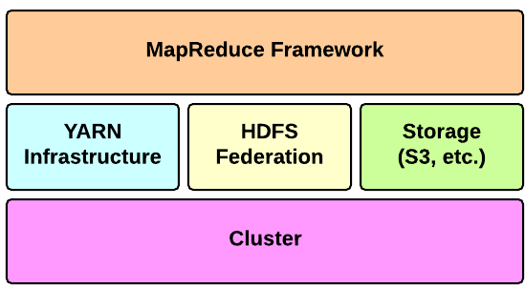
The three major components in Apache Hadoop 2.x architecture are as follows -

Map Reduce Framework

Map Reduce is a processing engine for distributed computing based on Java. Using this processor, we can write programs for processing huge amount or data, in parallel, on large clusters of commodity hardware in a reliable and efficient manner. Map Reduce framework contains two important tasks called the Mapper class and the Reducer class apart from the Driver Class which drives the tasks and helps produce the needed results. Map takes a set of data and converts it into another set of data, where individual elements are broken down into tuples (key/value pairs). Secondly, reduce task, which takes the output from a map as an input and combines those data tuples into a smaller set of tuples. As the sequence of the name MapReduce implies, the reduce task is always performed after the map job.

Working structure of Map Reduce

MapReduce concept is based on sending the computer to where the data resides. MapReduce program executes in three stages, namely map stage, shuffle and sort stage, and the reduce stage.
- Map stage: The input data is in the form of file or directory and is stored in the Hadoop file system (HDFS). The Mapper’s job is to process the input data such that the input file is passed to the mapper function line by line where the mapper processes the data and creates several small chunks of data.
- Reduce stage: This stage is the combination of the Shuffle and Sort stage and the Reduce stage. The Reducer’s job is to process the data that comes from the mapper as output. After processing, it produces a new set of output, which will be stored in the HDFS.
- During a MapReduce job, Hadoop sends the Map and Reduce tasks to the appropriate servers in the cluster.
- The framework manages all the details of data-passing such as issuing tasks, verifying task completion, and copying data around the cluster between the nodes.
- Major part of the computing happens on nodes with data on local disks that reduces the network traffic.
- After completion of the tasks, the cluster collects and reduces the data to form an appropriate result, and sends it back to the Hadoop server.
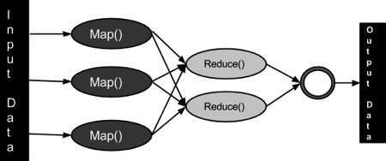

Inputs and Outputs
- The MapReduce framework operates on <key, value> pairs, that is, the framework views the input to the job as a set of <key, value> pairs and produces a set of <key, value> pairs as the output of the job, conceivably of different types.
- The key and the value classes should be in serialized manner by the framework and hence, need to implement the Writable interface. Additionally, the key classes have to implement the Writable-Comparable interface to facilitate sorting by the framework.
 | - Input | - Output
- Map | - <k1, v1> | - list (<k2, v2>)
- Reduce | - <k2, list(v2)> | - list (<k3, v3>)

YARN
YARN (Yet Another Resource Negotiator) is the architectural center of Hadoop framework that allows multiple data processing engines such as interactive SQL, real-time streaming, data science and batch processing to handle data stored in a single platform. It is the prerequisite for Enterprise Hadoop, providing resource management and a central platform to deliver consistent operations, security, and data governance tools across Hadoop clusters.
In YARN, the four main actors are:
- the Job Submitter (the client)
- the Resource Manager (the master)
- the Node Manager (the slave)
- the Application Master (like MapReduce, Pig, Hive etc processing engines)
The flow of operations is as follows:
- A client submits an application to the Resource Manager
- The Resource Manager allocates a container
- The Resource Manager contacts the related Node Manager
- The Node Manager launches the container
- The Container executes the Application Master
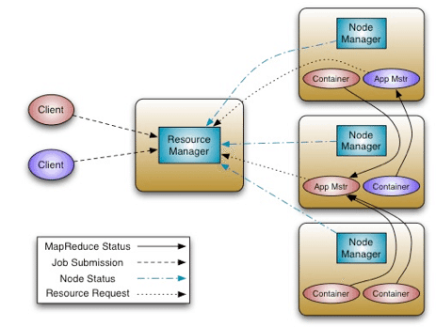
The Application Master is responsible for the execution of a single application. It asks for containers to the Resource Scheduler (Resource Manager) and executes specific programs (e.g., the main of a Java class) on the obtained containers. The Application Master knows the application logic and thus it is framework-specific. In case of the MapReduce framework, it provides its own implementation of an Application Master.
The Resource Manager is a single point of failure in YARN. Using Application Masters, YARN is spreading over the cluster the metadata related to running applications. This reduces the load of the Resource Manager and makes it fast recoverable.
YARN enhances a Hadoop system in the following way:
- Multi-tenancy - YARN allows multiple access engines (either open-source or proprietary) to use Hadoop as the common standard for batch, interactive and real-time engines that can simultaneously access the same data set.
- Cluster utilization - YARN’s dynamic allocation of cluster resources improves utilization over more static MapReduce rules used in early versions of Hadoop
- Scalability - Data center processing power continues to rapidly expand. YARN’s Resource Manager focuses exclusively on scheduling and keeps pace as clusters expand to thousands of nodes managing petabytes of data.
- Compatibility - Existing MapReduce applications developed for Hadoop 1 can run YARN without any disruption to existing processes that already work

HDFS
HDFS in Hadoop architecture provides high throughput access to application data and Hadoop MapReduce provides YARN based parallel processing of large data sets. The default big data storage layer for Apache Hadoop is HDFS. HDFS is the warehouse of Apache Hadoop components as users can dump huge datasets into HDFS and the data will sit there nicely until the user wants to leverage it for analysis. HDFS component creates several replicas of the data block to be distributed across different clusters for reliable and quick data access. HDFS comprises of 3 important components - NameNode, DataNode and Secondary NameNode. HDFS operates on a Master-Slave architecture model where the NameNode acts as the master node for keeping a track of the storage cluster and the DataNode acts as a slave node summing up to the various systems within a Hadoop cluster.

Features of HDFS
- Usage of distributed storage and processing.
- Optimization is used for throughput over latency.
- Efficient in reading large files but poor at seek requests for many small ones.
- A command interface to interact with HDFS is provided.
- The built-in servers of data node and name node helps the end users to check the cluster‘s status as per time intervals.
- Streams access the data of file system.
- Authentication of file permissions and authentication are provided.
- Uses replication are used instead of handling disk failures. Each block comprises of a file storage on several nodes inside the cluster and the HDFS NameNode continuously keep monitoring the reports which are sent by every DataNode to ensure due to failures no block have gone below the desired replication factor. If this happens then it schedules the addition of another copy within the cluster.
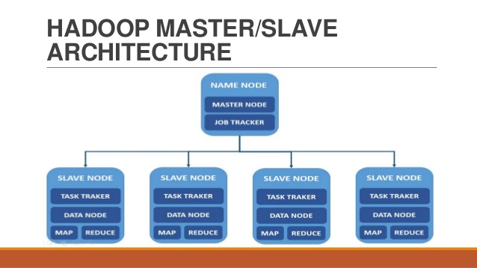

Namenode
The namenode is the commodity hardware that contains the GNU/Linux operating system and the namenode software. It is a software that can be run on commodity hardware. The system having the namenode acts as the master server and it does the following tasks:
- Manages the file system namespace.
- Regulates client’s access to files.
- It also executes file system operations such as renaming, closing, and opening files and directories.

Datanode
The datanode is a commodity hardware having the GNU/Linux operating system and datanode software. For every node (Commodity hardware/System) in a cluster, there will be a datanode. These nodes manage the data storage of their system.
- Datanodes perform read-write operations on the file systems, as per client request.
- They also perform operations such as block creation, deletion, and replication according to the instructions of the namenode.

Block
Generally the user data is stored in the files of HDFS. The file in a file system will be divided into one or more segments and/or stored in individual data nodes. These file segments are called as blocks. In other words, the minimum amount of data that HDFS can read or write is called a Block. The default block size is 64MB, but it can be increased as per the need to change in HDFS configuration.

HDFS Objectives
- Fault detection and recovery: It provide methods for fast and automatic fault detection and recovery of data.
- Huge datasets: It consists of multiple nodes per cluster to manage the applications with large amount of datasets.
- Hardware at data: HDFS reduces the network traffic and increases the throughput as per the required time intervals.

