ASSIGNMENT -2
Note: Screenshots are followed by the commands
- load_file = LOAD ‘employee_details.txt’ USING PigStorage(‘,’) AS (id: int, firstname: chararray, lastname: chararray, salary: int, rating:int);
- DUMP load_file;
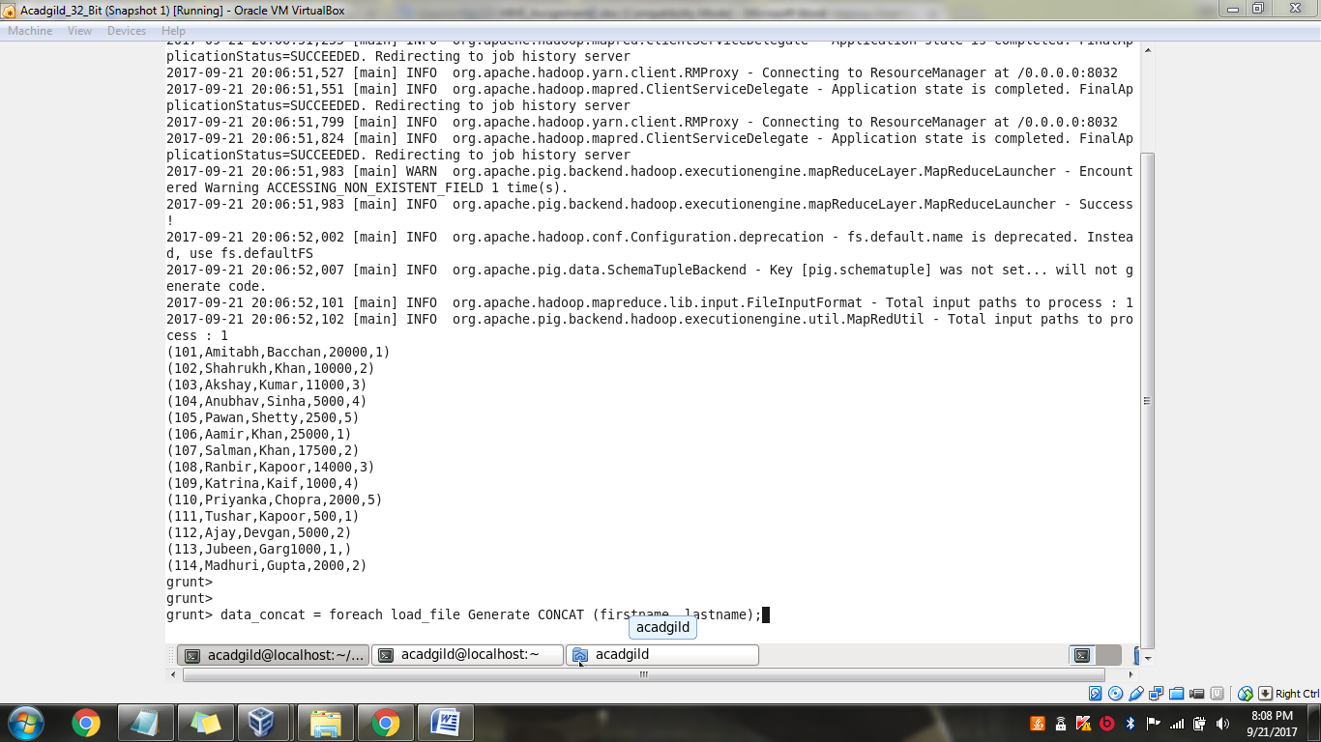

- data_concat = foreach load_file Generate CONCAT (firstname, lastname);
- DUMP data_concat;
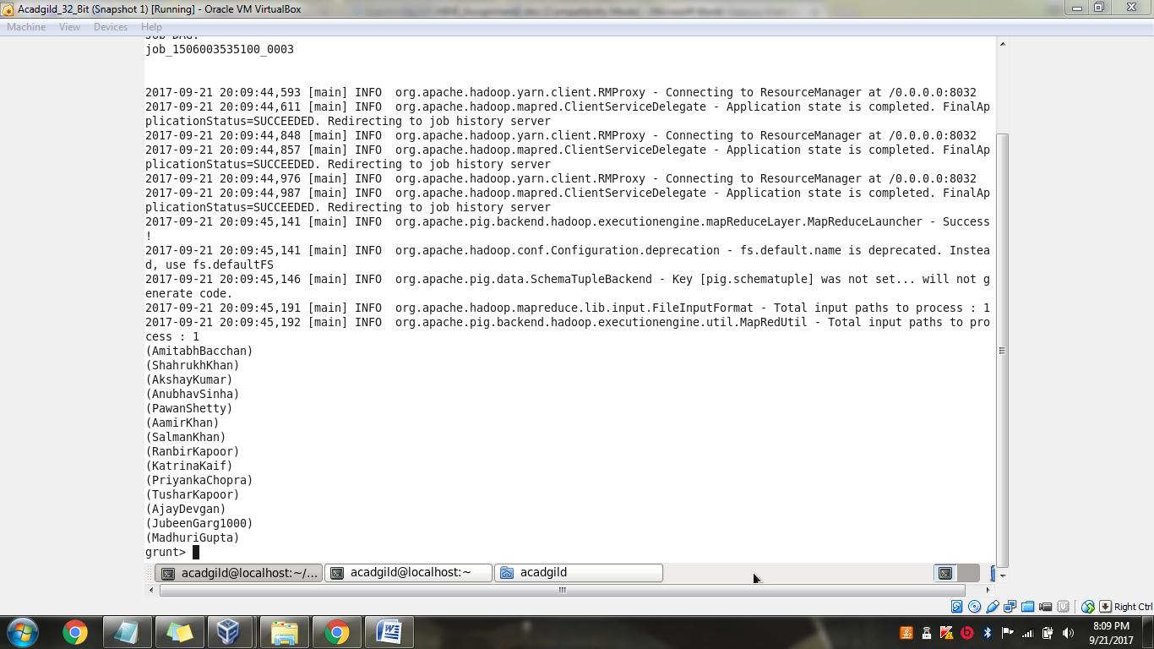

- data_tokenize = foreach load_file Generate TOKENIZE (firstname);
- dump data_tokenize;

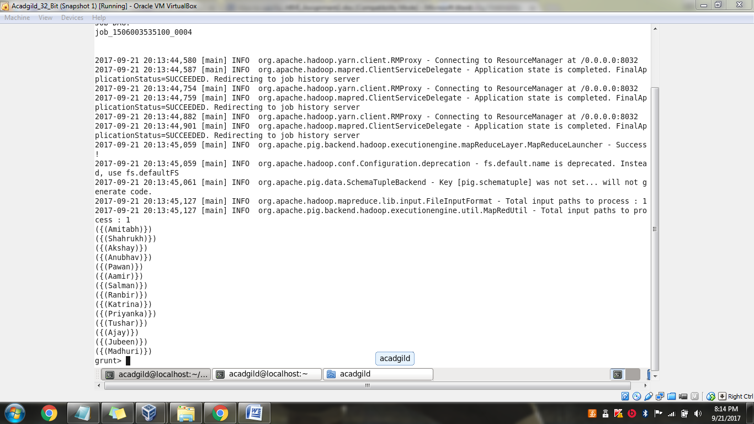

- data_group = Group load_file all;
- Dump data_group;

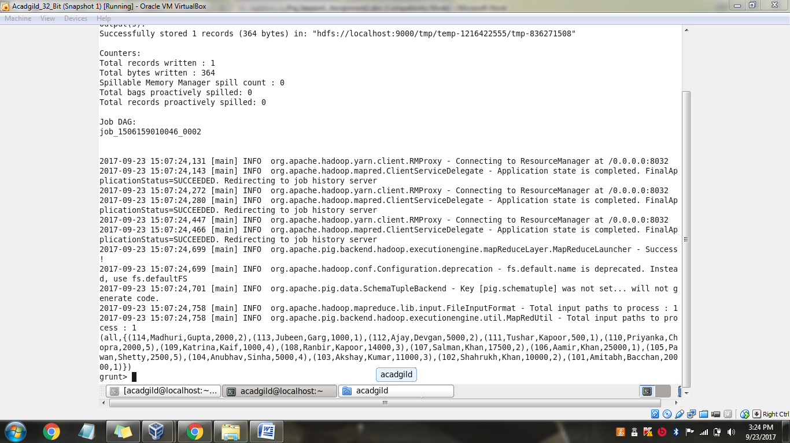

- data_sum = foreach data_group Generate (load_file.id, load_file.salary), SUM(load_file.salary);
- DUMP data_sum;
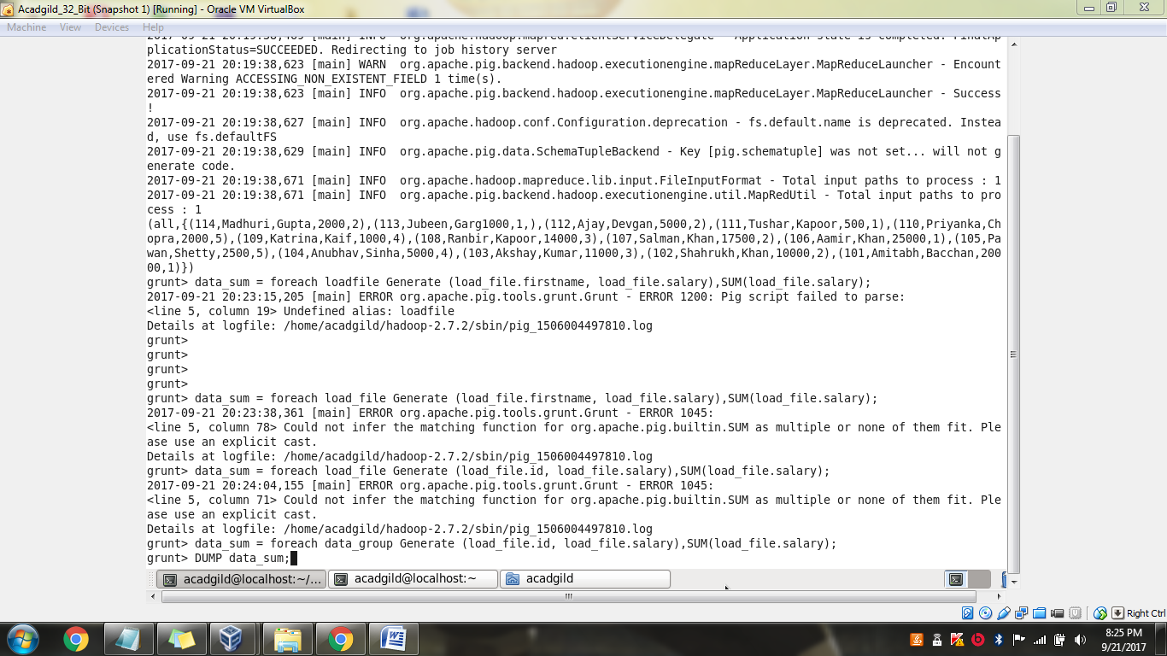

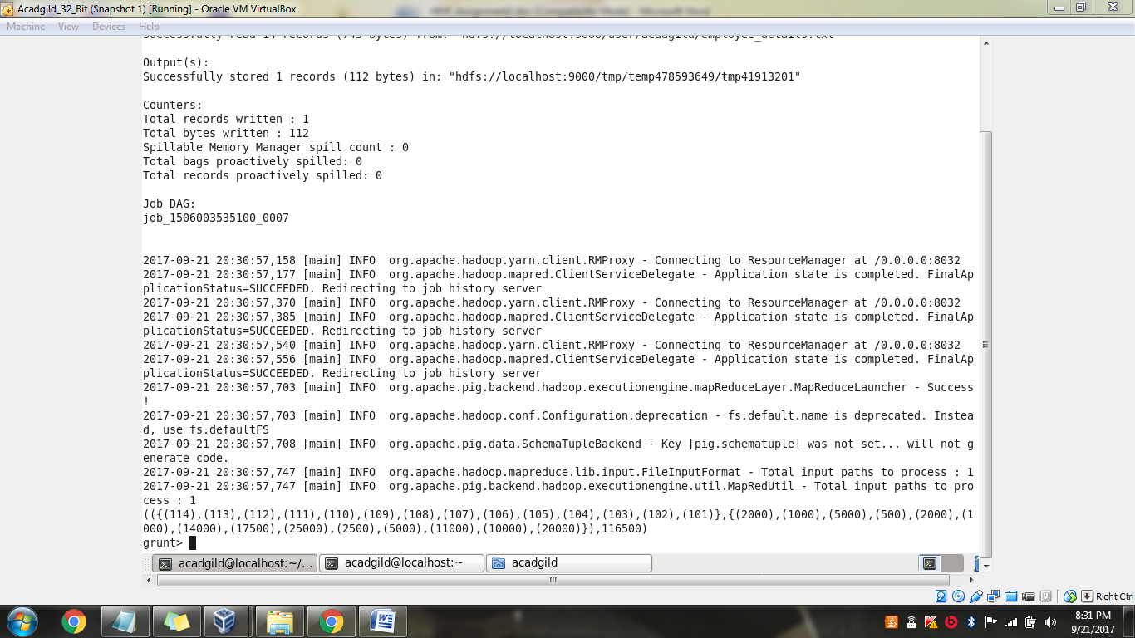
- data_min = foreach data_group Generate (load_file.firstname, load_file.salary), MIN(load_file.salary);
- DUMP data_min;

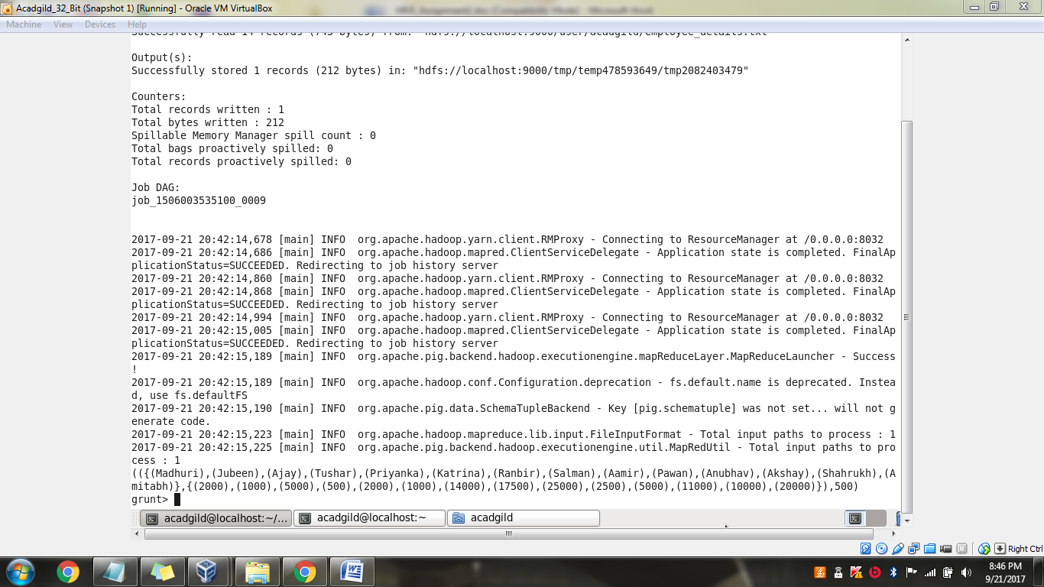

- data_max = foreach data_group Generate (load_file.firstname, load_file.salary), MAX(load_file.salary);
- DUMP data_max;

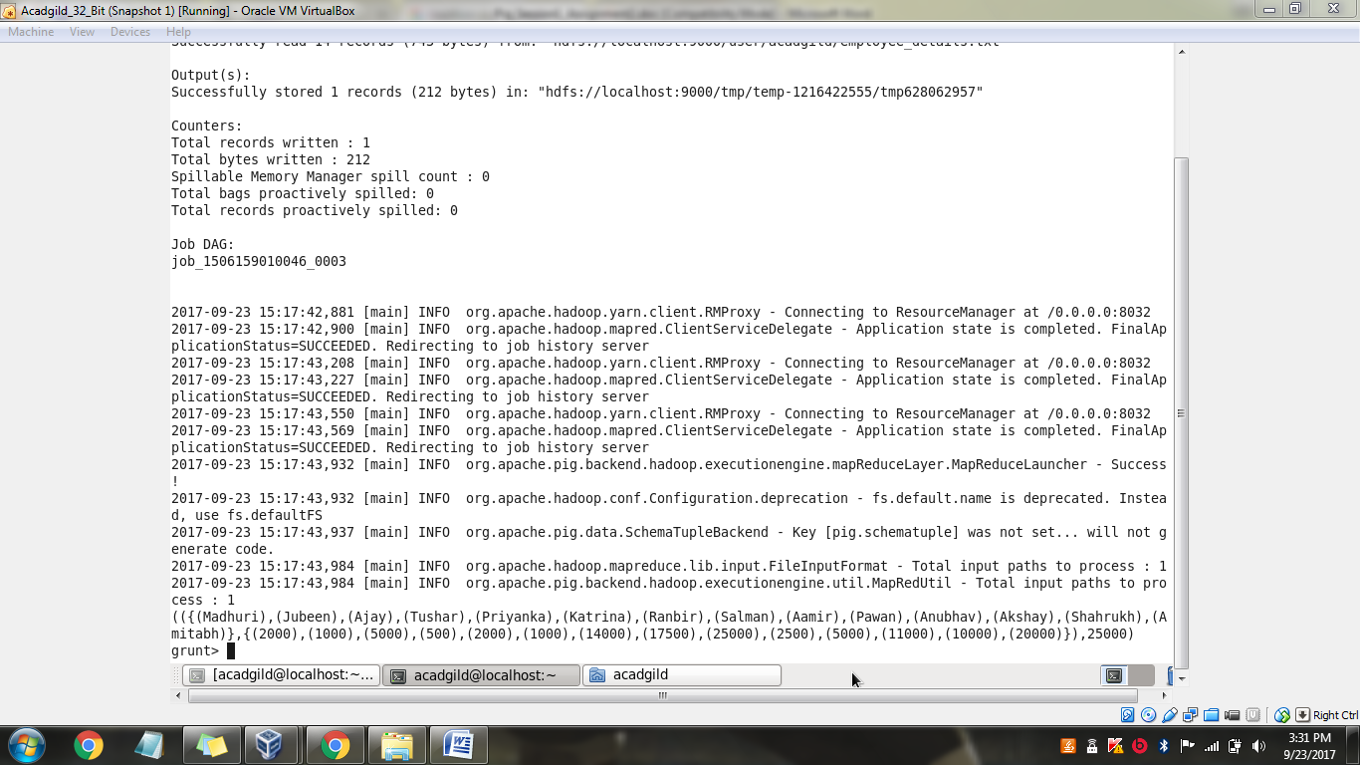

- data_limit = LIMIT load_file 8;
- DUMP data_limit;
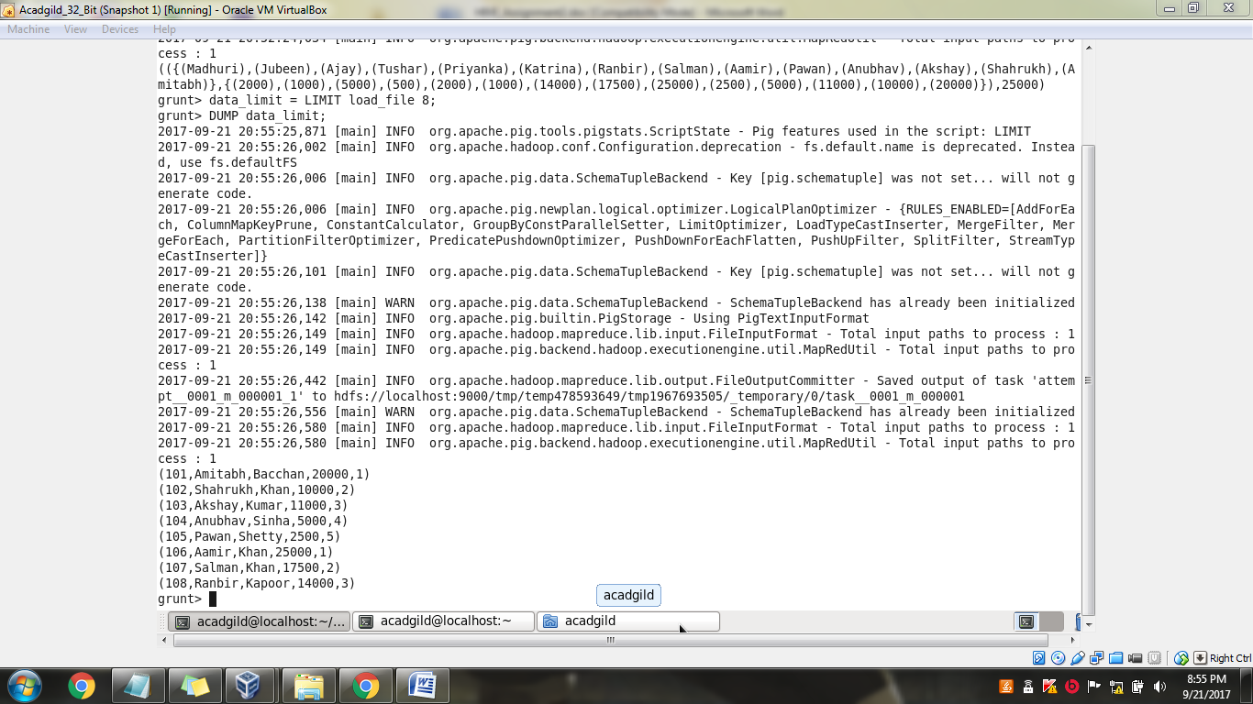

- STORE load_file INTO ‘hdfs://localhost:9000/PigLoad/’ USING PigStorage (‘,’);
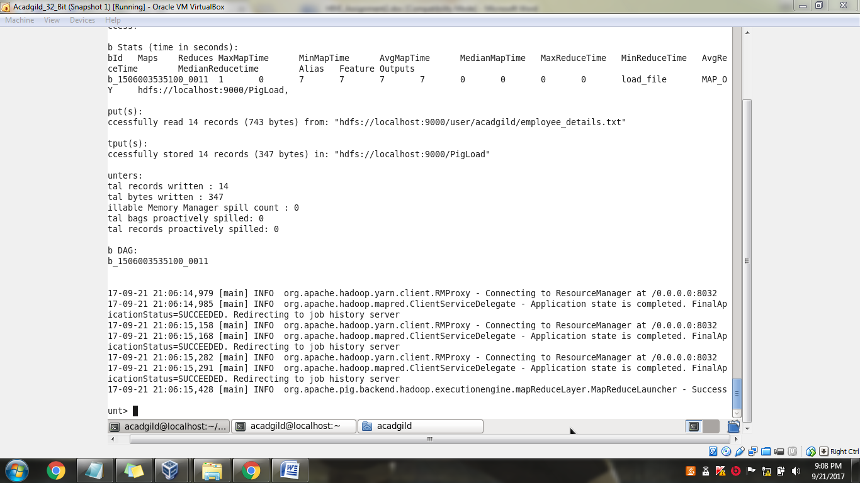

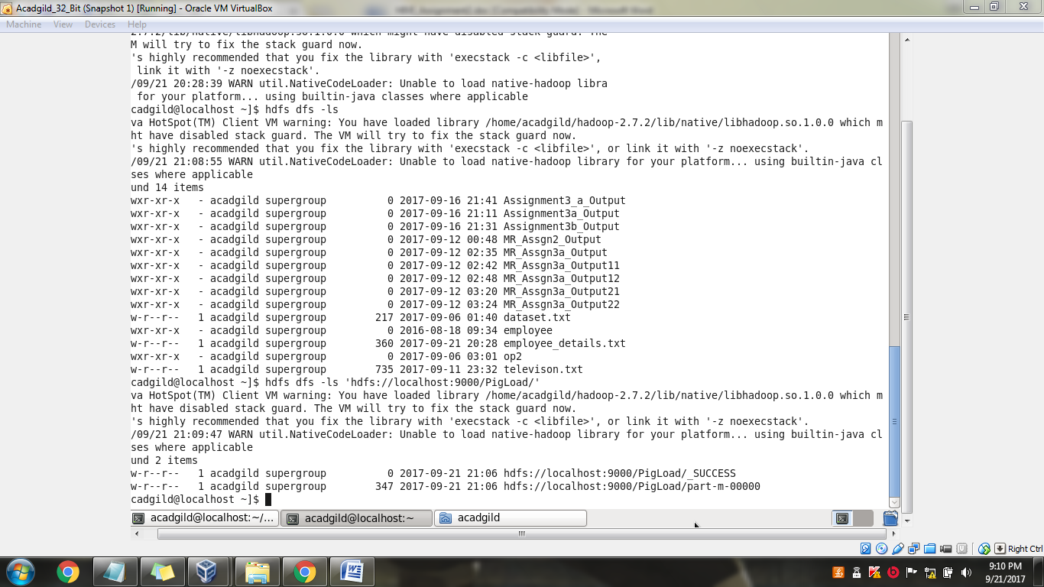

- data_distinct = DISTINCT load_file;
- DUMP data_distinct;
(No redundant data available so entire file content is displayed)
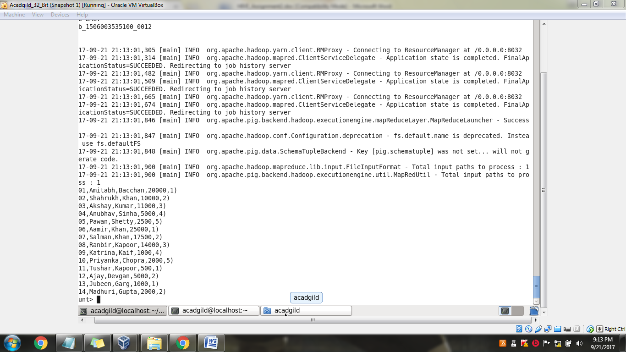

loadfile = LOAD ‘employee_details.txt’ as (line:chararray);
DUMP loadfile;
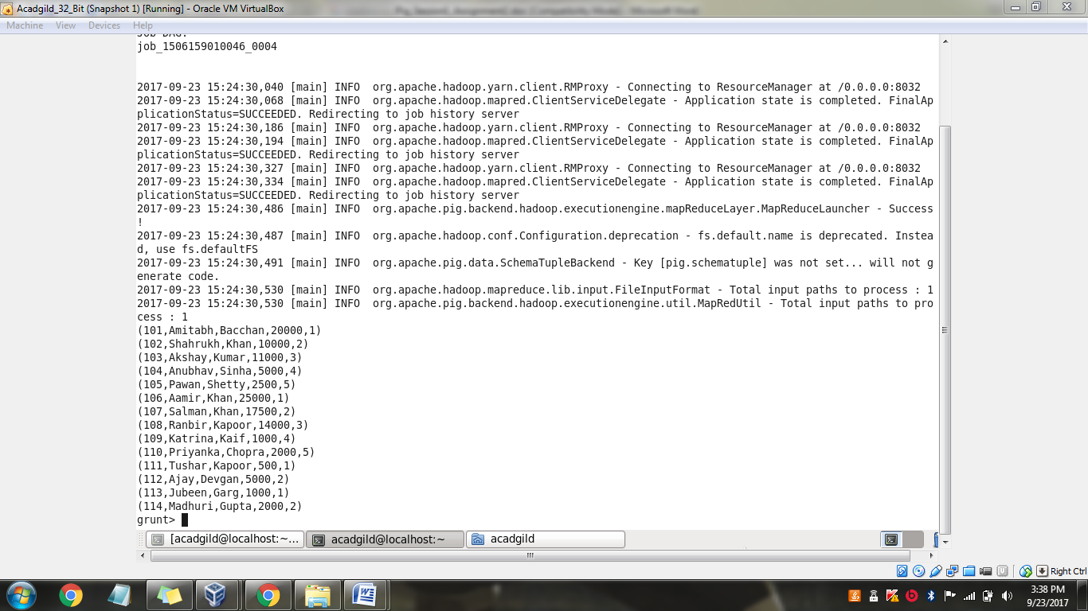
data_flatten = foreach loadfile Generate FLATTEN(TOKENIZE(line)) as word;
Dump data_flatten;
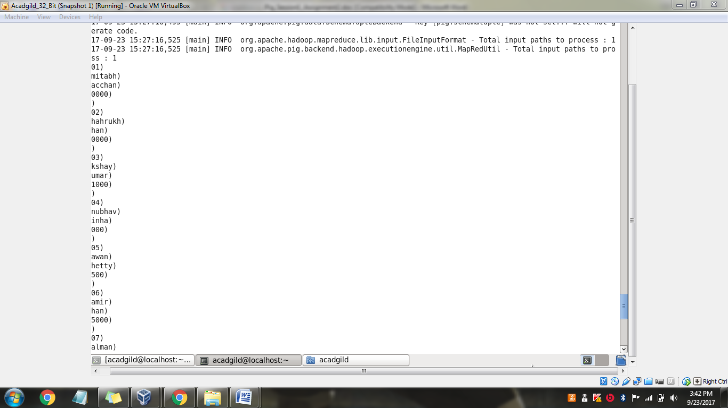
IsEmpty

