Milestone 1 Report: Detecting Illegal Pick-ups
Oct 25, 2026 · @a

1. Introduction
Our simulation detects all three illegal pick-up conditions, and accepts the one legal case, in every test we ran: five scripted scenarios plus a 300-iteration random run cross-checked by an independent checker.
Milestone 1 asks for two things only: no communication delay, and no full robot behaviour. The goal is to show that the simulation itself can catch every illegal pick-up. A target may only be picked up validly by exactly two robots, on the target's cell, in the same turn. Anything else is illegal:
- No target: one or more robots try to pick up on a cell with no target.
- Solo: exactly one robot tries to pick up a target.
- Crowd: more than two robots try to pick up the same target.
The robots in this milestone are deliberately simple (scripted, or random and uncoordinated) so that these mistakes happen on purpose. Coordinated behaviour comes in milestone 2, and random message delay in milestone 3. The communication channel is already built with a delay setting, held at zero here.

2. World model
The world is a 10 x 10 grid with cells numbered (0,0) at bottom-left to (9,9) at top-right. It holds any number of robots and a set of targets.
- Robots each have a unique ID, a cell and a heading (north, east, south or west). Several robots may share a cell, which is necessary for a two-robot pick-up. A robot that drives into the grid edge stays where it is.
- Targets appear at random free cells whenever none are left (the number per batch is configurable) and stay until a legal pair captures them.
- Controllers decide each robot's action. The engine does not care how a controller decides, so the same world can run scripted test robots now and real distributed control later.
Per turn | What the robot has
One action | Move forward one cell, turn left 90°, turn right 90°, or pick up
Sensing | Is there a target in the cell ahead? Which robot IDs are in the cell ahead? Which other robot IDs share my cell?
One broadcast | A message to every other robot. Ours carries the sender ID, its cell and the action it chose.
A robot cannot see a target on its own cell, only the cell ahead. To stand on a target it must see it ahead and then drive onto it, so it has to remember that it is standing on one.

3. Simulation loop
Each turn runs the five phases of the brief in a fixed order, and the illegal-behaviour test sits between deciding and acting. That placement means a violation is caught from the robots' intentions, before anything in the world changes.
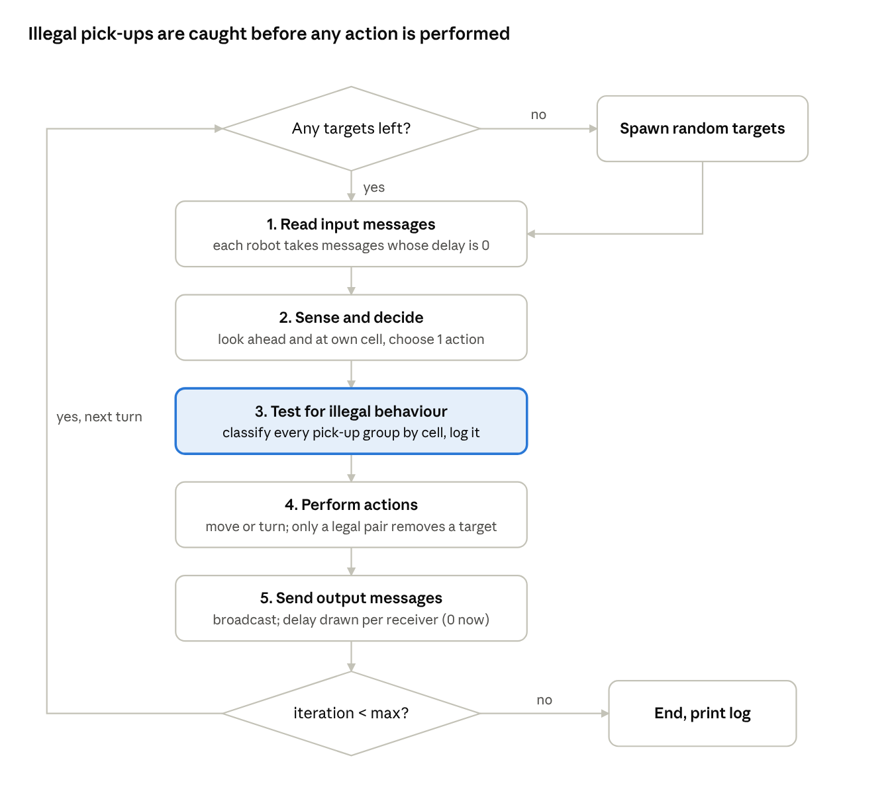
simulation loop · 5 phases per turn, 2 decisions
Phases 1, 2, 4 and 5 run for all robots before the next phase starts, so no robot sees another's move from the same turn. An illegal pick-up is logged and has no effect: the target stays where it is.

4. Illegal-condition detector
The detector looks at intentions, not results: after every robot has chosen its action, it groups all pick-up choices by cell and classifies each group on its own.
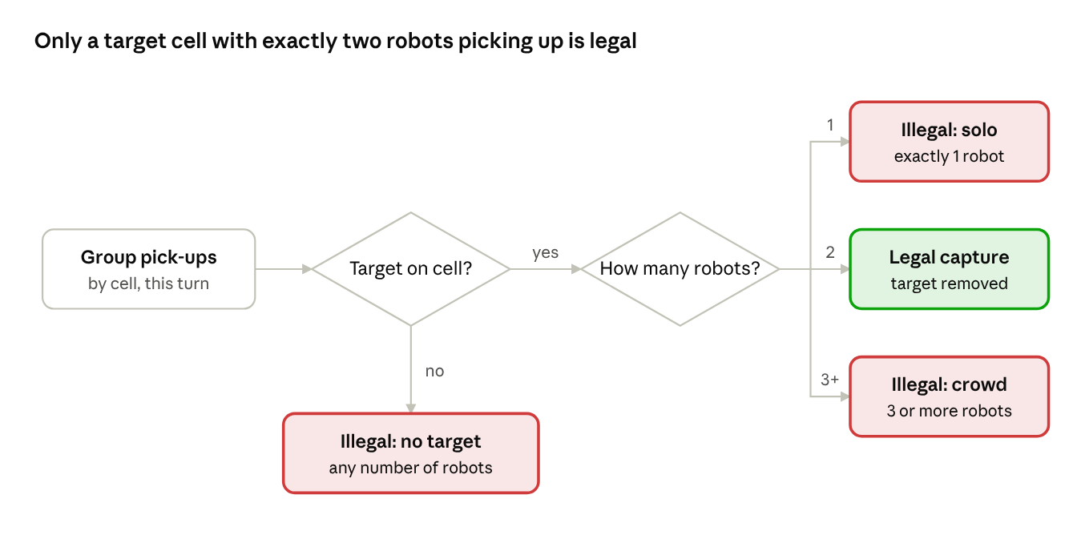
illegal-condition detector · 2 checks, 4 outcomes
The target check comes first, so two robots on an empty cell count as "no target", not as a legal pair. Because each cell is classified separately, one turn can raise several violations at different cells. Each violation is recorded with the turn number, the cell, the violation type and the IDs of the robots involved.
The same rule as a Petri net for one target cell. The Capture transition needs the target token and takes two request tokens, and the inhibitor arc stops it when three or more requests are present. The three illegal conditions are exactly the turns where requests exist but Capture cannot fire: no target token, only one request, or three or more requests.
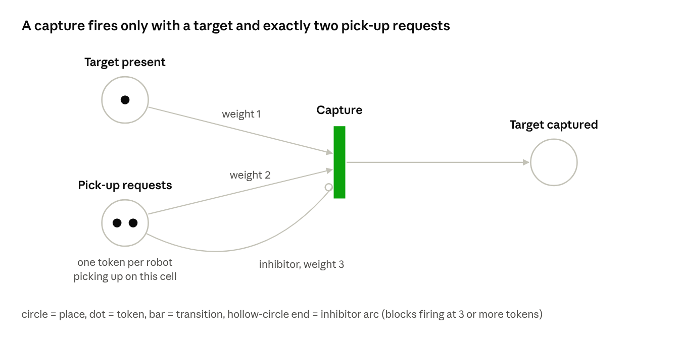
Petri net of one target cell · legal capture

5. Communication model
Messages go through a broadcast channel that gives every robot its own input queue. With the delay at zero, a message sent at the end of turn t is read by every other robot at the start of turn t + 1.
- Send: for each receiver other than the sender, draw a delay r and append (message, r) to that receiver's queue. The delay is drawn per receiver, not per message, as the brief requires.
- Read: for each entry in the queue, if r = 0 deliver it, otherwise lower r by 1 and keep it.
- Delay setting: r is drawn from an exponential distribution with a configurable mean, rounded to whole turns. Milestone 1 sets the mean to 0, so r is always 0.
In the scripted scenarios every message arrived exactly one turn after it was sent. For example, in S1 (3 robots, 4 turns) each robot received 6 messages: one from each of the other 2 robots for each of turns 0 to 2.

6. Test scenarios and results
All six scenarios passed: every illegal condition was flagged at the right cell, turn and robots, and the legal pair was never flagged.
Scenarios S1 to S5 use scripted robots that play a fixed list of actions, so each case is provoked on purpose. S6 uses ten uncoordinated robots that wander, step onto any target they see and try to pick it up whether or not a partner is there.
Scenario | Set-up | Expected | Detected
S1 No target | Robot 1 picks up alone on empty cell (3,1); robots 2 and 3 pick up together on empty cell (6,7) | 2 x No target | 2 x No target (turns 2 and 1)
S2 Solo | Robot 1 drives onto the target at (5,5) and picks up alone | 1 x Solo | 1 x Solo (turn 3)
S3 Crowd | Robots 1, 2, 3 reach the target at (7,3) from west, north and east and all pick up | 1 x Crowd | 1 x Crowd (turn 2)
S4 Legal pair (control) | Robots 1 and 2 meet on the target at (3,4) and pick up in the same turn | No violation, 1 capture | No violation, 1 capture (turn 4)
S5 All in one turn | 7 robots on 4 cells: empty cell, solo, crowd of 3, legal pair | 1 of each illegal case + 1 capture | All 4 classified correctly in turn 0
S6 Random, 10 robots, 300 turns | Uncoordinated greedy robots | Detector = independent checker | No target 144, Solo 122, Crowd 2, Captures 5; all match
S1 shows that two robots together are still illegal on an empty cell, so the "no target" rule is checked before the robot count. S6 compares the detector against a second checker that re-counts every recorded decision phase from scratch; both agree on every category.
The figures below show the decision phase of the turn in which each case happened. Triangles are robots pointing where they face, purple ones have chosen pick-up, stars are targets, red cells are illegal and green cells are legal.
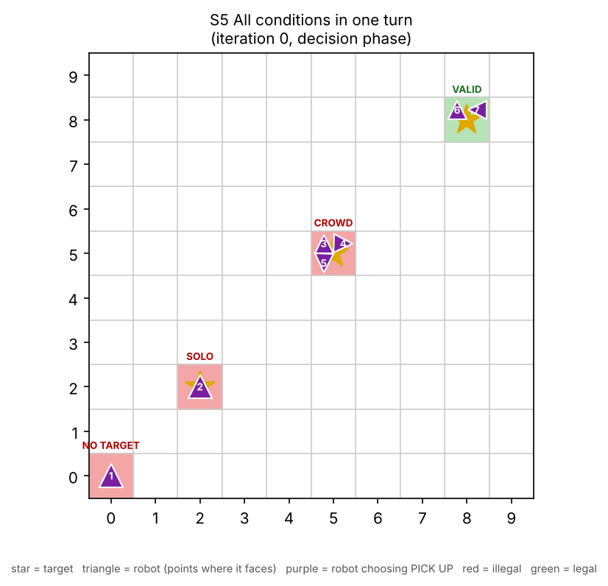
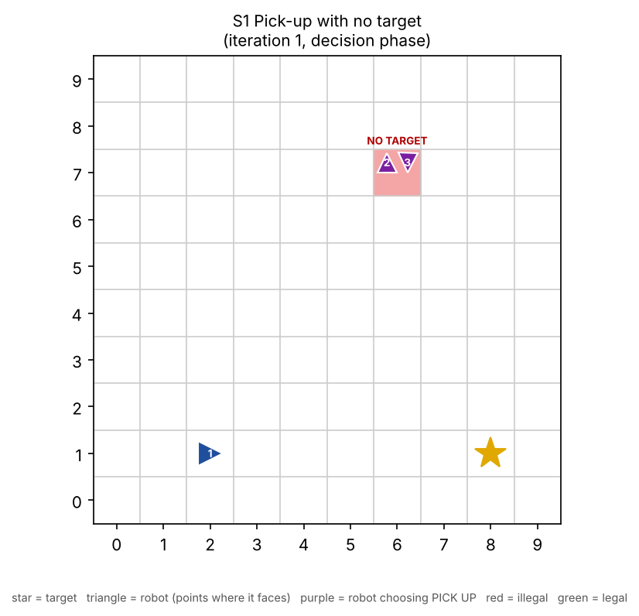
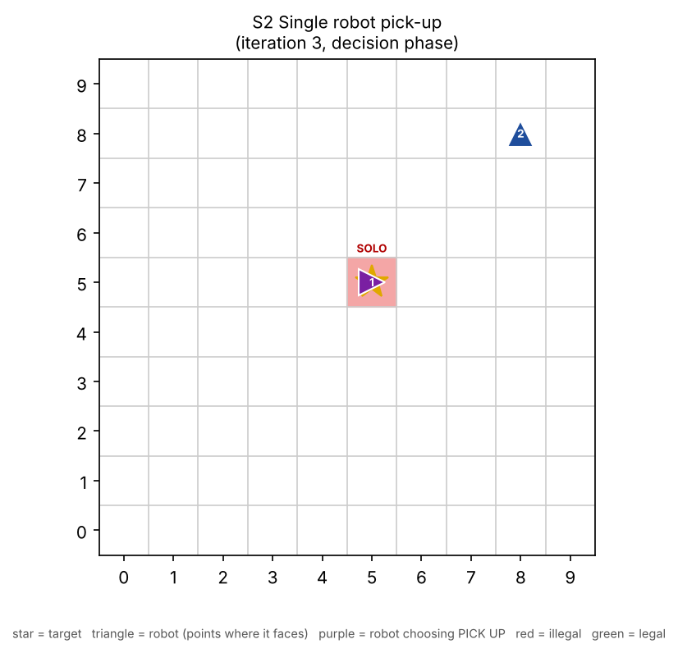
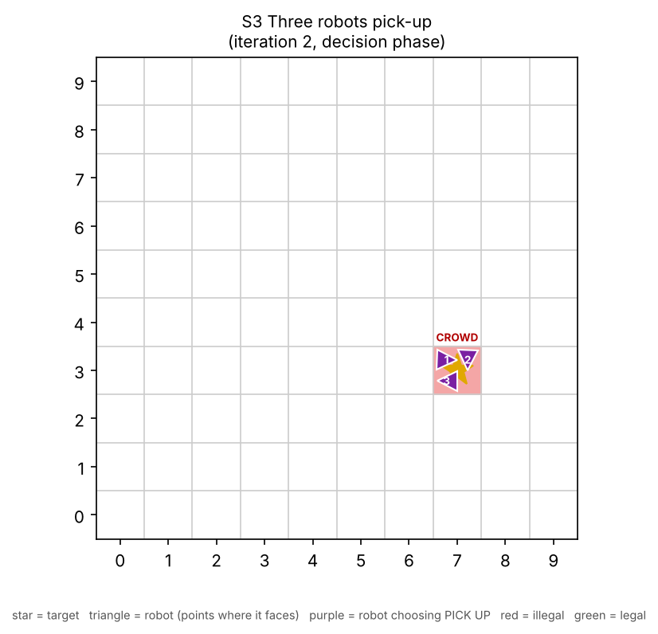
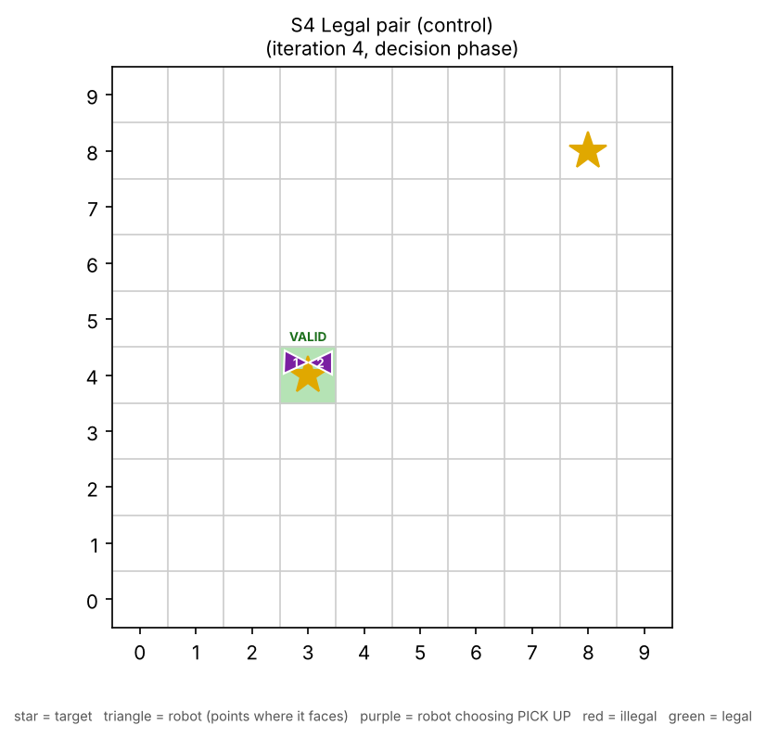
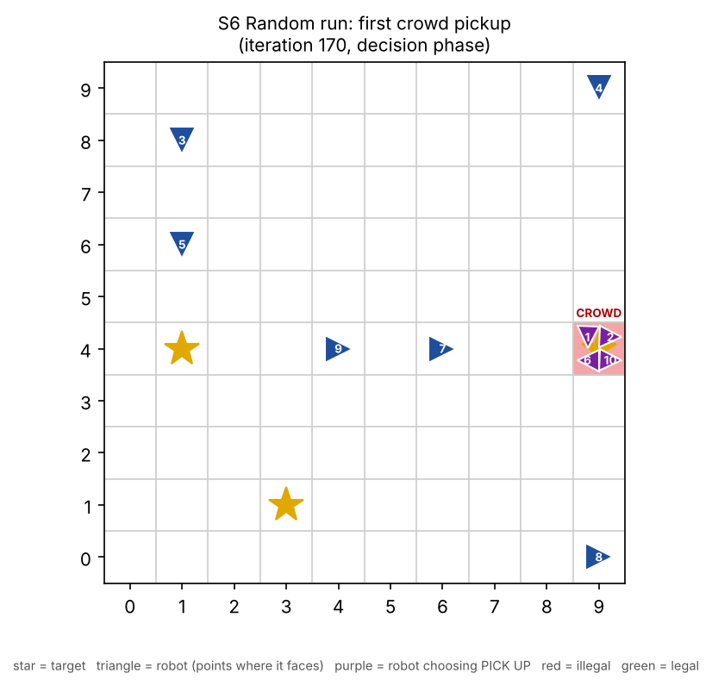

7. Conclusion and next steps
The simulation follows the brief's loop, broadcasts messages with zero delay, and detects all three illegal pick-up conditions while accepting the legal two-robot pick-up, so milestone 1 is met.
For milestone 2 the scripted robots are replaced by a real distributed controller: robots search for targets, announce a find, agree on exactly one partner per target, meet on the cell and pick up in the same turn. The same detector then measures success: a correct controller should produce zero violations. Milestone 3 only changes the delay setting of the channel.

