Blokus Project Report

Yong Shin
Brian Fish

3/20/2008
Table of Contents
1. Introduction 1
1.1 Project Overview 1
1.2 Project Scope 1
2. Architectural Design 3
2.1 Overview 3
2.2 Use case Diagram 4
2.3 Architecture 5
2.4 Class Diagram 6
2. Detailed Design of AI Components 7
2.1 Overview 7
2.2 AI Components in Detail 7
3. Evaluation 7
4. Discussion 7
5. Conclusion 7

1. Introduction

1.1 Project Overview

Blokus is a strategy board game for two to four players. It is a simple game where each player takes turns placing pieces on the board until no player can “play” any of his remaining pieces. The standard Blokus game board consists of 20 by 20 squares, and there are total of 84 game tiles organized into 21 shapes in each of four colors: blue, yellow, red and green. The object of each player is to maximize the number of tiles placed on board while trying to minimize those of the opponents. The project will simulate Blokus board game and provide various skilled computer players implementing Artificial Intelligence (AI) algorithms.
A typical user of this program will be a player who wants to play the Blokus board game with other human players or against the computer.
The program will allow any mix of human and computer players to play against each other. The program will detect invalid moves and the end of the game conditions to prevent entering into an invalid game state. The human players will be able to choose any of his/her remaining pieces, rotate it into any desired orientation, and place the piece on the board using keyboard or mouse controls. Initially, we intend to implement an AI that will be able to choose a random valid piece and place the piece in a valid location. Ideally, as a follow on to our first AI, we will implement multiple levels of AI competence. Our goal is to design computer players that will have sufficient intelligence to be able to play a 'good' game of Blokus against an average human player. The human player will be given a control to abort the current game and restart a new one at any point.
Blokus is a game of simple rules, thus the programming demand for implementing game logic will be moderate. Similarly to chess, potential moves can be determined using a search algorithm. Again, similar to chess, Blockus is surprisingly complex in the number of possible moves each player can make, and thus designing and implementing a good game playing algorithm will not be trivial. Another advantage of Blokus is that it has an online version available at http://www.blokus.com/online-game/; this is an indication that the problem is not as hard as the game of Go and that we will be able to measure our program by playing it against the online version. Finally, if we are able to implement multiple AIs following different strategies, we will be able to play them against each other. This will enable us to generate a good data set for measurement purposes and determine success of our AIs.

1.2 Project Scope

Blokus project is constructed using the Model-View-Controller (MVC) programming paradigm. In a MVC programming paradigm, the view (user-interface) component is decoupled from the model (data) component, and an intermediate controller component ties them together through clearly defined interfaces. The separation of view and model components allows for independent evolution of each components as well as easy replacement of one component with an entirely different implementation. In the Blokus project, the model component consists of the abstraction of the game objects (including the Board, Player and Game objects) and the game logic. The view component consists of java swing GUI components that form the user interfaces. The controller component consists of four different applications that serve four different purposes as described below:
- BlokusApp: this application was intended to be fully interactive version consisting of fully functional menus and java swing GUI components but was left in skeletal stage because of the time constraint. Since the GUI is not an essential part of the AI project, we felt that we could use the time more wisely by concentrating on the game logic rather than spending it on developing an elaborate user interface. If fully implemented, this application would have accepted full range of mouse inputs from the user and would have displayed the all relevant game status in GUI components.
- BlokusTestApp: this application is a text based application developed for the purpose of testing game logic as well as for debugging. This application accepts simple keyboard input from the user, selected from a limited menu options, and displays the Blokus board status as an array of characters.
- BlokusGUIApp: this application is a very simple GUI version developed for the purpose of demoing the project. This application accepts simple button clicks to advance the game one move at a time and displays the board status in a GUI component.
- BlokusAutoRunner: this application runs multiple games automatically. We’ve used this application for the purpose of evaluating the effectiveness of various game strategies. This application runs the game a pre-determined number of times playing pre-selected composition of players against each other, and displays the scoring averages for each AI strategies at the end.
The AI components are all implemented as a type of search algorithms. The simplest, the Random player, simply chooses an arbitrary move from all available moves. The MidBlocksCorners player uses a greedy algorithm that selects the “best” next move based on a metric composed of how close a move is to the middle of the board, how many blocks the piece has, and the number of “corner” blocks the piece has. The LikesMid player uses a greedy algorithm similar to the MidBlocksCorners player, but uses only single metric, namely how close the move is to the middle of the board. The LookAhead player uses the minimax search algorithm to look ahead a fixed number of plies and uses an evaluation function to evaluate board status. The BlokusAutoRunner application pits these different players against each other to measure their effectiveness.
All data stores for Blokus project are defined internally and there are no other outside data stores necessary.

2. Architectural Design

2.1 Overview

The model component of the Blokus project can be further divided into two parts: game objects and the game logic. The game objects consist of all the necessary pieces to represent an abstract Blokus game; the game logic includes the controlling mechanism to collect moves from different players as well as different AI game strategies used to select the next “best” moves.
Some of the major game objects are as follows:
- Board: the Board object represents the 20 by 20 Blokus game board.
- Piece: the Piece object represents one of 21 Blokus game pieces. The different pieces are identified by each object’s type field.
- Move: the Move object represents a possible move a player can make at his turn. It is defined in terms of the type of the Piece, its specific orientation, and the location of the Board where the Piece is to be placed.
- WeightedMove: the WeightedMove is a special type of a Move that can be compared to each other according to some weight metric.
- Hand: the Hand object represents the collection of available Pieces that a player can play at next turn.

Some of the major game logic components are as follows:
- Game: the Game class encapsulates much of game logic including starting, aborting, detecting end condition, and collecting moves from the players. It uses a private internal class, called Monitor, to run a separate thread to collect and dispatch moves from the players. This was necessary to allow computer players, which return Moves synchronously, and the human players, which return Moves asynchronously to run together.
- Player: the Player class is an abstract super class that both human player and the computer AI players inherit from.
- HumanPlayer: the HumanPlayer waits for the user input through GUI components and dispatches the selected Move to the Monitor object.
- ComputerPlayer: the ComputerPlayer selects the next best move through a specific AI component and dispatches the selected Move to the Monitor object.
- AI: an AI object embodies a specific AI game strategy. A ComputerPlayer uses it to select the next “best” Move.

2.2 Use case Diagram

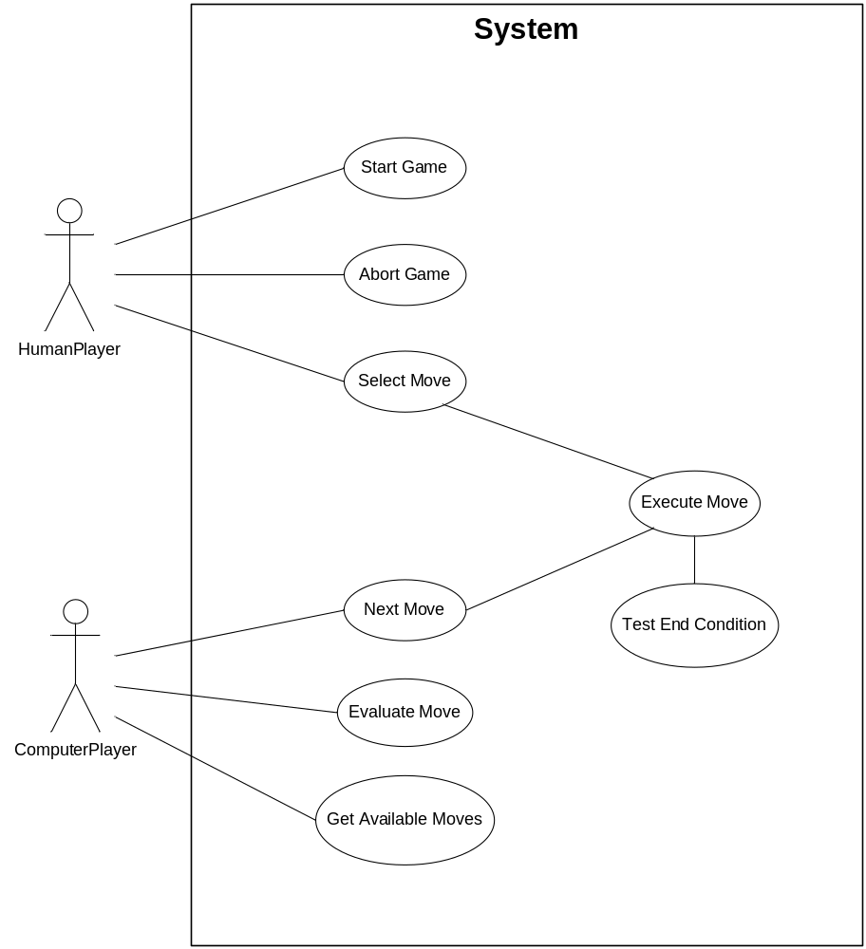

2.3 Architecture

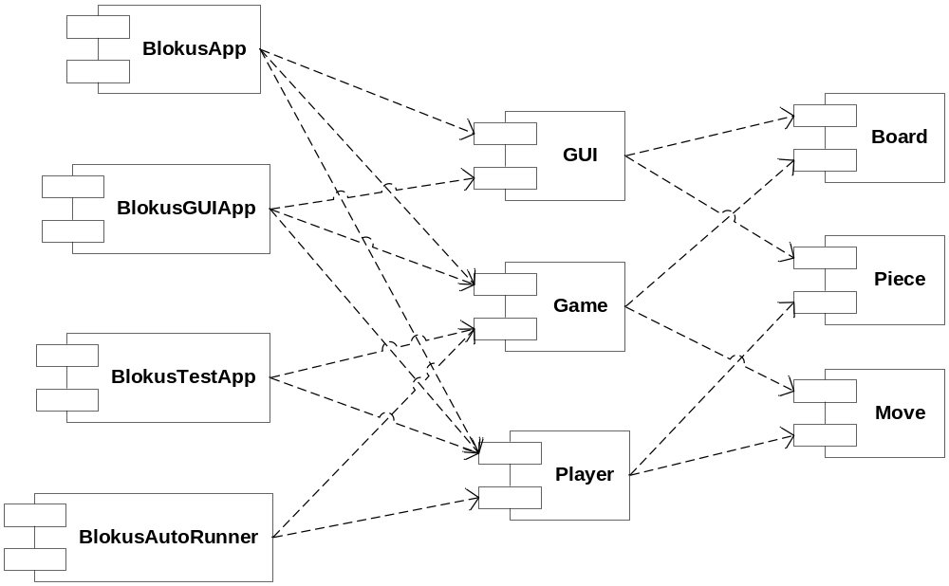

2.4 Class Diagram

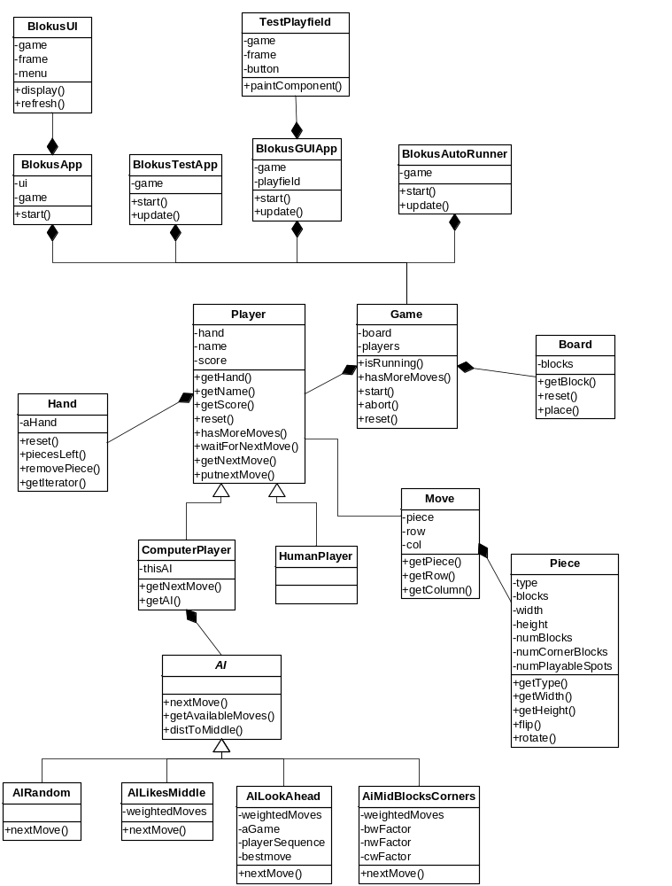

2. Detailed Design of AI Components

2.1 Overview

There are two major divisions to the AI components of the Blokus project. The model component of the Blokus project can be further divided into two parts: game objects and the game logic. The game objects consist of all the necessary pieces to represent an abstract Blokus game; the game logic includes the controlling mechanism to collect moves from different players as well as different AI game strategies used to select the next “best” moves.

2.2 AI Components in Detail

The model component of the Blokus project can be further divided into two parts: game objects and the game logic. The game objects consist of all the necessary pieces to represent an abstract Blokus game; the game logic includes the controlling mechanism to collect moves from different players as well as different AI game strategies used to select the next “best” moves.

3. Evaluation

3.1 Overview

The model component of the Blokus project can be further divided into two parts: game objects and the game logic. The game objects consist of all the necessary pieces to represent an abstract Blokus game; the game logic includes the controlling mechanism to collect moves from different players as well as different AI game strategies used to select the next “best” moves.

3.2 Results

The model component of the Blokus project can be further divided into two parts: game objects and the game logic. The game objects consist of all the necessary pieces to represent an abstract Blokus game; the game logic includes the controlling mechanism to collect moves from different players as well as different AI game strategies used to select the next “best” moves.

Discussion

  - Section Overview
  - Comparison with Other Systems

Conclusion

  - Section Overview
  - Comparison with Other Systems

