**P2 - Sustainable Supply Chain Performance Dashboard using Power BI**

**Week 1 task**

1.Open Power BI Desktop

2.Select Blank report

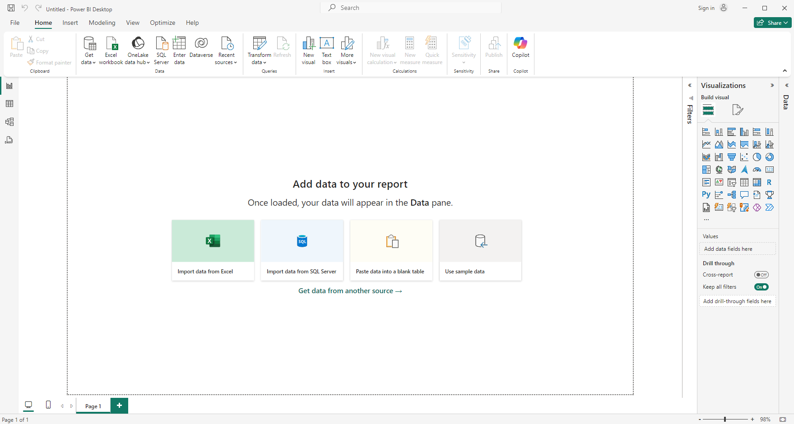

3.Click on Home > Get Data and choose data source (Excel, SQL Server, etc.).

Text/CSV :Sustainable Supply Chain Performance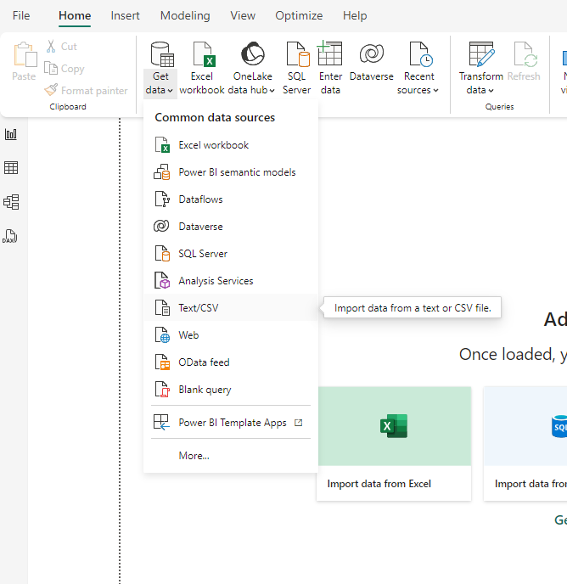

4.Load your dataset.

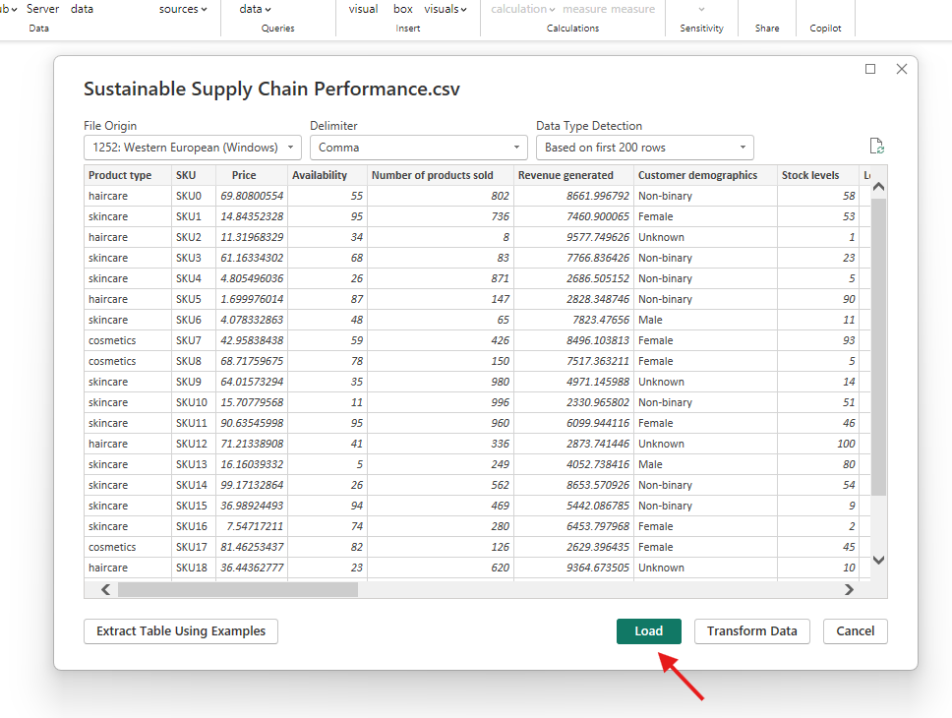

5.**Open Power Query Editor:**

In the Power BI Desktop, select Transform Data to open the Power Query Editor.

6.Go to **View**, select **column quality** to preview the validity, emptiness and errors in the

columns.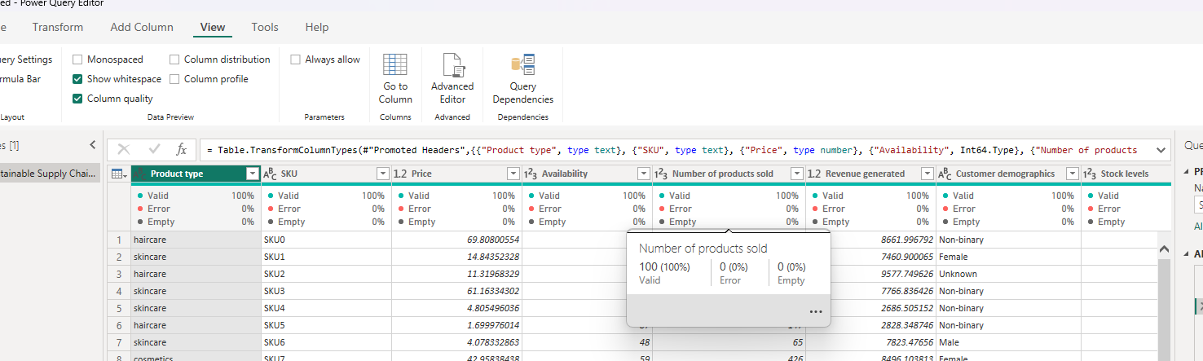

7.**Create Multiple Tables:**

In the Power Query Editor, right-click on main query (table) on the left pane.

Select Duplicate to create a new table based on the main query:

**Duplicate**: Creates a copy of the original table. Changes to the original will not affect the new one.

Original table is **Sustainable Supply Chain Performance.**

8.**Rename Tables:**

Right-click on each new table and select Rename. Give each table a meaningful name.

9.**Modify Each Table**:

Right-click on each column toTransform, filter, or remove columns which are required by our needs.

**Remove** the columns as per our needs.

**Tables needs be created are:**

**Inventory Table:**

1. Product type

2. SKU

3. Availability

4. Number of products sold

5. Customer demographics

6. Stock levels

7. Lead times

8. Order quantities

9. Lead time

10. Revenue generated

**Manufacturing table**

1. Product type

2. SKU

3. Production volumes

4. Manufacturing lead time

5. Manufacturing costs

6. Inspection results

7. ⁠ defect rates

**Supplier Table**

1. Supplier name

2. Location

3. Lead time

4. transportation modes

5. Routes

**Supply chain table**

1. Product type

2. SKU

3. Price

4. Availability

5. Number of products sold

6. Revenue generated

7. Customer demographics

8. Stock levels

9. Lead times

10. Order quantities

11. Shipping times

12. Shipping carriers

13. Shipping costs

14. Supplier name

15. Location

16. Lead time

17. Transportation modes

18. Routes

**Inventory table:**

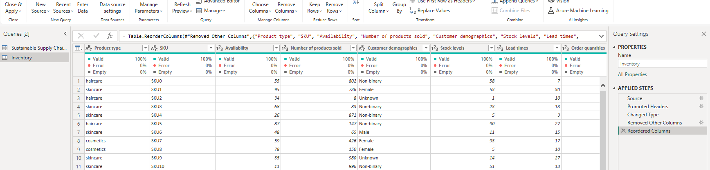

Thus ,all the tables can be created like this.

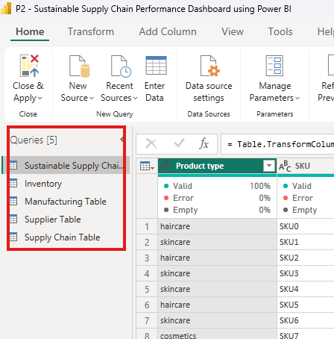

10.**Load Tables**:

Click Close & Apply in the top-left corner of the Power Query Editor to load the tables into the Power BI Data Model.

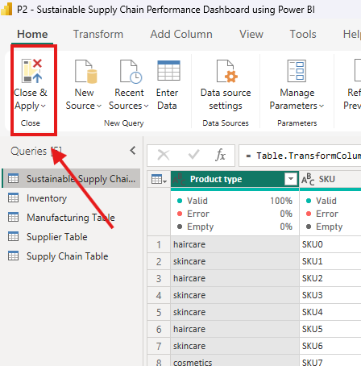

**This is the first week task of the power BI project.**