Building Your Theremin.

Parts
To build your Theremin, you will need the following parts:
- 10 * 0.1uF capacitors (C1, C2, C3, C5, C9, C10, C12, C13, C14, C15)
- 1 * 1uF capacitor (C4)
- 2 * 100uF capacitors (C6, C7)
- 1 * 470uF capacitor (C8)
- 2 * DO-41 size Schottky diodes (D5, D6)
- 1 * CUI SJ1-3525N 3.5mm audio jack (J2)
- 1 * Amphenol 10104110 USB port (J3)
- 1 * 510k resistor (R5)
- 1 * 4.7r resistor (R7)
- 2 * 1k resistors (R10, R11)
- 4 * 1M resistors (R12, R13, R14, R15)
- 2 * 10k resistors (R16, R17)
- 1 * 0.05” 10-pin debug header (SWD1)
- 1 * AP2204K-3.0 (pre-fitted) (U1)
- 1 * TDA2822 (pre-fitted) (U2)
- 2 * NE555P (U3, U4)
- 1 * STM32G051K8T6 (U5)
- 1 * 10k potentiometer (RV2)
- 1 * SPDT switch (SW3)
- 2 * SparkFun PRT-09739 binding posts (ANT1, ANT2)
- 1 * Hammond 1591XXSTBU, 1591XXSSBK, or 1591XXSSFLBK case.
- Antenna rods

Surface Mount Parts
If your board is partially assembled, the only Surface Mount part is the STM32 microcontroller, U5. This should be fitted first as it can be fiddly and is not made easier by having other parts in the way.
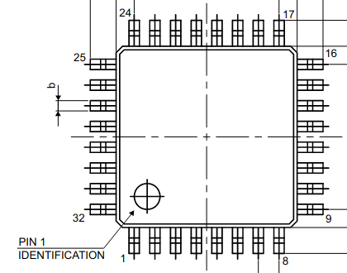
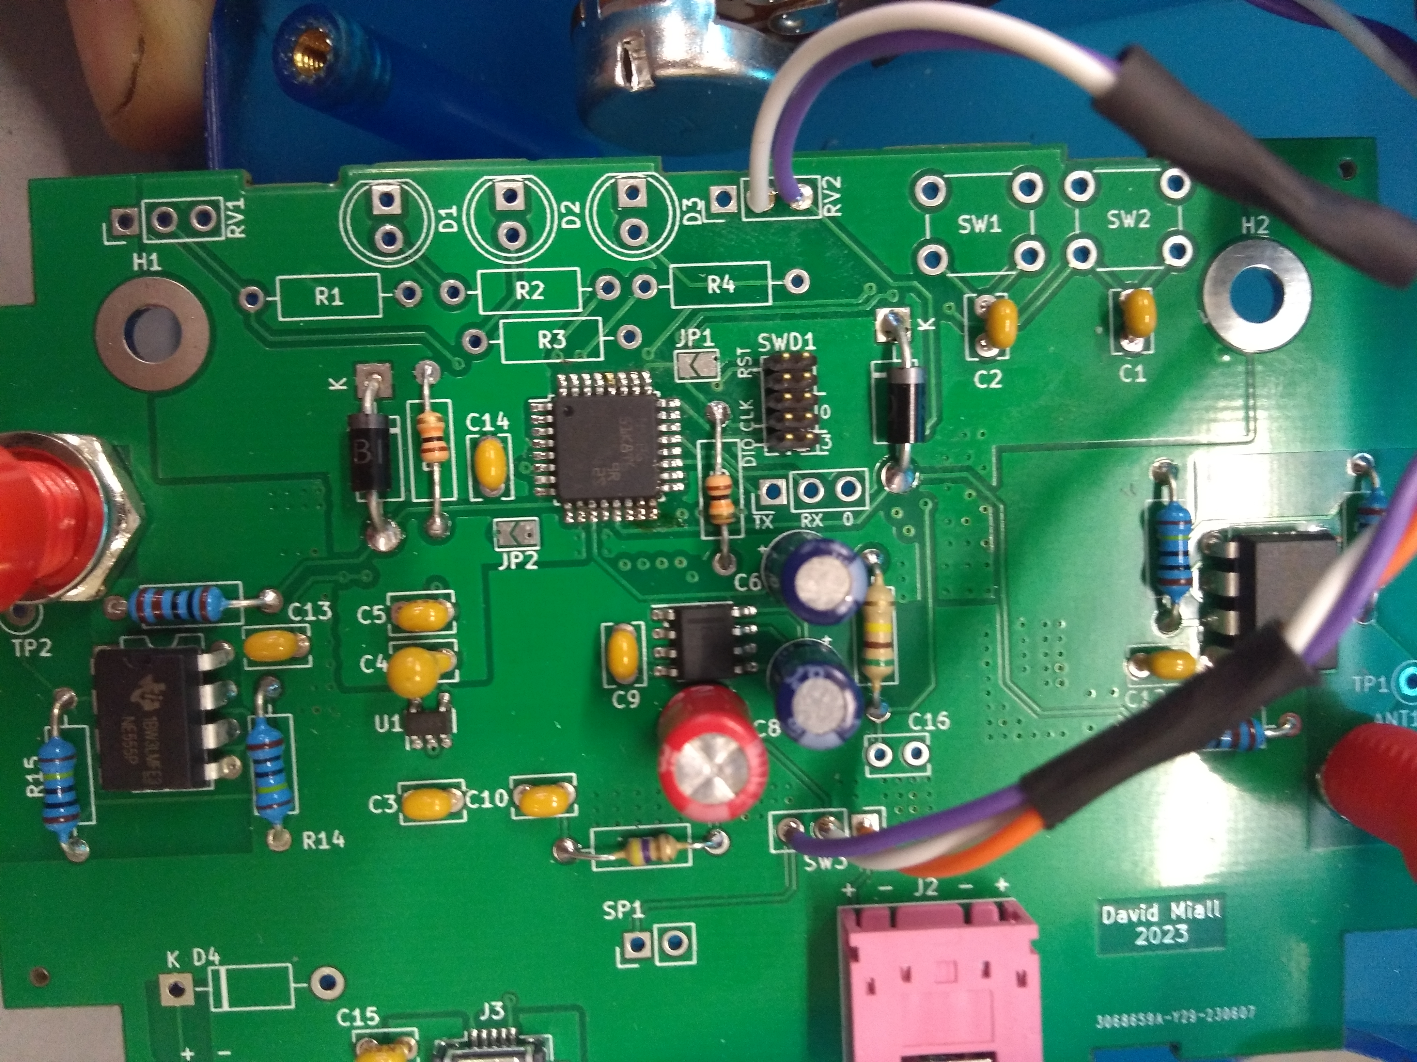
First apply plenty of Flux to the U5 pad, then, using tweezers, grab the chip by the sides (just above the legs) and place it in position with the dot on the chip at the same corner as the line on the board (see below).
Once in place, you can drag solder the chip. First solder a corner pin and then solder a pin at the opposite corner; then add solder to your iron’s tip and drag along each row of pins in turn – you may have to add more flux for each row.
STMicro
For a detailed explanation, watch this video: https://youtu.be/hoLf8gvvXXU?t=363
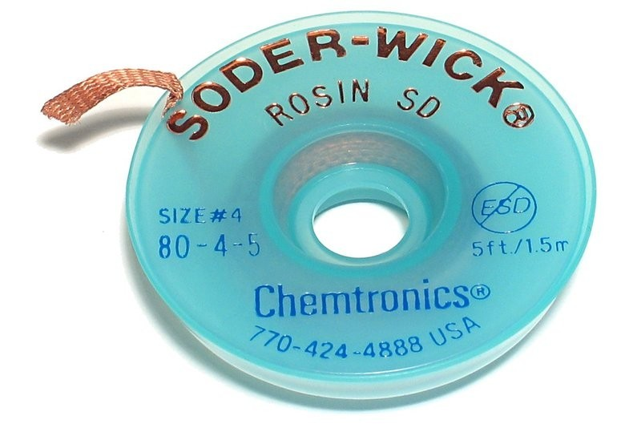
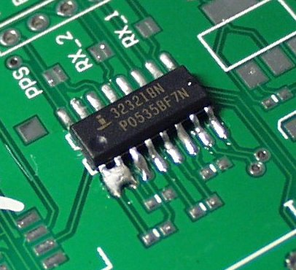
Once you have soldered all four rows, check for solder between any of the pins. These “bridges” can, if small, be removed with flux and a clean tip; if they are larger then apply flux, lay a short bit of solder wick on top of the bridged pins, and press the tip onto the wick dragging along the area (make sure to remove the wick whilst the iron is still in place!).
allaboutcircuits.com
partco.fi
A hot-air gun can also work on small bridges, with the solder flowing into the pads.

The other Surface Mount parts (TDA2822, AP2204K-3.0, USB Port) can now be fitted, if they are not already. They are soldered in a similar way to the STM32, but are easier as they have a larger pin pitch.

Through Hole Parts
The THT parts can now be attached. Start with the resistors and diodes, then attach the debug header and audio jack, then attach the two NE555 chips, then the capacitors.
An optional speaker may be connected, if available, to SP1.

Special Instructions
The switch, potentiometer, and binding posts require special care and attention.

Binding Posts
The binding posts should have the top plastic unscrewed and removed as well as all the nuts and washers removed (if attached); they should then be soldered in position on the top of the board using plenty of solder and with Blu Tack to keep them straight, once attached the threaded part sticking through the bottom of the board should be snipped off to allow the board to mount in the case.

Switch and Potentiometer
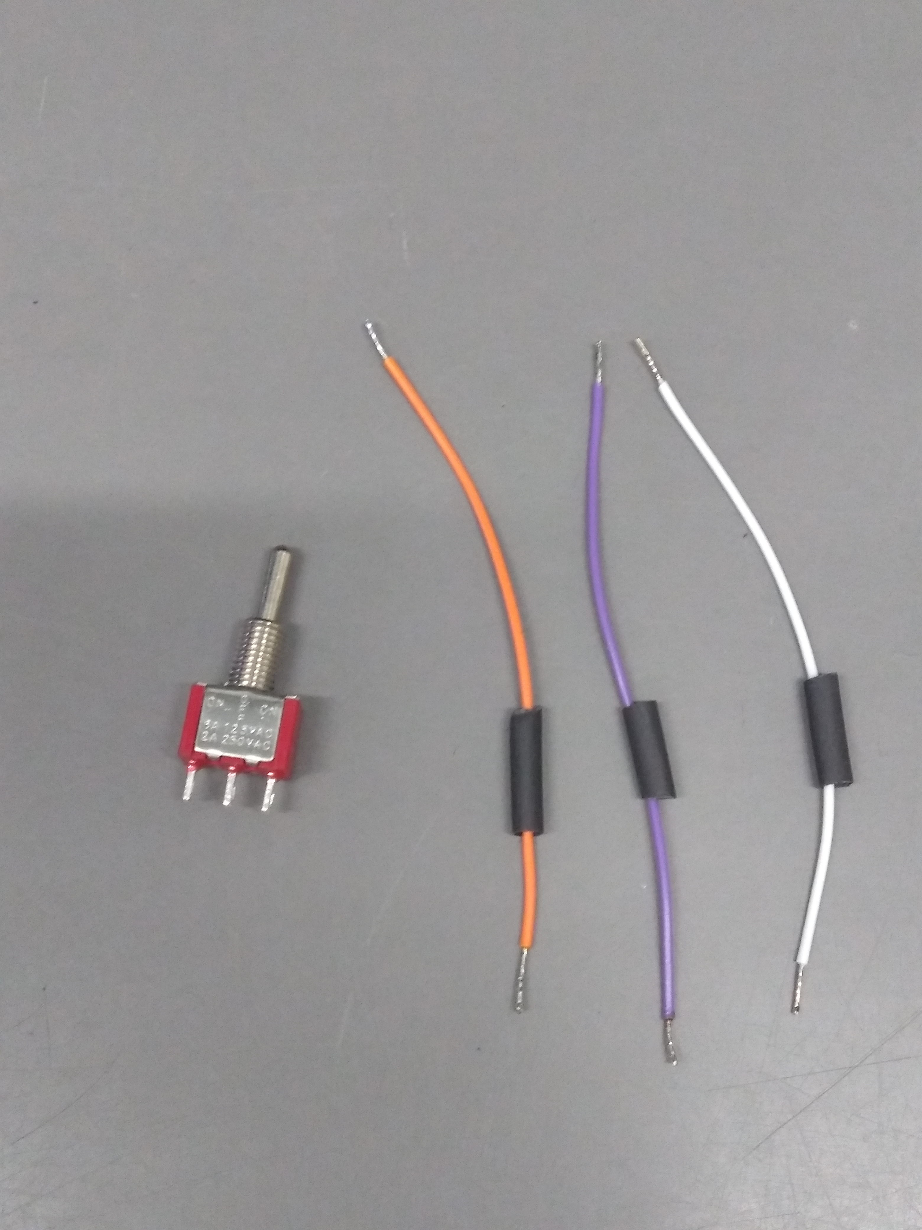
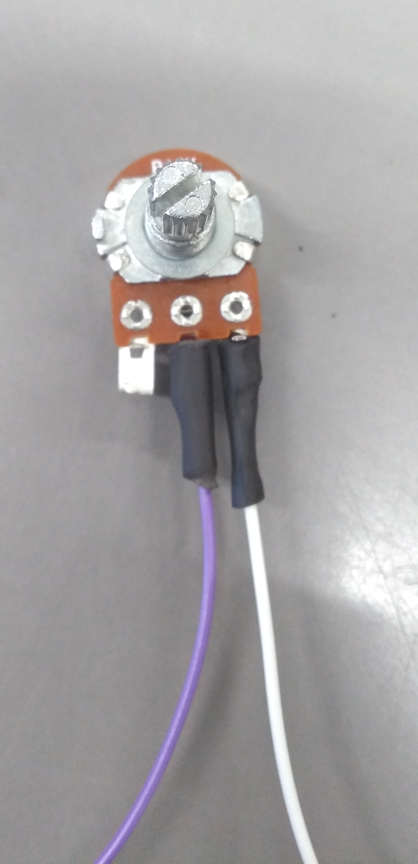
The switch and potentiometer attach with wires. For the switch cut three equal-length wires and for the potentiometer cut two - stripping, twisting, and adding solder to the ends of each wire.
Attach the three wires to the three switch pins and connect the wires to the board (SW3) in the same order as on the switch.
Attach the two wires to the inner and one outer pin of the potentiometer, connecting these between the two circular pads of the RV2.

Case
The case can now be prepared. It is required to drill two holes in the front, two in the back, and four in the top.
The front needs a 6.5mm hole for the switch and a 7.5mm hole for the potentiometer.
The back needs two 13mm holes for the USB port and the audio jack.
The top needs two 6mm (or 6.5mm if you prefer) holes at each end with one hole per pair exactly above the hole in the binding post when the board is mounted in the case and with the other hole positioned to allow the second leg of each antenna to enter the case and prevent the antenna moving around.
All the holes should be marked out first using a centre-punch and engineer’s square.

Antennae
The “antennae” can be made from any conductive rod which will fit into the binding posts and is easy to work, and should be made to a scale correct for the size of the case.
For the left side, you need a wide antenna which is roughly parallel to the desk; for the right side a long, thin, roughly vertical antenna is required. Make both of these with two legs.
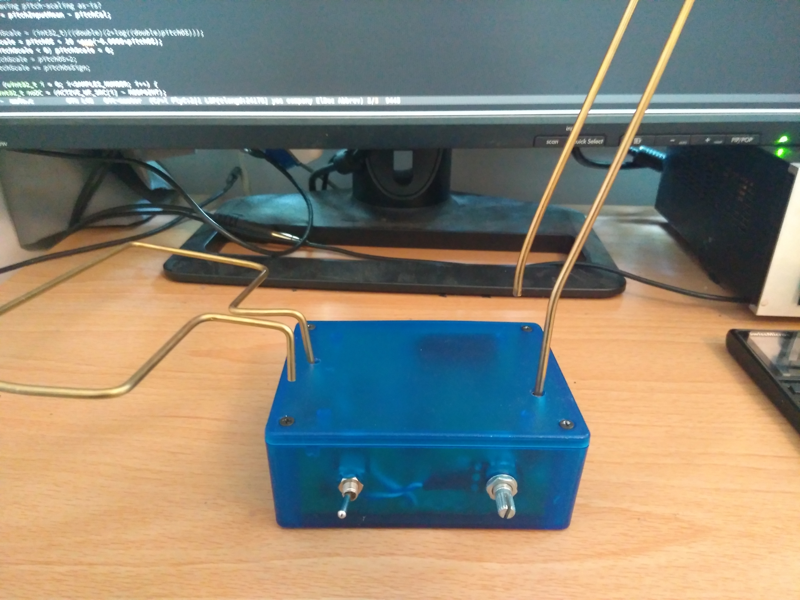

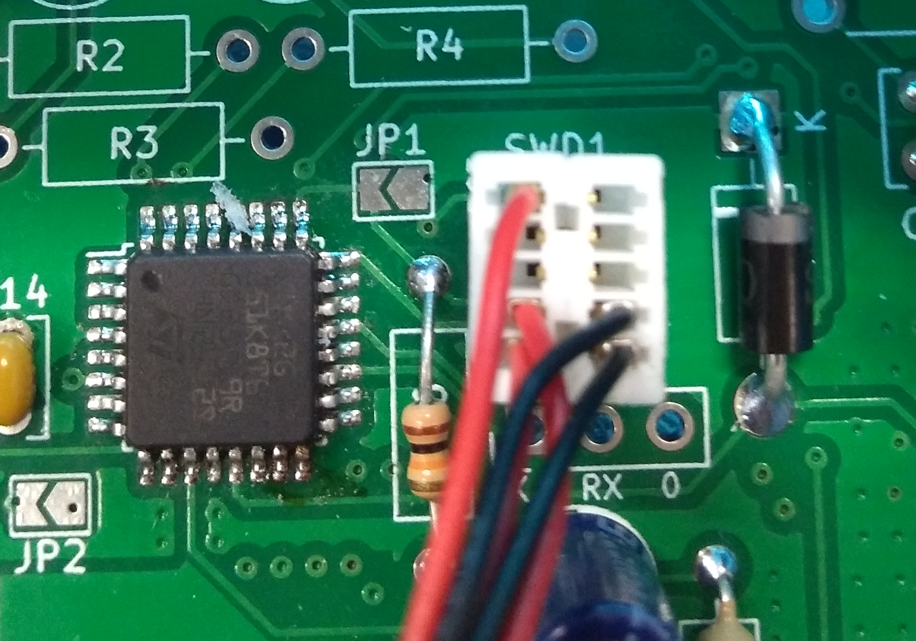
Programming
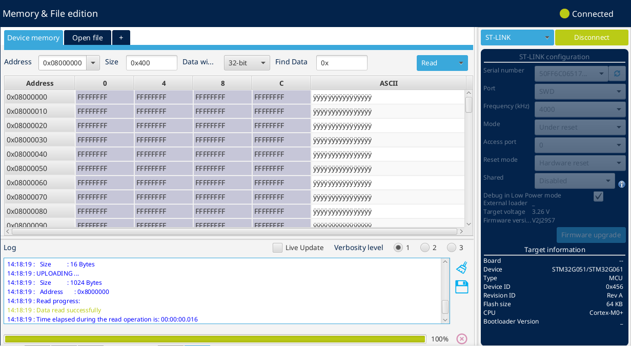
To test the device connect the micro USB to power the Theremin, connect the debug cable as shown, and connect the debugger to your PC’s USB. Open STM32CubeProgrammer and press connect. If the board is built roughly correctly the Programmer will connect and you will see the below screen.
Flash the programme through STM32CubeProgrammer – Open File and write, then disconnect.
If the board is correct, a sound will be heard either on the audio jack or speaker depending on the switch position; the sound should change when the binding posts are touched.
If no output is seen, check your board for bad connections.

