Dickens 2019-08-20 v1

一,build up environment
1, start.spring.io
2,
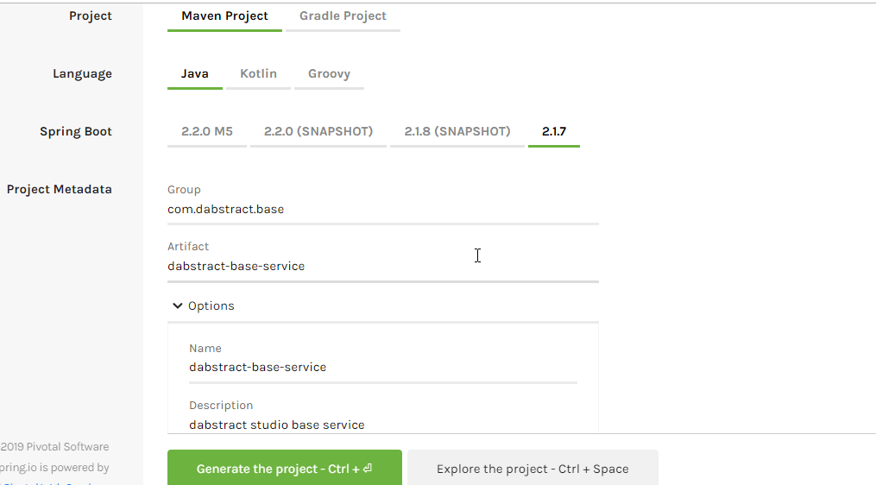
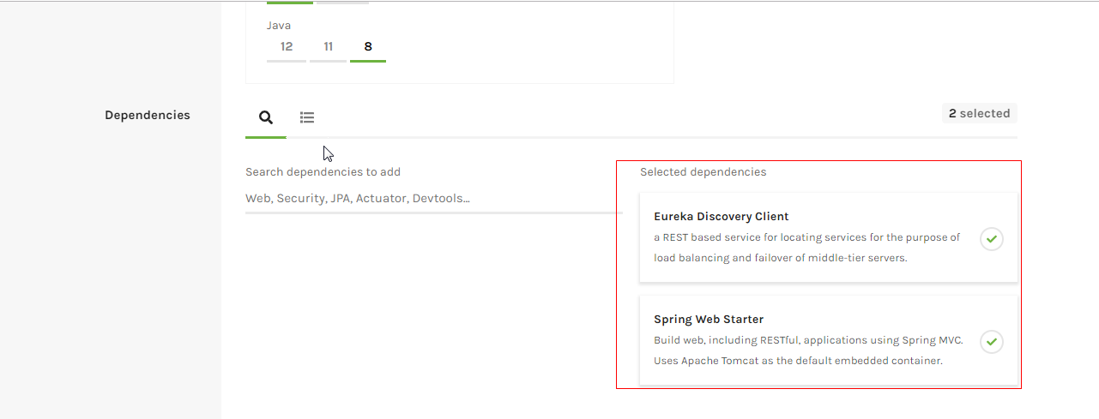

3,import to ide
4,add config properties to “application.properties”

#application
spring.application.name=dabstract-base-service

#port
server.port=8090

#context path
server.servlet.context-path=/service

#locate eureka server address
eureka.client.serviceUrl.defaultZone=http://localhost:8761/eureka/
eureka.instance.prefer-ip-address=true

5,add annotation to top of main method
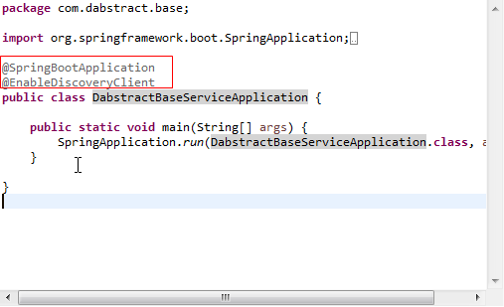

- start up main main method
- Test
