Dickens 2019-08-20 v1

一,build up environment
1, start.spring.io
2,
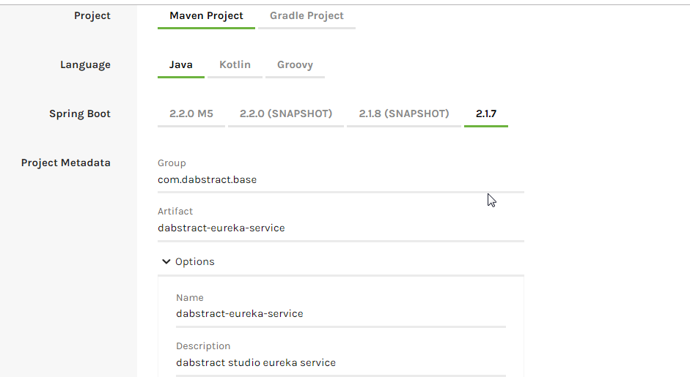
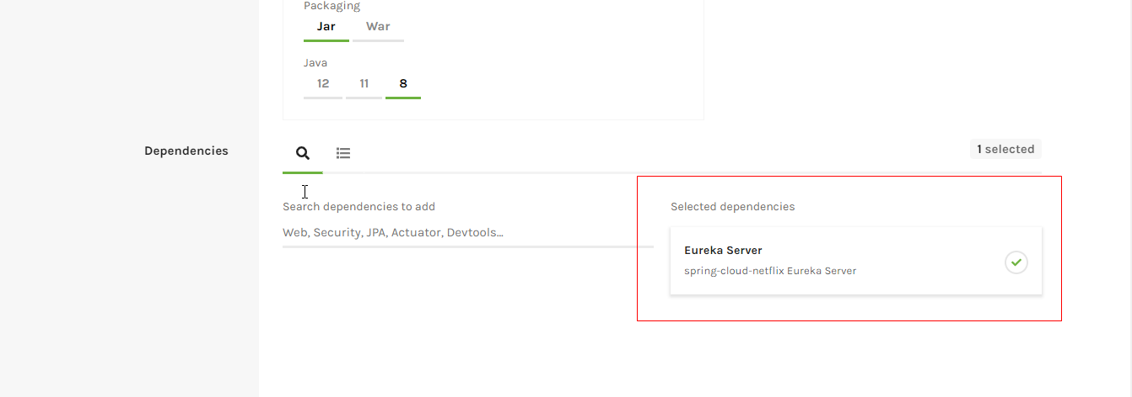
3,import to ide
4,add config properties to “application.properties”

#指定服务名称
spring.application.name=dabstract-eureka-service
#指定服务端口
server.port=8761

#指定eureka server地址
eureka.client.registerWithEureka=false
eureka.client.fetchRegistry=false

5,add annotation to top of main method

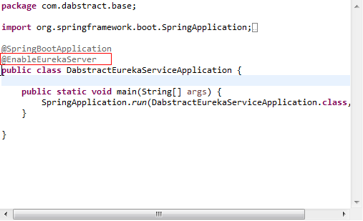

- start up main main method
- Test
