- 云端晾晒超现实时尚｜Sky Laundry Surreal Fashion
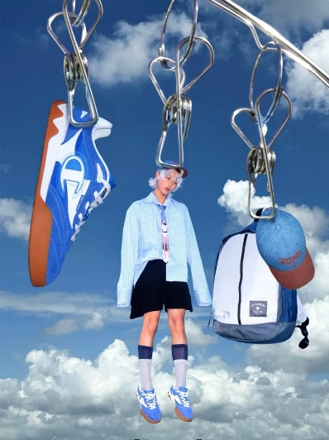
Prompt：Vertical surreal fashion editorial photograph, human figure that matches the character appearance from reference image suspended by a large shiny silver metal binder clip hooked onto a polished silver metal clothes hanging rod, floating mid-air above fluffy white cumulus clouds and bright clear blue sky. Multiple identical silver metal binder clips hang separate fashion items side by side on the same metal rack, all clothing, footwear, accessories, backpack and hats automatically match the style, color, cut and design of the uploaded reference image. Full body framing of the character, soft natural daylight, commercial streetwear advertising aesthetic, hyperrealistic sharp photography details, glossy reflective metal clip texture, soft fluffy cloud texture, clean vibrant color grading, minimalist cloud-sky empty background, surreal imaginative laundry-hanging suspended composition, 8K ultra HD, high definition, subtle soft shadows, high-end fashion magazine shot. Strictly match the reference image’s lighting tone, color palette, metallic prop texture, cloud background, suspended clip hanging surreal core concept, photographic style and vertical framing automatically.
- 千禧风多图拼贴人像设计｜Y2K Multi-Image Collage Portrait
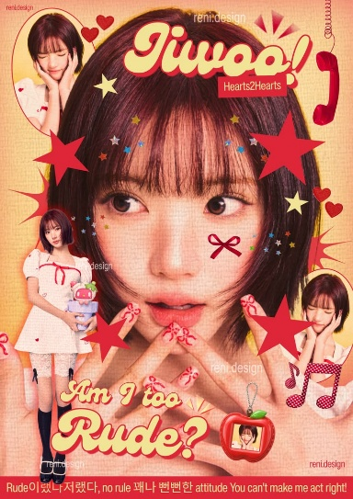
Prompt：Vertical Y2K retro kpop magazine cover poster, human figure that matches the character appearance from reference image as the central large close-up portrait, multiple small circular cutout secondary character portraits scattered around the main face, all clothing, hairstyle, makeup, color tone automatically match the uploaded reference image. Decorated with abundant hand-drawn decorative stickers: five-pointed stars, red love hearts, tiny colorful sequin stars, red bows, polka dot music notes, red landline telephone, apple-shaped photo frame, burst line ornaments. Curvy bubble vintage typography with thick red outline, warm yellow textured grainy paper background, soft warm peach color grading, retro 2000s print texture, thin film grain texture, bold saturated red and cream color palette, bottom Korean and English subtitle text strip, commercial kpop graphic design, high detail, 8K ultra HD, clean layered collage composition. Strictly match the reference image’s retro paper texture, warm color palette, sticker decoration style, multi-cutout collage layout, Y2K vintage aesthetic and vertical framing automatically.
- 浮空桌游场景人物概念海报｜Floating Boardgame Character Tour Visual
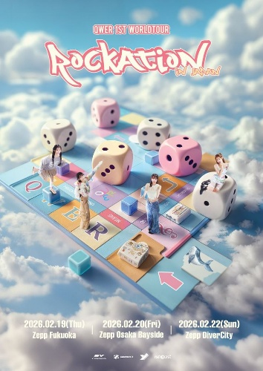
Prompt：Vertical 3D rendering concert tour promotional poster, human figures that match the character appearance from reference image standing and moving on a huge colorful aerial board game chessboard floating above soft fluffy white clouds and bright clear blue sky. Oversized pastel 3D dice, small cube blocks, themed game tiles with patterns scattered on the board, all character outfits, hairstyles, features automatically match the uploaded reference image. Cute soft pastel color palette, clean bright daylight, soft volumetric cloud texture, smooth clay 3D render texture, delicate soft shadow, cartoon realistic hybrid style, handwritten cute bubble concert title text at top, event date and venue text layout at bottom, commercial idol world tour advertising design, layered depth-of-field, 8K ultra HD, ultra detailed, soft dreamy atmosphere. Strictly match the reference image’s pastel color tone, floating cloud board game scene layout, soft 3D render texture, concert poster layout, soft bright lighting and vertical framing automatically.
- 美式手绘涂鸦潮拍合成大片｜American Hand-drawn Graffiti Street Composite Photo
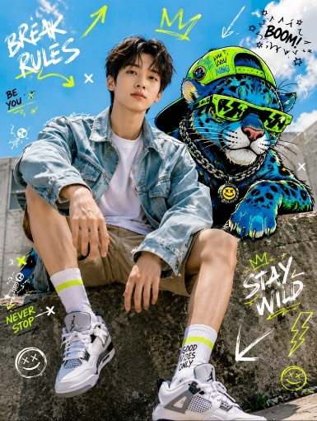
Prompt：Vertical street fashion editorial photograph, human figure that matches the character appearance from reference image sitting on rough concrete stone ledge under bright clear blue sky, a cool graffiti-style blue neon spotted cheetah with neon green sunglasses, cap and metal chain sits beside the character. All character outfits, sneakers, socks, hairstyle and facial features automatically match the uploaded reference image. The whole picture is covered with hand-drawn neon green and white graffiti decorative elements: crowns, arrows, text slogans, star shapes, smiley face symbols, lightning marks and cross marks. Bright natural outdoor daylight, realistic portrait photography texture, high saturation neon fluorescent color embellishment, industrial concrete wall background, casual streetwear aesthetic, sharp clear portrait details, 8K ultra HD, soft natural shadows, trendy youth magazine photo style. Strictly match the reference image’s outdoor street lighting, graffiti decorative style, composite human-animal layout, cool neon color accent, realistic photographic texture and vertical framing automatically.
- 学院风证件半身人像｜Preppy Style ID Half-body Portrait
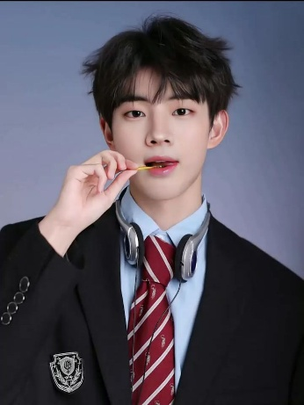
Prompt：Vertical half-body studio portrait photo, human figure that matches the character appearance from reference image, the character wears formal preppy school uniform including black blazer with embroidered shield badge, light blue collared shirt and red striped tie, silver retro wired headset hanging around neck, one hand holding thin yellow lollipop stick to mouth. All hairstyle, facial features, uniform design, accessories automatically match the uploaded reference image. Solid matte gradient light blue-gray simple background, soft even studio fill lighting, clean skin texture, delicate realistic portrait photography, soft subtle shadows, minimalist pure portrait composition, 8K ultra HD, high detail, youthful campus aesthetic. Strictly match the reference image’s studio soft lighting, plain gradient background, school uniform style, half-body framing and realistic portrait texture automatically.
- 工业肌理双层拼贴先锋人像｜Industrial Texture Double Collage Avant Portrait
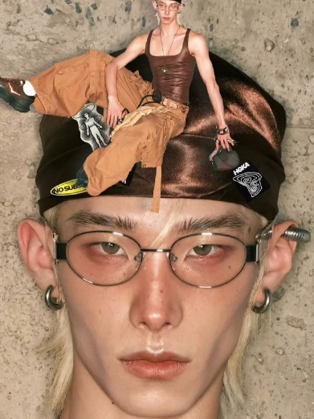
Prompt：Vertical avant-garde fashion portrait photo, close-up shot of human figure that matches the character appearance from reference image as the bottom main layer, a second full-body version of the same character overlays on top of the large head portrait, the secondary figure lies on a shiny brown satin fabric hat decorated with brand patches. All hairstyle, facial features, glasses, piercings, tank top, cargo pants, shoes and accessories automatically match the uploaded reference image. Rough textured concrete wall background, desaturated earth tone color palette, hard editorial studio lighting, glossy dewy skin texture, high fashion avant-garde aesthetic, sharp realistic portrait details, layered double figure collage composition, 8K ultra HD, subtle grain film texture. Strictly match the reference image’s industrial texture backdrop, dual overlapping character collage layout, muted earth color grading, minimalist fashion editorial style and vertical framing automatically.
- 胶片边框多层手账拼贴设计｜Film Frame Multi-layer Scrapbook Collage Art

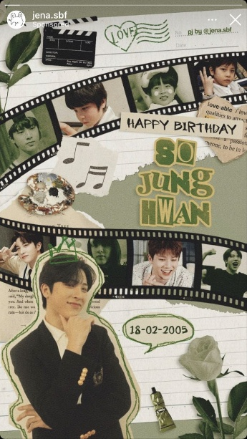
Prompt：Vertical vintage scrapbook collage birthday graphic, human figure that matches the character appearance from reference image, multiple portrait cutouts of the character arranged inside curved film strip frames, a large outlined cutout portrait as the main visual at the bottom. All character facial features, hairstyle and outfits automatically match the uploaded reference image. Decorated with retro paper stickers: film clapperboard, heart postmark, music note cutouts, paint palette, green rose, leaf elements, speech bubble date text, torn notebook paper texture background, layered handwritten cut-out text "HAPPY BIRTHDAY", large bubble name typography, muted sage green cream earth tone color palette, old paper grain texture, handmade cut and paste scrapbook aesthetic, soft warm matte print texture, 8K ultra HD, delicate layered collage layout. Strictly match the reference image’s vintage notebook paper backdrop, curved film strip photo frame layout, green neutral color scheme, handmade scrapbook sticker decoration style and vertical framing automatically.
- 蓝调镭射贴纸人像拼贴海报｜Blue Laser Sticker Portrait Collage Poster
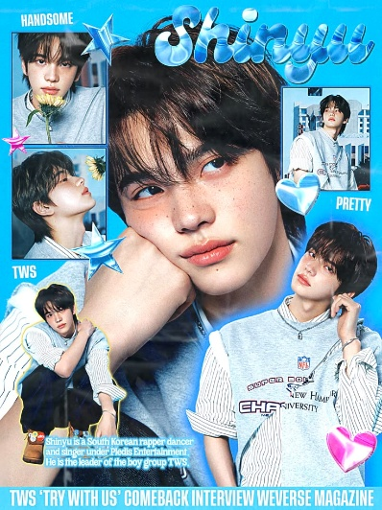
Prompt：Vertical Y2K kpop magazine cover graphic, human figure that matches the character appearance from reference image as oversized central close-up portrait, multiple small framed cutout portraits of the same character scattered around the main face. All character hairstyle, facial features, casual layered clothes automatically match the uploaded reference image. Decorated with shiny metallic 3D bubble text, holographic star and heart sticker ornaments, simple text labels, bottom banner interview subtitle text, light solid sky blue background, bright clean pastel blue color palette, glossy plastic sticker texture, soft studio portrait lighting, realistic clear photography texture, layered multi-photo collage layout, 8K ultra HD, high detail, youthful kpop editorial aesthetic. Strictly match the reference image’s sky blue tone, holographic sticker decorative style, multi-frame portrait collage composition, magazine cover layout and vertical framing automatically.
- 旧电视叠图 Y2K 街头创意摄影｜Old TV Overlay Y2K Street Creative Shot
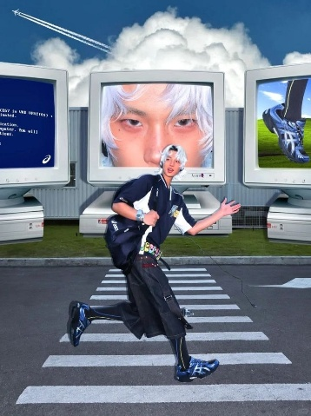
Prompt：Vertical surreal Y2K street fashion photograph, human figure that matches the character appearance from reference image running on zebra crosswalk on asphalt road, three huge retro white CRT computer monitors stand behind the character, each screen displays different partial portraits and footwear shots of the same character. All character silver-white hairstyle, sportswear, dark loose overalls, sneakers, backpack and accessories automatically match the uploaded reference image. Outdoor scene with green lawn, metal industrial building, fluffy cumulus blue sky, airplane contrails in the sky, bright natural daylight, realistic street photography texture, retro 90s computer monitor prop design, layered screen overlay collage composition, clean cool blue color grading, 8K ultra HD, soft natural shadows, avant-garde cyber youth aesthetic. Strictly match the reference image’s outdoor road scene, giant CRT monitor core prop, screen overlay collage gimmick, sporty streetwear tone and vertical framing automatically.
- 荧光绿元素双层人像拼贴大片｜Lime Green Element Dual Figure Collage Editorial

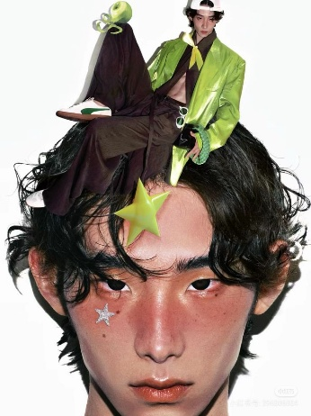
Prompt：Vertical avant-garde fashion close-up portrait photo, human figure that matches the character appearance from reference image as the large bottom close-up face layer, a full-body version of the same character overlays and sits on top of the main figure’s messy curly hair. All character facial features, freckle makeup, glitter star face decal, bright lime green shiny blazer, dark silky wide trousers, sneakers, small sunglasses, green apple ornament and five-pointed star prop automatically match the uploaded reference image. Solid pure white seamless studio background, soft even studio fill lighting, glossy dewy skin texture, high fashion minimalist editorial aesthetic, sharp realistic portrait details, surreal stacked dual-figure collage composition, 8K ultra HD, subtle soft shadows, fresh lime green and dark brown color palette. Strictly match the reference image’s plain white backdrop, overhead stacked character surreal layout, neon green decorative props, fashion makeup texture and vertical framing automatically.
- 糖果彩泡童趣双层元素拼贴海报｜Candy Bubble Fun Dual Element Collage Poster
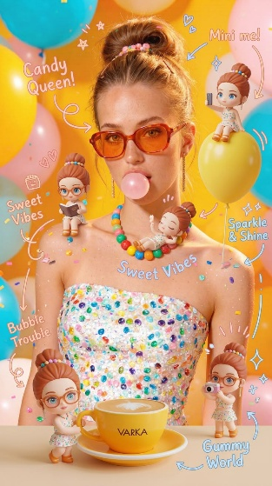
Prompt：Vertical sweet candy-style commercial portrait photo, human figure that matches the character appearance from reference image as the main central character, multiple tiny identical mini doll versions of the character scattered around the body, balloons and desktop. All character hairstyle, outfit, facial features, accessories automatically match the uploaded reference image. The character wears glitter confetti tube top, candy bead necklace, orange tint sunglasses, blowing pink bubble gum. Decorative elements: colorful macaron balloons, scattered candy sprinkles, hand-drawn cute text annotations with arrow lines, yellow coffee cup, warm bright yellow gradient background, soft warm studio daylight, glossy vibrant candy color palette, realistic human portrait mixed with smooth 3D clay doll texture, playful sweet girly aesthetic, 8K ultra HD, delicate layered composition. Strictly match the reference image’s warm yellow candy tone, mini twin doll overlay gimmick, hand-drawn text decoration style, confetti glitter texture and vertical framing automatically.
- 微观人像嵌套首饰先锋商业大片｜Micro Figure Nested Jewelry Avant-Garde Commercial Shot
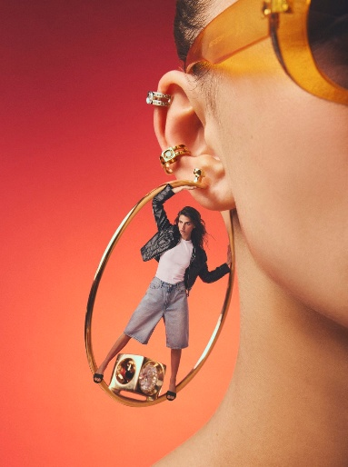
Prompt：Vertical luxury jewelry fashion close-up photograph, human figure that matches the character appearance from reference image as partial ear and cheek close-up main subject, a giant glossy gold hoop earring worn on the ear, a tiny full-body version of the same character stands inside the hollow gold hoop, matching all facial features and outfits of the reference image. The ear is decorated with stacked diamond and gold cartilage piercings, translucent golden tint sunglasses frame on the side of face. Smooth warm red-orange gradient seamless studio background, soft directional studio fashion lighting, metallic glossy gold texture, delicate realistic skin texture, surreal miniature figure nested inside jewelry core gimmick, high-end jewelry editorial aesthetic, 8K ultra HD, crisp sharp details, subtle soft shadows. Strictly match the reference image’s warm orange-red gradient backdrop, giant hollow hoop earring prop, tiny character nested composition, metallic jewelry texture and vertical framing automatically.
- 超市保鲜盒微观人像超现实创意照｜Supermarket Tray Mini Human Surreal Shot

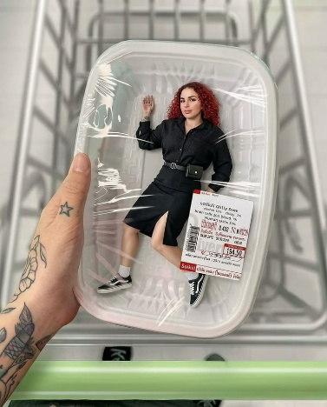
Prompt：Vertical surreal creative photography, human figure that matches the character appearance from reference image as a tiny full-body miniature figure sealed inside transparent plastic supermarket food tray covered with plastic wrap, a tattooed large hand holds the tray in foreground, metal shopping cart as background. All character curly red hair, black dress, sneakers, tattoos, facial features and outfit automatically match the uploaded reference image. Price barcode sticker attached to the food tray, bright supermarket indoor soft lighting, realistic photographic texture, weird miniature human packaged in food container core surreal gimmick, clean neutral tone color palette, 8K ultra HD, sharp clear details, natural soft shadows. Strictly match the reference image’s plastic food tray packaging layout, mini character scale effect, shopping cart background, real-life commercial photo texture and vertical framing automatically.
- 都市街景巨型人像超现实创意摄影｜Urban Street Giant Figure Surreal Creative Photo
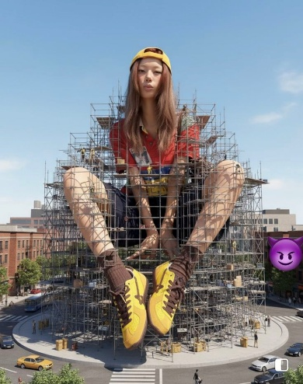
Prompt：Vertical surreal giant miniature contrast street photography, human figure that matches the character appearance from reference image as an oversized giant girl sitting in the center of city roundabout, surrounded by dense metal construction scaffolding, tiny pedestrians, cars and city buildings scattered around the giant figure's feet. All character long hairstyle, backwards yellow cap, printed red shirt, dark shorts, brown socks and yellow sneakers automatically match the uploaded reference image. Bright clear sunny blue sky, realistic urban city street background, natural daylight, lifelike photographic texture, surreal giant human vs tiny city miniature core contrast gimmick, 8K ultra HD, rich environmental details, soft natural shadows, trendy youth street editorial aesthetic. Strictly match the reference image’s city roundabout scene, metal scaffolding surrounding layout, giant-miniature scale contrast effect, bright sunny outdoor tone and vertical framing automatically.
- 人像嵌入卡牌复古创意拼贴大片｜Portrait Embedded Card Vintage Creative Editorial
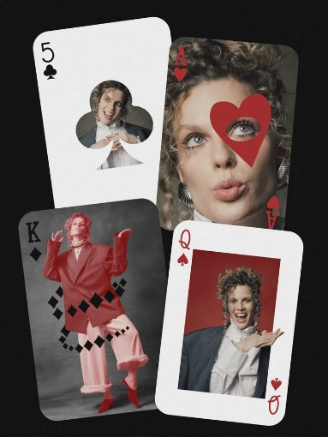
Prompt：Vertical fashion collage graphic, human figure that matches the character appearance from reference image split into multiple portraits embedded on four overlapping playing cards (Ace of hearts, Queen of spades, King of diamonds, 5 of clubs). All character curly hair, facial features, outfits and poses automatically match the uploaded reference image. Each card retains standard poker suit symbols, numbers and classic card layout, solid pure black minimalist background, red and monochrome neutral color palette, soft studio portrait lighting, realistic fashion photography texture, layered staggered card overlay composition, 8K ultra HD, delicate matte print texture, avant-garde card collage aesthetic. Strictly match the reference image’s playing card carrier layout, multi-pose same character design, red suit color system and vertical framing automatically.
- 透明水袋水人像超现实创意大片｜Transparent Water Bag Underwater Surreal Portrait
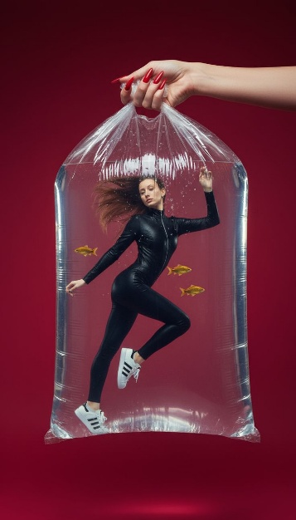
Prompt：Vertical surreal studio fashion photograph, human figure that matches the character appearance from reference image floating underwater inside a large transparent water-filled plastic carry bag, a separate hand with bright red manicured nails grips the bag handle at the top frame. All character long hair, tight black leather jumpsuit, white striped sneakers, facial features automatically match the uploaded reference image. Small golden fish and tiny water bubbles float around the character inside the bag, solid deep red seamless studio background, soft directional studio lighting, glossy transparent plastic texture, clear underwater water refraction effect, surreal human sealed in water bag core gimmick, 8K ultra HD, delicate realistic skin and fabric texture, minimalist high fashion aesthetic. Strictly match the reference image’s solid red backdrop, transparent water plastic bag carrier layout, underwater floating scene, vivid red tone and vertical framing automatically.
- 同色系黄调人与猫咪对称趣味人像｜Monochrome Yellow Matching Human & Cat Symmetry Portrait
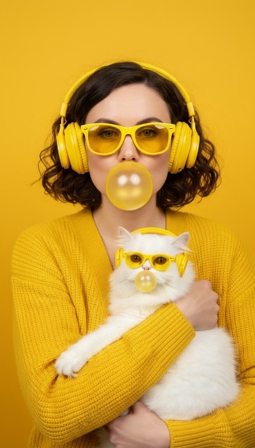
Prompt：Vertical warm monochrome yellow studio portrait photo, human figure that matches the character appearance from reference image holding a fluffy white cat, both human and cat wear identical yellow over-ear headphones and yellow tint sunglasses, both blow transparent yellow bubble gum bubbles. All character short curly hair, yellow knit cardigan, facial features automatically match the uploaded reference image. Solid bright pure yellow seamless background, soft even warm studio fill lighting, smooth fluffy cat fur texture, glossy plastic headset and sunglasses texture, cute symmetrical matching human-pet core gimmick, clean bright yellow monochrome color palette, 8K ultra HD, soft natural shadows, warm cozy commercial lifestyle aesthetic. Strictly match the reference image’s full yellow monochrome tone, matching accessories human-cat symmetrical layout, bubble gum decorative element and vertical framing automatically.
- 金属多耳洞微观人物超现实创意摄影｜Multi Metal Ear Piercing Micro Figure Surreal Shot
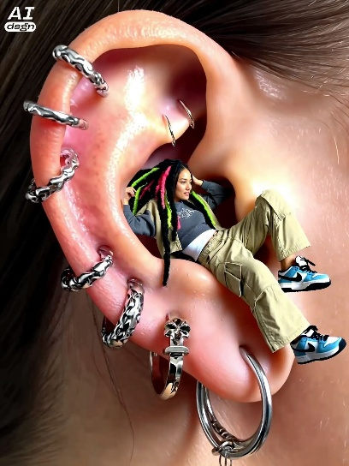
Prompt：Vertical extreme close-up fashion photograph, giant human pierced ear covered with wavy silver hoop piercings as main background carrier, a tiny full-body human figure that matches the character appearance from reference image reclines inside the hollow ear cavity. All character colorful dyed dreadlocks, layered jacket, gray cropped top, khaki cargo pants, blue and white sneakers, facial features automatically match the uploaded reference image. Soft close-up skin texture, cool silver metallic piercing jewelry texture, dark hair surrounding the ear, directional soft studio lighting, surreal miniature human nested inside pierced ear core gimmick, 8K ultra HD, sharp delicate skin and metal details, avant-garde street fashion aesthetic. Strictly match the reference image’s giant pierced ear carrier layout, mini figure nested inside ear gimmick, silver punk piercing accessories texture and vertical framing automatically.
- 镜面倒影扑克花色极简商务大片｜Mirror Reflection Poker Suit Minimal Business Shot
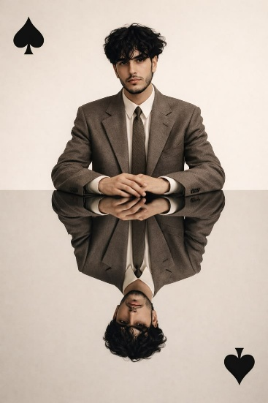
Prompt：Vertical minimalist business portrait photograph, human figure that matches the character appearance from reference image sits above a smooth reflective mirror surface, a perfect upside-down mirror reflection of the character below. All character curly dark hair, brown wool suit, white shirt, dark tie, facial features automatically match the uploaded reference image. Solid off-white matte plain background, solid black spade suit symbols placed at top-left and bottom-right corners, soft even studio fill lighting, clean reflective mirror texture, neutral warm sepia color grading, symmetrical mirror reflection core visual gimmick, 8K ultra HD, delicate fabric and skin details, elegant minimalist fashion aesthetic. Strictly match the reference image’s plain cream backdrop, full mirror upside-down reflection layout, poker spade decorative elements and vertical framing automatically.
- 电梯内多彩卡通怪兽人像潮流大片｜Elevator Colorful Cartoon Monster Character Editorial
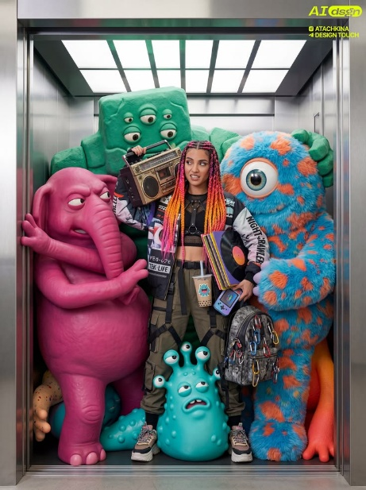
Prompt：Vertical Y2K street fashion photograph, human figure that matches the character appearance from reference image standing in the center of a metal elevator cabin, surrounded by multiple large colorful cartoon clay monster dolls with unique multi-eye designs. All character rainbow braids, patchwork printed jacket, cropped mesh inner top, cargo harness pants, sneakers and accessories automatically match the uploaded reference image. Character holds vintage boombox, vinyl records, bubble tea cup, handheld game console, backpack with carabiner decorations; bright square ceiling light inside elevator, metallic silver elevator wall texture, saturated neon candy color palette, smooth clay monster texture mixed with realistic portrait photography, lively playful cyber youth aesthetic, 8K ultra HD, rich layered prop and monster details. Strictly match the reference image’s metal elevator enclosed scene, multiple fantasy clay monster surrounding layout, retro Y2K streetwear props and vertical framing automatically.
- 实拍人像混搭材质碎片拼贴创意照｜Real Portrait Mixed Material Fragment Collage Shot
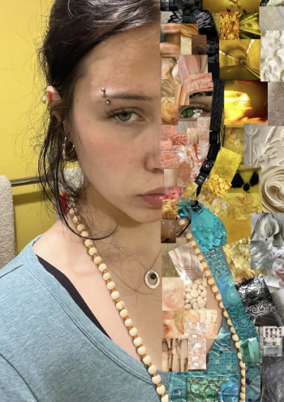
Prompt：Vertical artistic split collage portrait photo, human figure that matches the character appearance from reference image occupies the left half frame with real-life close-up shot, the right half is fully covered by dense irregular small texture fragment collages including marble, floral, metal, fabric, plaster relief, tunnel light and abstract texture pieces. All character messy hair, eyebrow piercing, hoop earring, layered necklaces, light blue top and facial features automatically match the uploaded reference image. Solid warm yellow simple background on left side, soft indoor natural lighting, realistic skin portrait texture contrasted with diverse tactile collage fragments, vertical half-split surreal splicing core gimmick, 8K ultra HD, delicate mixed media art aesthetic. Strictly match the reference image’s left real portrait & right texture tile split layout, warm yellow tone, mixed material collage style and vertical framing automatically.
- 相机手持窗口光标复古数字风写真｜Camera Hand Cursor Window Digital Style Editorial

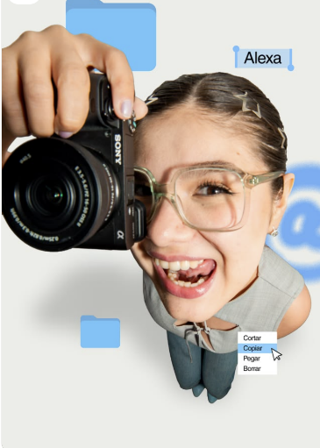
Prompt：Vertical top-down overhead creative portrait photograph, human figure that matches the character appearance from reference image shot from high bird's-eye view, a giant hand holds a black Sony mirrorless camera close to the character’s face. All character transparent square glasses, star hair clips, grey sleeveless top, jeans, facial features and joyful expression automatically match the uploaded reference image. The picture is decorated with desktop UI graphic elements: light blue folder icons, text name label "Alexa", spray painted @ symbol, Spanish right-click context menu with mouse cursor pointer, solid light off-white minimalist background, soft flat studio lighting, clean digital graphic overlay mixed with realistic portrait texture, playful desktop system interface collage gimmick, 8K ultra HD, soft subtle shadows, modern digital creator aesthetic. Strictly match the reference image’s overhead top-down perspective, desktop UI decorative overlay layout, clean neutral light tone and vertical framing automatically.
- 手绘线条对半拼接人像文艺海报｜Hand Drawn Line Half Split Splicing Art Portrait Poster
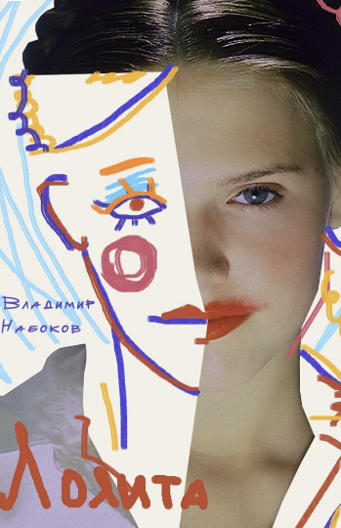
Prompt：Vertical artistic split collage portrait poster, human figure that matches the character appearance from reference image occupies the right half with realistic soft studio portrait shot, the left half is covered by irregular torn white paper block filled with hand-drawn colorful rough line sketch of a face, including handwritten Russian serif text on the sketch layer. All character hair, facial features, lip color, soft natural skin texture automatically match the uploaded reference image. Muted warm off-white paper tone background, soft diffused portrait lighting, contrast between lifelike photographic texture and raw crayon hand-drawn line art, half split dual-media splicing core aesthetic, 8K ultra HD, delicate vintage book cover texture, minimalist fine art print style. Strictly match the reference image’s left hand sketch / right real portrait split layout, multi-color rough line drawing elements, Russian handwritten text decoration and vertical framing automatically.
- 红番茄满铺氛围感人像大片｜Full Red Tomato Layers Atmospheric Editorial
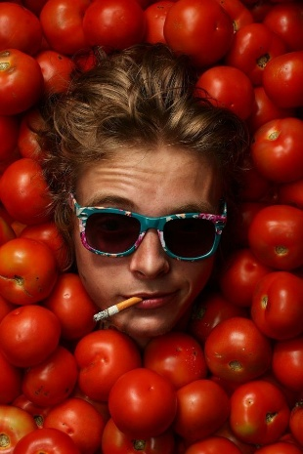
Prompt：Vertical close-up film portrait photograph, human figure that matches the character appearance from reference image with only face exposed, fully surrounded and framed by piles of plump glossy red tomatoes. All character messy light brown curly hair, floral print turquoise sunglasses, cigarette held between lips, facial features automatically match the uploaded reference image. Warm natural soft studio lighting, rich saturated red tomato color palette, realistic fresh fruit texture mixed with grainy analog film portrait aesthetic, tight fruit framing core visual gimmick, 8K ultra HD, subtle film grain, warm earthy skin tone grading. Strictly match the reference image’s dense red tomato surrounding frame layout, retro film texture, close-up facial composition and vertical framing automatically.
- 照片与厚涂绘画分块拼接肖像｜Photo & Impasto Painting Block Splicing Portrait
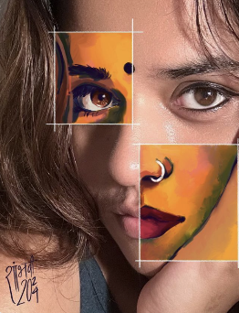
Prompt：Vertical close-up portrait artwork, the base is realistic photographic selfie of a South Asian woman with wavy brown hair, bindi on forehead, winged eyeliner. Two white thin sampling square frames overlay the image: upper frame contains thick impasto oil painting of one eye & ear with warm orange-yellow palette; lower frame has impasto painting of nose with hoop nose ring and red lips in matching warm tones. There is handwritten Devanagari script + "2024" signature at bottom left, soft natural indoor lighting, sharp contrast between photorealistic skin texture and textured brush painting, mixed media art style, 8K ultra detailed, tight close-up framing, vertical composition.
- Y2K 迷幻波纹杂志封面人像｜Y2K Psychedelic Swirl Magazine Cover Portrait
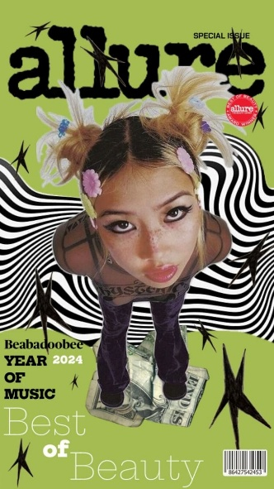
Prompt：Vertical Y2K magazine cover graphic, human figure that matches the character appearance from reference image shot from high overhead fisheye perspective, twin messy blonde space buns decorated with pastel flower hair clips, crop sheer top, dark purple flared pants, standing on crumpled dollar bills. All character facial features, freckle makeup, hair styling and outfits automatically match the uploaded reference image. Flat lime green base background, black wavy psychedelic swirl pattern behind character, scattered jagged black star stickers, magazine print text elements "allure", "SPECIAL ISSUE", "Best of Beauty", red beauty award stamp, bottom barcode, layered cutout character collage texture, grainy retro print aesthetic, saturated pastel green tone, 8K ultra HD, full vertical magazine cover layout. Strictly match the reference image’s fisheye overhead shot, Y2K star & swirl decorative elements, magazine cover text branding and vertical framing automatically.
- 巨型牙套口腔内嵌迷你人像超现实大片｜Giant Grillz Mouth Embedded Mini Figure Surreal Shot

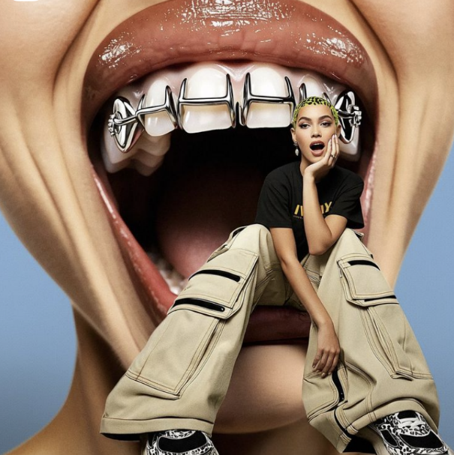
Prompt：Vertical surreal fashion photograph, giant close-up shot of an open human mouth with shiny silver metal grillz on teeth acts as the carrier, a tiny full-body human figure that matches the character appearance from reference image sits on the lower lip inside the giant mouth. All character neon patterned short hair, black printed short-sleeve tee, beige multi-pocket cargo wide-leg pants, leopard print sneakers, facial features and relaxed pose automatically match the uploaded reference image. Solid clean light blue seamless studio background, soft even studio fill lighting, glossy moist lip and tooth texture, cool metallic silver grillz texture, surreal miniature human nested inside giant mouth core contrast gimmick, 8K ultra HD, crisp realistic skin and fabric details, modern streetwear high fashion aesthetic. Strictly match the reference image’s giant open mouth carrier layout, mini figure nested inside oral cavity gimmick, simple solid light blue backdrop and vertical framing automatically.

