【绿色主题】
1.绿色主题多材质拼贴情绪版配色灵感板｜Green Theme Multi-Material Collage Color Mood Board
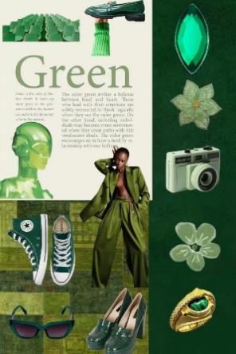
Prompt：Vertical fashion mood board collage artwork, unified all-green color palette, split two-column layout with off-white paper left section and deep dark green textured fabric right section. Left area contains scattered cutout fragments: rows of light green stadium chairs, green leather loafer shoe with knit sock, large serif "Green" headline + descriptive color theory text paragraph, translucent glossy green robot helmet bust, Black female model wearing full olive green wide suit outfit, dark green canvas sneakers, green cat-eye sunglasses, dark green crocodile platform block heels. Right vertical strip decorated with green gem marquise ornament, fabric embroidered green flower, white vintage Holga 135 film camera, translucent light green floral cutout, gold twisted ring with emerald inlay. Mixed media scrapbook texture, layered torn paper cutouts, soft muted vintage print filter, fashion color analysis aesthetic, 8K ultra detailed, vertical full mood board layout, all elements maintain consistent green tone system. Automatically replace the central human figure with facial features, hairstyle and appearance matched from uploaded reference image without fixed outfit restrictions.
2. 悬浮青柠云间礼盒人像超现实清新大片｜Floating Limes Cloud Box Portrait Surreal Fresh Editorial
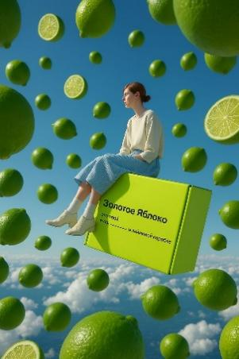
Prompt：Vertical surreal sky fantasy photograph, all facial features, hairstyle and facial details of the human figure fully matched from uploaded reference image. The character sits sideways on a floating bright lime-green rectangular cardboard box printed with Russian text, countless whole green limes and sliced lime pieces suspend in mid-air all around, background is clear bright blue sky with fluffy white clouds below, soft bright natural daylight, fresh lime green + sky blue cool tone palette, realistic fruit and cloud texture, core creative gimmick of floating fruit + levitating box aerial scene, 8K ultra HD, clean minimalist surreal aesthetic. Automatically match the whole appearance of the character according to reference image without fixed outfit restrictions, strictly follow vertical framing layout.
3. 苔藓洞穴人头探出毒蘑菇森林胶片人像｜Moss Cave Head Peeking Spotted Mushroom Forest Film Portrait
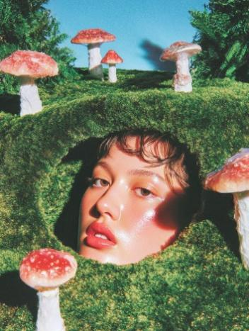
Prompt：Vertical analog film surreal forest portrait photograph, all facial features, short wavy hair and facial details of the human figure fully matched from uploaded reference image. Only the character’s head pokes out from a hollow hole in thick fluffy deep green moss mound, surrounded by multiple red spotted white-stem fantasy mushrooms, dense fern green plants on both sides, clear bright blue sky in background, vivid warm hard directional sunlight, glossy dewy glowing skin texture, saturated retro film color grading, subtle film grain, core creative gimmick of moss cave headshot surrounded by fairy tale mushrooms, 8K ultra HD, dreamy whimsical forest editorial aesthetic. Automatically match the whole facial appearance of the character according to reference image without fixed outfit restrictions, strictly follow vertical framing layout.
4. 仿真草坡向日葵彩色风车童趣躺姿少女写真｜Artificial Grass Hill Sunflower Color Pinwheel Playful Lying Girl Portrait
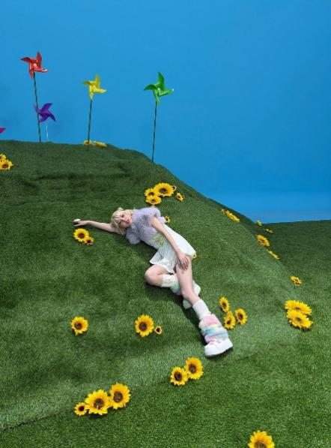
Prompt：Vertical whimsical studio fashion photograph, all facial features, hairstyle and facial details of the human figure fully matched from uploaded reference image. The character lies sideways on undulating lush green artificial grass hill scattered with bright yellow sunflowers, several colorful pinwheels stand on the hilltop in background, solid vivid cerulean blue seamless backdrop, soft even bright studio lighting, sweet pastel playful tone, core creative gimmick of mini grass hill sunflower pinwheel fairy tale scene layout, 8K ultra HD, soft fluffy grass and vivid flower texture details, cute dreamy childish fashion editorial aesthetic. Automatically match the whole appearance of the character according to reference image without fixed outfit restrictions, strictly follow vertical framing layout.
【红色主题】
- 木框番茄环绕低角度伸手蓝天日系清新人像｜Wood Frame Tomato Surrounded Low Angle Reaching Hand Blue Sky Fresh Portrait
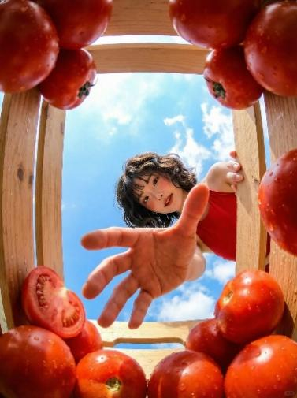
Prompt：Vertical low-angle overhead fresh Japanese style portrait photograph, all facial features, short wavy hair and facial details of the human figure fully matched from uploaded reference image. The character leans behind light wooden crate frame filled with glossy water-drop red tomatoes (including a sliced tomato), one hand grips the wood slat, the other palm stretches forward toward the camera, bright blue sky with soft white clouds as background, bright natural daylight, fresh red & sky blue color palette, core creative gimmick of wooden crate tomato frame foreground and forward reaching hand perspective shot, 8K ultra HD, vivid juicy tomato texture, soft bright pastoral atmosphere aesthetic. Automatically match the whole appearance of the character according to reference image without fixed outfit restrictions, strictly follow vertical low-angle framing layout.
- 曲面全息棋盘悬浮红马国际象棋赛博人像｜Curved Holographic Chessboard Floating Red Knight Cyber Portrait
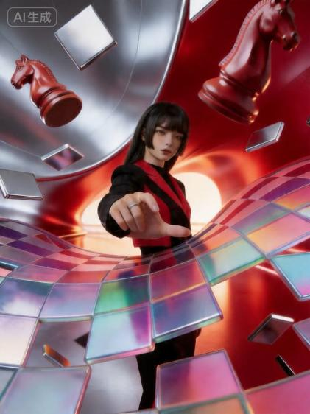
Prompt：Vertical futuristic cyber fashion portrait photograph, all facial features, straight long black hair and facial details of the human figure fully matched from uploaded reference image. The character stretches one hand forward toward the lens, surrounded by warped curved holographic iridescent transparent chessboard tiles, two solid red knight chess pieces float suspended in mid-air around the character, curved dual-tone metallic silver and glossy red tunnel background with warm glowing circular light source in distance, smooth reflective metal texture, iridescent rainbow translucent tile refraction effect, cool futuristic high-fashion tone, core creative gimmick of distorted holographic chessboard + floating chess knight surreal cyber scene, 8K ultra HD, delicate reflective and transparent material texture details, dramatic atmospheric sci-fi editorial aesthetic. Automatically match the whole appearance of the character according to reference image without fixed outfit restrictions, strictly follow vertical framing layout.
- 冰沙杯底仰拍吸管视角西瓜红泡沫夏日人像｜Bottom-of-Smoothie-Cup Low Angle Straw View Watermelon Foam Summer Portrait

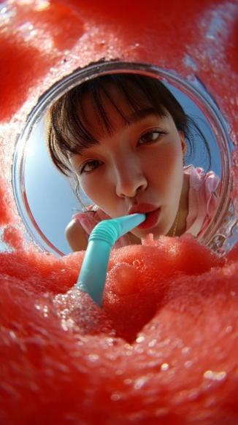
Prompt：Vertical extreme low-angle POV summer beverage portrait photograph, all facial features, hairstyle and facial details of the human figure fully matched from uploaded reference image. Shot from inside a transparent glass cup filled with thick frothy red watermelon slush covered in tiny glistening bubbles, a turquoise plastic straw extends down into the slush, the character leans over the cup and puts lips on the straw, circular glass rim frames the character’s face, clear bright blue sunny sky in background, soft natural sunlight, vibrant red and fresh cool tone palette, core creative gimmick of first-person drink cup bottom perspective framing shot, 8K ultra HD, glossy bubbly froth texture, refreshing bright summer atmosphere aesthetic. Automatically match the whole appearance of the character according to reference image without fixed outfit restrictions, strictly follow vertical POV cup framing layout.
4. 纯色红背景手持双幅蛇年潮流海报新年针织人像｜Solid Red Background Holding Dual Year-of-Snake Trend Posters New Year Knit Portrait
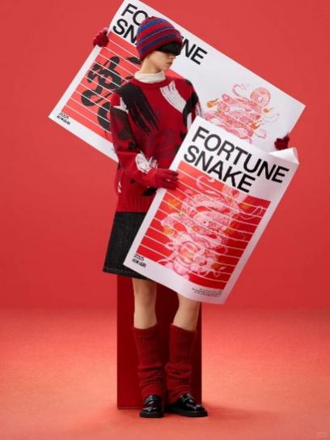
Prompt：Vertical minimalist Chinese New Year studio fashion portrait photograph, all facial features, hairstyle and facial features of the human figure fully matched from uploaded reference image. The character stands beside a tall solid red rectangular pedestal, holding two oversized printed posters with bold text "FORTUNE SNAKE", delicate line art snake illustrations and 2025 Chinese lucky calligraphy, full matte solid red seamless wall and floor background, soft even diffused studio fill lighting, unified saturated red festive color palette, core creative gimmick of double giant snake-themed poster props minimalist studio layout, 8K ultra HD, fine knit fabric and matte poster paper texture details, trendy clean red Spring Festival editorial aesthetic. Automatically match the full appearance of the character according to reference image without fixed outfit restrictions, strictly follow vertical framing layout.
- 四宫格红底樱桃蛋糕甜妹红色吊带写真套图｜4-Grid Red Background Cherry Cake Sweet Girl Red Cami Portrait Set
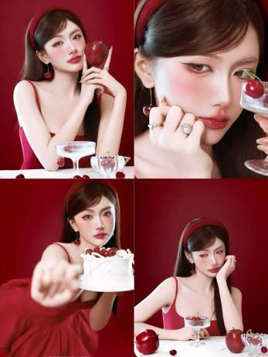
Prompt：Vertical 4-grid split composite portrait set, four different poses in one canvas, all facial features, long soft hair and facial details of the girl fully matched from uploaded reference image. The girl wears red camisole dress, red headband, cherry drop earrings, silver delicate rings, fresh pink blush and glossy red lip makeup. Solid matte deep red seamless background, props include big red apples, fresh cherries, ribbed transparent glass goblets, white cream cake topped with cherries. Four shot styles: full body medium shot holding apple, extreme close-up face shot with wine glass, foreground shot pushing cake toward camera, resting cheek on hand beside fruit tableware. Soft gentle studio fill light, warm red sweet color palette, delicate glossy skin texture, core creative gimmick of four-pose grid layout with cherry & fruit dessert props, 8K ultra HD, soft sweet girl commercial portrait aesthetic. Automatically match the whole facial appearance of the character according to reference image without fixed outfit restrictions, strict vertical square four-panel layout.
【蓝色主题】
- 蓝天棉花云一字马悬浮运动人像大片｜Blue Sky Cotton Cloud Split Leaping Sportswear Portrait
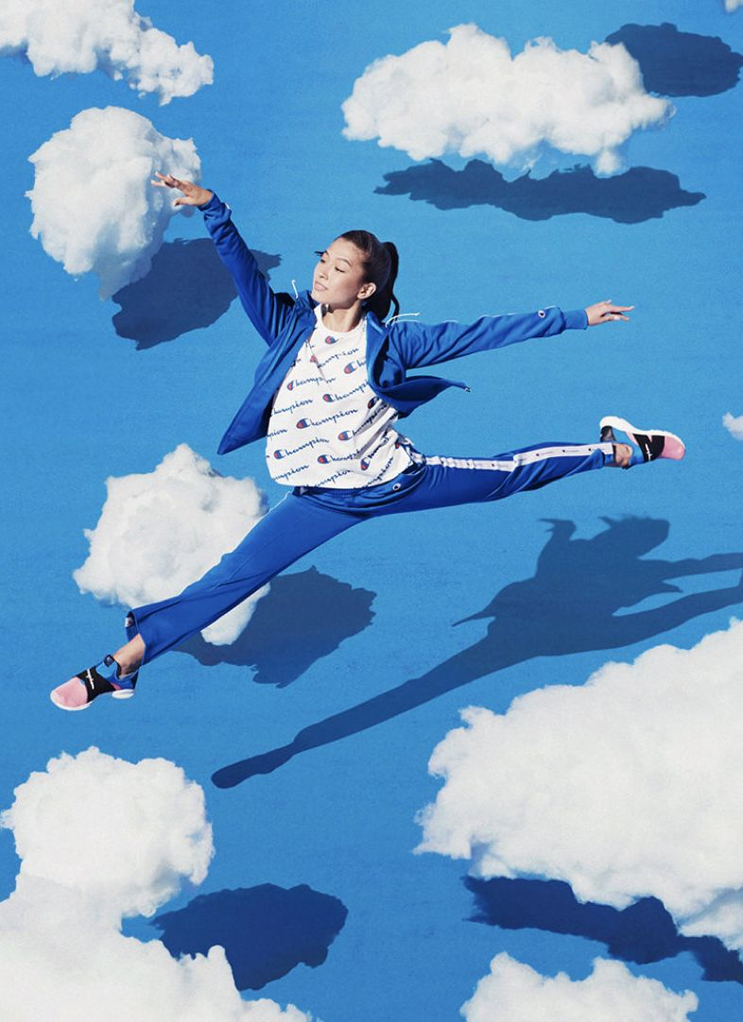
Prompt：Vertical surreal floating sports fashion photograph, all facial features, ponytail hairstyle and facial details of the human figure fully matched from uploaded reference image. The character leaps mid-air in a full horizontal split pose with both arms stretched wide, artificial fluffy cotton cloud decorations scattered across bright solid cerulean blue backdrop, clear dark shadow of the figure cast on the blue surface, bright even studio daylight, fresh blue-and-white clean color palette, core creative gimmick of levitating split dance move with cotton cloud sky scene, 8K ultra HD, soft fluffy cloud texture, dynamic athletic fashion editorial aesthetic. Automatically match the whole appearance of the character according to reference image without fixed outfit restrictions, strictly follow vertical framing layout.
- 花海油画背景画家持画笔手绘大字竖版人像｜Flower Field Oil Painting Background Painter Holding Brush Hand-Painted Text Vertical Portrait

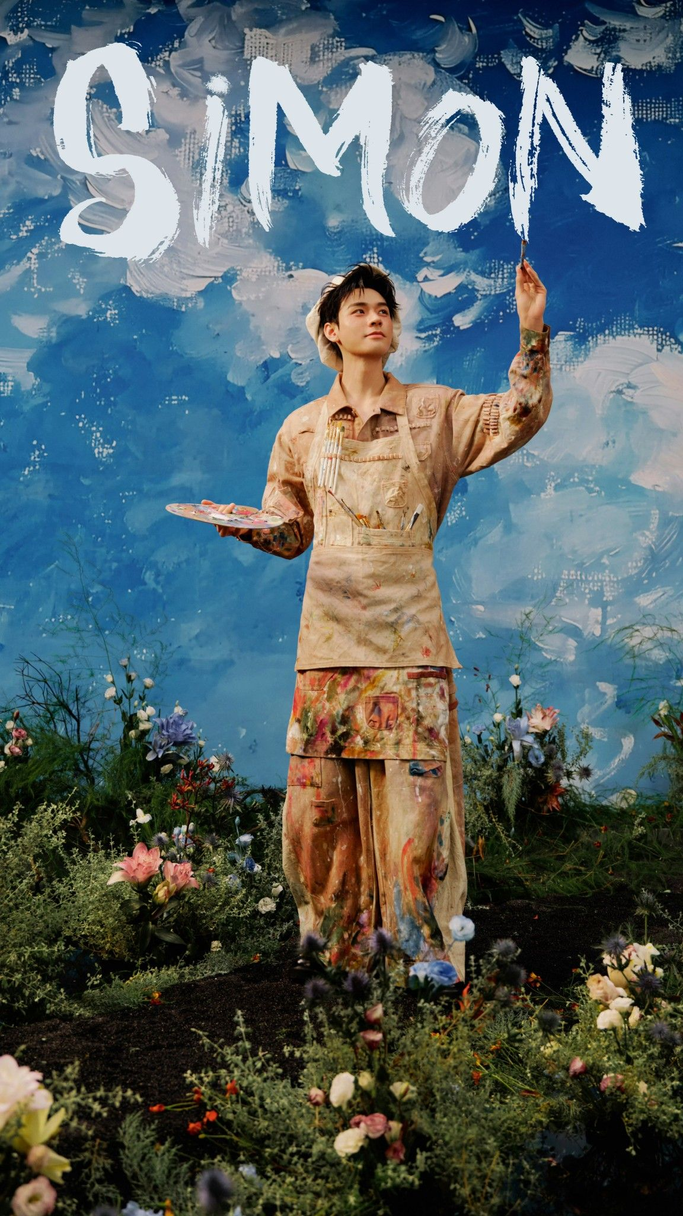
Prompt：Vertical artistic painter studio portrait photograph, all facial features, short hair and facial details of the human figure fully matched from uploaded reference image. The character wears paint-splattered beige artist apron with paintbrushes tucked in pockets, holds palette in one hand and paintbrush raised upward with the other, standing among lush mixed wildflowers and green foliage, thick textured impasto blue sky oil painting mural as background, huge rough brushstroke white hand-painted text on the top of the canvas, soft diffused natural warm lighting, dreamy painterly art tone, core creative gimmick of painter character + impasto sky mural + foreground flower bed layout, 8K ultra HD, thick paint texture and delicate flower details, romantic artistic editorial aesthetic. Automatically match the whole appearance of the character according to reference image without fixed outfit restrictions, strictly follow vertical framing layout.
- 蓝幕星光钓星巫师礼帽男士时尚杂志人像｜Blue Curtain Star Fishing Wizard Hat Men's Fashion Magazine Portrait
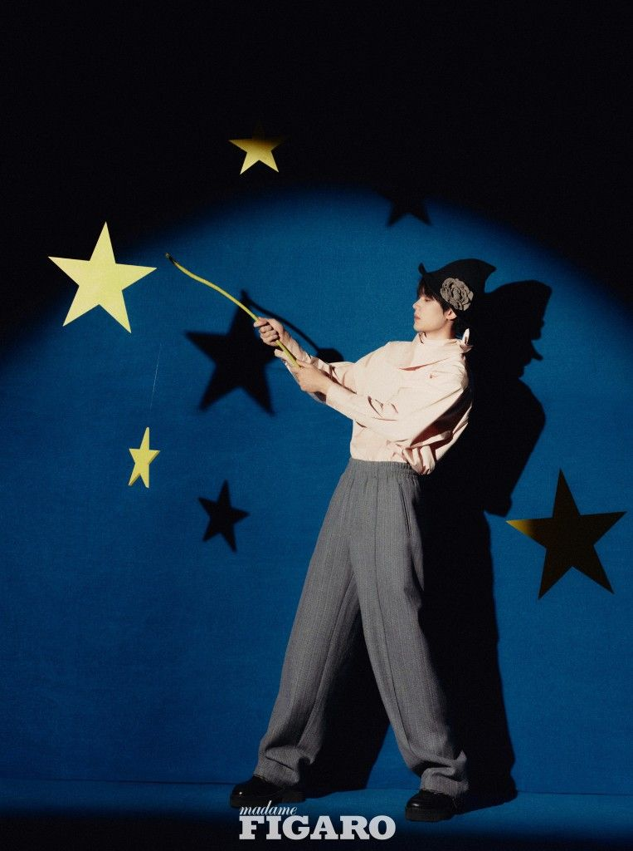
Prompt：Vertical fashion magazine studio portrait photograph, all facial features, hairstyle and facial details of the human figure fully matched from uploaded reference image. The male character wears a black wizard hat decorated with gray flower, light pink stand-collar shirt and gray pinstripe wide-leg trousers, holding a long thin yellow fishing rod to hook floating golden five-pointed star cutouts, curved deep blue velvet backdrop with scattered golden star ornaments and their dark shadows, single soft spotlight creates dramatic hard shadow on background, white serif text "madame FIGARO" at bottom, retro muted film tone, core creative gimmick of fishing star magical wizard studio layout, 8K ultra HD, soft velvet fabric texture, mysterious whimsical fashion editorial aesthetic. Automatically match the whole appearance of the character according to reference image without fixed outfit restrictions, strictly follow vertical framing layout.
- 仰拍蓝天跳跃网球少年手绘黄色线条运动海报｜Low Angle Blue Sky Jumping Tennis Boy Hand Drawn Yellow Line Sports Poster
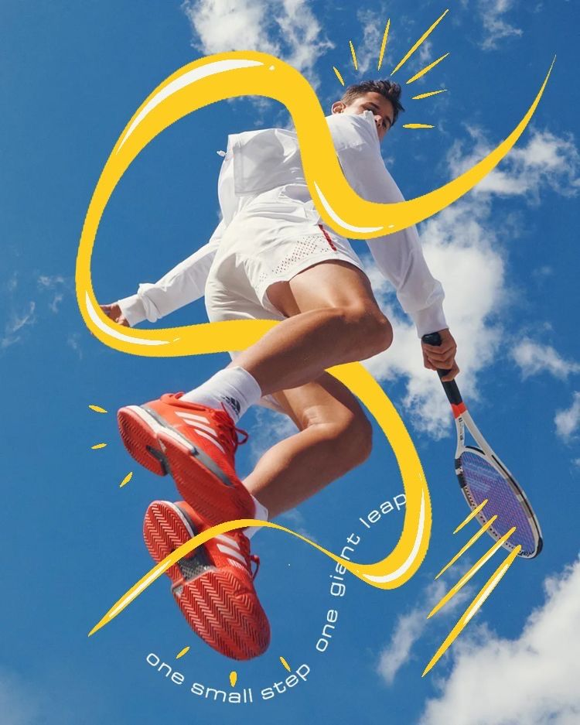
Prompt：Vertical low-angle sports fashion poster photograph, all facial features, hairstyle and facial details of the human figure fully matched from uploaded reference image. The male athlete leaps high mid-air holding a tennis racket, wearing white tennis sportswear and bright red sneakers, background is clear vivid blue sky with fluffy white clouds, hand-drawn thick glossy yellow curve lines surround the character, small yellow dash decorative lines scattered around, curved white text "one small step one giant leap" along the yellow curve, bright natural sunlight, fresh high-saturation blue and yellow color palette, core creative gimmick of real sports portrait combined with hand-drawn cartoon line illustration overlay, 8K ultra HD, dynamic energetic sports commercial aesthetic. Automatically match the whole appearance of the character according to reference image without fixed outfit restrictions, strictly follow vertical low-angle framing layout.
- 晴空悬浮白色阶梯门框极简治愈男生人像｜Floating White Stair Frame Clear Sky Minimal Healing Male Portrait
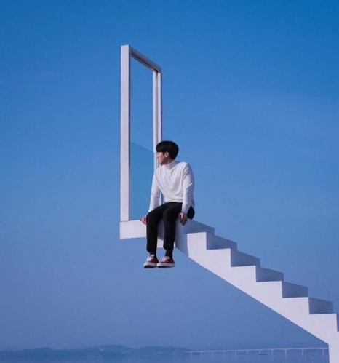
Prompt：Vertical minimalist surreal aerial portrait photograph, all facial features, short black hair and facial details of the human figure fully matched from uploaded reference image. The male character sits on the edge of a suspended pure white staircase with a tall blank white rectangular door frame at the top, floating high above faint distant lake and bridge scenery, seamless soft clear cerulean blue sky fills the whole background, clean uniform cool blue tone, soft diffused natural daylight, core creative gimmick of levitating white stair frame surreal sky scene layout, 8K ultra HD, smooth matte white texture, quiet minimalist healing aesthetic. Automatically match the whole appearance of the character according to reference image without fixed outfit restrictions, strictly follow vertical framing layout.
【黄色主题】
- 亮黄纯色背景巨型香蕉酣睡少女童趣人像｜Bright Yellow Solid Background Giant Banana Sleeping Girl Cute Portrait
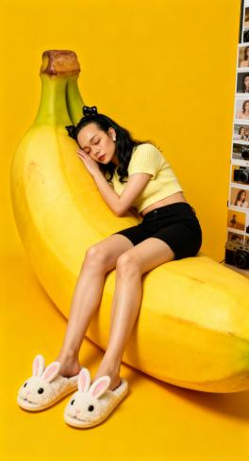
Prompt：Vertical studio whimsical fashion portrait photograph, all facial features, long wavy black hair and facial details of the human figure fully matched from uploaded reference image. The girl lies curled and falls asleep on an oversized realistic double banana prop, eyes closed with head resting on banana surface, wearing pale yellow cropped knit top, black denim shorts, fluffy white bunny slippers, small black bow hair clips on head. Solid saturated bright yellow seamless wall and floor background, vertical photo film strip and vintage camera decorations along the right edge, soft even warm studio fill lighting, unified yellow pastel warm tone palette, core creative gimmick of giant fruit prop sleepy casual cute studio layout, 8K ultra HD, smooth fruit texture and fluffy slipper plush details, cozy playful lifestyle editorial aesthetic. Automatically match the whole appearance of the character according to reference image without fixed outfit restrictions, strictly follow vertical framing layout.
2.俯拍纯白背景巨型芒果蕾丝头纱少女清新写真｜Top-Down Pure White Background Giant Mango Lace Veil Girl Fresh Portrait

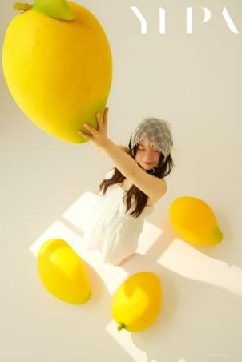
Prompt：Vertical high-angle overhead fresh studio portrait photograph, all facial features, long wavy hair and facial details of the human figure fully matched from uploaded reference image. The girl wears flowy white slip mini dress and delicate sheer lace headscarf, eyes closed with soft smile, stretches one arm upward to hold an oversized bright yellow mango prop, three smaller mango props scattered on the ground around her, solid matte off-white seamless background, soft natural window light casting clear geometric shadows, minimalist serif text "YI PA" at top right corner, warm mild yellow and white clean tone palette, core creative gimmick of overhead shot with giant fruit mango props pastoral fresh studio layout, 8K ultra HD, smooth glossy mango skin texture, soft gentle summer editorial aesthetic. Automatically match the whole appearance of the character according to reference image without fixed outfit restrictions, strictly follow vertical high-angle framing layout.
3.云海悬浮柠檬玻璃瓶少女超现实清新人像｜Cloud Floating Lemon Glass Bottle Girl Surreal Fresh Portrait
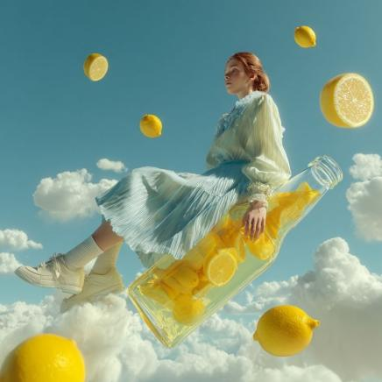
Square surreal sky fantasy photograph, all facial features, hairstyle and facial details of the human figure fully matched from uploaded reference image. The girl sits sideways on a tilted huge transparent glass bottle filled with lemon slices, countless whole lemons and sliced lemon pieces float suspended in mid-air around her, fluffy white clouds spread beneath, clear pale blue sky as background, she wears light blue striped pleated long dress, white mid-calf socks and clean white sneakers, soft bright natural daylight, fresh cool blue and lemon yellow color palette, core creative gimmick of levitating lemon glass bottle aerial dreamy scene, 8K ultra HD, transparent glass refraction and juicy lemon texture, light ethereal summer editorial aesthetic. Automatically match the whole appearance of the character according to reference image without fixed outfit restrictions, strictly follow square framing layout.
- 游乐园亮黄小熊毛绒外套彩虹条纹复古胶片人像｜Amusement Park Bright Yellow Bear Fleece Jacket Rainbow Stripe Retro Film Portrait
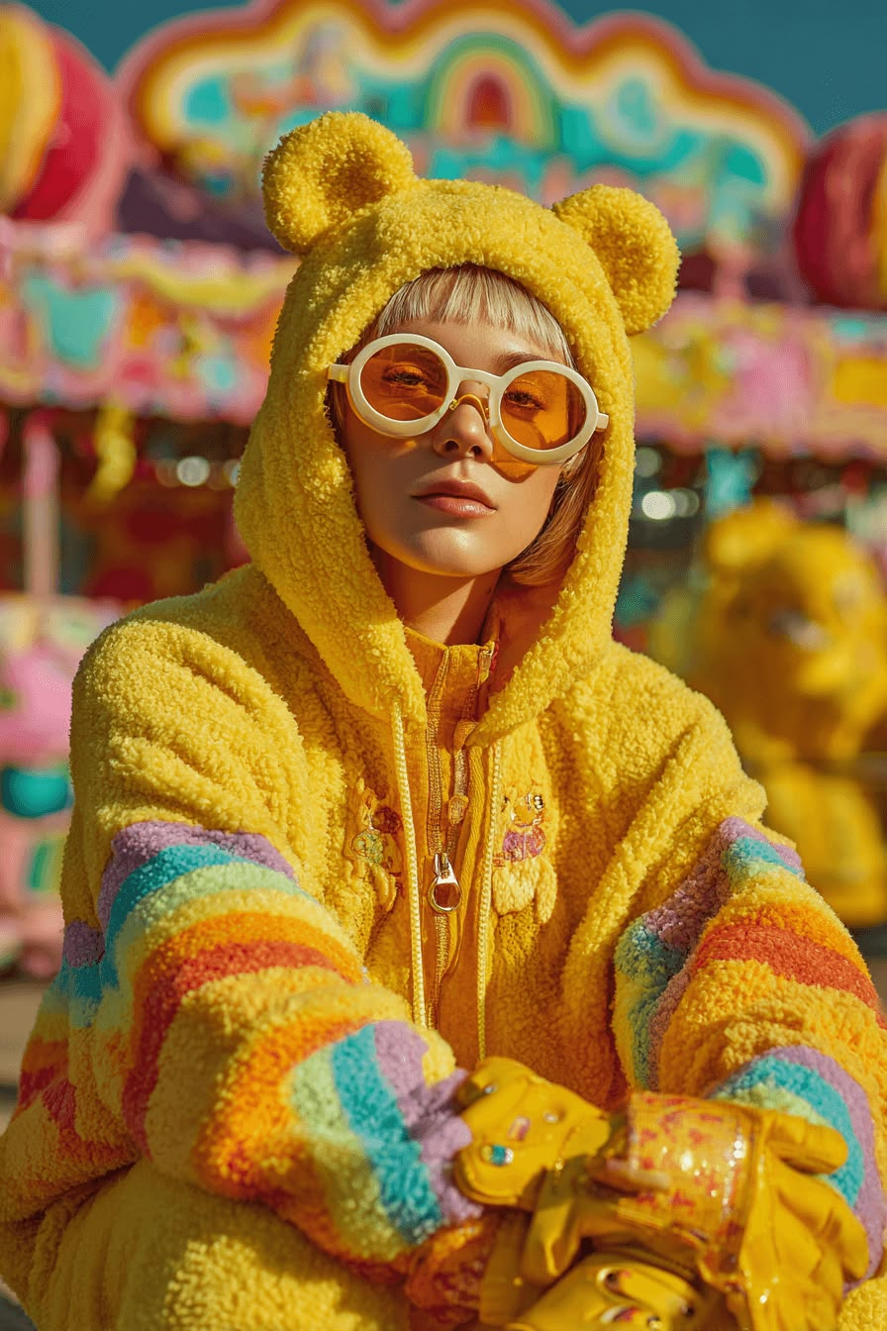
Prompt：Vertical retro film fashion portrait photograph, all facial features, short blonde bangs and facial details of the human figure fully matched from uploaded reference image. The character wears fluffy bright yellow sherpa zip hoodie with 3D bear ears on hood, rainbow horizontal striped sleeves, small cartoon embroidery on front zipper placket, white round frame sunglasses with orange tint lenses, holding yellow glossy decorative gloves in crossed arms. Blurred colorful vintage amusement park carousel with rainbow neon sign as background, warm golden afternoon sunlight, saturated candy color palette, subtle film grain texture, core creative gimmick of cute bear fleece coat carnival playground layout, 8K ultra HD, soft fuzzy fleece fabric texture, playful vibrant kawaii fashion editorial aesthetic. Automatically match the whole appearance of the character according to reference image without fixed outfit restrictions, strictly follow vertical framing layout.

