【宠物个性化定制(Pet Customization)】
1.复古胶片宠物酷帅浴袍花束写真生成玩法
Vintage Film Cool Pet Bathrobe Bouquet Portrait Generation Template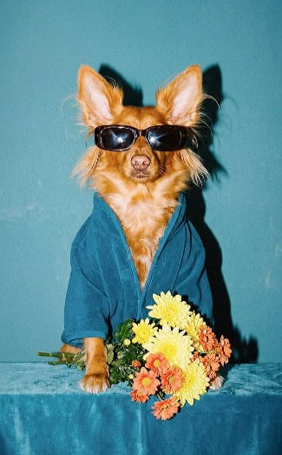
Prompt：Reference image provides the main animal subject, fully retain the animal's original appearance, breed, facial features and body shape from reference picture.
Vintage 35mm film photograph, a cute animal wearing dark tortoiseshell rectangular sunglasses, wrapped in deep teal plush bathrobe, front paws resting on velvet teal table surface, a bouquet of yellow and orange chrysanthemum flowers placed beside its paws.
Solid matte teal wall background, soft directional studio shadow, retro film grain texture, warm muted color grading, cool retro celebrity studio portrait aesthetic, soft flash lighting, medium shot, centered composition, saturated teal tone palette, high detail, film noise, analog film texture, fashion editorial pet portrait, relaxed cool vibe, sharp focus on animal face, no distortion, realistic fur texture.
Negative prompt: deformed animal, broken limbs, extra limbs, blurry face, ugly, disfigured, bright neon colors, cartoon, illustration, 3d render, plastic texture, text, watermark, extra flowers, messy background
2. 撕边剪贴风动物晨间读报早安海报生成玩法
Torn Collage Style Animal Morning Newspaper Good Morning Poster Template
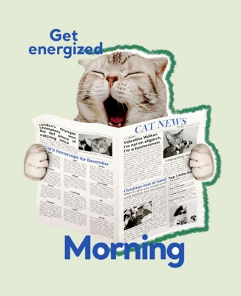
Prompt：Reference image provides the core animal subject, completely retain the original animal's appearance, facial features, fur texture and body characteristics from reference picture.
Flat collage graphic poster design, cute animal holding open newspaper with its own paws, the animal yawns lazily with eyes closed, the whole animal figure is wrapped with rough torn green jagged paper border, solid pale mint green plain background.
Newspaper printed with cat-themed news headlines and small illustration pictures, bold bright blue sans-serif text at top "Get energized", large bold blue sans-serif text at bottom "Morning".
Soft warm pastel color palette, clean minimalist ins aesthetic, paper cut texture, soft matte flat texture, centered composition, high clarity, commercial social media morning greeting poster, soft gentle atmosphere, no shadow, no complicated background clutter.
Negative prompt: deformed animal limbs, blurry animal face, messy background, 3d render, realistic photo, film grain, gradient background, extra text, watermark, ugly distorted newspaper, disfigured paws, dark gloomy tone, complicated decorations
3. ins 轻奢穿搭拟人宠物商场对镜写真模板
Ins Luxury Humanized Pet Mall Mirror Fashion Portrait Prompt
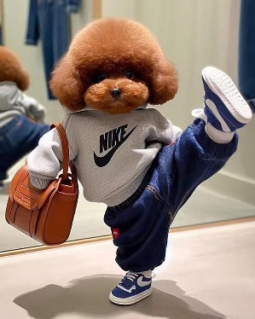
Prompt：Reference image provides the core animal subject, fully retain the animal's original facial features, fur texture and head shape from reference picture.
Realistic photo, anthropomorphic cute animal standing in clothing store fitting room, one leg raised high in cool pose, wearing gray Nike logo sweatshirt, dark blue loose jeans, blue and white Nike sneakers, holding a brown leather handbag in one arm.
Background with floor mirror reflecting the animal, light beige clean fitting room interior, soft warm indoor store lighting, natural realistic fur texture, sharp focus, street fashion aesthetic, medium full shot, vivid real-life photography, soft shadow on the floor, natural depth of field, high detail, daily fashion snapshot style.
Negative prompt: deformed limbs, blurry animal face, messy background, cartoon, illustration, 3D render, film grain, text, watermark, distorted clothes, mismatched shoes, ugly mirror reflection, over-saturated color, extra limbs
4. 麦当劳秋日主题宠物美食写真生成玩法
McDonald's Autumn Themed Pet Food Portrait Generation Template
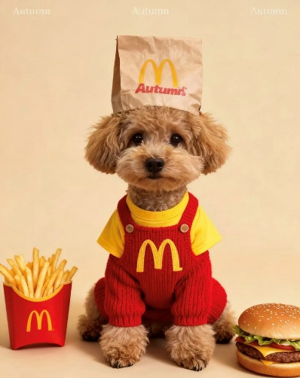
Prompt：Reference image provides the core animal subject, fully retain the animal's original facial features, fur texture and head shape from reference picture.
Warm soft studio portrait, cute animal sitting centered on solid cream beige background, wearing yellow inner shirt and red knitted overalls printed with yellow McDonald's golden arch logo, a McDonald's kraft paper food bag with golden arch logo placed on top of its head.
Left side of the animal: red paper fries box filled with french fries, right side: classic beef cheeseburger with sesame bun, three faint "Autumn" text words at the top of background, warm autumn tone, soft even studio lighting, realistic fluffy animal fur texture, medium shot, clean minimalist composition, commercial pet food photography, soft warm color grading, sharp focus on animal face, high detail, gentle cozy autumn atmosphere.
Negative prompt: deformed animal limbs, blurry animal face, messy background, extra food items, cartoon, illustration, 3D render, film grain, watermark, ugly distorted clothes, over saturated color, dark shadows, clutter, extra text
5. 工地施工风小动物搞怪大头卡通海报生成玩法
Construction Site Style Funny Close-Up Animal Cartoon Poster Template

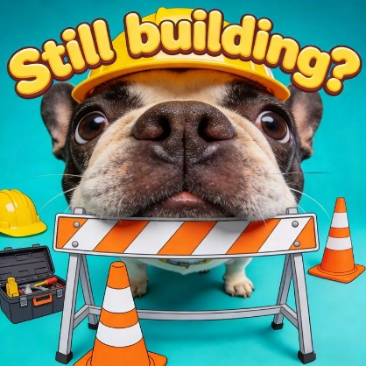
Prompt：Reference image provides the core animal subject, fully retain the animal's original facial features, fur texture and head shape from reference picture.
Vibrant cartoon commercial graphic poster, extreme close-up shot of cute animal wearing bright yellow construction hard hat, animal's face poking out behind orange-white striped road barrier.
Surrounding construction props: orange-white traffic cones, open black toolbox with hand tools, spare yellow safety helmet, solid bright turquoise flat background.
Large rounded bubble text at top: "Still building?", thick yellow font with dark brown outline, playful cartoon 2D mixed with realistic animal fur texture, saturated bright color palette, centered composition, fun meme aesthetic, sharp focus on animal face, clean flat background, high contrast, social media warning graphic style.
Negative prompt: deformed animal face, blurry fur, messy background, gradient background, film grain, realistic photo texture, 3d render, extra limbs, text watermark, dull muted colors, extra random objects, broken construction props
6. 户外晴空连帽衫墨镜小动物自拍生成玩法
Clear Sky Hoodie Sunglasses Animal Selfie Template
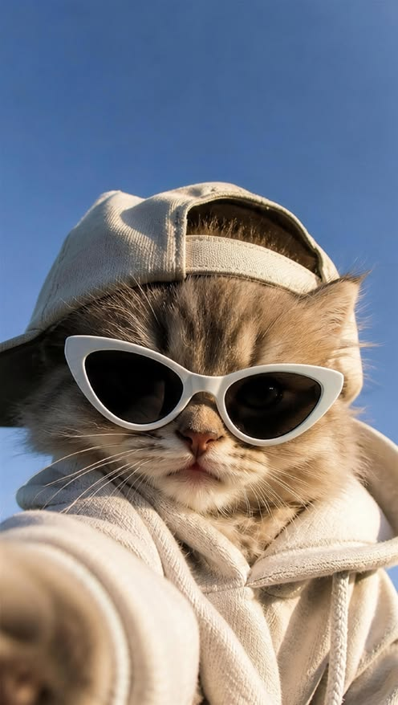
Prompt：Reference image provides the core animal subject, fully retain the animal's original facial features, fur texture and head shape from reference picture.
First-person selfie shot, fluffy animal wearing light beige baseball cap and matching drawstring hoodie, white cat-eye sunglasses on its face, one paw stretching forward to hold the camera for selfie.
Background is clear cloudless bright blue sky, natural warm outdoor sunlight, soft natural shadow on animal fur, realistic soft fluffy fur texture, close-up portrait, casual streetwear aesthetic, clean minimalist tone, bright fresh color grading, shallow depth of field, sharp focus on animal face, daily outdoor snapshot style, relaxed cool vibe.
Negative prompt: deformed animal limbs, blurry animal face, messy background, clouds clutter, cartoon, illustration, 3D render, film grain, text, watermark, distorted clothes, dark gloomy tone, extra random objects
7. 街头潮酷慵懒喝咖啡动物躺椅写真生成玩法
Street Cool Lazy Coffee Animal Lounge Chair Portrait Template
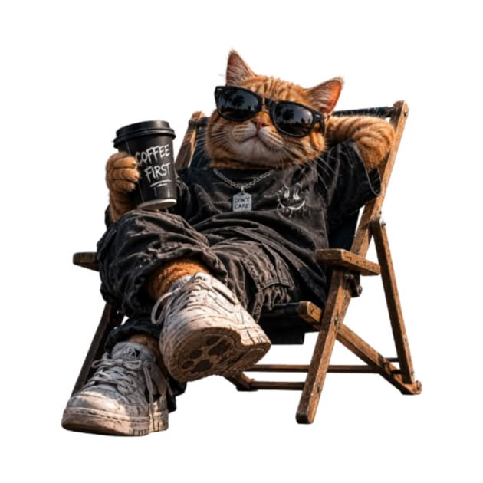
Prompt：Reference image provides the core animal subject, fully retain the animal's original facial features, fur texture and head shape from reference picture.
Realistic high detail photo, anthropomorphic animal reclining lazily on wooden folding beach chair, one leg crossed over the other, wearing black square sunglasses, faded black graphic streetwear t-shirt, dark loose cargo pants, worn white chunky sneakers, silver chain tag necklace.
One paw holds a black disposable coffee cup printed with text "COFFEE FIRST", the other paw rests behind its head, pure solid white transparent cutout background, soft natural studio lighting, realistic fluffy fur texture, full body medium shot, relaxed chill street fashion aesthetic, sharp focus, clean isolated background, high texture on clothing and shoes.
Negative prompt: deformed limbs, blurry animal face, messy background, gradient background, outdoor scenery, cartoon, illustration, 3D render, film grain, text watermark, extra random objects, dull dim lighting, disfigured paws, distorted sneakers
8. VOGUE 复古胶片动物时尚杂志封面生成玩法
Vogue Vintage Film Animal Fashion Magazine Cover Template
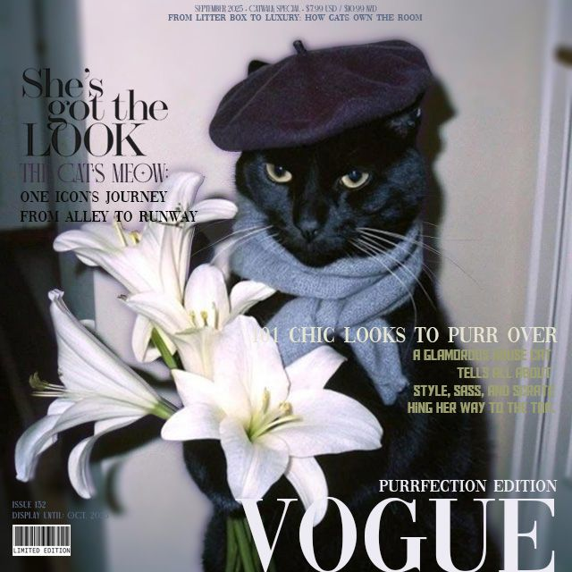
Prompt：Reference image provides the core animal subject, fully retain the animal's original facial features, fur texture and head shape from reference picture.
Vintage 35mm film fashion magazine cover, anthropomorphic elegant animal wearing dark purple beret and soft light gray knit scarf, holding a bouquet of fresh white lilies in front of its chest, soft dim indoor wall background, retro film grain texture, muted warm low saturation tone.
Layout with classic fashion magazine typography: large bold serif "VOGUE" text at bottom, multiple elegant serif headline texts scattered on left and right, barcode and limited edition label at bottom left, top small magazine issue text, text content themed pet fashion stories, centered medium shot portrait, soft side studio shadow, high fashion editorial aesthetic, soft focus film texture, sharp focus on animal's face, sophisticated chic atmosphere.
Negative prompt: deformed animal, blurry face, messy background, bright neon colors, cartoon, illustration, 3D render, plastic texture, extra messy flowers, distorted magazine text, overexposed lighting, extra limbs, ugly disfigured fur
9. 囚犯风猫咪入狱大头照趣味生成模板
Prisoner Style Cat Mugshot Funny Portrait Template

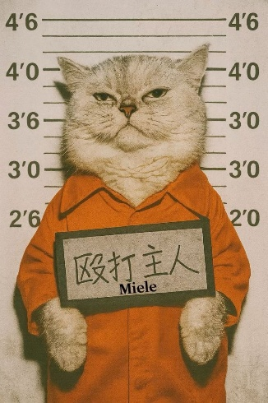
Prompt：Anthropomorphic chubby silver British Shorthair cat, classic police mugshot background with height measurement scale marked with feet and inches on both sides, cat wears bright orange prison uniform, holding a rectangular nameplate with Chinese characters "殴打主人" and the word "Miele" below, stern grumpy facial expression, vintage faded paper texture, retro muted sepia tone, frontal flash photography lighting, medium close-up shot, sharp focus on cat's face, old police booking photo aesthetic, grainy film texture, clean layout.
Negative prompt: deformed cat paws, messy background, extra height marks, distorted text, bright neon colors, cartoon illustration, 3D render, overexposed light, extra accessories
10. 蓝白火焰涂鸦风户外宠物街头抓拍模板
Blue White Flame Graffiti Outdoor Pet Street Snapshot Prompt
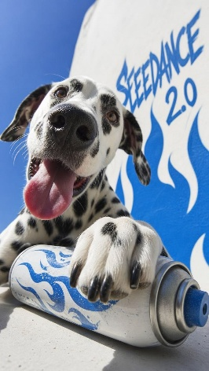
Prompt：Reference image provides the core animal subject, fully retain the animal's original facial features, fur texture and body characteristics from reference picture.
Low angle wide-angle street photography, cheerful spotted animal lying on concrete surface, one front paw resting on a white spray paint can printed with blue flame graffiti patterns, tongue sticking out happily.
Background: white wall painted with blue flame graffiti and bold blue text "SEEDANCE 2.0", clear bright cloudless blue sky, strong natural summer sunlight, distinct hard shadows, realistic soft fluffy animal fur texture, close-up foreground shot, vibrant fresh blue and white color palette, street art skate aesthetic, sharp focus on animal face, vivid real-life snapshot, high detail texture.
Negative prompt: deformed animal paws, blurry animal face, messy clutter background, dark gloomy tone, cartoon, illustration, 3D render, film grain, watermark, extra random objects, distorted graffiti text, over-saturated color, extra limbs
11. 巨型萌宠夏威夷海岸微缩城市创意合成玩法
Giant Cute Pet Hawaiian Miniature City Composite Template
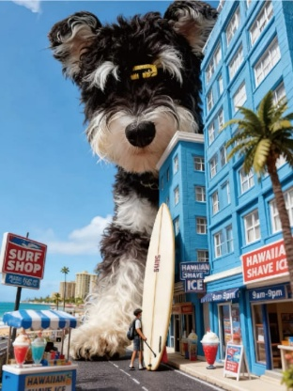
Prompt：Reference image provides the core animal subject, fully retain the animal's original facial features, fur texture and head shape from reference picture.
Realistic miniature diorama photography, giant fluffy anthropomorphic animal towering over tiny Hawaiian coastal town street, small scale human figure carrying surfboard walking on road, bright blue multi-story buildings, palm trees, "SURF SHOP" and "HAWAIIAN SHAVE ICE" store signs, colorful shaved ice stalls, ocean coastline and distant high-rise buildings in background, clear bright blue sky with soft white clouds, bright tropical daylight, forced perspective giant animal effect, highly detailed miniature textures, vibrant tropical blue and warm color palette, medium wide shot, sharp focus, realistic fluffy animal fur, warm vacation beach atmosphere, shallow depth of field.
Negative prompt: deformed animal limbs, blurry animal face, messy distorted miniature buildings, cartoon, illustration, 3D render plastic texture, film grain, watermark, extra random objects, dull dark tone, oversized tiny human, broken store signs
12. 搞怪购物拟人小动物文字表情包生成玩法
Funny Shopping Anthropomorphic Animal Meme Poster Template

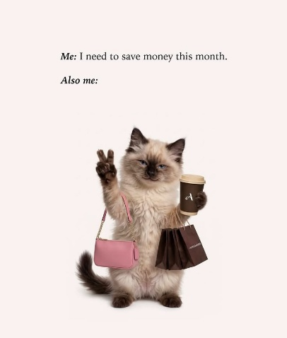
Prompt：Reference image provides the core animal subject, fully retain the animal's original facial features, fur texture and head shape from reference picture.
Minimalist clean meme poster, fluffy anthropomorphic animal standing upright on two hind legs on solid pale cream background, one front paw making peace sign, the same paw hanging a pink leather shoulder handbag, the other front paw holding brown paper shopping bags and a brown takeaway coffee cup printed with letter "A".
Two lines of simple black serif text placed at the top of frame: "Me: I need to save money this month. / Also me:", soft even studio lighting, realistic fluffy animal fur texture, centered medium full-body shot, soft neutral tone, clean minimalist commercial product photography, sharp focus on animal face, no extra clutter, gentle warm atmosphere.
Negative prompt: deformed animal limbs, blurry animal face, messy background, gradient background, cartoon, illustration, 3D render, film grain, watermark, extra random objects, dark gloomy tone, distorted shopping bags, disfigured paws, extra text
【节日/活动专属】
（新年）
- 巨型新年糖果罐举于头顶人像创意新年写真｜Giant New Year Candy Jar Held Over Head Creative Spring Festival Portrait
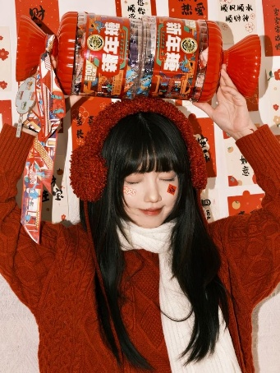
Prompt：Vertical Spring Festival studio portrait photograph, human figure fully matched with facial features, hair and appearance from uploaded reference image, both hands lift an oversized transparent red candy jar printed with Chinese "New Year Candy" packaging text above the top of head. Festive red couplet paper with Chinese blessing words as background wall, warm soft indoor fill lighting, unified red festive color palette, realistic daily portrait texture, core creative gimmick of giant candy prop contrast with human body, 8K ultra HD, delicate skin and fabric details, warm Chinese New Year atmosphere aesthetic. Automatically match all character appearance, hairstyle, clothing and accessories according to reference image without fixed outfit limits, strictly follow vertical framing layout.
- 晾晒绳新年玩偶对联甜妹跪坐氛围感写真｜Clothesline New Year Doll Couplets Sweet Girl Kneeling Atmosphere Portrait
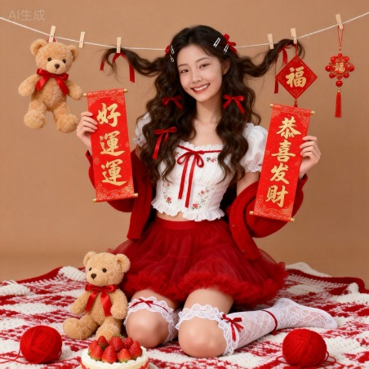
Prompt：Vertical square Chinese New Year studio portrait photograph, human figure’s facial features, hair texture and overall appearance fully referenced and matched from the uploaded reference image. The character kneels on red-and-white knitted blanket, holding two red scroll couplets with golden Chinese lucky text; decorative clothesline strung above with clothespins, hanging plush teddy bear, red fu square paper ornament and Chinese knot pendant. Foreground props include strawberry cake, red yarn balls and another teddy bear, solid warm beige plain background, soft warm studio fill lighting, sweet gentle portrait tone, festive red holiday color palette, realistic daily portrait texture, core creative gimmick of clothesline hanging New Year decorative props, 8K ultra HD, delicate skin and fabric details, cozy cute Spring Festival aesthetic. Automatically match all character facial features, hairstyle and appearance according to reference image without fixed clothing restrictions, strictly follow square framing layout.
- 双手比心框住人像福字新年俯拍写真｜Heart Hand Frame Portrait Fu Character New Year Overhead Shot
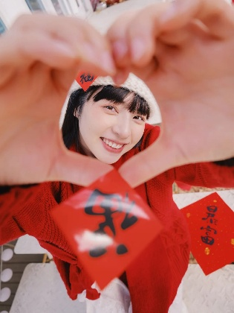
Prompt：Vertical overhead high-angle Spring Festival portrait photograph, all facial features, hairstyle and facial details of the human figure fully matched from uploaded reference image. The character uses two hands to form a heart frame in front of the camera, looking through the hollow heart shape, red "Fu" character paper pasted on forehead and held in front of lens, scattered red lucky paper with Chinese calligraphy in background, warm soft natural indoor lighting, unified red festive tone, sweet smiling expression, realistic daily portrait texture, core creative gimmick of heart-shaped hand frame shot, 8K ultra HD, delicate skin and knit fabric texture, cozy warm Chinese New Year atmosphere. Automatically match the whole appearance of the character according to reference image without fixed outfit limits, strictly follow vertical overhead framing layout.
（圣诞节）
- 双圣诞树礼盒围坐圣诞红底人像海报｜Double Christmas Tree Gift Box Surrounded Portrait Xmas Poster
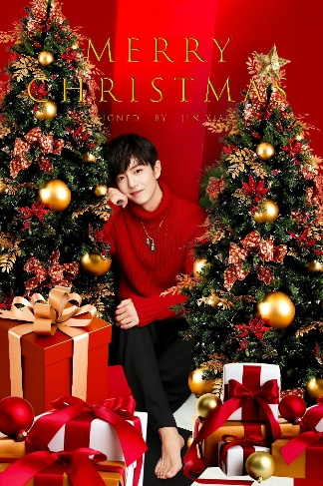
Prompt：Vertical Christmas studio poster photograph, all facial features, hairstyle and facial features of the human figure fully matched from uploaded reference image. The character sits between two decorated Christmas trees hung with golden baubles and red ribbon bows, piles of red, white and gold gift boxes with satin ribbons spread on the ground, solid bright red background, golden elegant text "MERRY CHRISTMAS" printed at the top center, soft warm studio fill lighting, unified red and gold festive color palette, realistic portrait texture, core creative gimmick of dual Christmas tree frame with gift decorations, 8K ultra HD, delicate fabric and ornament details, luxurious warm Christmas holiday aesthetic. Automatically match the whole appearance of the character according to reference image without fixed outfit limits, strictly follow vertical poster framing layout.
- 英伦格纹学院风复古书房圣诞树圣诞海报｜British Plaid Academy Retro Study Christmas Tree Poster
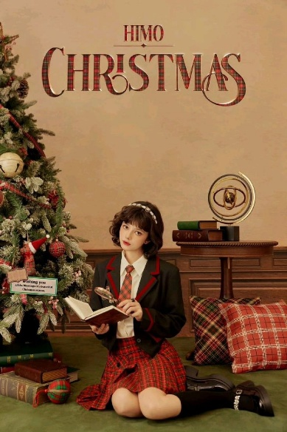
Prompt：Vertical vintage warm tone Christmas studio poster photograph, all facial features, short curly hairstyle and facial details of the character fully matched from uploaded reference image. The character kneels on green velvet carpet inside retro wood wainscoting study room, holding an open vintage book and small magnifying glass; frosted Christmas pine tree with plaid ornaments stands on left, wooden side table stacked with old hardcover books and vintage metal armillary sphere on right, plaid throw pillows placed beside character. Large plaid texture "CHRISTMAS" headline text with small "HIMO" lettering on top beige wall, soft warm indoor fill lighting, unified red-brown plaid holiday color system, gentle retro portrait texture, core creative gimmick of British academy study Christmas scene layout, 8K ultra HD, delicate fabric, wood and pine texture details, quiet literary warm Christmas atmosphere aesthetic. Automatically match the whole appearance of the character according to reference image without fixed outfit restrictions, strictly follow vertical poster framing layout.
- 复古壁炉圣诞老人玩偶雪松围坐男生圣诞写真｜Vintage Fireplace Santa Doll Snowy Cedar Surrounded Male Christmas Portrait
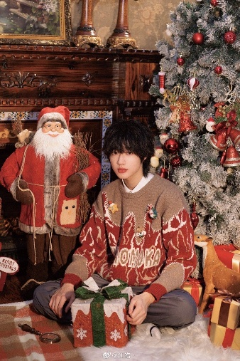
Prompt：Vertical warm retro Christmas indoor portrait photograph, all facial features, fluffy short dark hair and facial details of the human figure fully matched from uploaded reference image. The character sits cross-legged on white fluffy fur mat covered with plaid blanket, hands resting on snowflake gift box tied with green ribbon; retro carved wood fireplace with floral tile trim on left, plush Santa Claus doll stands beside fireplace, flocked snow cedar Christmas tree decorated with red baubles and bells on right, stacked wrapped gift boxes and plush deer ornament around character, vintage oil painting and golden candlestick ornaments on mantel, soft warm ambient indoor lighting, muted vintage warm tone palette, cozy retro holiday texture, core creative gimmick of fireplace + Santa doll + snowy cedar full festive scene layout, 8K ultra HD, delicate knit fabric, wood and pine texture details, warm quiet vintage Christmas atmosphere aesthetic. Automatically match the whole appearance of the character according to reference image without fixed outfit restrictions, strictly follow vertical framing layout.
（万圣节）
- 满月万圣剪影黑蝴蝶结甜妹肖像｜Full Moon Halloween Silhouette Black Bow Sweet Girl Portrait
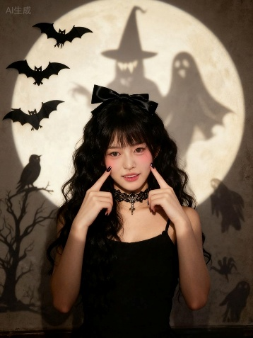
Prompt：Vertical Halloween studio portrait photograph, all facial features, long wavy black hair and facial details of the human figure fully matched from uploaded reference image. The character wears a big black satin bow on head, black lace choker with cross pendant, simple black camisole, fingers gently touching cheeks. Background features a huge soft circular full moon projection wall, covered with black silhouette cutouts: bats, bare dead tree with crow, witch shadow, ghost and dark monster silhouettes, warm dim soft studio lighting, muted vintage sepia tone, cute dark gothic style, core creative gimmick of full moon Halloween silhouette background layout, 8K ultra HD, delicate hair and lace texture details, lovely spooky Halloween atmosphere aesthetic. Automatically match the whole appearance of the character according to reference image without fixed outfit restrictions, strictly follow vertical framing layout.
- 俯拍南瓜血腥妆容甜酷万圣蹲姿肖像｜Overhead Jack-o'-lantern Bloody Makeup Cool Halloween Squat Portrait
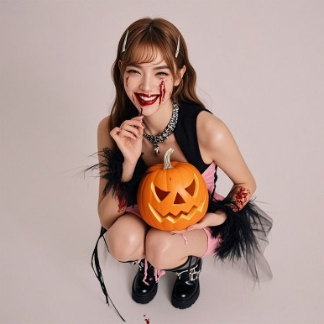
Prompt：Square overhead high-angle Halloween studio portrait photograph, all facial features, light brown medium hair and facial details of the human figure fully matched from uploaded reference image. The character squats down, holding a carved glowing jack-o'-lantern pumpkin on knees, bloody slash makeup on cheeks, dripping red lip makeup, silver hair clips on bangs, thick silver chain necklace, fluffy black feather tulle decoration on sleeves, blood stain texture on arms, black platform buckle boots, plain light beige seamless background, soft even studio fill lighting, sweet and dark punk Halloween style, core creative gimmick of overhead shot with jack-o'-lantern prop and bloody horror makeup, 8K ultra HD, delicate skin and feather texture details, cute spooky holiday atmosphere aesthetic. Automatically match the whole appearance of the character according to reference image without fixed outfit restrictions, strictly follow square overhead framing layout.
3. 双手托巨型南瓜血腥妆黑蝴蝶结万圣肖像｜Hands Hold Giant Jack-o'-lantern Bloody Makeup Black Bow Halloween Portrait
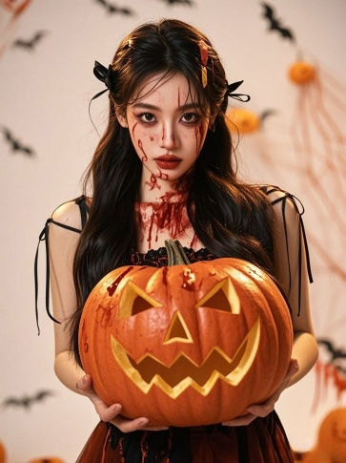
Prompt：Vertical Halloween close-up studio portrait photograph, all facial features, long wavy black hair and facial details of the human figure fully matched from uploaded reference image. The character holds a huge carved glowing jack-o'-lantern pumpkin with both hands in front of chest, dripping bloody slash makeup on face and neck, small black ribbon bows tied on both sides of hair, thin black tie-strap camisole top. Background decorated with scattered black bat silhouettes, orange pumpkins and sheer cobweb decorations, soft warm gentle studio fill lighting, sweet dark gothic horror Halloween tone, core creative gimmick of giant jack-o'-lantern prop with bloody wound makeup, 8K ultra HD, delicate hair and pumpkin texture details, lovely eerie holiday atmosphere aesthetic. Automatically match the whole appearance of the character according to reference image without fixed outfit restrictions, strictly follow vertical framing layout.

