28-29 May 2027

Last date of paper submission and other dates to be modified accordingly

Fees Increased by 25% overall

International Conference on Intelligent, Connected and Sustainable Computing (ICICSC-2027)

Refine the below tracks such that we have any 7 tracks with 10 subtopics each
## Track 1: Artificial Intelligence & Machine Learning
1. Deep Learning Architectures and Applications
2. Generative AI and Large Language Models
3. Reinforcement Learning and Decision Systems
4. Natural Language Processing and Understanding
5. Explainable and Trustworthy AI
6. Federated and Distributed Learning
7. AI for Healthcare Diagnostics
8. Neural Network Optimization Techniques
9. Transfer Learning and Few-Shot Learning
10. AI-Driven Predictive Maintenance
11. Multi-Agent and Agentic AI Systems
12. Knowledge Graphs and Semantic Reasoning
13. AI Ethics, Bias and Governance
14. Edge AI and TinyML
15. Hybrid AI-Symbolic Reasoning Systems

## Track 2: Internet of Things & Cyber-Physical Systems
1. IoT Architectures and Protocols
2. Industrial IoT (IIoT) for Smart Manufacturing
3. Smart Cities and Urban Infrastructure
4. Wearable and Ubiquitous Computing
5. IoT Security and Device Authentication
6. Edge and Fog Computing for IoT
7. Digital Twins for Cyber-Physical Systems
8. Precision Agriculture using IoT
9. Smart Healthcare and Remote Patient Monitoring
10. Energy-Efficient IoT Networks
11. Vehicular IoT and Connected Mobility
12. IoT Data Interoperability and Standards
13. Low-Power Wide-Area Networks (LPWAN)
14. IoT-Based Environmental Monitoring
15. Middleware and Platforms for IoT Systems

## Track 3: Robotics & Intelligent Automation
1. Autonomous Mobile Robots
2. Human-Robot Interaction and Collaboration
3. Swarm Robotics and Multi-Robot Systems
4. Robotic Process Automation (RPA)
5. Robot Perception and SLAM
6. Industrial Robotics and Industry 5.0
7. Medical and Surgical Robotics
8. Robotic Manipulation and Grasping
9. Bio-Inspired and Soft Robotics
10. Unmanned Aerial Vehicles (UAV) Systems
11. Autonomous Underwater Vehicles
12. Motion Planning and Control Systems
13. Robotics in Agriculture and Logistics
14. Reinforcement Learning for Robotic Control
15. Ethical and Safety Frameworks in Autonomous Robots

## Track 4: Data Analytics & Big Data
1. Big Data Architectures and Frameworks
2. Predictive and Prescriptive Analytics
3. Real-Time Stream Data Processing
4. Data Mining and Pattern Discovery
5. Business Intelligence and Decision Support
6. Graph-Based Data Analytics
7. Time-Series Analysis and Forecasting
8. Data Warehousing and ETL Pipelines
9. Social Media and Sentiment Analytics
10. Recommender Systems
11. Data Visualization Techniques
12. Data Quality and Governance
13. Scalable Distributed Data Processing (Hadoop/Spark)
14. Data-Driven Decision Making in Enterprises
15. Analytics for Sustainability and ESG Reporting

## Track 5: Blockchain & Distributed Ledger Technologies
1. Blockchain Architectures and Consensus Mechanisms
2. Smart Contracts and Decentralized Applications
3. Blockchain for Supply Chain Management
4. Cryptocurrency and Digital Asset Systems
5. Decentralized Finance (DeFi)
6. Blockchain Interoperability and Cross-Chain Protocols
7. Blockchain Scalability and Layer-2 Solutions
8. Blockchain for Healthcare Record Management
9. Non-Fungible Tokens (NFTs) and Digital Ownership
10. Blockchain-Based Identity Management
11. Blockchain for IoT Security
12. Permissioned vs Permissionless Blockchain Systems
13. Blockchain Governance and Regulatory Frameworks
14. Energy-Efficient and Green Blockchain Systems
15. Blockchain Integration with AI and Machine Learning

## Track 6: Cybersecurity & Privacy
1. Network Security and Intrusion Detection
2. Malware Analysis and Threat Intelligence
3. Cryptography and Post-Quantum Security
4. Zero Trust Architecture
5. Digital Forensics and Incident Response
6. Privacy-Preserving Computation
7. Cloud and Virtualization Security
8. Cybersecurity for Critical Infrastructure
9. Ethical Hacking and Penetration Testing
10. Security in Wireless and Mobile Networks
11. AI-Driven Cyber Threat Detection
12. Identity and Access Management
13. Ransomware Detection and Mitigation
14. Security Policy, Compliance and Risk Management
15. Blockchain-Based Cybersecurity Solutions

## Track 7: Image Processing & Computer Vision
1. Object Detection and Recognition
2. Medical Image Analysis and Diagnostics
3. Facial Recognition and Biometric Systems
4. Image Segmentation Techniques
5. Video Analytics and Surveillance Systems
6. 3D Reconstruction and Depth Estimation
7. Generative Adversarial Networks for Image Synthesis
8. Remote Sensing and Satellite Image Processing
9. Optical Character Recognition (OCR)
10. Image Enhancement and Restoration
11. Vision-Based Autonomous Navigation
12. Multi-Modal Vision-Language Models
13. Image Compression Techniques
14. Anomaly Detection in Visual Data
15. Augmented and Virtual Reality Vision Systems

## Track 8: Cloud Computing & Distributed Systems
1. Cloud Service Models and Architectures
2. Serverless and Function-as-a-Service Computing
3. Cloud Resource Management and Scheduling
4. Multi-Cloud and Hybrid Cloud Strategies
5. Container Orchestration and Microservices
6. Cloud Security and Compliance
7. Cloud-Native Application Development
8. Distributed Consensus and Fault Tolerance
9. Cloud Cost Optimization and Green Computing
10. Edge-Cloud Continuum Architectures
11. Cloud-Based DevOps and CI/CD Pipelines
12. Virtualization Technologies
13. Cloud Data Storage and Replication Strategies
14. Load Balancing in Distributed Systems
15. Cloud Computing for AI/ML Workloads

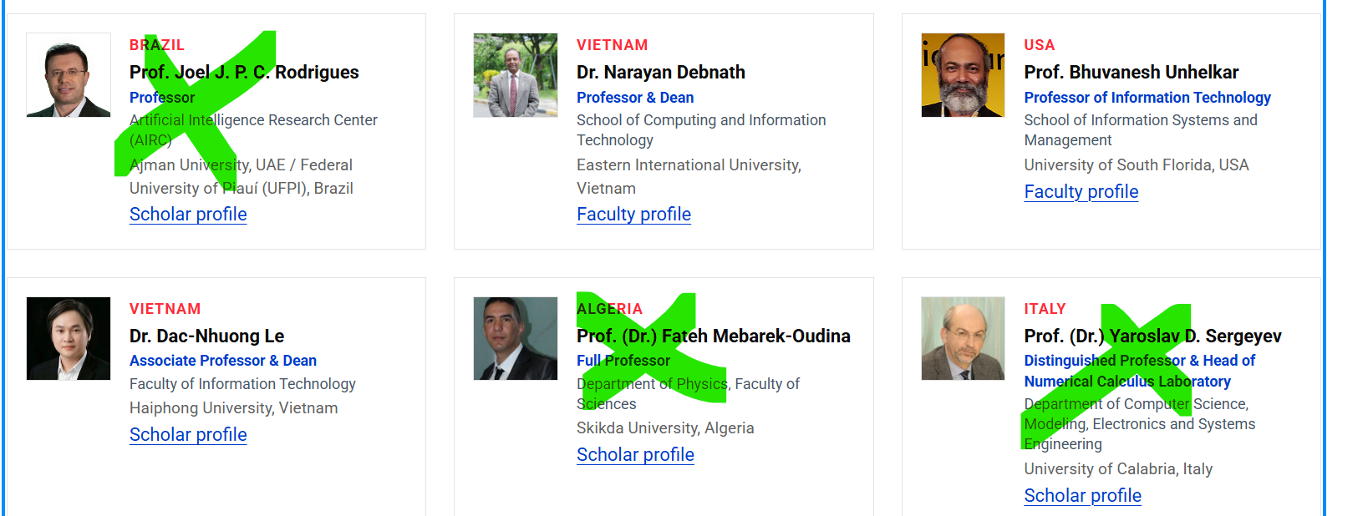

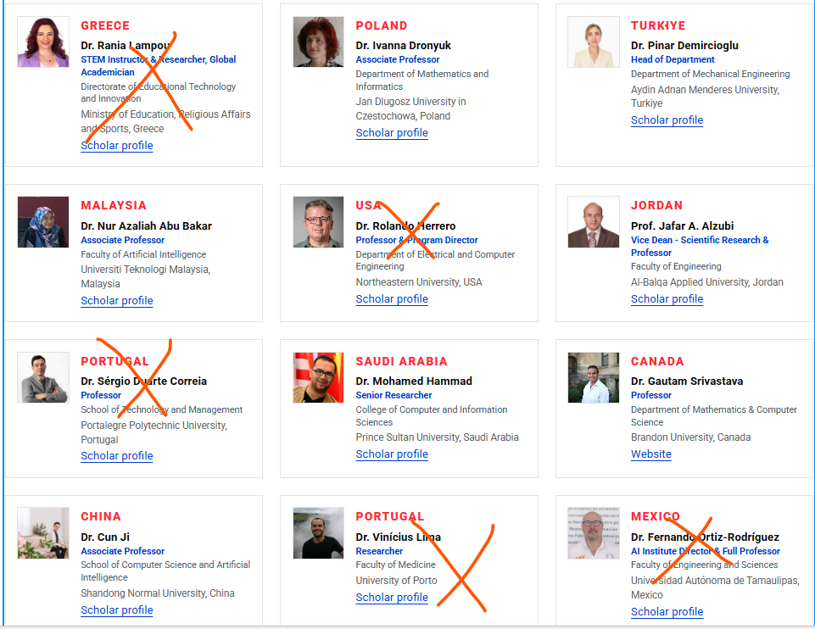
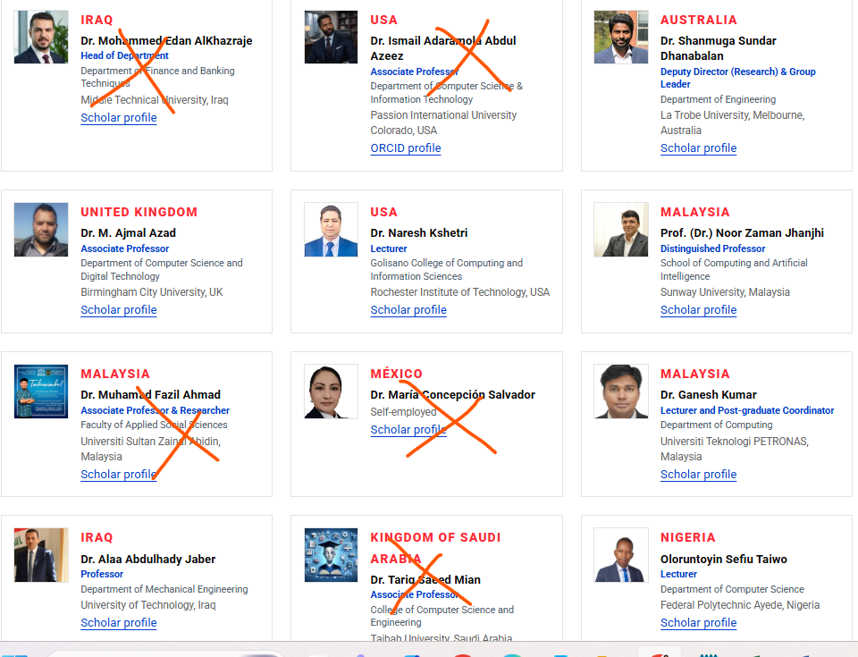

In national only keep these people
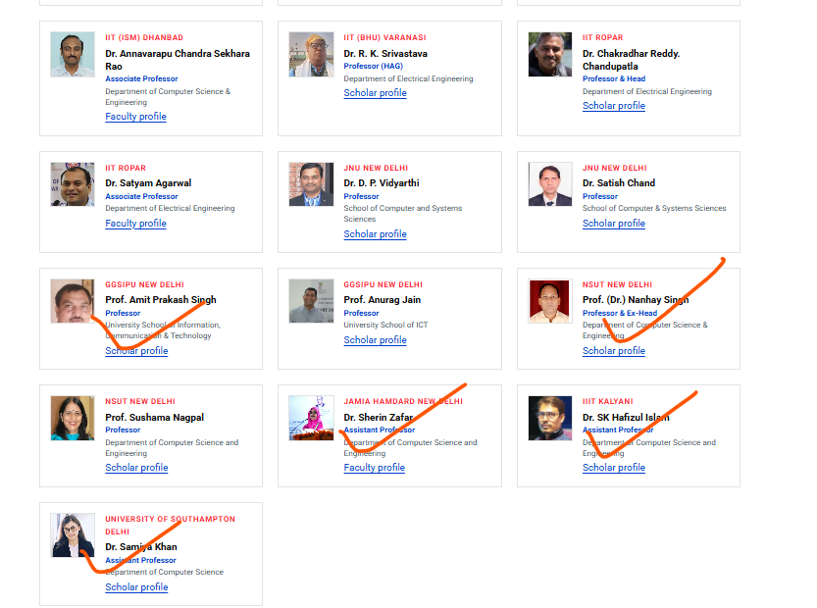

Add the below TPC in national/international committee

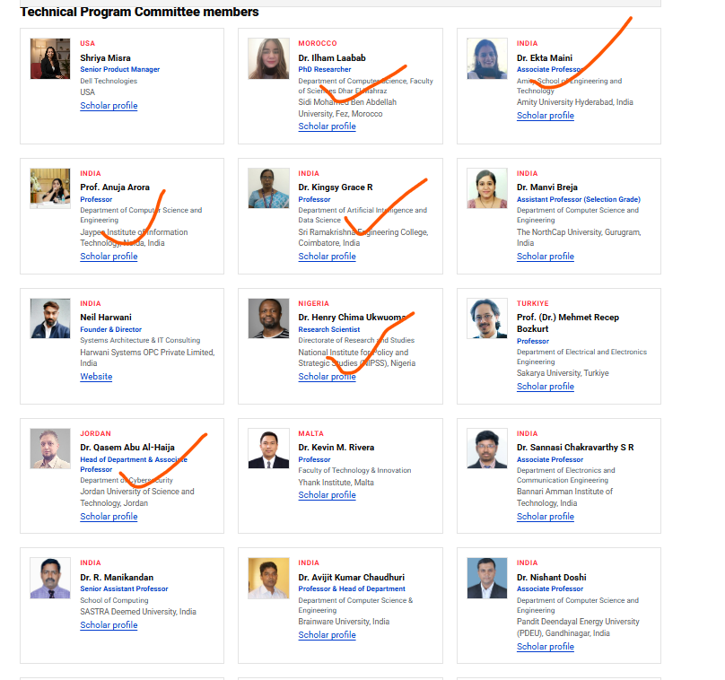

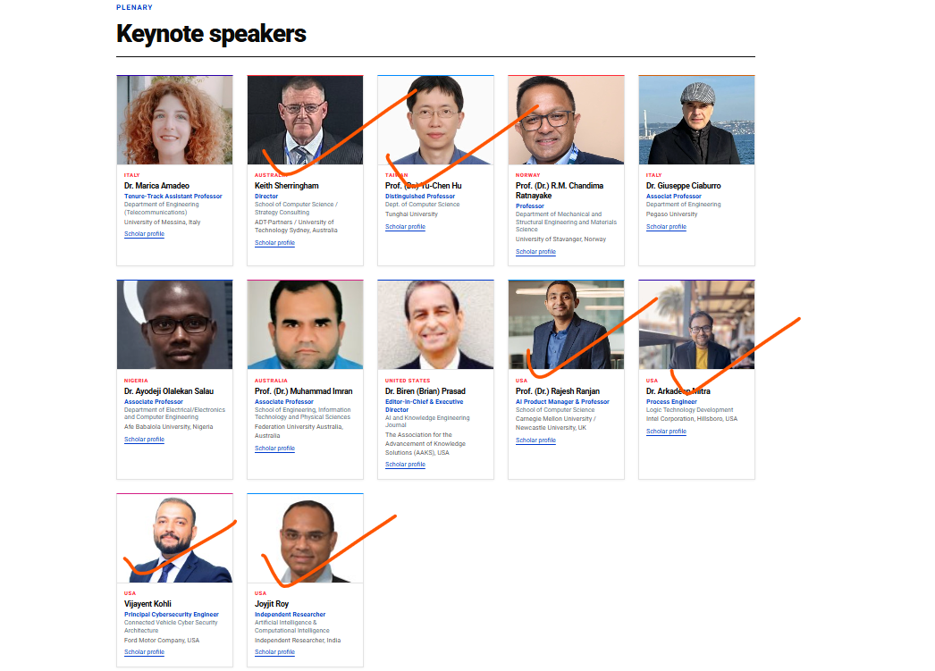

Add these people in international advisory committee

https://scholar.google.com/citations?user=cmLFeRkAAAAJ&hl=en
https://scholar.google.com/citations?user=znmrVSoAAAAJ&hl=en

Meriem MANDAR
Department of Mathematics and Computer Science, Superior Normal School
HASSAN II University, Casablanca, MOROCCO
m.mandar@enscasa.ma
https://orcid.org/0000-0002-6734-0830
+212 6 70 80 99 25

https://www.salford.ac.uk/our-staff/surbhi-khan

Dr. Hari Mohan Rai
Designation & Organization: Assistant Professor, School of Computing and Artificial Intelligence (SCAI), Astana, Kazakhstan

https://scholar.google.com/citations?user=GBkDDr0AAAAJ&hl=en

https://scholar.google.com/citations?user=TCrqBsAAAAAJ&hl=en

https://scholar.google.com/citations?user=NN-PHcIAAAAJ&hl=en

https://scholar.google.com/citations?user=4fEs7-UAAAAJ&hl=ar

https://scholar.google.com/citations?user=9KXgKl8AAAAJ&hl=en

About the Conference
The International Conference on Intelligent, Connected and Sustainable Computing (ICICSC) brings together researchers, academicians, and industry practitioners to explore the technologies shaping the next era of computing. As artificial intelligence, connected systems, and sustainable digital infrastructure increasingly converge, the conference provides a focused platform to examine how these advances are transforming industries, governance, and everyday life.
Spanning eight core tracks — Artificial Intelligence & Machine Learning, Internet of Things & Cyber-Physical Systems, Robotics & Intelligent Automation, Data Analytics & Big Data, Blockchain & Distributed Ledger Technologies, Cybersecurity & Privacy, Image Processing & Computer Vision, and Cloud Computing & Distributed Systems — ICICSC offers a comprehensive view of both foundational research and emerging applications in computer science and engineering. The conference welcomes original, unpublished research that pushes the boundaries of intelligent systems, secure and connected infrastructure, and sustainable computing practices.
To maintain the highest scholarly standards, all submissions undergo a rigorous double-blind peer review process, with an acceptance rate maintained under 7%. The organizing committee has also built in deliberate diversity safeguards — capping contributions from any single institute or author, and ensuring strong international representation — so the final proceedings reflect a genuinely global cross-section of research rather than a concentration from any one region or institution.
ICICSC is hosted at Sharda University, Greater Noida, India — a globally connected campus with 43% female students, 1,300+ distinguished faculty, 300+ international academic collaborations, 200+ patents awarded, a 1,800+ bed super-speciality teaching hospital, and a 30,000+ alumni network spanning the world. The conference is supported by an international Advisory Committee spanning 10+ countries and a National Advisory Committee drawing heavily from India's premier IITs, ensuring both global perspective and deep technical rigor in the review process.
Accepted papers will be published as part of a peer-reviewed proceedings volume, offering authors visibility through established academic indexing channels and connecting their work to a wider international research community.

