**ISCG7436 Advanced Mobile Programming Assignment 3**

**DiscountNZ**

**Team Name**: Insight

**Team members**:

Youfa Wang (wyf_1212@163.com) 1485428

Yixin, Zhang (hxy820718@163.com)    1483998

### Projcet Idea

* Team name and application name.

The name of our team is "Insight" and this application is called "DiscountNZ".

* The background to the application:
  + The aim of the application

The main aim of this application is to help the user to find the discount information easily and quickly.

At present, there is no similar applications, most of us know these discount information by receiving lots of junk mails or advertisement sheets and we have to filter these information all by ourselves, it's quite inefficient. So this application is supposed to give the consumers a much better experience of shopping.

* + Source

As there is no such application, this assignment does not extend existing application.

Similar application that works in New Zealand on iOS or android platform cannot be found so far, which means that we don't have any existing application to refer to.

* The target audience.

The target audience of our application is those who care about the price, who need to buy groceries, who need to fuel the tank, who want to eat fast food. Everyone will be benefit from the application.

* The proposed **total** cost of application.

|  |  |  |  |
| --- | --- | --- | --- |
| Process | Time used (hours) | Cost per hour | Cost |
| **Preparing** | 5 | $ 30.00 | $ 150.00 |
| **Analysing** | 5 | $ 30.00 | $ 150.00 |
| **Designing** | 10 | $ 30.00 | $ 300.00 |
| **Coding** | 30 | $ 30.00 | $ 900.00 |
| **Testing** | 15 | $ 30.00 | $ 450.00 |
| **Collecting Information** | 10 | $ 30.00 | $ 300.00 |
| **Total** | | | $ 2250.00 |

Table 1 cost of application

* The development time needed to build an initial version.

As Table 1 shows, the process of development include the following steps:

* Preparing for idea 5 hrs
* Analysing idea 5 hrs
* Designing 10 hrs
* Coding 30 hrs
* Testing 15 hrs
* Collecting information 10 hrs

So, total hours for building an initial version would be 75 hrs.

### Design and architecture

* Design for the implementation of a prototype.

Storyboard of your app.

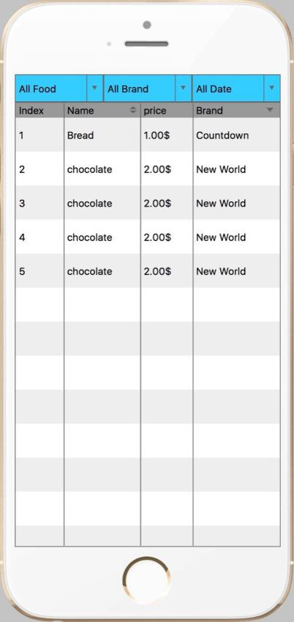 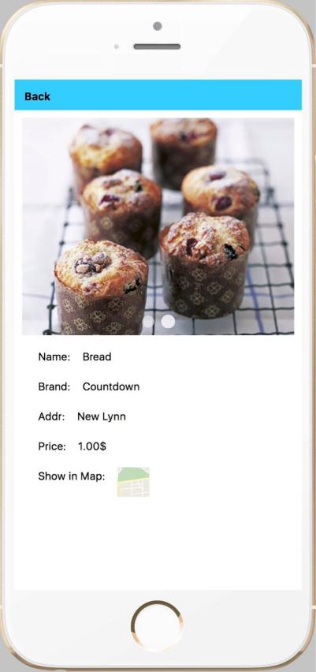 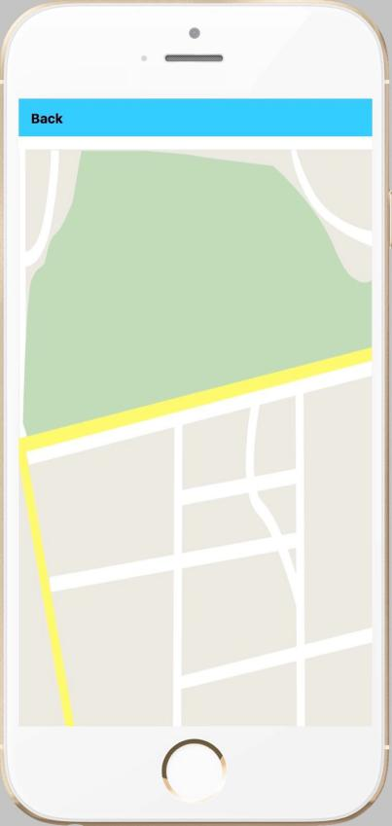

Main page Details page Map page

* + Overall architecture design. Draw diagram. Take photo and submit an electronic copy.

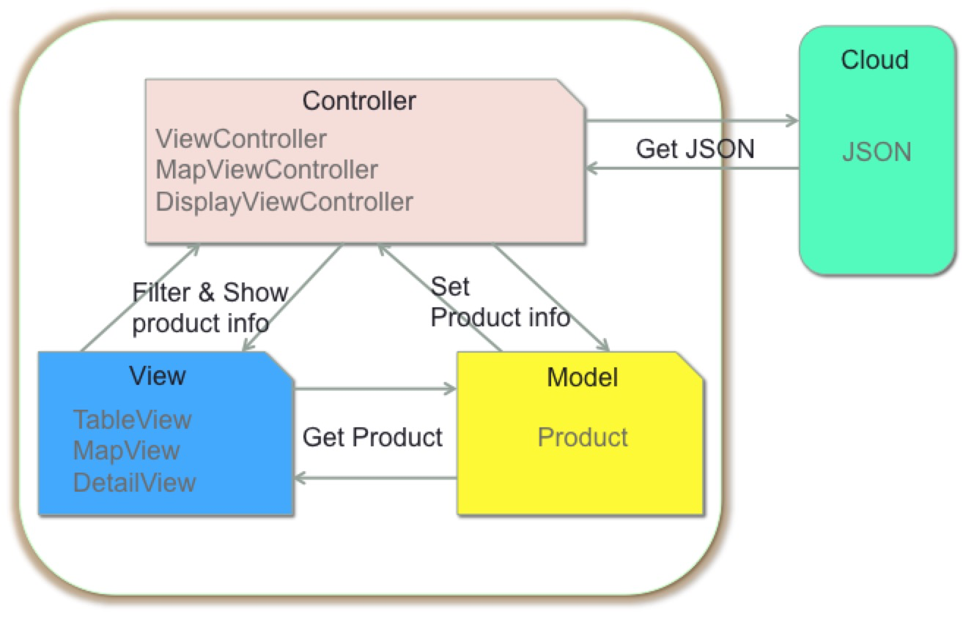

* + Technologies to be used.

We use online json file as the source data, and create URLSessionDataTask to parse it.

We use present() method to pass the product object from ViewController to the DisplayViewController.

We use URLSession and establish dataTask to show online images.

We use apis of MapKit to show the location of the sellers.

* + Supported iOS versions

iOS 10.3 and higher

* + Supported platforms

Both iPhone and iPad

* A work plan
  + Oct 15th - 18th Youfa will implement the product list page

Oct 20th - 28th Yixin will implement the product detail page and the map page

* + No one need skill upgrade to get the job done
  + The way for our team reaching agreement

Discuss face to face, or through the Email, the app of WeChat.

* + Negotiation and collaborations.

Negotiation: at first, Yixin suggest we should use the coredata to store the discount information, however, Youfa maintain that using json we can get the online data, it can be updated easily, this is more flexible and more useful for a real application. So finally we choose to use json as our source data.

Collaborations: we use github, url: <https://github.com/super1212/IOS_DiscountNZ.git> to manage our code. Youfa commit on the master and Yixin commit on the addDisplay branch. We would pull the code from the other’s branch when it is necessary. For example, after youfa commit the method to pass the product info from ViewController to DisplayViewController, Yixin would pull from the master and go on coding based on product info.

* A risk assessment plan – an outline of the key technical, business, or implementation risks and how these risks are to be mitigated during the course of development.

Technology risk: Json and URLSessionDataTask are technologies we have not used before,So there iss a risk of we can’t make it work successfully.

Time risk: As Youfa and I both have other assignment to do at the same time, we are not sure if we can complete this before the due date.

### Team reflection

From Chunkai Meng

Question1: Do you like the idea?

very good

Question2:Is this application easy to use?

no

Question3:Do you think it will help you to save money?

No, because I never buy things because they have disdount.

Question4:What kind of discount product do you need?

Bread, redWine, tickets.

Question5:Do you need to filter products from the range of map?

Yes, but the label of “brand” should change to “seller”

“brand” make me confused.

And the filter bar should be put at the bottom of the table.

From Tianjun Ding

Question1: Do you like the idea?

good

Question2:Is this application easy to use?

very easy

Question3:Do you think it will help you to save money?

No, actually , many of them are not necessary, I don’t have to spend the money on them.

Question4:What kind of discount product do you need?

Clothes, shoes.

Question5:Do you need to filter products from the range of map?

Yes