**github:vincent0628**

**------------------------------------------------------------------------------------------------------------------------**

[ initial ]

**ssh nvidia@tx2-24.local**

**vncviewer -quality 10 -encodings "tight" tx2-24.local:5901**

**------------------------------------------------------------------------------------------------------------------------**

[ Git tutorial ]

1. **基本指令**

$ apt-get install git //在local 安裝git

$ ls -la // -l 參數為列出詳細資料，-a 為列出隱藏資料夾 (可忽略)

$ git status // 查看狀態 (可忽略)

$ git diff // 比較現在檔案和上次 commit 之間的差異，也就是說你做了哪些修改

讓 Git 知道這台電腦做的修改要連結到哪一個使用者 :

$ git config --global user.name "<Your Name>"

$ git config --global user.email "<your@gmail.com>"

1. **How to push?->到要上傳的資料外面[cd..[目標自料外]]**

$ git init

$ git add [目標物]

$ git commit -m " [say something]"

$ git commit -a -m "修改了 ????"

// 上兩行可以簡化成這行-a 是 add，-m 為 message 簡寫，後面接訊息資訊）

$ git remote add origin [remote 網址] // 本地端專案知道 origin 對應到遠端網址

$ git push -u origin master

**-----------------------------------------------------------------------------------------------------------------------------------**

[ docker build ]

**可以的 docker build -t="labmini" --no-cache -f=Dockerfile .**

docker build -t sis_competition -f Dockerfile .

**docker run -it --rm --name** sis_competition **--net host -e DISPLAY=$DISPLAY -v /tmp/.X11-unix/:/tmp/.X11-unix --privileged -v /dev/bus/usb:/dev/bus/usb** sis_competition **bash**

rosp[ docker tear ]

**https://stackoverflow.com/questions/22049212/copying-files-from-docker-container-to-host/26150548**

**------------------------------------------------------------------------------------------------------------------------**

[ docker run ]

* **有BASH 會進去container, 可以改 但出來會全部消失**

**tx2 $ docker run -it [--rm] --name [name] --net host --privileged -v /dev/bus/usb:/dev/bus/usb [dockerhub account]/sis_competition:[task_name] bash**

* **沒BASH 直接roslaunch**

**tx2 $ docker run -it [--rm] --name [name] --net host --privileged -v /dev/bus/usb:/dev/bus/usb [dockerhub account]/sis_competition:[task_name]**

**有時候.py檔不能rosrun soluntion:變執行檔**

**chmod +x object_detection.py**

**------------------------------------------------------------------------------------------------------------------------**

**1/13問題**

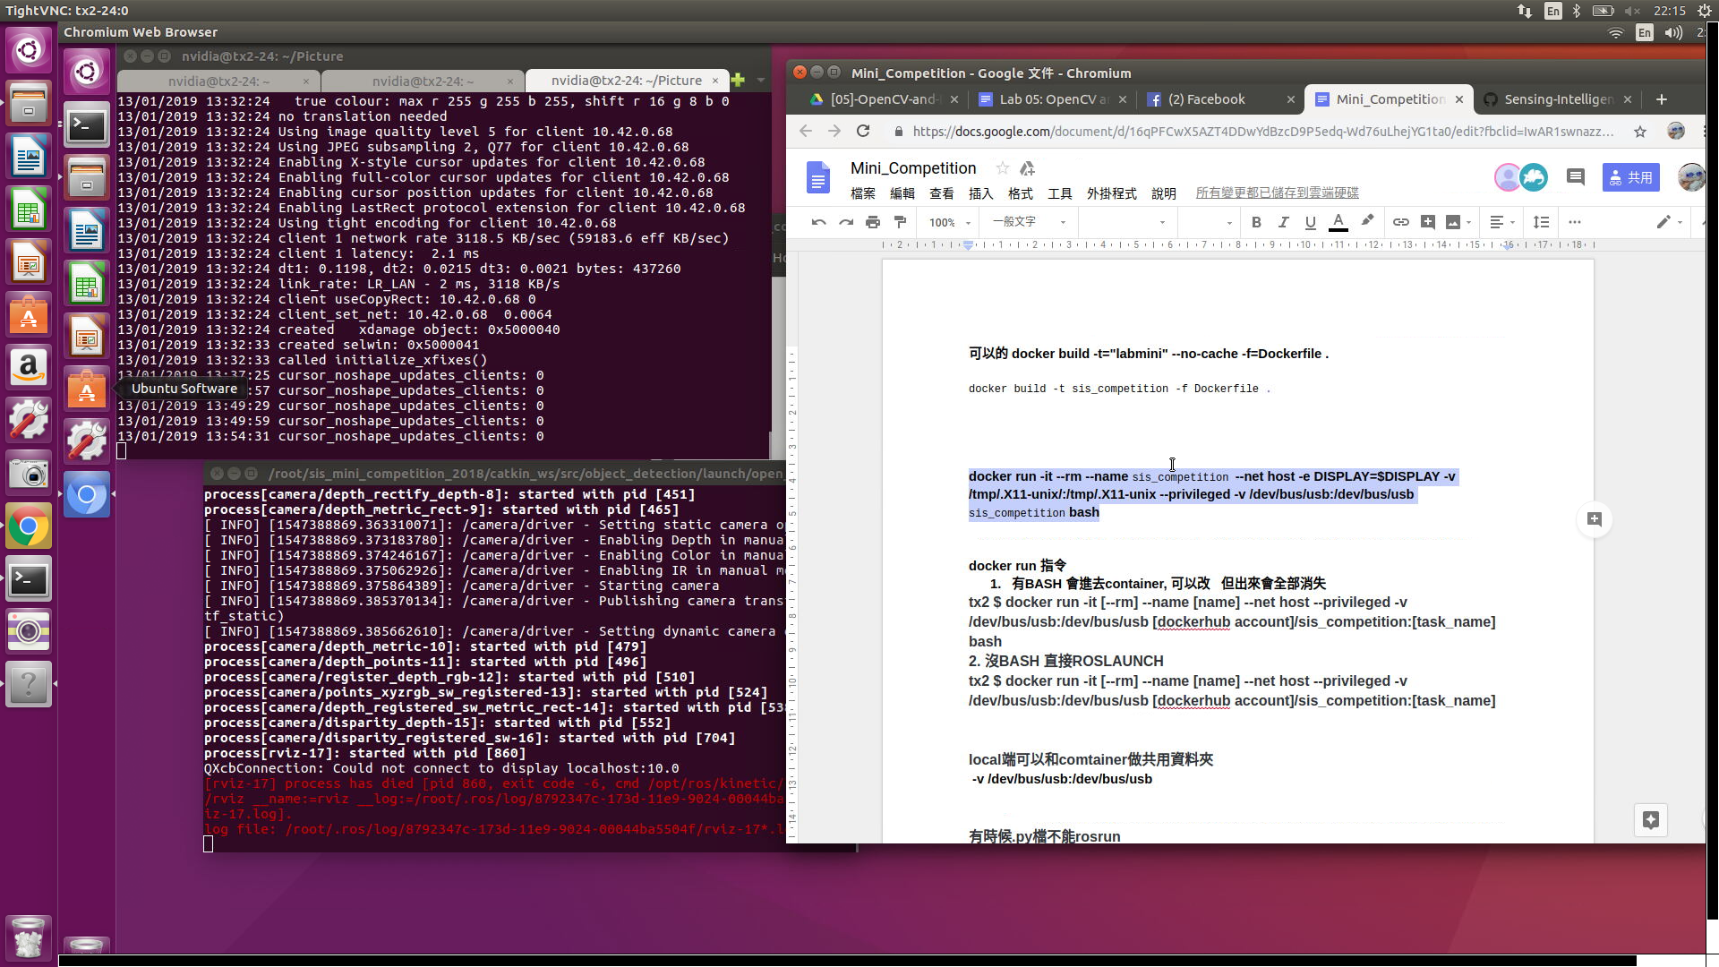

**用lab5的方法可以build docker 和run**

**但是**

**用助教的source方法不能開rviz**

**lab5**

**docker run -it --rm --name lab5 --net host -e DISPLAY=$DISPLAY -v /tmp/.X11-unix/:/tmp/.X11-unix --privileged -v /dev/bus/usb:/dev/bus/usb -w /home/nvidia/sis_lab_all/05-Opencv_and_Depth_Sensing/catkin_ws/ lab5 bash**

**@@@@@助教的@@@@@@**

**tx2 $ docker run -it --rm --name** sis_competition **--net host -e DISPLAY=$DISPLAY -v /tmp/.X11-unix/:/tmp/.X11-unix --privileged -v /dev/bus/usb:/dev/bus/usb vincent0628/sis_competition:object_detection bash**

**chmod +x object_detection.py**

**source devel/setup.bash**

**先catkin_make再 source**

[Dockerfile](https://github.com/Sensing-Intelligent-System/sis_competition_task_template/blob/master/Dockerfile) **→ run_task.sh →** launch sis_arm_planning master_task.launch → 這邊應該要

**<include file="$(find object_detection)/launch/open_realsense_and_vis.launch"/>**

**image = windows**

**containner = computer**

**------------------------------------------------------------------------------------------------------------------------**

[ docker build S.O.P ]

**source docker_build.sh**

**docker tag sis_competition vincent0628/sis_competition:labmini12**

**docker push vincent0628/sis_competition:labmini12**

**------------------------------------------------------------------------------------------------------------------------**

[docker build in runnung docker ]

1. **go out to tx2 &&docker ps**
2. **docker commit [Container ID] [vincent0628/sis_competition:Tag]**
3. **docker push vincent0628/sis_competition:Tag**

**------------------------------------------------------------------------------------------------------------------------**

[ sync and docker run for debug]

**nvidia@tx2-24:~/sis_mini_competition_2018$**

**docker run -it --name sis_competition --net host -e DISPLAY=$DISPLAY -v /tmp/.X11-unix/:/tmp/.X11-unix --privileged -v /dev/bus/usb:/dev/bus/usb -v /home/nvidia/sis_mini_competition_2018/sync:/root/sis_mini_competition_2018/sync vincent0628/sis_competition:task2done bash**

**local端可以和comtainer做共用資料夾 -v /dev/bus/usb:/dev/bus/usb**

**------------------------------------------------------------------------------------------------------------------------**

[手臂 pi3 SOP ]

**TX2$ docker run -it --name sis_competition --net host -e DISPLAY=$DISPLAY -v /tmp/.X11-unix/:/tmp/.X11-unix --privileged -v /dev/bus/usb:/dev/bus/usb -v /home/nvidia/sis_mini_competition_2018/sync:/root/sis_mini_competition_2018/sync vincent0628/sis_competition:task2done bash**

**[TX2 docker$** roslaunch pose_estimation_and_pick moveit_tutorial.launch **] //move it 打開**

**TX2$ ssh ubuntu@mm_pi**

**TX2 docker$ roscore**

**pi$ cd sis_mini_competition_2018/catkin_ws && source devel/setup.bash**

**pi$ roslaunch sis_mobile navigation_pi.launch car_id:=[13] # Make sure you have start ROS master in TX2**

**TX2$ docker ps docker exec -it [Container ID] bash**

**TX2$**

**TX2 docker $ source run_task.sh**

[vim .py SOP ]

**TX2 docker $ cd catkin_ws/src/moveit_example/src/**

**TX2 docker $ cd ../../../**

**TX2 docker $ catkin_make**

**TX2 docker $ cd ~/sis_mini_competition_2018 && source run_task.sh**

**------------------------------------------------------------------------------------------------------------------------**

[navi pi3 SOP ]

1.

**TX2 $ docker run --rm -it --net=host --name=navigation vincent0628/sis_competition:task3done bash**

**TX2 docker $ source catkin_ws/devel/setup.sh**

**TX2 docker $ roslaunch robot_navigation robot_navigation.launch**

**2.**

**TX2 $ docker exec -it navigation bash**

**TX2 docker $ source catkin_ws/devel/setup.bash**

**TX2 docker $ roslaunch sis_mobile tag_detection.launch**

**3.**Then launch Sean’s navigation_pi.launch with these parameter in second terminal

**TX2 $ ssh ubuntu@mm_pi (passwd : ubuntu)**

**PI3 $ source ~/.bashrc**

**PI3 $ source sis_mini_competition_2018/catkin_ws/devel/setup.bash**

**PI3 $ roslaunch sis_mobile navigation_pi.launch x:=1 y:=0.9 th:=0 car_id:=13 [mecanum:=true]**

4.

**TX2 $ docker exec -it navigation bash**

**TX2 docker $ source catkin_ws/devel/setup.sh**

**TX2 docker $ rosrun robot_navigation demo.py**

**------------------------------------------------------------------------------------------------------------------------**

[ rosbag ]

1. **roslaunc**h ⇒ publish all topics
2. In another terminal, go to container (**docker exec -it [ID] bash**)
3. **rosbag record [topic1] [topic2] [...]**
4. **ctrl C** to stop the record

How to use rosbag

1. roslaunch
2. just rosbag play [rosbag name] -l to replace camera

**object_detection.py topic:**

/camera/rgb/camera_info

/camera/rgb/image_rect_color

/camera/depth_registered/sw_registered/image_rect

/camera_rgb_optical_frame

/object_detection/mask_eroded

/object_detection/mask_eroded_dilated

/object_detection/img_result

##

rosbag record /camera/rgb/camera_info /camera/rgb/image_rect_color /camera/depth_registered/sw_registered/image_rect /camera_rgb_optical_frame /object_detection/mask_eroded /object_detection/mask_eroded_dilated /object_detection/img_result

**------------------------------------------------------------------------------------------------------------------------**

[ color detection of object_detection.py ]

**lower_red=[170,50,50]**

**upper_red=[180,255,255]**

**lower_blue=[95,100,10]**

**upper_blue=[120,255,255]**

**lower_green=[65,50,50]**

**upper_green=[85,255,255]**

**popo理解：**

**可以先做好**

**chmod +x→ docker_build.sh**

**→ Dockfile(在包成image中已做好catkin make & source)**

**→ docker run (執行CMD， run_task.sh)**

**→ launch master_task.launch**

**→ 利用master_task.launch launch我們要的task**

**之前把指令放在docker_build.sh會catkin make失敗的原因：因為已先build完才執行catkin make 等同於在本機端執行並非docker內，而本機內未安裝ROS所以失敗。放在run_task.sh可以的原因是我們會先docker run 才會進入run_task.sh，這等同於在docker內執行catkin make，故成功。註：在Dockerfile中其實已經幫我們catkin make了**

**------------------------------------------------------------------------------------------------------------------------**

**########################################################################**

[柏辰借用區]

**source docker_build_test.sh**

**docker run -it --rm --name sis_competition --net host -e DISPLAY=$DISPLAY -v /tmp/.X11-unix/:/tmp/.X11-unix --privileged -v /dev/bus/usb:/dev/bus/usb -v /home/nvidia/sis_mini_competition_2018/sync:/root/sis_mini_competition_2018/sync labyoyo bash**

**@@@@@@@@@@@@@@@@@@@@@@@@@@@**

**@@@@@@@@@@@ Remember to add @@@@@@@@@@@@@@@**

**@@@@@@@@@@@@@@@@@@@@@@@@@@@@@@**

**docker_build.sh**

**need to change the dir**

**/root/.torch/models/**

**srv ? task1out**

**docker run -it --rm --name lab14 --net host -e DISPLAY=$DISPLAY -v /tmp/.X11-unix/:/tmp/.X11-unix --privileged -v /dev/bus/usb:/dev/bus/usb -v ~/sis_lab_all:/home/nvidia/sis_lab_all -v /home/nvidia/sis_mini_competition_2018/sync:/root/sis_mini_competition_2018/sync -w /home/nvidia/sis_lab_all/14-PCL_ICP/catkin_ws/ peterx7803/ctsp-00-ros bash**

**docker run -it --name sis_competition --net host -e DISPLAY=$DISPLAY -v /tmp/.X11-unix/:/tmp/.X11-unix --privileged -v /dev/bus/usb:/dev/bus/usb -v /home/nvidia/sis_mini_competition_2018/sync:/root/sis_mini_competition_2018/sync vincent0628/sis_competition:task2_bridge_8 bash**

**######################### Task1 ###############################**

**ssh nvidia@tx2-**

**export DISPLAY=:0 && xrandr --fb 1800x900**

**x11vnc**

**ssh nvidia@tx2-**

**vncviewer -quality 10 -encodings "tight" tx2.local:**

**xhost +**

**######################################**

**docker run -it --name sis_competition --net host -e DISPLAY=$DISPLAY -v /tmp/.X11-unix/:/tmp/.X11-unix --privileged -v /dev/bus/usb:/dev/bus/usb vincent0628/sis_competition:task2_bridge_7 bash**

**cd catkin_make && source devel/setup.sh**

**roslanuch ob**

**[another]**

**docker exec**

**cd catkin_make && source devel/setup.sh**

**rosrun**

**/camera/rgb/image_rect_color**”, “**/object_detection/mask_eroded**”, “**/object_detection/mask_eroded_dilated**”, “**/object_detection/img_result**

**1-1**

**source run_task.sh**

**/camera/rgb/image_rect_color**”, “**/object_detection/mask_eroded**”, “**/object_detection/mask_eroded_dilated**”, “**/object_detection/img_result**”

**1-2**

**[another term]**

**cd catkin_ws/src/object_detection/src && python task1_2_pub.py**

**########################################################################**

**如遇到空間滿**

**docker system prune (notice:把所有沒再使用的docker刪除 包含暫存)**

**df -h 查看空間使用**

[**https://drive.google.com/drive/u/0/folders/1ENMUKBpGmBVuJXdtIRNjvoq1-kMj50BU**](https://drive.google.com/drive/u/0/folders/1ENMUKBpGmBVuJXdtIRNjvoq1-kMj50BU)

Select frame id as “camera_rgb_optical_frame”

Subscribe “/camera/depth_registered/points” topic (type: Polint cloud2)

Subscribe “/bounding_box” (type: Marker)

Subscribe “/product_pose” topic (type: Pose)