Hashtag | Average number of tweets per hour | Average number of followers of users posting the tweets per tweet | Average number of retweets per tweet
#gohawks | 340.97 | 2217.92 | 2.01
#gopatriots | 41.47 | 1427.25 | 1.41
#nfl | 461.43 | 4662.38 | 1.53
#patriots | 759.69 | 3280.46 | 1.79
#sb49 | 1275.56 | 10374.16 | 2.53
#superbowl | 2343.27 | 8814.97 | 2.39
QUESTION 1: Report the following statistics for each hashtag

QUESTION 2: Plot “number of tweets in hour” over time for #SuperBowl and #NFL (a histogram with 1-hour bins).
- For #SuperBowl:
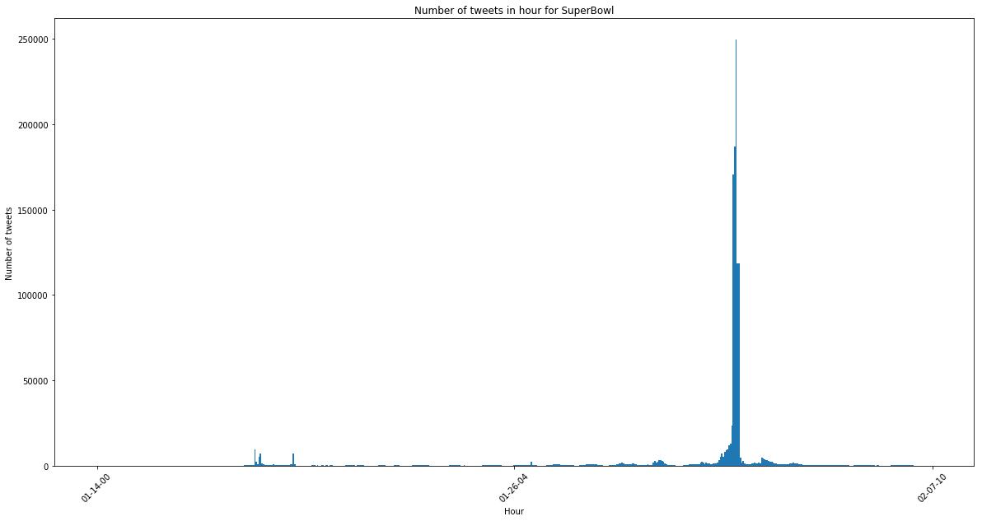
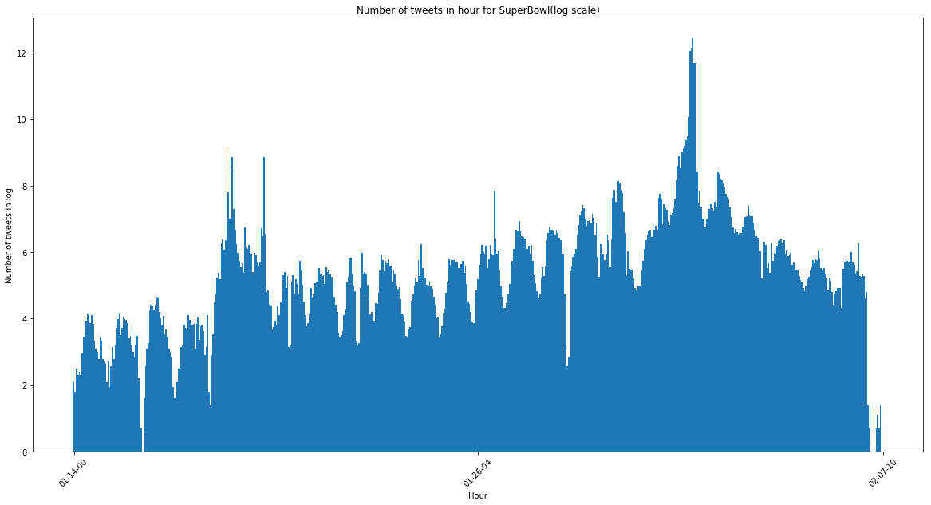
- For #NFL
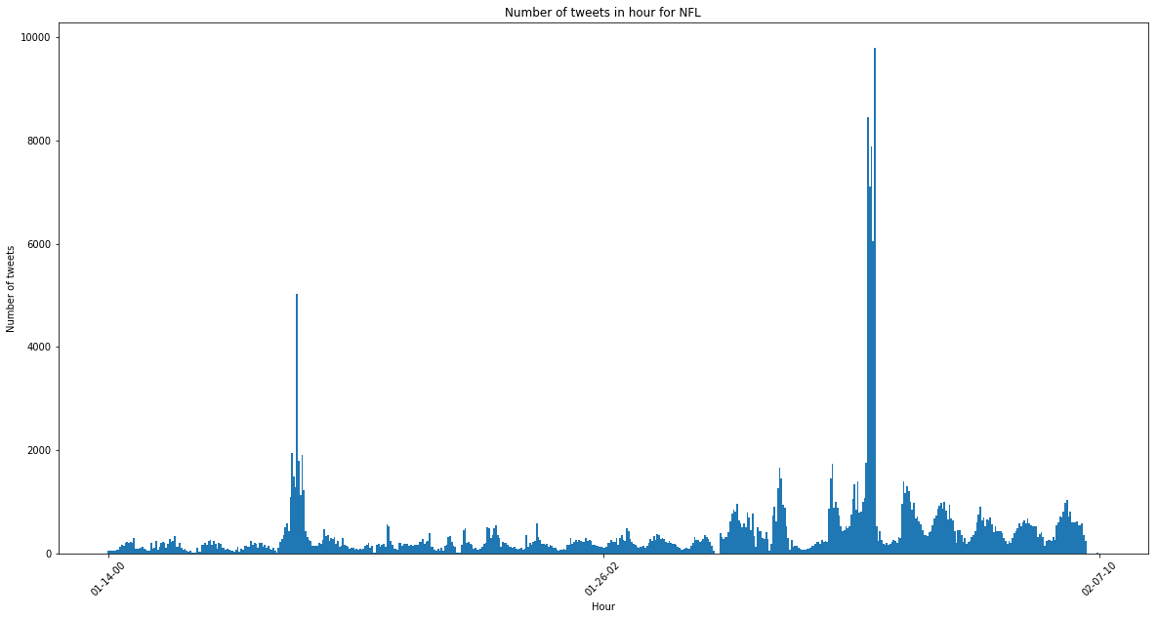

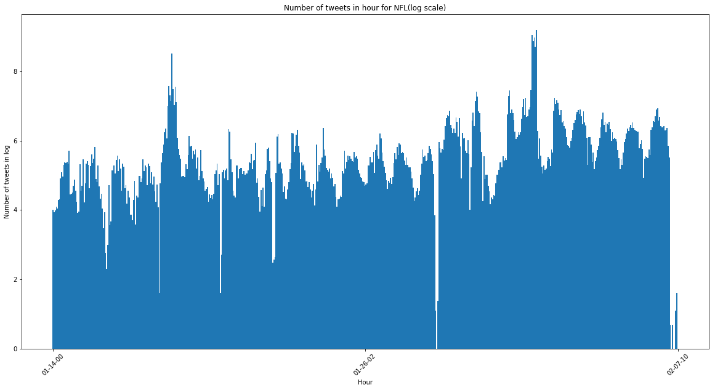

QUESTION 3: For each of your models, report your model’s Mean Squared Error (MSE) and R-squared measure. Also, analyse the significance of each feature using the t-test and p-value.
- #gohawks:
MSE value: 716101.690801841
R-squared measure: 0.5289248105728146
feature | t-test | P-value
Number of tweets | 9.5294923 | 4.42086862e-20
Number of retweets | -4.44705288 | 1.04587450e-05
Sum of the number of followers of the users posting the hashtag | -3.8401074 | 1.36692130e-04
Maximum number of followers of the users posting the hashtag | 2.14594155 | 3.22970250e-02
Time of the day | 2.20091074 | 2.81404313e-02

- #gopatriots:
MSE value: 30590.490704986703
R-squared measure: 0.6058234151577628
feature | t-test | P-value
Number of tweets | -0.47930696 | 0.63190443
Number of retweets | 3.0076869 | 0.00274877
Sum of the number of followers of the users posting the hashtag | 0.81210353 | 0.41707184
Maximum number of followers of the users posting the hashtag | -1.42904424 | 0.15354026
Time of the day | 0.96439399 | 0.33525811

- #nfl:
MSE value: 274001.9984320582
R-squared measure: 0.6517996737809222
feature | t-test | P-value
Number of tweets | 4.71348753 | 3.05131530e-06
Number of retweets | -2.66286299 | 7.96262358e-03
Sum of the number of followers of the users posting the hashtag | 4.08398895 | 5.04816949e-05
Maximum number of followers of the users posting the hashtag | -3.03572152 | 2.50706971e-03
Time of the day | 4.01589862 | 6.69902841e-05

- #patriots:
MSE value: 4579216.244725382
R-squared measure: 0.7146966270449413
feature | t-test | P-value
Number of tweets | 15.41251794 | 3.47298678e-45
Number of retweets | -5.01275882 | 7.13446446e-07
Sum of the number of followers of the users posting the hashtag | 1.57531078 | 1.15729057e-01
Maximum number of followers of the users posting the hashtag | 0.70103572 | 4.83561393e-01
Time of the day | 1.39257318 | 1.64281585e-01

- #sb49:
MSE value: 13171504.39991799
R-squared measure: 0.8416361286654217
feature | t-test | P-value
Number of tweets | 13.02630523 | 3.46364913e-34
Number of retweets | -2.22756426 | 2.62944491e-02
Sum of the number of followers of the users posting the hashtag | 0.91650475 | 3.59785108e-01
Maximum number of followers of the users posting the hashtag | 4.42783206 | 1.13873506e-05
Time of the day | -1.18988154 | 2.34582314e-01

- #superbowl:
MSE value: 34209180.3254181
R-squared measure: 0.8699072245830363
feature | t-test | P-value
Number of tweets | 24.00671388 | 5.91198600e-89
Number of retweets | -4.84396911 | 1.63518170e-06
Sum of the number of followers of the users posting the hashtag | -20.05965064 | 2.21115533e-68
Maximum number of followers of the users posting the hashtag | 10.98490362 | 1.24170842e-25
Time of the day | -2.26364349 | 2.39646799e-02

QUESTION 4: Design a regression model using any features from the papers you find or other new features you may find useful for this problem. Fit your model on the data of each hashtag and report fitting MSE and significance of features.

In this part, we use 14 features, calculate their statistics in hours and train models on the data we get.
The features are:
['Number of tweets', 'Total number of retweets',
'Sum of the number of followers', 'Maximum number of followers',
'Time of the day', 'Total number of impressions',
'Total number of momentum', 'Total number of favorite count',
'Total number of ranking score', 'Total number of acceleration',
'Total number of replies', 'Total number of unique users',
'Total number of unique authors', 'Total number of user mentions']

- #gohawks:
MSE value: 414743.142968156
R-squared measure : 0.7271683517202944
p values :
[4.32658730e-04 6.09384448e-05 1.34927098e-01 2.63677589e-01
7.83523860e-03 1.73215741e-03 1.30150293e-16 2.57739273e-09
2.55563154e-06 4.85694869e-01 9.24758854e-09 3.26926042e-02
1.76026196e-01 1.01607789e-04]
t-test :
[-3.54031072 -4.03969286 -1.49709824 -1.11885666 -2.66863321 3.1477661
-8.53490438 6.05414237 4.7522881 0.69763197 5.83166609 -2.14111638
1.3547922 3.91464638]

- #gopatriots:
MSE value: 11176.642696427321
R-squared measure : 0.8559823413567706
p values :
[5.77234745e-01 3.23316657e-13 2.10858207e-40 5.45714893e-20
1.10254121e-01 9.85475249e-24 9.15501130e-01 7.21365262e-04
7.49629580e-01 6.58658511e-01 9.24197599e-01 6.07378314e-19
8.21335928e-20 5.10791411e-44]
t-test :
[ 0.55775476 -7.46378187 14.4389285 -9.51251785 -1.59958749
-10.51779325 0.10615028 -3.40019053 -0.31928486 -0.44200184
-0.09519046 -9.21819072 9.46303665 15.21744533]

- #nfl :
MSE value: 166528.59341512353
R-squared measure : 0.7883763224948585
p values :
[3.01377080e-01 1.27090668e-02 2.33048083e-01 4.14838130e-03
5.37258839e-01 1.23184554e-01 2.15657474e-01 4.64225986e-29
7.73308910e-01 5.23172650e-01 1.23648251e-01 4.43465294e-02
2.97779437e-02 6.97922515e-10]
t-test :
[1.0344198 -2.49969416 -1.19380764 2.87824472 -0.61733593
-1.54382177 1.23953033 -11.83515329 -0.2881858 -0.63885552
-1.54191096 2.01524242 -2.17847925 6.27329779]

- #patriots:
MSE value: 3568809.458762839
R-squared measure : 0.7776489858517225
p values :
[1.73738836e-01 1.65083385e-02 9.24242568e-04 3.43381686e-09
7.77782200e-01 9.16049970e-01 1.91389211e-03 3.35497701e-01
1.65606833e-01 6.96285866e-01 5.80794184e-01 1.78965259e-04
9.35407844e-05 5.41098419e-11]
t-test :
[-1.3619847 -2.40456943 3.33004486 -6.00342856 0.28234358 -0.10545724
-3.11775862 0.96391134 1.38823198 -0.3905357 0.55254014 -3.77177149
3.9347083 6.6874702 ]

- #sb49:
MSE value: 5532649.055765376
R-squared measure: 0.9334797532154293
p values :
[1.63125863e-02 2.16129022e-01 1.63012674e-05 9.35502386e-04
2.45265048e-01 4.16080948e-02 7.05345538e-03 4.46572739e-03
1.47996269e-01 3.85667066e-04 2.91569431e-13 1.61150471e-12
4.34859664e-46 6.78630862e-02]
t-test :
[-2.40902177 -1.23826589 4.34775564 3.32672861 -1.1631303 -2.04204825
2.70413776 -2.85465135 1.44861737 3.57106599 -7.47614165 -7.22589689
15.63446821 -1.82940451]

- #superbowl.txt :
MSE value: 17383904.794833045
R-squared measure: 0.9338914174256394
p values :
[1.08823835e-04 1.59193948e-26 1.49322937e-03 4.42400693e-02
6.49641228e-01 1.31890629e-01 1.52971535e-19 3.29515873e-13
1.99682465e-02 5.90614579e-18 3.44271086e-02 5.81459719e-06
1.35386323e-03 1.10551978e-01]
t-test :
[-3.89726698 11.2165766 3.19148154 -2.01626455 0.45450068 -1.50884841
-9.38056793 -7.45750738 2.33349687 -8.92812647 2.12011358 4.57614376
-3.22018971 -1.59819858]

