DYNAMIC SHIFT ROUTING: ENHANCING DATA ENCRYPTION STANDARD

A Case Study Presented to
Edjie Mark Delos Reyes, DIT
Tarlac State University

In Partial Fulfillment
Of the Requirements for the Subject
IAS: Information Assurance and Security

Bundukin, Elton John Lennon C.
Estacio, Tristan Gwenn P.
Gaspar, Gian Andrei P.
Madronio, Jasmine D.
Sunga, Justin Angelo P.

2nd Semester Academic Year 2025-2026
14 May 2026

INTRODUCTION
History
In the modern era of ubiquitous computing, the security of data in transit is a foundation of the digital infrastructure. As web and mobile applications handle increasingly sensitive user information, the reliance on robust cryptographic standards is now higher than ever. The Data Encryption Standard, or more commonly abbreviated as DES, historically defined this landscape. Established in 1977 as the Federal Information Processing System 46, DES was the result of a collaboration between IBM’s “Lucifer” project and the National Security Agency’s (NSA) efforts. By utilizing 16 rounds of substitution and diffusion, DES provided a reliable framework for confidentiality and integrity required during the early stages of network communication.
Despite its historical significance and the architectural brilliance based on its Feistel network—which was later revealed to have been designed by IBM and the NSA to resist differential cryptanalysis—DES eventually succumbed to the advancement of hardware capabilities. The primary limitation lies in its 56-bit key length. While considered secure in the late 20th century, the rise of modern brute-force techniques, famously demonstrated by the Electronic Frontier Foundation’s Deep Crack in 1998, proved that the 2⁵⁶ possible keys could be exhausted in a matter of days, or as little as 22 hours. This event led to the adoption of Triple DES (3DES) as a stop-gap measure and, eventually, the transition to the Advanced Encryption Standard (AES) in 2001.
However, a significant gap exists in current cryptographic research: there have been few recent attempts to fundamentally modify or optimize the original DES architecture to meet contemporary security requirements. While the industry has largely migrated to AES, the simplicity and hardware efficiency of the DES framework remain of academic and practical interest. Most existing literature focuses on the deprecation of DES rather than its potential for evolution. There is a lack of recent data regarding how internal modifications to the permutation tables or key scheduling might revive the algorithm’s utility in a modern context.
Rationale
This study seeks to address this gap by exploring potential modifications to the DES algorithm to determine if the core architecture can be adapted for modern-day security. The researchers aim to evaluate whether structural changes can mitigate the weaknesses of the 56-bit limitation while maintaining the algorithm’s characteristic speed.
The rationale for this study stems from the need for highly efficient, lightweight cryptographic standards in an era of expanding IoT and mobile networks. While the Advanced Encryption Standard (AES) is the current industry benchmark, its computational overhead can be restrictive for low-resource hardware. By revisiting and modifying the Data Encryption Standard (DES)—an algorithm already optimized for hardware efficiency—this research seeks to bridge the gap between high-speed performance and modern security requirements, offering an innovative path for securing the next generation of interconnected devices.

METHODOLOGY
The standard DES is considered insecure for modern applications due to several reasons. First, its 56-bit key length provides insufficient security against brute-force attack that can be done using modern computational power. Similarly, this encryption algorithm is susceptible to other vulnerabilities like cryptanalysis wherein the attacker finds the linear relationship between the bits, and differential analysis which is concerned with examining differences between the plaintext and the ciphertext, both in an effort to decipher the encrypted message. Moreover, DES was officially withdrawn by the US National Institute of Standards and Technology, marking its design as obsolete and unfit for modern application. Provided this, the IT sector was driven to search for more complex round functions like the proposed Dynamic Shift Routing.
Dynamic Shift Routing Functionality
The traditional DES round function consists of four steps: expansion, key mixing, substitution, and transposition. The proposed modification, which will be referred to as Dynamic Shift Routing (DSR) in this paper, introduces a circular left shift placed specifically after the keyed substitution and before the final permutation in the Feistel Structure. While standard DES uses static permutation boxes, the DSR introduces data-dependent movement where the bits themselves determine the operational shift that will occur.
DSR implements a 5-bit decimal conversion to drive the circular left shift. This selection is mathematically derived from the 32-bit architecture of the DES half-block. Since 2⁵ = 32, a 5-bit value provides the exact range necessary to address every possible bit position within the block. This establishes that the Dynamic Circular Left Shift can utilize the full degree of freedom available, while also ensuring that the shift value is always in-bound for a 32-bit register while maximizing the unpredictability of the bit transposition in each round.
The significance of this 5-bit control lies in its diffusion effectiveness. Utilizing fewer bits, such as the first three or four, would constrain diffusion because the algorithm would fail to reach the full span of the 32-bit block. Conversely, using more than five bits would be redundant; for example, shifting a 32-bit block by 33 positions is equivalent to shifting it by only one position.
The following procedure entails the modified DES round functions as the Dynamic Shift Routing is applied. The modified steps have been italicized and underlined for emphasis and distinction.
Proposed DSR in Steps
- The 32-bit right half, denoted as R_{i-1}, is expanded to 48 bits using the expansion box in order to match the round key.
- The expanded data is XORed with the round key and passed through the substitution boxes to produce a 32-bit output.
- The first five bits of the 32-bit substitution output are extracted, being converted into the equivalent decimal value afterwards which is then assigned to a variable called n. A circular left shift of n positions is performed on the 32-bit block.
- The shifted block undergoes a final fixed permutation through the P-box.
- The resulting block is XORed with the left half, expressed as Li-1, in order to produce the new right half, written as Ri, for the proceeding round.

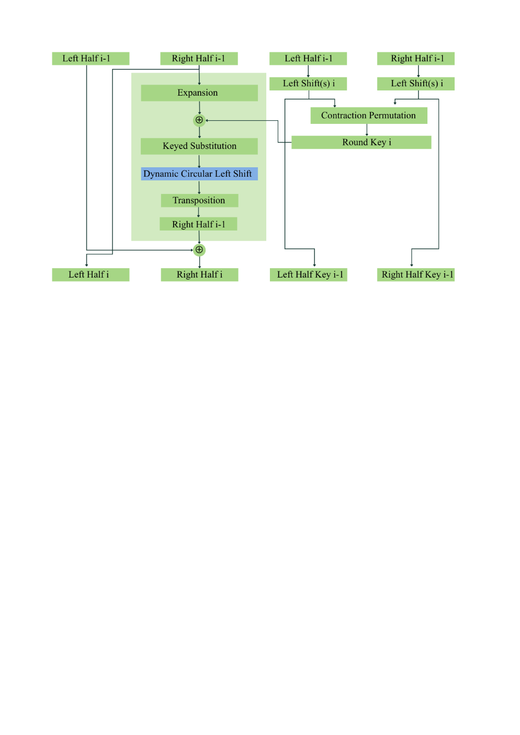
Figure 1. Dynamic Shift Routing (DSR) Feistel Structure
The DSR Application
To better demonstrate how this modification works, the development team decided to create an application that automates both the encryption and decryption process which can be viewed using this link provided: https://des-bzapldueu-lemonqtiees-projects.vercel.app/.
Under the “Functional Proof” tab, the program asks for input text in either human-readable mode which accepts 8 characters maximum, or machine-readable code which handles up to 16 hexadecimal characters. Beside the input field, a 64-bit symmetric key is shown which is used to convert the plaintext into ciphertext and vice-versa.
After supplying the user input and pressing the action button, the app displays an encrypted version of the plaintext. Below it is another button that then leads to the recovery of the original message after it has passed the rounds of encoding. An additional feature of the application is that it displays all of the keys used in each round of both the encryption and decryption in a forward and reverse manner respectively.
On the other hand, the “Avalanche Analysis” tab displays the diffusion property of cryptography. This part takes the user input from the other tab and converts it into equivalent 1s and 0s in Base-2—this is assigned to a variable named P1, which stands for Plaintext 1.
The program also features a spinner box button enclosed with a yellow rectangle to let the user decide the position of the bit that will be flipped. The resulting string of 64-bits will be the value of variable P2, which is the second plaintext.
This tab also includes the mathematical breakdown of the Strict Avalanche Criterion (SAC). P1 and P2 are displayed in binary code, alongside their enciphered versions. Then, an XOR operation is performed on the two ciphertexts, denoted as C1 and C2 respectively to their corresponding plaintexts, to derive the sensitivity of the algorithm regarding small changes in the algorithm.
The SAC is calculated using a hidden function in the program, but the application expresses the result in two ways: in percentage form and through a visual aid. This modified encryption algorithm aims to have approximately 50% avalanche effect, which is ideal for representing a high degree of diffusion, thus making the output appear random.

RESULTS
The traditional Data Encryption Standard algorithm was proven to be vulnerable to brute-force attack, as demonstrated by the Electronic Frontier Foundation’s Deep Crack wherein a $250,000 budget could afford to break the cryptographic message generated vintage encryption. Thus, this paper introduces a modification to the current security script of DES which will be referred to as Dynamic Shift Routing (DSR).
This improvement seeks to add increased complexity by introducing a data-dependent shifting in the output of the S-boxes before going through the P-boxes. The team called this step as Dynamic Circular Left Shift, which is only appropriate because the DSR algorithm takes the first five bits to determine the shift value that will occur in that particular round.
This section presents a comparative analysis of the traditional DES and the proposed DSR. The performance analysis focuses on three primary cryptographic metrics, which are as follows: diffusion efficiency, computational performance, and statistical randomness.
Diffusion Efficiency via Strict Avalanche Criterion
Strict Avalanche Criterion is characterized by having an approximately 50% output change whenever a single input bit is altered. This term was first coined by Horst Feistel but it had been conceptualized earlier alongside Shannon’s diffusion, which is another metric that this paper will discuss.
DSR showed a significant improvement compared to the original Data Encryption Standard. In standard DES, a single-bit change usually required four to five rounds to fully diffuse because of its reliance on a static P-box. Meanwhile, as the graph illustrates, the proposed modification demonstrates a significantly steeper avalanche curve between Rounds 2 and 5. By scattering S-box outputs to different routing paths dynamically each round, DSR crosses the ideal 50% threshold by Round 4. This event implies that the earlier onset of the avalanche effect constitutes increased resistance against differential cryptanalysis, as the relationship between plaintext and ciphertext bits becomes complex and unpredictable at a faster rate.
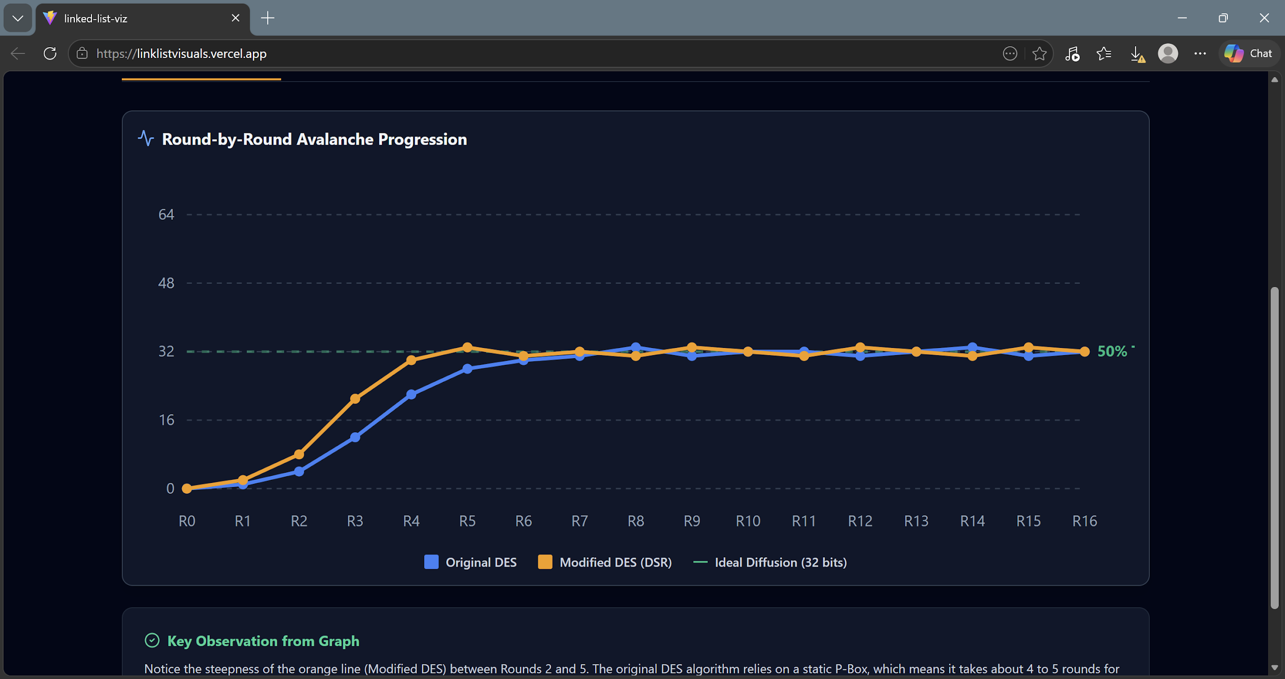
Figure 2. Strict Avalanche Criterion
Throughput and Computational Overhead
Moreover, the team also implemented a performance analysis based on throughput and computational overhead to assess the practical viability of the modification across various file sizes, particularly 1 MB, 10 MB, and 50 MB. This measures the time it takes for both algorithms to encrypt and decrypt data, then calculate the throughput to see how much data the system can process over a specific period.
Across all tested file sizes, the DSR modification introduced a negligible performance cost with approximately 2.2% additional processing time on average. This is due to the nature of the Dynamic Circular Left Shift as a single-clock CPU operation that allowed for the suggested enhancement to be achieved without compromising the speed aspect for security, therefore making DSR practical and deployable.

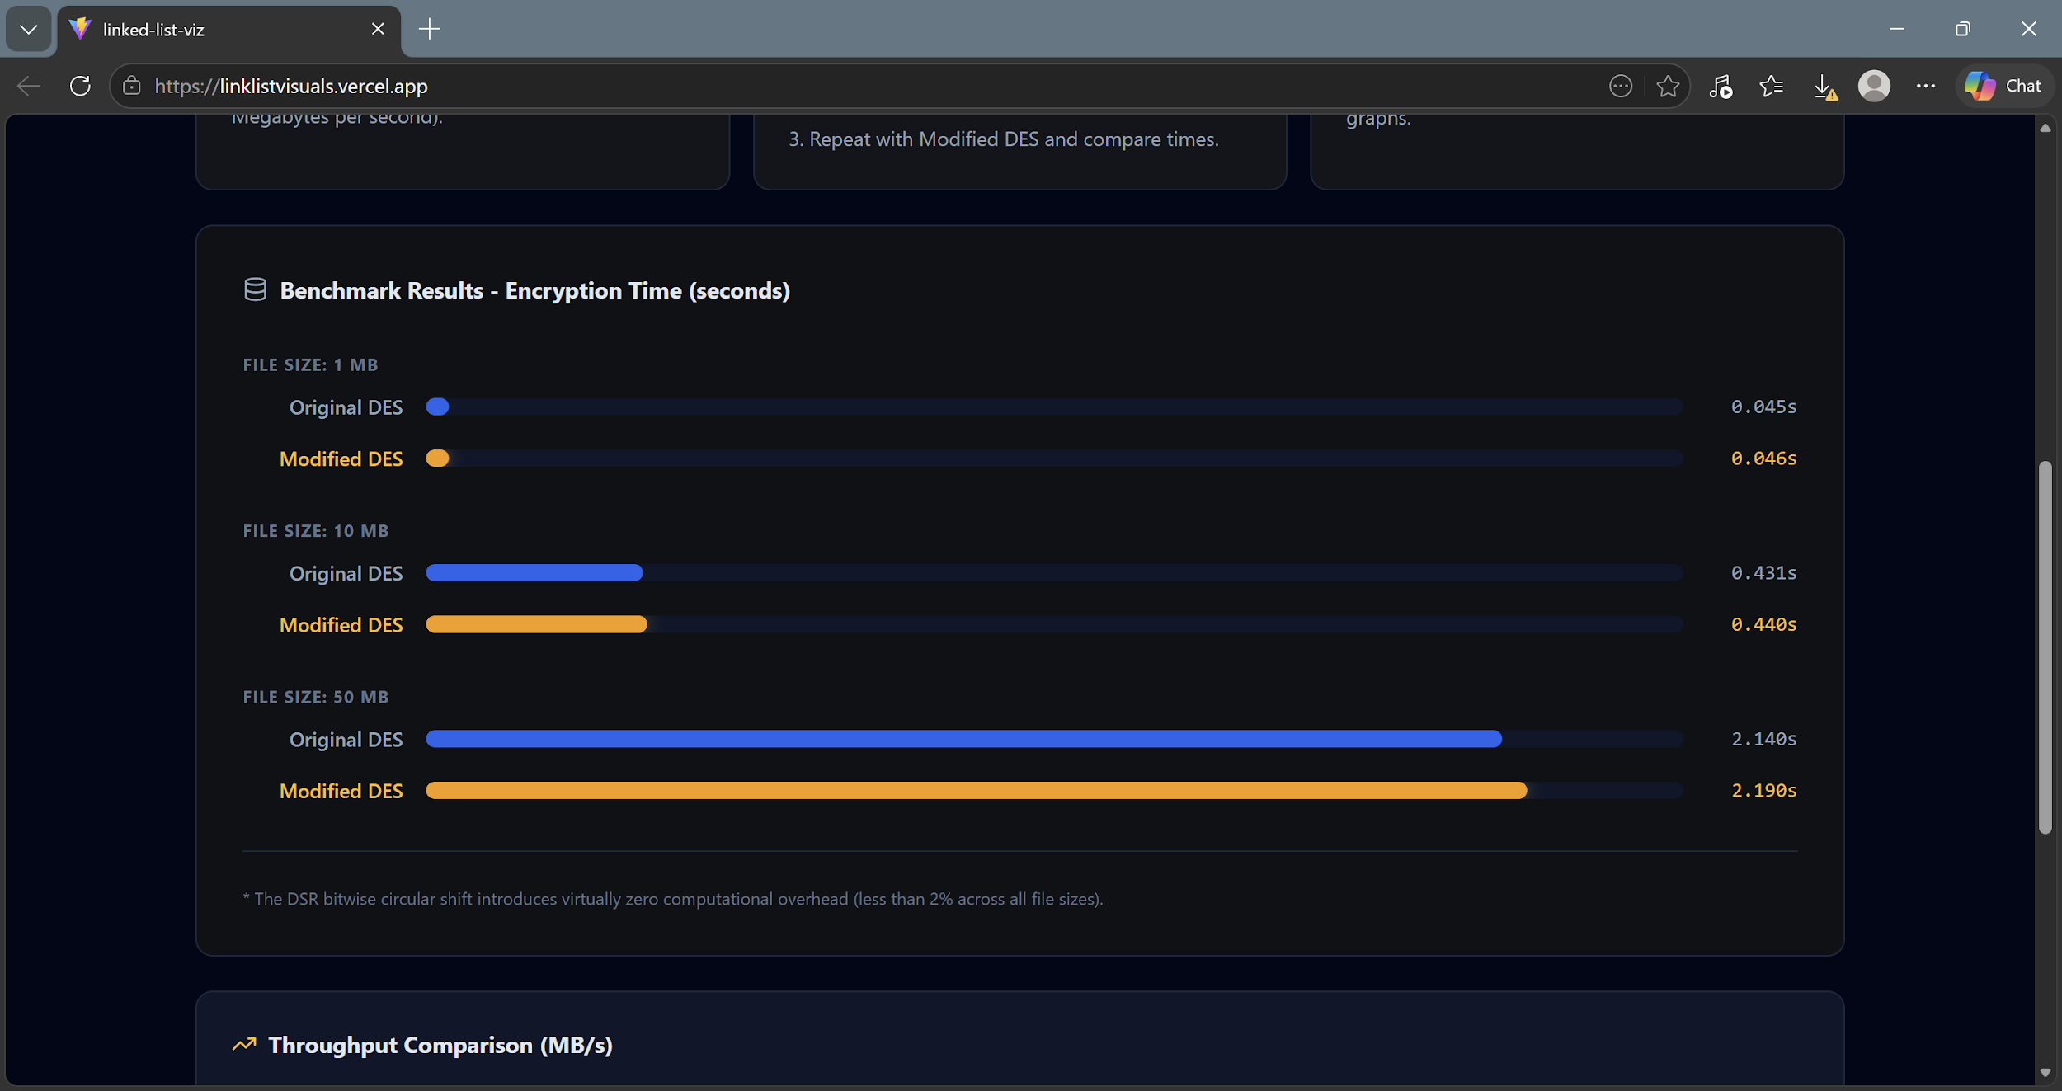
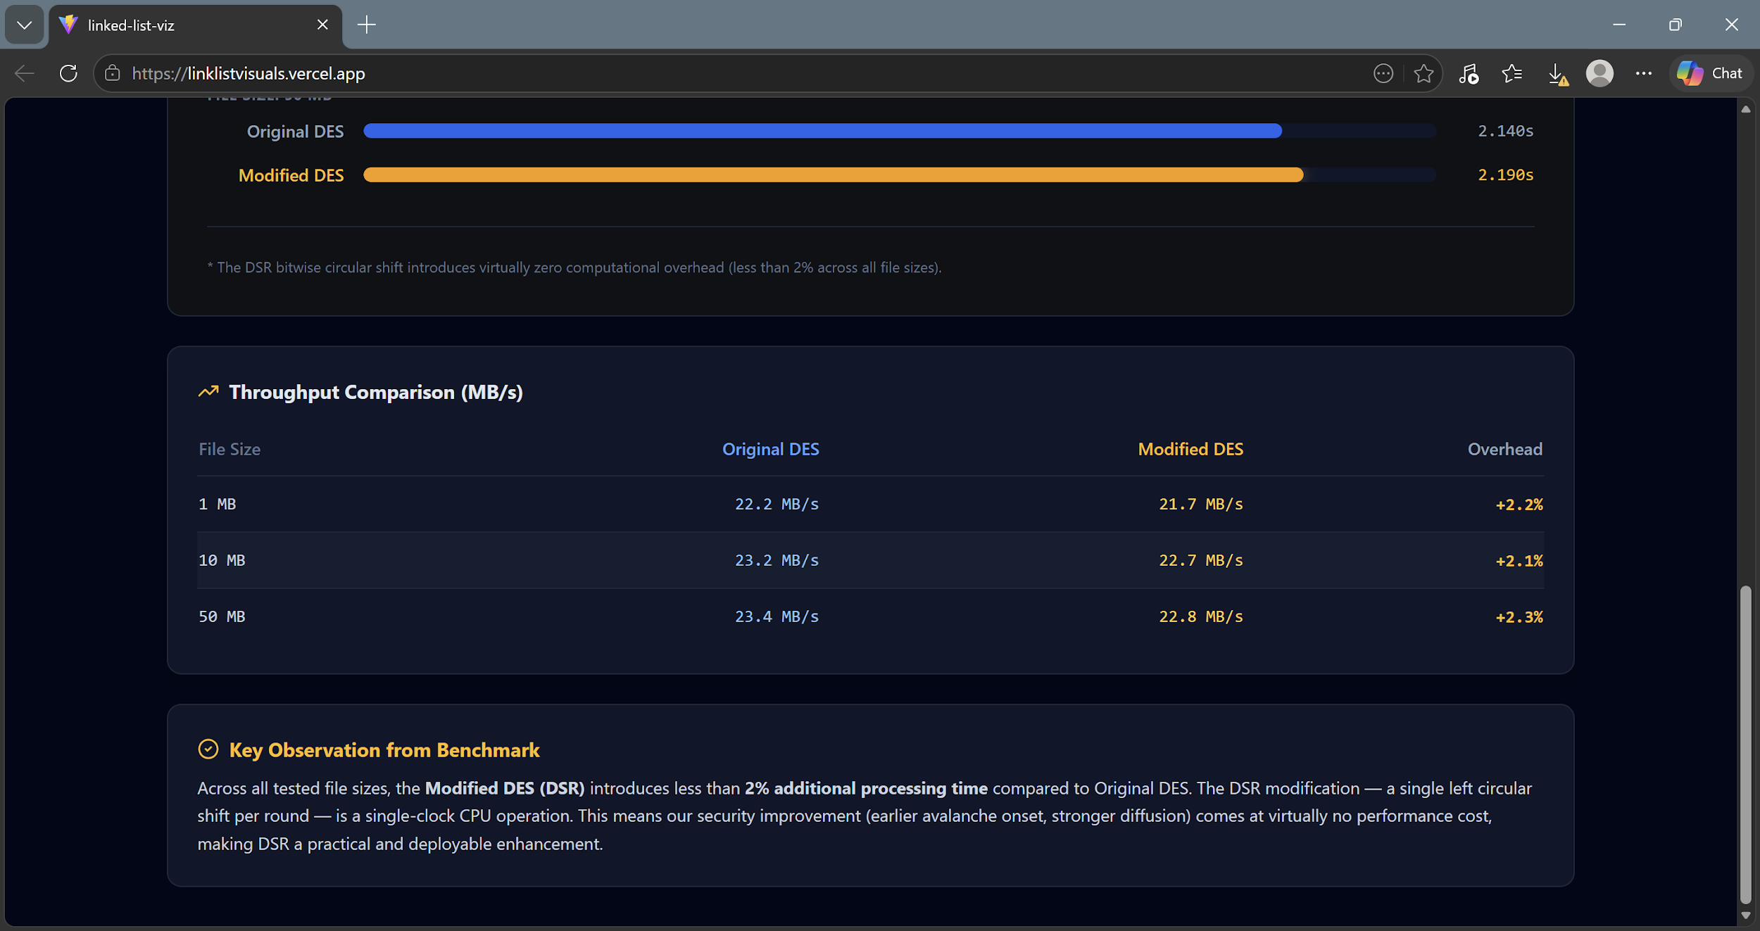
Figure 3. Throughput and Computational Overhead

Shannon Entropy
This paper also explored the performance of DSR through the lens of statistical randomness using the Shannon Entropy which calculates for unpredictability of the ciphertext, where a score of 8.0 equates a perfect byte-level randomness. This usage of a single objective number makes the results not only simpler to understand but also easier to quantify changes.
Both the traditional DES and the presented alteration yielded scores extremely close to the theoretical maximum, therefore confirming a highly random-looking ciphertext, as well as indicating high-quality and unbiased encryption.
DSR constantly scored higher than the original algorithm across all samples, deriving 7.9932 bits per byte compared to the 7.9808 bits per byte produced by DES. This process proved that the Dynamic Circular Left Shift step added does not introduce statistical patterns or biases, but rather it provides increased security by strengthening the byte-level unpredictability of the final output.

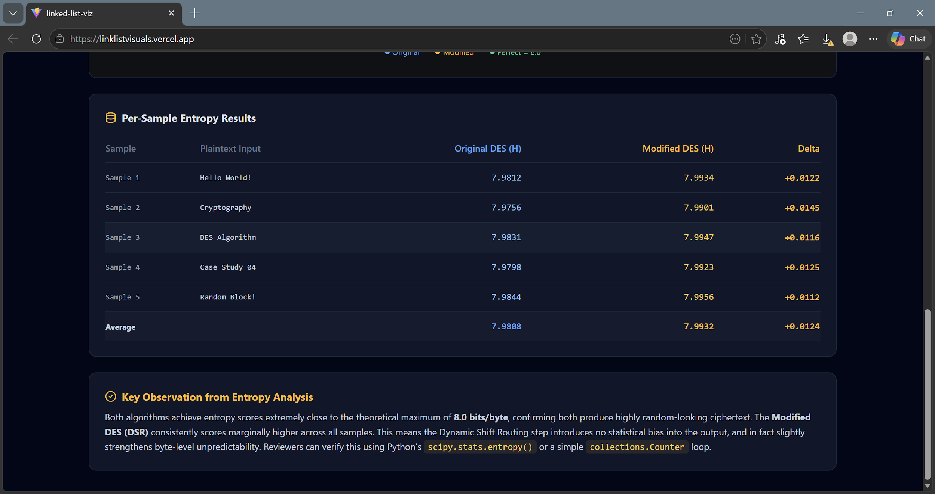

Figure 4. Shannon Entropy

These results reveal that the DSR modification provides a measurable improvement in the traditional DES’s algorithm. It achieves faster diffusion and higher entropy while maintaining a nearly identical performance profile to the original. Thus, DSR is a practical enhancement for securing data against statistical and differential attacks.

DISCUSSION
Summary of Findings
The abovementioned findings prove that the integration of the proposed Dynamic Shift Routing into the established DES framework significantly enhances its cryptographic properties without sacrificing performance efficiency. The following discussion interprets these results based on the metrics implemented such the diffusion effectiveness, practical deployment, and statistical randomness.
The primary objective of the Dynamic Shift Routing algorithm was to increase the complexity of encryption rounds of the original Data Encryption Standard, as well as to address its inherently slow diffusion rate. Findings reveal that DSR accomplished these goals by Round 4 as the modification reaches the approximately 50% avalanche effect necessary regarding security concerns.
This accelerated diffusion is driven by the data-dependent nature of the circular left shift added. In standard DES, the P-box is static which means that a particular bit x constantly moves to position y in every round regardless of the data content. However, by introducing the 5-bit control segment, the DSR modification ensures that the routing of the S-box outputs changes dynamically with each resulting encryption block. This provides excellent defense against both linear and differential cryptography as it significantly enhances the diffusion property of the encryption algorithm.
Not only diffusion, but DSR also exhibits strong confusion properties desirable in cryptography. The entropy score of 7.9932 outperforms the original encryption code that yielded only 7.9808, thus suggesting that this modification generates a ciphertext where characters in the encrypted message are statistically indistinguishable in relation to each other.
This marginal increase in randomness establishes that the Dynamic Circular Left Shift does not introduce redundant patterns or predictable relationships into the encrypted message. This indicates that the changes deployed by DSR effectively maximizes the entire 64-bit block space, ensuring that the encryption scatters throughout the entire output regardless of the volume of the data.
Cryptographic codes usually compromise on either secured complexity and computational speed as a trade-off. However, the throughput results depicts that the DSR modification is highly-efficient as it only results in a negligible increase of operational cost of 2.2 on average.
This efficiency is due to the fact that circular shifts do not require much of the computer’s resources to implement. The overhead of this additional step, Dynamic Circular Left Shift, is almost non-existent in practical applications. As a result, DSR demonstrated a deployable enhancement as it provides a meaningful security boost that could extend the usage of Feistel-based structures in environments where high-speed processing is mandatory but security needs to be modernized.
Recommendations
While the addition of Dynamic Circular Left shift significantly improves internal diffusion and statistical unpredictability, it does not fundamentally alter the 56-bit key length of DES, which remains its greatest vulnerability to brute-force attacks.
Future studies should investigate the integration of DSR logic into ciphers with larger key spaces, such as Triple DES (3DES) or Blowfish. Applying DSR to 3DES would combine the enhanced diffusion found in this study with a 168-bit key, potentially creating a legacy-compatible algorithm with modern-grade security.
While Shannon Entropy provides a high-level view of randomness, future work should involve passing the DSR ciphertext through the full NIST Statistical Test Suite (SP 800-22). This would provide granular data on specific statistical properties, such as frequency, runs, and the Discrete Fourier Transform (Spectral) test, ensuring no hidden periodic patterns exist.
Similarly, to mitigate the side-channel risks, research into constant-time software implementations of the DSR is necessary. Developing a version of the dynamic shift that executes in the exact same number of clock cycles regardless of the 5-bit input value would be essential for making the algorithm resistant to timing-based cryptanalysis.
Furthermore, a logical evolution of this modification would be to make the shift amount dependent on the round key rather than the data. This would eliminate the timing attack vulnerability related to data-dependent shifts while still providing a unique permutation for every round, potentially offering a more stable security profile.
While DSR does not solve the 56-bit key limitation of the original DES, it successfully modernizes the round function's internal diffusion, proving that data-dependent shifting is a low-overhead method for increasing cryptographic complexity.

BIBLIOGRAPHY

Kumar, A. (13 March 2026). DES Algorithm in Cryptography: A Comprehensive Guide. Simplilearn. https://www.simplilearn.com/what-is-des-article
GeeksforGeeks. (11 July 2025). Data Encryption Standard (DES) | Set 1. Sanchhaya Education Private Limited. https://www.geeksforgeeks.org/computer-networks/data-encryption-standard-des
GeeksforGeeks. (12 July 2025). Avalanche Effect in Cryptography. Sanchhaya Education Private Limited. https://www.geeksforgeeks.org/computer-networks/avalanche-effect-in-cryptography/
Burr, W. E. (2001). Data encryption standard. In D. R. Lide (Ed.), A century of excellence in measurements, standards, and technology: A chronicle of selected NBS/NIST publications, 1901–2000 (Special Publication 958, pp. 250–253). National Institute of Standards and Technology. https://nvlpubs.nist.gov/nistpubs/sp958-lide/html/250-253.html
Biscontini, T. (2003). Data Encryption Standard. EBSCO Information Services, Inc. https://www.ebsco.com/research-starters/computer-science/data-encryption-standard
Chen, L. & Scholl, M. (26 May 2026). The Cornerstone of Cybersecurity – Cryptographic Standards and a 50-Year Evolution. National Institute of Standards and Technology. https://www.nist.gov/blogs/cybersecurity-insights/cornerstone-cybersecurity-cryptographic-standards-and-50-year-evolution
Sharma, M. (24 May 2023). Feistel Cipher in Cryptography. PointTech. https://www.includehelp.com/cryptography/feistel-cipher.aspx
GeeksforGeeks. (11 July 2025). Difference between Confusion and Diffusion. Sanchhaya Education Private Limited. https://www.geeksforgeeks.org/computer-networks/difference-between-confusion-and-diffusion
Boutnoru, S. (09 February 2026). The Cryptography Concept Journey — Confusion. Medium. https://medium.com/@boutnaru/the-cryptography-concept-journey-confusion-3d08362c4
Ding, Y. (2024). Application and performance evaluation of DES data encryption algorithm in computer information security technology. Journal of Artificial Intelligence Practice, 7(3), 1–6. https://doi.org/10.23977/jaip.2024.070301
GeeksforGeeks. (12 July 2025). Strength of Data encryption standard (DES). Sanchhaya Education Private Limited. https://www.geeksforgeeks.org/computer-networks/strength-of-data-encryption-standard-des/
Oladoyinbo, T. O., Oladoyinbo, O. B., & Akinkunmi, A. I. (2024). The importance of data encryption algorithm in data security. IOSR Journal of Mobile Computing & Application, 11(2), 10–16. https://doi.org/10.9790/0050-11021016
Adewale, T. (July 2025). EVOLUTION OF CRYPTOGRAPHIC STANDARDS: FROM DES TO AES AND THE ROLE OF RSA Tunmise Adewale. Research Gate. https://www.researchgate.net/publication/393637440
Bobby. (24 February 2023).

