Seismic Duck Design Notes
Arch D. Robison
11/26/2009

Typical Geometry

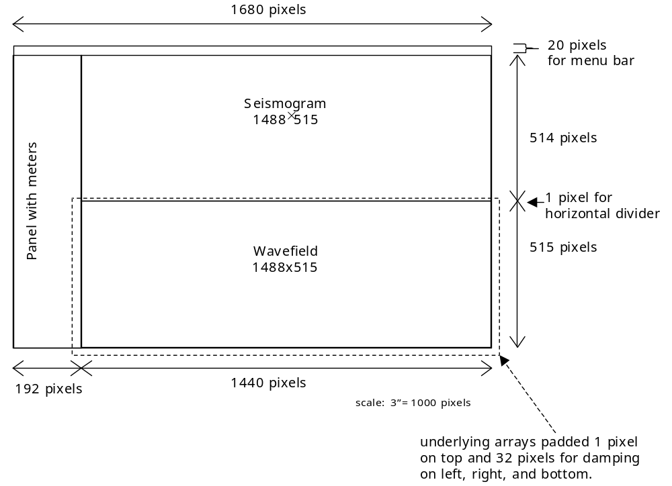

Processor Assumption
Minimum: 1.8 GHz Core-2 Duo

Display Assumptions
 | Screen | Wavefield | Array Elements (With Padding)
Minimum: Old monitor | 1024×768 | 784×374 | 363,776
Sketch: 21” widescreen display | 1680×1050 | 1440×515 | 848944
Maximum: 24” monitor. | 1920×1200 | 1680×590 | 1114624

Physics
Acoustic impedance = ρv
Velocity v of P wave is sqrt((λ+2μ)/ρ)
Share modulus = λ
Water has λ=0. So μ≈ρv²/2
Rocks have λ≈μ. So μ≈ρv²/3

Array Description
Add padding of about 32 pixels for damping to left, right, and bottom of each array.
Be careful to avoid 4K aliasing between rows (Core-2 performance issue).

Without interpolation, and with padding, each underlying array has maximum of ≈1.1×10⁶ elements. Table below summarizes the arrays and update costs.
Array and Update Formula | Update Cost |  |  | Comment
Array and Update Formula | Add  Sub | Mul |  | Comment
S_{i,j} += (M _{i,j+1}+M_{i,j})×(V_{i,j+1}−V_{i,j}) | 3 | 1 |  | Horizontal stress
T_{i,j} += (M_{i+1,j}+M_{i,j})×(V_{i+1,j}−V_{i,j}) | 3 | 1 |  | Vertical stress
V_{i,j} += L_{i,j}×(S_{i,j}−S_{i,j-1}+T_{i,j}−T_{i-1,j}) | 4 | 1 |  | Velocity
M_{i,j} | Read-only |  |  | Lamé μ/2
L_{i,j} |  |  |  | Lamé λ
Total | 10 |  | 3
Points in the damping border require another multiplication by D_{i,j}.
Maximum space is 21.7 MByte. Will not fit in L1 or L2 cache of most machines.

Floating-point additions dominate. Max. of 10×10⁶ floating point additions per update.
Memory traffic: Each update requires 24 MBytes reads and 12 MByte writes.
30 update/sec would be good frame rate. Requires 300×10⁶ floating-point additions/sec and 2.16 GByte of memory traffic per update.

Computation Optimizations
Single loop iteration can update 4 elements at once using SSE.
Each iteration does:
Update S & T in parallel
Update V
Generate four pixels pixel
Doing these in blocks of 4x4 pixels might help L1 cache reuse.

Dependence graph:

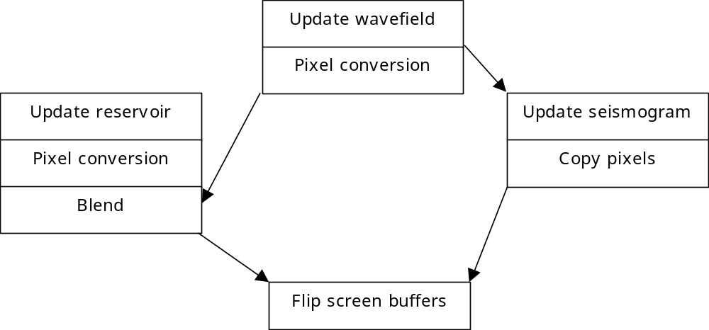

Panel Details
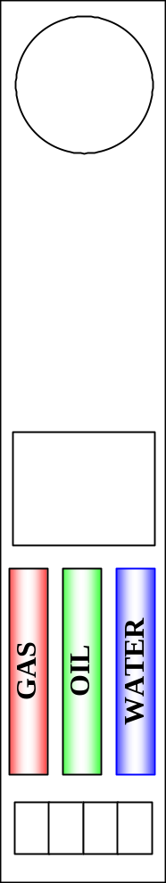

PML
See “Notes on Perfectly Matched Layers (PMLs)” by
Steven G. Johnson ( http://math.mit.edu/~stevenj/18.369/pml.pdf , particularly pages 11-12.
For bottom we need:
ΔV/Δt = L×(ΔS+ΔT) – sigma×V + psi
ΔT/Δt = M×(ΔV/Δy) – sigma×T
ΔS/Δt = ... same as without PML...
Δpsi/Δt = L×sigma×ΔS/Δx

Need to introduce a new field for psi.

Game Play
Have levels.
Need certain amount of money to reach a level.
Geology becomes more complex at each level.
Player decides when to quit.

