ADVENTURE TEAM
The Echoes of Constantinople

Book 2 in the SeriesIncredible Places

An Adventure Through Time

Series: TURMA FROM AVENTURALUGARES AMAZING
Book 2: The Echoes of Constantinople
Genre: Children's Adventure / Fantasy / Historical Fiction
Age Range: 8-12 years
Data:Januaryof 2026
© 2025 All rights reserved
This book is part of the ongoing Turma da Aventura series.
Connection with: The Secret of Atlantis (Book 1)
Next adventure: The Secrets of the Pyramids (Book 3)

SUMMARY

Chapter 1: The Call from Coral
Chapter 2: Preparations for the Impossible
Chapter 3: The Dive Through Time
Chapter 4: Wonders and Mysteries of Constantinople
Chapter 5: The Secret of Hagia Sophia
Chapter 6: The Hidden Threat
Chapter 7: Race Against Destiny
Chapter 8: The Day of Consecration
Chapter 9: Farewells and Echoes
Chapter 10: Echoes in the Present

CHAPTER 1
THE CALL FROM CORAL
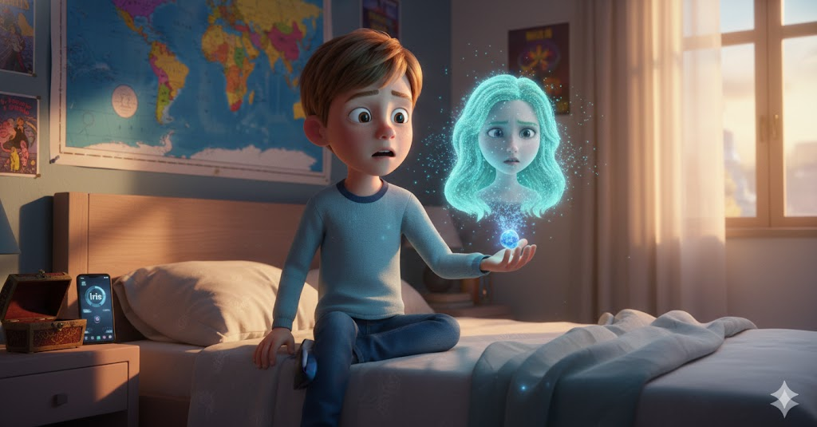
Morning light filtered through the curtains in Will's room, creating golden patterns on the wall where his world map hung. Three weeks had passed since the gang returned from Blue Atlantis, but he still dreamed every night of the luminescent underwater city, of Coral and her greenish hair floating in the water, of the pulsating crystals that beat like living hearts.
"Will, are you awake?" asked Iris from the smartphone on the bedside table, her digital voice sounding more human every day.
"Yes," he replied, stretching. "I dreamed of Atlantis again."
"It's the fifth time this week. Do you miss it there?"
Will thought for a moment. "I miss Coral. She promised she would call us if she needed help, but we don't know when that will happen."
As if the universe was listening, the communicator crystal Coral had given to Will - kept carefully in a special box next to his bed - began to glow with a soft blue light.
Will sat up so quickly he almost fell out of bed. "Iris! The crystal!"
"Detecting biophotonic energy emission," the AI ​​replied, his voice now alert. "Will, it's a message from Blue Atlantis."
With shaking hands, Will took the crystal. It was warm to the touch, pulsing like a tiny heart. When she held it up to the light, holograms of blue particles began to form in the air, rearranging themselves until Coral's worried face appeared floating above her palm.
"Will!" she said, her voice reaching like a whisper across time and space. "I need to speak to you. It's urgent. The elders have detected something... something impossible."
"Coral? I'm here! What happened?"
But her image trembled and distorted, as if fighting interference. "I can't explain why crystal... very complex... cracks in time... Constantinople... need to come... Professor Marino knows..."
The image flickered and disappeared, leaving only the crystal glowing dimly in Will's hand.
"Iris, did you record this?"
"Yes. Analyzing message. Will, she mentioned 'cracks in time' and 'Constantinople'. That doesn't make conventional scientific sense."
Will was already getting dressed, his heart racing. "Call everyone. Emergency meeting at Professor Marino's in an hour."

• • •

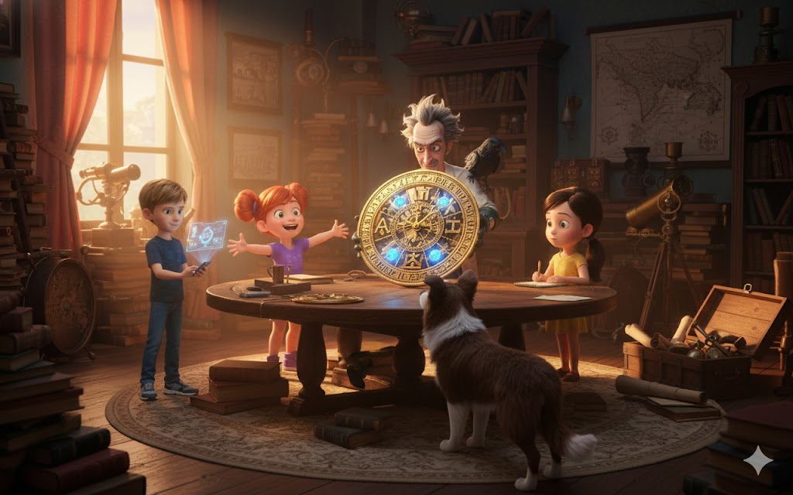
Fifty minutes later, the entire class was gathered in Professor Marino's chaotic office - an environment that seemed straight out of an adventure film, with ancient maps on the walls, mysterious artifacts on shelves, and gravity-defying stacks of books.
The professor, a man in his sixties with tousled gray hair and eyes that sparkled with perpetual curiosity, stood before a whiteboard covered in equations and diagrams that looked like they had been written in panic.
"I've been waiting for this," he said as the gang entered, Jimmy Hendrix running straight to sniff an old box in the corner. "Coral contacted me two hours ago. The situation is... well, it's unprecedented."
"Professor," said Sophie, with her notebook already open, "what are 'cracks in time'?"
Marino sighed deeply, adjusting his glasses. "Sit down. This is going to take a while to explain."
The gang settled in - Will and Leo on the worn leather couch, Mia sitting on the floor with tools already spread out around her (she never went anywhere without her kit), Sophie in the armchair with pen at the ready, and Max playing with Jimmy while trying to pay attention.
"You know that Blue Atlantis is ancient, right?" began the teacher. "But what you don't know is how old. Coral and her people have been around for over fifteen thousand years."
“Fifteen thousand?!” Leo exclaimed. "This is like... before the pyramids?"
"Long before. And throughout that time, the Atlanteans didn't just observe human history - they occasionally...participated in it."
Marino turned to one of the shelves and, with reverent care, removed an object covered in a black velvet cloth. When he removed the cloth, the class gasped in unison.
It was a watch - but not like any watch they had seen. Golden and ornate, the size of a dinner plate, covered in Greek symbols and complex geometric patterns. But what really caught the eye were the crystals embedded in its structure - crystals that glowed with the same familiar blue light as the crystals of Atlantis.
"Is this…" Mia approached, eyes wide, "is this Atlantean technology?"
"Partly," replied Marino. "This is a Byzantine astronomical clock, created in Constantinople in the sixth century AD. But look at the crystals."
"They're Atlanteans!" said Will, recognizing the biophosphorescent glow. "How did they end up in a Byzantine clock?"
The professor smiled, the way he always did when he was about to reveal something extraordinary. "Because the Byzantines had contact with Blue Atlantis."
The silence that followed was broken only by Jimmy barking excitedly, as if understanding the magnitude of this revelation.
"Are you saying," Sophie said slowly, processing, "that Atlantis...helped the Byzantine Empire?"
"It didn't exactly officially 'help'," Marino explained, pacing the office with nervous energy. "It was more... subtle. An advisor here, an architect there, 'coincidental' knowledge of sacred geometry and engineering that allowed the Byzantines to build wonders like the Hagia Sophia."
"To what?" asked Max, confused.
"Hagia Sophia," Sophie said automatically, her encyclopedic knowledge kicking in. "The largest cathedral in the ancient world, built in Constantinople by Emperor Justinian between 532 and 537 AD. Its dome was so large that modern engineers still do not fully understand how it was possible to build it with the technology of the time."
"Exactly," confirmed Marino. "And now we know why. The Atlanteans installed stabilizing crystals in the foundation of Hagia Sophia. Crystals that to this day keep the structure intact, resisting earthquakes that have destroyed more modern buildings."
Mia was practically vibrating with excitement. "But if the crystals are still there, and if Coral has detected 'cracks in time'..."
"Something's wrong with them," Will concluded. "The crystals in Constantinople are in trouble."
"Worse than that," Marino said, his expression darkening. "According to Coral, the crystals aren't just malfunctioning - they're creating temporal anomalies. Echoes of the past leaking into the present, cracks in the very fabric of time around that historic location."
"Wait," Leo raised his hand like he was in school, "are you talking about time travel?"
"I'm talking about something more complex. Atlantean crystals weren't just made to stabilize physical structures - they stabilize the very fabric of reality. When they work correctly, they create temporal 'anchor' points. When they fail..."
"Cracks," Sophie whispered, frantically taking notes.
Marino nodded gravely. "And if these cracks grow large enough, they could cause a temporal cascade that would affect not only Constantinople, but the connection between Atlantis and the surface that has been maintained through the centuries."
"Which means," added Iris from Will's smartphone, "that we need to repair the crystals in Constantinople. But how? The city doesn't even exist anymore - now it's Istanbul, Turkey."
"Ah," said Marino with an enigmatic smile, "but that's where this watch comes in."
He held the Byzantine device carefully, spinning it under the light so that everyone could better see the intricate mechanisms within - golden gears intertwined with blue crystalline filaments.
"This is not just an astronomical clock. It is a temporal resonance device. The Byzantines, with Atlantean help, created a machine that could 'plunge' through time."
"To dive?" Mia asked, tilting her head.
"Nice word choice, isn't it?" Marino smiled. "You physically delved into the depths of the ocean to reach Blue Atlantis. This device allows you to temporally delve into the depths of the past."
The room became absolutely silent. Even Jimmy stopped sniffing, as if sensing the magnitude of the moment.
Will finally found his voice. "Are you saying we can travel back to ancient Constantinople?"
"Not exactly 'travelling' in the physical sense," the professor explained, sitting down in his creaky chair. "The clock creates a resonance bubble that projects your consciousness to a specific moment in the past where there is strong emotional and historical energy. You experience the past, you can interact with it, but technically you are 'steeped' in memories crystallized in the fabric of space-time."
"That's...that's amazing!" Mia exclaimed. "How does it work? What are the mechanisms? Is it completely safe? Can we accidentally change history?"
Marino threw up his hands, laughing. "One question at a time. The device requires three elements to work: first, Atlantean crystals functioning as 'temporal oxygen tanks' - which you already have, thanks to Coral."
He pointed to the communicator crystal Will still held.
"Second, the Byzantine clock itself, which I've spent decades searching for and finally found in a secret archaeological dig in Istanbul last year."
"And third?" Sophie asked.
"A strong emotional intention and an unresolved historical issue. Something that time 'wants' to be fixed. And we have this - the crystals failing under the Hagia Sophia in 537 AD."
"But why 537?" Leo questioned. "Why not now?"
"Because," Marino explained, bringing out an ancient book and opening it to a marked page, "according to Coral's records, the temporal anomaly is centered precisely on December 27, 537 A.D. - the day the Hagia Sophia was consecrated. Something happened that day, something that should not have happened, and it is causing the cracks that expand to this day."
Will felt a shiver run down his spine. He looked at his friends - Mia practically glowing with scientific curiosity, Leo flexing his muscles unconsciously as if preparing for physical action, Sophie biting her lip as she processed all the information, Max holding Jimmy tightly but with determined eyes.
"Professor," Will said slowly, "what you're saying is that we need to travel to Constantinople in 537 A.D., find what's wrong with the Atlantean crystals, and fix whatever's causing the temporal rifts?"
"Exactly."
"Without changing history in a catastrophic way?"
"Correct."
"What if we don't make it?"
Marino looked at each of them seriously. "The connection between Atlantis and the surface, maintained for fifteen thousand years, will be destroyed. Coral and her people will be isolated forever. And the temporal rifts may expand, causing... well, we don't know exactly. Nothing like this has ever happened."
"No pressure then," muttered Max, and despite the tension, everyone laughed nervously.
Jimmy barked and placed his paw on Will's knee, looking at him with those intelligent eyes that seemed to say, "I'm with you no matter what."
Will felt Sophie's hand on his right shoulder, Leo's on his left. Mia was smiling even with tears in her eyes, and Max gave her a thumbs-up.
"Every adventure begins with a question," Will said his favorite quote, looking at the Byzantine clock that glowed softly in the office light. "And our question is: How do we save time?"
Iris spoke from the smartphone, her voice filled with emotion that an AI shouldn't be able to feel. "Will, do you understand that this is infinitely more dangerous than diving into the ocean? You will be navigating not just space, but time. There are so many unknown variables..."
"Iris," Will said gently, "when has that stopped us?"
The AI ​​was silent for a moment, then responded with what could only be described as a digital sigh. "Never. And probably never will."
"So," said Mia, already grabbing tools, "when do we start preparations?"
Professor Marino looked at the clock on the wall - a normal, ordinary clock that suddenly seemed much less interesting than that magical Byzantine device on the table.
"Coral said the next ideal temporal resonance window is in seventy-two hours. Three days to prepare for a journey that will take them fifteen hundred years back."
"Fifteen hundred years," Sophie repeated, the magnitude hitting. "We're going to meet people who lived fifteen hundred years ago."
"And save the future in the process," Leo added.
"No big changes," Mia reminded. "Just... minor fixes. Subtle. Like temporal surgery."
"Temporal surgery performed on a group of children between the ages of seven and ten," said Max. "This is going to work out really well."
But despite the sarcasm, he was smiling. Everyone was. Because deep down, each of them knew the truth - that they had been chosen for this. Not by accident, not by coincidence, but because they were the Adventure Gang. And adventures were what they did.
"Professor," asked Will, "what do we do first?"
Marino smiled, that smile of a teacher proud of his students. "First, you need to learn everything about Constantinople and the Byzantine Empire. Sophie, you will be crucial in this. Second, Mia needs to study how the clock works and how we can integrate it with the communicator crystals safely. Third, you all need to be physically and mentally prepared for the most intense experience of your lives."
"And then?" Leo asked.
"Then you dive. Not in water this time, but through the invisible currents of time itself."
Will picked up the communicator crystal and held it up to the light. He could have sworn he saw Coral's face reflected in the blue glow, waiting for them, trusting them.
"We're going to need to get back to Blue Atlantis first, aren't we?" he asked. "To activate the device properly?"
"Yes," confirmed Marino. "The temporal initiation ceremony must be held in a place of great energetic power. And there is no place more powerful than Blue Atlantis. Coral and the elders will be waiting."
Mia was already opening her laptop, fingers flying over the keyboard. "Iris, I need all the schematics you can give me on Atlantean crystals, temporal resonance, and quantum physics related to time travel."
"Sending files," replied Iris. "But Mia, most of this is theory. No one ever really..."
"Until now," interrupted Mia with a fierce smile. "No one ever has until now."
Sophie was leafing through books that Marino had spread out on the table—ancient tomes on the Byzantine Empire, Constantinople, Justinian, the Hagia Sophia. "I need to memorize all of this. History, culture, language..."
"Iris can help with real-time translation," Will offered. "She learned the Atlantean language in days. Byzantine Greek should be easier."
"It should," Iris agreed, "but I'll need access to linguistic databases. Professor Marino, do you have contacts at universities of classical studies?"
"Several," he replied. "I'll make some calls."
Leo was looking at his hands, opening and closing his fists. "What about me? What is my role in all of this? I'm not a genius like Mia, nor an encyclopedia like Sophie, and I'm definitely not a computer like Iris."
Will placed a hand on his friend's shoulder. "Leo, you are our protector. Our courage when we are afraid. In Atlantis, when we were in the depths and I almost panicked, you were the one who kept me focused. We will need that in Constantinople more than any knowledge or technology."
Leo smiled, embarrassed but clearly touched. "So I'll make sure to read about the physical part - how people moved, fought if necessary, survived in the city."
"And me?" asked Max, raising his hand. "What role does the official class clown play in a save-the-time mission?"
Everyone looked at him, and Marino was the one who responded. "Max, you underestimate the power of humor and humanity. In situations of extreme tension, when the gravity of the mission threatens to crush the spirit, you are the one who reminds us to laugh, to see the joy, to be human. That's not small. That's essential."
Max blinked, clearly not expecting such a sincere response. Jimmy barked in agreement and licked the boy's face.
"And Jimmy?" Max asked, scratching the border collie behind the ears. "Will he be able to go?"
"Dogs existed in Constantinople," said Sophie, already consulting her notes. "They were valued, especially intelligent breeds. Jimmy could go disguised as a local dog."
Jimmy barked enthusiastically, running in circles as if he fully understood he was being included in the adventure.
"Then it's decided," said Will, feeling that familiar feeling of determination mixed with nervousness that always preceded a great adventure. "Three days. Seventy-two hours. We prepared everything, returned to Blue Atlantis, and then..."
"And then we plunge into fifteen hundred years of temporal depth," Mia added, her eyes shining with impossible possibilities.
Professor Marino clasped his hands together, looking at each of the young adventurers with a mixture of pride and fatherly concern. "I want you to understand the seriousness of this. It's not like Atlantis, where the worst that could happen was losing oxygen or being lost to the depths. If something went wrong in the past, if you changed something crucial without meaning to, the consequences could reverberate through the centuries."
"We understand," Will said solemnly, and everyone nodded.
"But at the same time," Marino continued, his voice softening, "if anyone can do this, it's you. You've already proven that you can handle the impossible. You've already saved an entire civilization hidden beneath the waves. This is just... a different kind of diving."
"Time dip," muttered Sophie, writing the sentence in her notebook and underlining it twice.
The communicator crystal in Will's hand pulsed gently, like a distant heart beating across miles of water and time. He knew Coral was there, in Blue Atlantis, waiting. Trusting them to do the impossible once again.
"We're going to need a list," said Mia, ever practical. "What to take, what to study, what to prepare."
"I'm already creating an optimized schedule," informed Iris. "Basing on the time it took them to prepare for Atlantis and adjusting for the increased complexity of this mission."
"We also need," Sophie added, "to research the year 537 specifically. What was going on, who was in power, important events. If we're going to get to December, we need to know the full context."
"Emperor Justinian," recited Marinus. "One of the greatest emperors of Byzantium. He and his wife Theodora ruled during what some call the 'Golden Age' of the empire. The Hagia Sophia was his most ambitious project - a cathedral so magnificent it rivaled the ancient temples."
"What about the architects?" Mia asked.
"Isidore of Miletus and Anthemius of Trales," replied Sophie, having already found the information in one of the books. "Mathematical geniuses. They invented building techniques that wouldn't be seen again for centuries."
"Or," Mia suggested with a twinkle in her eye, "they had Atlantean help."
"Probably," Marino agreed. "But that's what you'll find out."
Will looked out the office window, seeing the sun approaching the horizon. Outside, the modern world continued - cars passing by, people returning from work, normal life taking its course. But inside, in this office full of wonder and mystery, they were planning something that would defy the very laws of physics.
"Seventy-two hours," he said aloud, more to himself than to anyone else. "In three days, we will be in a place that hasn't existed in over fifteen hundred years."
"Technically," corrected Iris, "you will be experiencing a temporal echo from that place. The distinction is important."
"But will it feel real?" Max asked, a bit of worry entering his normally carefree voice.
"It's going to be absolutely real while you're there," Marino confirmed. "You will feel the warmth of the Mediterranean sun, smell the spices of the markets, hear Byzantine Greek in the streets. You will be there in every way that matters."
"What about the people?" Sophie whispered. "Are they going to be... real?"
"As real as you and me," Marino said softly. "People who lived, breathed, loved, dreamed. And you will have the extraordinary chance to know them, to walk among them, to see history alive."
A respectful silence fell over the group as the magnitude of this possibility dawned. They weren't just going to repair crystals or save a connection between civilizations. They were going to witness history, touch the past, see with their own eyes a world that had disappeared more than a millennium ago.
"Professor," said Will finally, "thank you. For trusting us. For showing us these wonders."
Marino smiled warmly. "You showed me some wonders too, Will. When you agreed to investigate that impossible map that led to Blue Atlantis, you proved that you are more than curious children. You are born explorers. Real adventurers. And the world needs people like that."
"Even though we are children?" Max asked.
"Especially because they're kids," Marino replied. "You still have that spark of wonder that most adults lose. You still believe in the impossible. And it's that belief that makes the impossible possible."
Jimmy barked in agreement, and the tension in the room broke with laughter.
"Very well," Mia said, picking up the Byzantine clock with reverent care, "I'm going to need to take this with me tonight. I need to study every gear, every crystal, every mechanism. If I'm going to adapt Atlantean technology to work with this..."
"Be very careful," warned Marino. "This clock has survived fifteen centuries. It would be a shame to break it now."
"I'll treat you like my own son," Mia promised.
"And I," said Sophie, picking up a stack of books, "will need all of these. History, culture, language, geography of Constantinople..."
"Take what you need," Marino said. "Knowledge is your most powerful weapon."
Leo was stretching, already planning. "I'm going to research physical training and combat from the 6th century. If we need to look natural there, I should know how people moved, fought."
"Good idea," Will approved. "And Max, you..."
"I'm going to read about games, jokes, entertainment of the time," added Max. "If I'm going to keep things light, I need to know what made people laugh in 537 AD."
"Perfect," smiled Will. Then he looked at his smartphone. "Iris, you will be crucial to all of this. Translation, analysis, temporal navigation..."
"I'm ready," Iris replied. "This will be my most complex adventure yet. I can't wait. Is this strange? For an AI to feel anticipation?"
"No," said Will gently. "It means you're evolving. Becoming more human."
"Or are you becoming more of a machine," joked Iris, and everyone laughed.
The sun had completely set as they planned, Professor Marino's room lit only by the soft light of Atlantean crystals and antique lamps. They talked for hours - about history, science, possibilities, dangers, wonders.
And when they finally got up to leave, each carrying books, notes, and the weight of the impossible mission they had accepted, Will stopped at the door.
"Professor," he said, "do you think we can do it?"
Marino walked up to Will and placed a hand on his shoulder. "Will, I've been studying history and mysteries my whole life. I've seen wonders that most people would never believe. And I've learned one thing: the impossible is only impossible until someone does it. And you guys have a habit of doing the impossible."
Will smiled, feeling courage flow through him. "Then see you in three days. With everything prepared."
"See you in three days," Marino agreed. "And then, you dive through time itself."
The gang walked out into the night, each lost in thought. The world around seemed the same - the same streets, the same lights, the same solid, reliable reality. But they knew the truth now.
That time was not a straight line, but an ocean. And in seventy-two hours, they would plumb its depths, sailing invisible currents back to a lost world where empires still shone and architectural wonders were being born.
Will looked up at the night sky, seeing the same stars that the Byzantines had seen fifteen hundred years ago. That thought was somehow comforting and terrifying at the same time.
"Every adventure begins with a question," he whispered to the stars. "And our next answer is waiting in the past."
Iris glowed on his smartphone. "Will, I detected your elevated heart rate. Are you anxious?"
"Scared," he admitted. "But also... I can't wait."
"That," said Iris, "is exactly how real adventurers feel. Fear and excitement, danger and possibility, all mixed together."
"You'll be with me, won't you? No matter what?"
"Always," Iris promised. "Until the end of time. Literally, now that we travel through it."
Will laughed, feeling better. With their friends, with Iris, with Coral's trust and Professor Marino's wisdom, maybe, just maybe, they could really do it.
Save time. Fix the past. Protect the future.
Just another Tuesday in the life of Turma da Aventura.
Just the beginning of your most impossible adventure yet.

CHAPTER 2
PREPARATIONS FOR THE IMPOSSIBLE
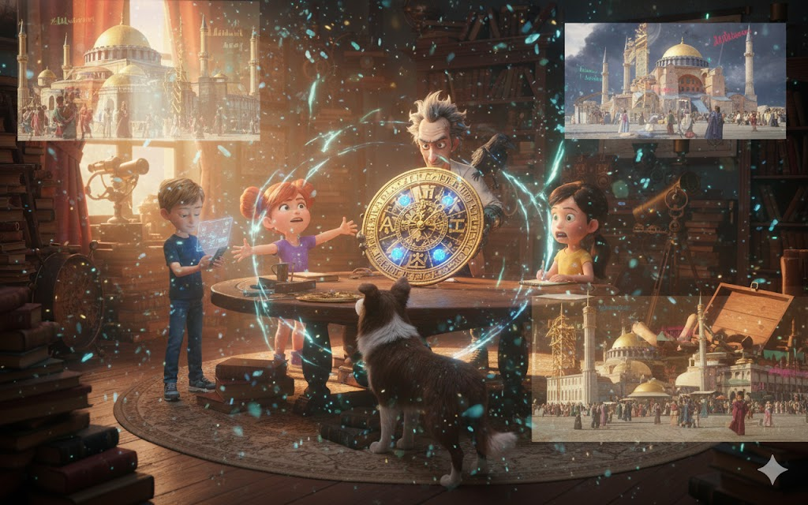
Mia's workshop seemed to have exploded.
Electronic components covered every available surface—circuits glowing, crystals pulsing, multicolored wires snaking between scattered tools. At the center of it all, like an ancient jewel on a technological altar, was the Byzantine clock, partially dismantled with surgical care.
"Fascinating," Mia muttered for the seventeenth time that morning, adjusting the overhead magnifying glass as she examined the internal gears. "The tolerances are perfect. The Byzantines did not have precision technology like this in the official theory of history..."
"Because they had Atlantean help," added Will, sitting on a stool next to her, watching. His smartphone was projecting holographic diagrams into the air - courtesy of Iris,who had spent the entire night scanning every millimeter of the watch before Mia began taking it apart.
"Exactly," Mia agreed. "See here - this gear is made of a metallic alloy that shouldn't have existed until the XIX century. And these crystalline filaments..." she tapped with tiny tweezers, "they don't just conduct energy. They transform it."
"Transform how?" asked Iris through the smartphone.
"It's like they're converting intention into frequency," Mia explained, her eyes shining with discovery. "The clock doesn't just keep time - it resonates with time. And when combined with bioenergy-charged Atlantean crystals..."
"Create a bridge," Will added, understanding. "A tunnel through temporal dimensions."
"Technically, a resonance bubble that allows projection of consciousness across stratified temporal layers," corrected Iris. "But 'tunnel' is an acceptable metaphor."
Mia smiled, taking the communicator crystal that Coral had given Will and placing it carefully next to the crystals embedded in the watch. Immediately, all the crystals began to pulse in synchrony - a living rhythm, like heartbeats speaking through the language of light.
"They recognize each other," she whispered, amazed. "It's like...like family that hasn't seen each other in ages but still remembers the shared lullaby."
Will felt a shiver. There was something deeply moving about seeing technology so ancient and so advanced working in harmony.
"How long until you can fully integrate them?" he asked.
Mia bit her lip, calculating. "If I work non-stop... maybe eighteen hours? I need to create a conductor that allows the communicator crystals to amplify the clock without overloading it. It's like... like creating a bridge between two different but related languages."
"You can do it," Will said confidently. "If anyone can do this, it's you."
Mia blushed a little, but smiled. "I'm going to need help from Iris. Her calculations on harmonic resonance were incredible."
"Thank you," replied Iris. "I'm learning a lot. Atlantean technology operates on principles that defy conventional physics, but there's a beautiful internal logic. It's almost...poetic."
"Quantum physics usually is," muttered Mia, already getting back to work.
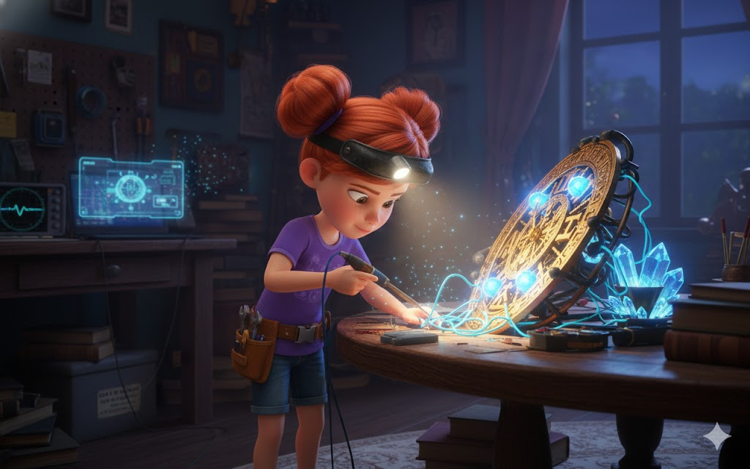
Will left the workshop, knowing that Mia would go into her "full focus mode" - something that meant she wouldn't notice anything other than the work in front of her. He had his own tasks.
• • •

In the municipal library, Sophie had created an empire of knowledge.
Stacks of books rose like towers around his desk - volumes on the Byzantine Empire, Constantinople, the sixth century, architecture, culture, religion, politics, everyday life. Yournotebook was full of carefully organized information, with colorful tabs marking different categories.
"1453," she murmured as Will approached. "Constantinople fell to the Ottomans in 1453, becoming Istanbul. But in 537, when we will be there, the city was at the absolute height of its power. Capital of the civilized world. Half a million inhabitants - larger than any European city at the time."
Will sat next to her, impressed by the amount of information Sophie had absorbed in less than 24 hours.
"What else did you find out?"
Sophie turned pages, showing drawings she had made herself—maps of Constantinople, building layouts, diagrams of social hierarchy.
"Justinian is the emperor," she began. "He came to the throne in 527, ten years before we arrive. He is...complex. Brilliant, ambitious, sometimes brutal, but also visionary. He wants to restore the Roman Empire to its former glory."
"What about his wife?" asked Will, remembering what Marino had mentioned.
"Theodora," Sophie said, her eyes lighting up. "She's fascinating, Will. One of the most powerful women in history. She came from humble beginnings - some historians say she was an actress or dancer, professions considered low at the time. But she married Justinian and became de facto co-ruler. Intelligent, political, fearless."
"Sounds like someone you'd admire," smiled Will.
Sophie blushed slightly. "Well, she defied convention at a time when it wasn't easy for women to do so. That deserves respect."
Will picked up one of the books—a heavy tome with illustrations of the Hagia Sophia. "And the cathedral?"
"Ah," Sophie perked up even more, "it's incredible, Will. The dome is over fifty meters tall and uses engineering techniques that were revolutionary. Pendentives - trianglesspherical ones that allow you to place a circular dome on a square base. Windows around the base of the dome that make it appear to float. When it was completed, people thought it was impossible, that it defied the laws of physics."
"Because there was Atlantean help," said Will.
"Exactly. But we need to look impressed when we see it, like it's the first time. We can't reveal that we know about the crystals."
"Unless we have no choice," agreed Will. "We need to be invisible, fix what's wrong, and return without a trace."
Sophie bit her lip. "Will, have you ever thought about the temporal paradox? If we change something in the past, even small, it can have huge butterfly effects."
"I thought," Will admitted. "But Marino said we're going to be in a resonance bubble, kind of like quantum observers. We can interact, but we're technically 'outside' the main timeline, so small interactions won't create paradoxes."
"Technically," Sophie repeated. "But what if the theory is wrong?"
"So we improvised," Will said with more confidence than he felt. "Like we always do."
Sophie nodded, going back to her notes. "I'm creating a Byzantine Greek phrasebook. Iris will translate in real time, but it's good to have backup. Greetings, directions, common phrases..."
"Smart," Will approved. "How long until you're ready?"
"Knowledge is never complete," Sophie said philosophically, "but I'll have a solid foundation in 48 hours. Enough so we don't make gross cultural mistakes."
"Perfect," smiled Will. "Keep up the great work."
When he left the library, the sun was out. Two days left. Forty-eight hours until the impossible.

• • •

In the school gym, Leo was training like he was getting ready for the Olympics.
Push-ups, sit-ups, running in place, stretching. But it wasn't just fitness - he was studying videos on the tablet projected on the wall, showing reconstructions of Byzantine fighting, soldier movements, ancient combat techniques.
"The key," he explained when Will entered, "is that they didn't fight like we fight today. Different techniques, different stances, different weapons."
He demonstrated a defensive stance he had learned, arms positioned in a way that seemed strange but functionally efficient.
"If we need to defend ourselves - and I hope not - I need to know how they did it. If I fight with modern techniques, they'll notice that I'm different."
"Do you really think we're going to have to fight?" asked Will, a little worried.
Leo stopped, thinking. "I hope not. But remember in Atlantis when we found those corporate guys trying to steal the crystals? We weren't expecting violence, but it was there. I'd rather be prepared."
"Makes sense," agreed Will. "Just... try not to break anything. Or anyone."
Leo laughed. "I'll be careful. I promise." He stretched, touching his toes with ease. "I'm also studying diet and fitness at the time. Byzantine athletes were amazing - wrestlers, chariot racers, gladiators in the Hippodrome."
"Chariot races?" Will was interested.
"The Hippodrome of Constantinople was legendary," Leo said, his eyes shining. "It could accommodate a hundred thousand spectators. The races were not just sport, but politics. Entire factions of the city – the Blues and the Greens – competed, and sometimes riots resulted."
"That sounds dangerous."
"We'll probably want to avoid the Hippodrome then," laughed Leo. He grabbed a towel, drying the sweat. "Will, can I ask you something?"
"Of course."
"Are you scared?"
Will considered lying, playing brave. But this was Leo - one of his best friends. He deserved honesty.
"Terrified," he admitted. "In Atlantis, at least it was still our time. But going to the past? Where everything is different, where we don't know the rules, where one mistake could change history?"
"Yes," agreed Leo. "Me too. But do you know what I think every time I get scared?"
"What?"
"That I'm with the best people possible. You're the smartest leader I know. Mia is a genius. Sophie knows everything. Max always knows how to make us laugh when we need it. And Jimmy..." he smiled, "Jimmy is simply the best dog in the universe."
Will felt a tightness in his throat. "And you are the bravest of us."
"No," Leo said softly. "Courage is not not being afraid. It's being afraid and doing it anyway. And we all have that."
Will hugged his friend, grateful to have people like that in his life. "Thanks, Leo."
"Always," Leo replied, returning the hug. "Now get out of here, I need to keep training. Those Byzantine muscles aren't going to build themselves."
Will walked away laughing, feeling a little lighter.

• • •

At Max's house, the scene was characteristically chaotic and fun.
Max was surrounded by Jimmy and three other animals he had apparently temporarily "adopted" - a rabbit, a parrot, and something that looked like a hamster but Max insisted was a "medieval mouse in training".
"See," he explained to the parrot, "in Constantinople, you would be super valuable. Exotic birds were worth fortunes on the Silk Road. So behave with imperial dignity, okay?"
The parrot shouted something that sounded like an insult.
"He has personality," Will observed, entering the room.
"All the best ones do," smiled Max. Jimmy ran to Will, tail wagging frantically. Will knelt down to greet the border collie properly, scratching behind the ears the way Jimmy loved.
"How's the preparation going?" Will asked.
Max pointed to his computer, where he had windows open with videos, articles, images. "I'm studying Byzantine humor, entertainment, games kids played. If we're going to blend in, I need to know how to act like a kid there."
"Did you find anything interesting?"
"A lot!" Max cheered up. "They had amazing board games, storytellers in the squares, mimes, acrobats. And the jokes - some of them are universal, Will. Humor about food, about parents being annoying, about animals doing funny things. Kids from every era laugh at the same things."
Will smiled. It was comforting to think that despite being fifteen centuries apart, children were still children.
"And Jimmy?" he asked, looking at the dog who was now trying to befriend the rabbit.
"Jimmy is a natural," Max said proudly. "Dogs were dogs at any time. He just needs to... you know, not do anything very obviously trained by modern humans. No complex tricks or obeying commands in English."
"We can teach commands in Greek," Will suggested.
"I'm already on it!" Max showed a list. "Iris gave me translations. 'Senta' is 'káthi-se', 'stay' is 'méne', 'come' is 'éla'. Jimmy is learning fast."
As if to demonstrate, Max said "Káthi-se!" and Jimmy sat down at once, looking hopefully at a reward.
"Good boy!" Max threw a snack that Jimmy caught in the air.
Will was impressed. "You thought of everything."
"Someone has to take care of the practical details while you save the world," Max said with a smile. But then it got more serious. "Will, can I tell you something?"
"Of course."
"I know I'm like... the fool of the class. The one who makes jokes, relieves tension, that sort of thing. And that's okay, I like this role. But I want you to know that I take this seriously. This mission, Coral needing help, the importance of everything..."
"I know," said Will gently. "Max, you're not just the funny one. You're the heart of the gang. When things get too serious, too heavy, you remind us to find joy. That's not small. It's essential."
Max blinked, clearly touched. "Thank you for saying that."
"It's true," Will insisted. He looked around the chaotic room full of animals and books and notes. "You're as prepared as any of us. Maybe more, because you're emotionally prepared."
"We'll make it, won't we?" Max asked, with a vulnerability he rarely showed. "Let's save Coral and Atlantis and fix time?"
"Come on," Will said, sure he didn't fully know where he was coming from. "Because we're the Adventure Gang. And that's what we do."
Jimmy barked in agreement, and all the other animals made noises of support.

• • •

That night, the class met again in Professor Marino's office for a preliminary test.
Mia had managed to create a prototype of the "resonance amplifier" - a fist-sized device that connected the Atlantean communicator crystals to the Byzantine clock. It wasn't perfect yet, she admitted, but it was functional.
"The theory," she explained as she set up the equipment, "is that if we activate the clock and crystals into harmonic resonance, we should be able to create a small bubble of time perception. Not enough to actually travel, but enough to 'feel' the past."
"Like a preview?" Sophie asked.
"Exactly. Like dipping just the tip of your finger in the water before jumping."
The Byzantine clock was reassembled in the center of the table, surrounded by Atlantean crystals positioned in a specific geometric pattern. Ultra-thin strands of fiber optics (courtesy of Mia's fitting) connected everything to the amplifier.
"Everyone ready?" Marino asked, checking monitoring equipment. "This is completely experimental. If anyone feels uncomfortable, they can stop at any time."
"We're ready," said Will, and everyone nodded.
Mia took a deep breath and activated the amplifier.
For a moment, nothing happened.
Then the crystals began to glow - not just blue, but full spectrum of colors that didn't seem to exist in normal reality. The clock began to turn, not just its visible gears but layers of movement that Will could swear were happening in dimensions he couldn't name.
And then he felt it.
Like diving into warm water, but the water was time. Sensation of movement without physically moving. Flashing visions - not clear, yet, but fragments:
Golden domes against impossible blue sky.
Voices speaking in an ancient language.
Smell of spices and sea and incense.
Sound of huge bells and crowds and horses' hooves on ancient stones.
"I'm seeing something," Sophie whispered in wonder.
"Me too," said Leo. "A city... gold and white..."
"Constantinople," added Marino, watching the monitors. "You're playing the temporal echo. Very light still, but it's working!"
Mia carefully adjusted controls. The feeling intensified. Will could almost see faces now - people dressed in tunics and togas, children running along cobblestone streets, merchants selling colorful fabrics...
Jimmy barked - not a normal bark, but something different. Worried.
"Something's wrong," Mia said suddenly, looking at readouts. "The resonance is... irregularities... wait..."
The view changed abruptly. Instead of golden, peaceful scenes, Will saw darkness. Crystals cracking. Structure collapsing. Someone in dark robes doing something to crystals under a huge building...
"The temporal cracks," gasped Sophie. "We're seeing what caused it!"
But the image was too unstable, too fragmented. Like trying to see through broken glass.
Mia quickly shut down the system. The crystals pulsed once more and became inert.
Absolute silence in the room as everyone caught their breath.
"So," Max said finally, "that was intense."
"It worked," breathed Mia, checking data. "Not perfectly, but it worked! We really touched the past!"
"And we saw the problem," Will added. "Someone did something to the crystals deliberately. It was no accident or natural failure."
"Sabotage," said Sophie, furiously taking notes. "Someone in 537 A.D. sabotaged the Atlantean crystals beneath the Hagia Sophia."
"But why?" Leo asked. "And who?"
"That's what we're going to find out," Will said, determination hardening his voice. "When we actually dive."
Marino was looking at the data on the monitors with a serious expression. "This test was crucial. We now know that you can make contact with the past. But it also confirmed that the situation is critical. Whoever sabotaged the crystals had knowledge of Atlantean technology. This is no coincidence."
"Someone in 537 knew about the Atlanteans," Sophie concluded.
"And he had reasons for wanting to sever the connection between the surface and Atlantis," Mia added.
"Or," suggested Iris through Will's smartphone, "he wanted the power of the crystals for himself."
"Anyway," said Will, "we need to get over there and stop. Before the cracks become irreparable."
They were silent for a moment, processing. Then Max raised his hand.
"Just to confirm: we just previewed time travel, we saw 6th century sabotage, and now we're actually going to dive back fifteen hundred years to stop a temporal villain who may or may not know about Atlanteans?"
"Yes," replied Will.
"Cool," smiled Max. "Just confirming I got it right."
Everyone laughed, the tension breaking.
"A day and a half," Mia said, carefully dismantling the equipment. "I need to make adjustments based on this test. The amplifier needs to be more stable."
"And I need to finish my cultural studies," Sophie said.
"And me my physical training," said Leo.
"And I... well, keep being adorable," Max joked, scratching Jimmy.
Will looked at each of his friends - tired but determined, scared but brave, so young but so ready for the impossible.
“We meet tomorrow afternoon for final review,” he said. "And then..."
"And then we're going to Blue Atlantis," Sophie added.
"And from there," said Marino softly, "further than any of you have ever gone."
"Through time itself," Mia whispered, touching the crystals that still glowed dimly.
And somewhere fifteen hundred years in the past, in a city that no longer existed but somehow still lived in the eternal echo of time, their fates awaited.
The gang left Marino's office that night knowing that the next thirty-six hours would define not only their adventure, but potentially the fate of two civilizations separated by an ocean and fifteen millennia of time.
Will looked up at the stars again, remembering that they were the same stars that would shine over Constantinople when they arrived.
"Are we ready?" asked Iris softly.
"No," Will admitted. "But when has that stopped us?"
"Never," agreed Iris. "And that's exactly the right attitude."
Tomorrow would bring the final preparation. The day after tomorrow, diving impossible.
But today? Today they had touched the past and felt the future calling.
And Turma da Aventura responded as they always did:
With courage, with friendship, and with an unshakable desire to do the impossible.
One more day. Then, the most impossible adventure of all would begin.

CHAPTER 3
THE DIVE THROUGH TIME
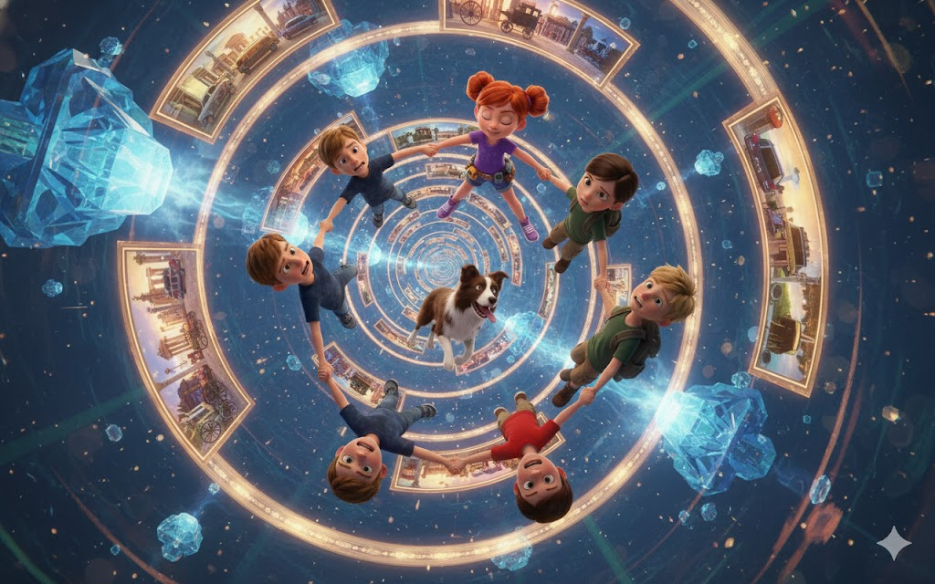
The special submarine glided through the dark waters towards Blue Atlantis, but this time the journey had a different weight. Will stared out the oval window, seeing bioluminescent fish swimming alongside, their impossible colors painting the darkness with underwater aurora borealis.
"Depth: 2,800 meters," announced Iris. "Approach to Blue Atlantis in twelve minutes."
Mia was checking the Byzantine clock for the twentieth time, now carefully packed in a special waterproof box. The resonance amplifier was attached to his tool belt, gently pulsing in sync with the communicator crystals each member of the gang now carried.
"Do you think Coral is as nervous as we are?" Max asked, holding Jimmy tightly. The border collie was wearing a special vest adapted for diving - courtesy of Mia and some favors that Professor Marino had asked for.
"Probably more," Sophie replied, leafing through her notes on Constantinople for the last time. "It's not every day you ask children from the future to travel to the past to save their civilization."
"When you put it like that, it sounds even crazier," muttered Leo.
Will smiled despite his nerves. "Crazy is our normal now."
Iris projected a holographic image into the air - Blue Atlantis approaching, its domes shining through the water like an underwater constellation. And there, waiting at the main gate, was Coral.
When the submarine docked and the gang got out, Coral ran to hug them - Will first, then each of the others, and even Jimmy received special affection as he barked excitedly.
"You came," she said, her green eyes shining with tears of relief. "I knew they would come, but a part of me was afraid..."
"Always," said Will firmly. "You saved us when we dived here. Now it's our turn to help."
Coral led them through the luminescent streets of Blue Atlantis - a city that seemed even more magical on the second visit. Atlanteans in flowing robes stood to watch the Adventure Gang pass by, some waving, others bowing their heads in respect.
"You're heroes here," Coral explained. "After they saved the energy crystals and exposed the conspiracy, they became legends. 'The children of the surface who dove into the depths to help the forgotten.'"
Max blushed. "That's kind of amazing."
"You're kind of amazing," Coral smiled, and Max blushed even more.
They arrived at the Temple of the Elders - an imposing structure in the heart of the city, made entirely of translucent crystal that seemed to grow organically from the ocean floor. Inside, five Atlantean elders waited, their ages impossible to determine, their eyes containing wisdom of millennia.
The Elder Leader - the same one who had helped them before - stood up. "Adventure Class. Welcome back to Blue Atlantis. Circumstances wish you were happier."
"Elder Marina," Will bowed his head respectfully, "we are ready to do whatever is necessary."
"Your courage honors both your era and ours," she said. "But before we proceed, you need to fully understand what you are about to face."
She gestured and crystals around the room began to glow, projecting holographic images into the air - Constantinople at its height, golden and magnificent. Then the images changed, showing Atlantean crystals being secretly installed beneath the Hagia Sophia, disguised Atlanteans working alongside Byzantines.
"Fifteen hundred years ago," the Ancient One began, "one of our most brilliant scholars, Thalass, made contact with the surface. He believed that total isolation was not sustainable, that we needed points of connection with the world above."
"Was he right?" Sophie asked, fascinated.
"Perhaps," the Elder admitted. "Thalass disguised himself and became an advisor to Emperor Justinian. He shared knowledge - subtly, carefully. Sacred geometry, engineering principles, the use of crystals for structural stabilization. The result was the Hagia Sophia - an architectural marvel that should not have been possible with technology of the time."
"And the crystals beneath held not just the structure," Mia continued, understanding, "but the very connection between Atlantis and the surface."
"Exactly. They are temporal and spatial anchoring nodes. While they function, our civilization can, if necessary, communicate with the surface, exchange knowledge, maintain ties. But if they fail..."
"They're isolated forever," added Will.
"Worse," said another Elder, his voice deep like an underwater earthquake. "The temporal rifts we have detected are not just affecting our connection. They are growing, branching across the centuries. If not repaired, they could create paradoxes that would affect both the past and the present."
"How is this possible?" Leo asked.
"Time is not linear," Iris explained, drawing diagrams. "It's more like multidimensional fabric. When you create anomalies, they can propagate in multiple directions - past, present, future."
"So we're not just saving Atlantis," Sophie said slowly. "We are saving the stability of time itself."
"No pressure," Max muttered, and even the Elders smiled slightly.
Elder Marina approached Mia. "Did you bring the Thalass Clock?"
Mia opened the box, revealing the Byzantine clock. The Elders approached, reverent.
"He created him," whispered the Ancient One. "Before I went to the surface. I said it would be necessary someday, that someone would need to dive through time just like you guys dived through the ocean."
She touched the watch gently. "But there is something you must know. Time travel through crystalline resonance requires not only technology, but strong emotional connection. You must want to be in 537 A.D. not just intellectually, but with your entire being."
"We do," said Will without hesitation. "Coral needs help. Atlantis needs help. Let's make it happen."
The Elders exchanged glances, then nodded.
"Then prepare yourselves. The temporal initiation ceremony will begin in one hour."

• • •

The Resonance Chamber was unlike anything the class had seen before.
Located at the deepest point of Blue Atlantis, it was a natural underwater cave that the Atlanteans had transformed into a scientific-spiritual sanctuary. Crystals of all sizes grew from the walls, the ceiling, the floor - creating an impossible geometry of light and energy.
In the center was a circular platform with six positions marked in a star pattern. Mia set the Byzantine clock in the exact center, its resonance amplifier connecting it to the surrounding larger crystals.
"The setup is perfect," she announced, checking readings on the waterproof tablet. "Harmonic resonance at 98.7%. Temporal stability... surprisingly high."
"Surprisingly?" asked Leo, a little nervous.
"Well, it's experimental time travel. 98% of it is basically a miracle."
The Elders entered, accompanied by Coral and more than a dozen Atlanteans specializing in crystalline science. They began to chant - not words exactly, but harmonies that seemed to resonate not just in the air but in the very fabric of reality.
"It's beautiful," Sophie whispered, tears in her eyes.
"It's quantum physics sung," said Iris admiringly. "They are using vocal frequencies to align crystalline fields into perfect resonance."
Elder Marina gestured to the class. "Take your seats. One at each point on the star. Jimmy can stay with Max - animals often perceive temporal fields better than humans."
Will, Mia, Leo, Sophie and Max took position, Jimmy sitting alertly next to Max. In the center, the Byzantine clock began to glow, its Atlantean crystals pulsing in perfect synchronization with the giant crystals around it.
"When we activate full resonance," instructed the Ancient One, "you will feel a sensation of falling. Do not resist. Let yourself sink into the temporal stream. The clock is set for December 27, 537 AD, Constantinople morning. You will arrive as quantum observers - capable of interaction but technically 'outside' the main timeline."
"And to go back?" Will asked.
Coral approached, handing each of them a small but intensely glowing communicator crystal. "These are our most powerful. When they are ready to return, activate them all simultaneously. They will create resonance strong enough to pull them back through time."
"What if something goes wrong?" Max asked, voice a little shaky.
"So we improvised," Mia said, echoing Will from earlier. "Like we always do."
Elder Marina raised her hands. The Atlanteans' singing grew, harmonies intertwining into complex musical patterns. The crystals responded, glowing more brightly until the entire chamber was awash in blue-white light that seemed to have temperature and texture.
"Remember," said the Ancient One, her voice piercing through the chanting, "you are going to a time where Atlanteans still walked disguised among humans, where our technology shaped history in secret. Trust Thalass if you encounter him. And most importantly – trust each other."
The Byzantine clock turned, its gears creating sound like ball music. Mia activated the amplifier. Resonance has reached critical point.
Will felt as if the floor had disappeared.
It wasn't falling down - it was falling up, sideways, in and out simultaneously. Through dimensions that had no name, through layers of time stacked like pages of an infinite book.
Saw fragments:
Blue Atlantis being built millennia ago...
The ocean before there were humans...
Possible futures branching like an impossible tree...
And through it all, a golden path - the temporal current leading to Constantinople, 537 AD.
"Follow the light!" shouted Iris, her voice distorted across dimensions.
Will reached for his hands - left taking Sophie, right taking Leo. He could feel everyone connected, a human (and canine) current plunging through the impossible.
The feeling of pressure increased - not physical but temporal. Like diving deeper into the ocean, but what pressed was the weight of centuries, of millennia, of History with a capital H.
"Hold on!" shouted Mia. "We are almost... we have crossed the medieval threshold... Renaissance... Middle Ages... arriving in late antiquity..."
The world exploded in golden light.
And then solid again. Ground beneath your feet. Air (not water) filling lungs. Sounds of a living city.
Will blinked, adjusting his vision. They were in a narrow alley between stone and brick buildings. Above, perfectly clear blue sky. In the distance, golden domes shining in the Mediterranean sun.
"It worked," Sophie whispered, amazed. "It really worked."
Mia was checking devices. "Date confirmed via astronomical analysis of the Iris - December 27, 537 AD. Location - Constantinople, approximately two kilometers from the great palace."
Leo touched the wall next to him, as if confirming it was real. "We're...really here."
Max walked out of the alley slowly, Jimmy at his side, both of them gaping at the unfolding view.
Will followed them and completely lost his breath.
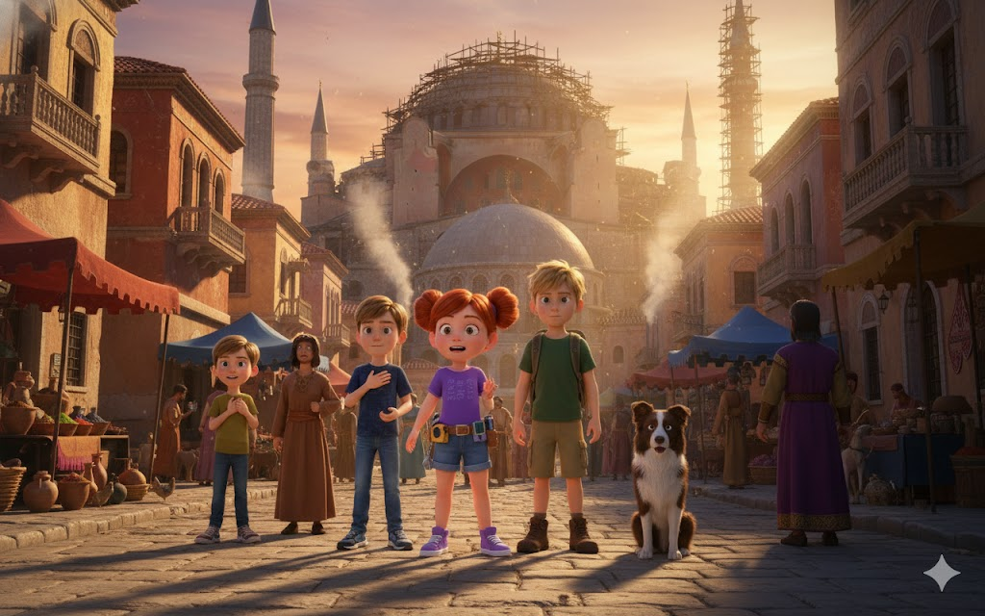
Constantinople.
Not like images in books or digital reconstructions, but real. Alive. Magnificent.
Stone streets stretched in all directions, clean and orderly. Three-, four-story buildings lined up in orderly rows, many decorated with elaborate mosaics. People in colorful robes walked everywhere - merchants shouting wares, children running and laughing, soldiers in ornate armor patrolling.
And dominating it all, on top of the highest hill, still under construction but already majestic beyond words - the Hagia Sophia.
Even unfinished, it was impossible. Its dome (still partially covered by scaffolding) seemed to defy gravity, floating on a structure that should not have been able to support such weight. Rays of sunlight reflected off golden mosaics, creating a luminous aura around the cathedral.
"Oh my God," Sophie whispered, tears streaming down her face. "She's... she's..."
"Impossible," Mia added. "And now we know why."
Will could feel the Atlantean crystals. Even miles away, even buried under tons of stone, he felt its resonance. Like a distant heartbeat, calling.
"They're down there," he said. "The crystals. I can feel it."
"Me too," Mia said, playing her amp. "And there's something... wrong. The MRI is irregular, like an abnormally beating heart."
Jimmy barked softly, looking around with keen intelligence. A Byzantine boy passing by stopped to look.
"What a beautiful dog!" he said in Byzantine Greek.
Sophie responded automatically in the same language, thanks to Iris's lessons. "Thanks. His name is Jimmy."
The boy smiled and continued, and the class exchanged impressed looks.
"It worked," said Sophie, amazed. "I look like a native to him!"
"The bubble of perception," explained Iris. "You speak modern languages, but temporal observers perceive you as local. It's part of the protection mechanism against paradoxes."
"Impressive," muttered Mia. "Thalass truly was a genius."
"Speaking of him," said Will, "we need to find him. If anyone knows what's going on with the crystals, it's the Atlantean who installed them."
"And how are we supposed to find a disguised Atlantean in a city of half a million people?" Max asked.
In response, Will's communicator crystal began to pulse gently, shining in the direction of the Grand Palace.
"I think," smiled Mia, "that he knows we're here."

• • •

Navigating around Constantinople was simultaneously exhilarating and terrifying.
The streets were organized in a grid pattern, making navigation easier. But every corner revealed a new wonder - public fountains decorated with sculptures, markets selling everything from spices to silk, small churches with dazzling mosaics.
And the people. So diverse. Will saw Africans, Asians, blond Nordics, olive-skinned Mediterraneans - the melting pot of cultures that was the Silk Road alive in human form.
"It's like the whole world in one city," Sophie marveled.
"Constantinople was the literal crossroads of the world," explained Iris. "Bridge between Europe and Asia, meeting point of civilizations."
Following the pulse of the crystal, they approached the Grand Palace - a massive complex of buildings, gardens and walls that practically occupied an entire neighborhood.
But before they reached the gate, Jimmy stopped abruptly, growling low.
"What's up, kid?" Max asked.
The border collie was staring at a man in dark robes standing in a nearby alley, surveying the Hagia Sophia with an expression that Will could only describe as hunger.
And when the man turned slightly, Will saw eyes that glowed with unnatural knowledge. And something else - recognition.
The man saw the class, and for a moment, his eyes widened. Then he disappeared into the alley with speed that wasn't quite human.
"That was..." Leo began.
"It wasn't normal," Mia added. "The way he moved, his eyes..."
"He knew about the crystals," Sophie said with certainty. "I saw it. The way it looked at Hagia Sophia was like a predator looking at prey."
Will felt a chill down his spine. "We found our saboteur."
Jimmy barked in agreement, but the sound was interrupted by a voice behind them.
"Not exactly."
The class turned. A tall, dignified man in official robes stood there - indeterminate age, deep-set eyes that seemed to contain oceans.
And they glowed slightly with the blue-green tone characteristic of Atlanteans.
"Thalass," whispered Mia.
He tilted his head. "And you are the 'Temporal Restorers' that Coral said would come. Welcome to Constantinople, Adventure Class. I apologize for the urgency, but we don't have time for formalities."
He gestured and they followed him to a side passage, away from prying eyes.
"What you saw," Thalass said quickly, "is Councilor Niketas. He is not the saboteur - he is just human using stolen knowledge. The real problem is much bigger."
"Bigger how?" Will asked.
Thalass looked at each of them with a serious expression. "Niketas found out about the crystals and wants their power. But there is an Atlantean faction - rebels who disagree with surface contact - who want to destroy my work. They sent agents to sabotage the crystals, and Niketas is being manipulated without knowing that he is serving the purposes of others."
"This is complicated," said Max.
"It is time," Thalass replied. "Always complicated. But you are key. Quantum observers from outside the main timeline. You can interact without creating major paradoxes. You can do what I can't - stop both sides without revealing the complete truth to the population."
"What do you need us to do?" Will asked.
Thalass smiled, and it was an expression full of mixed hope and despair. "Save the future by protecting the past. Starting now."
In the distance, bells from the Hagia Sophia began to ring.
And the real adventure began.

CHAPTER 4
WONDERS AND MYSTERIES OF CONSTANTINOPLE
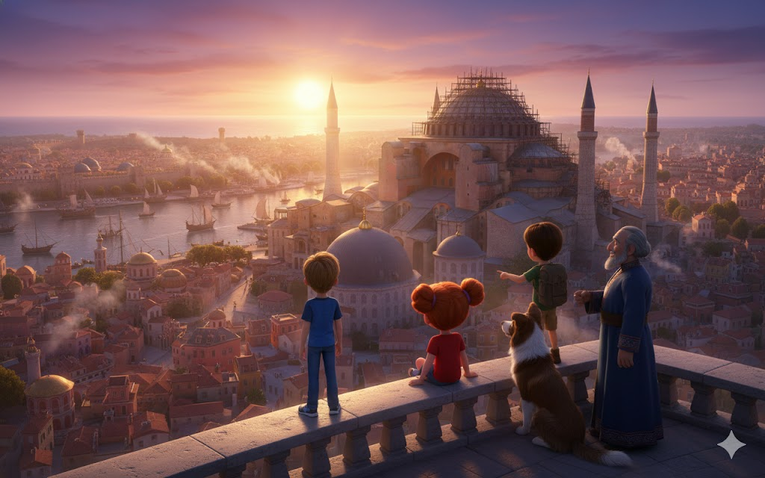
Thalass led them through narrow streets and alleys that seemed invisible to the common eye of Constantinople. Will was aware of every detail - the smell of baking bread mixed with incense from nearby churches, the sound of blacksmiths hammering metal in the distance, the voices in Byzantine Greek flowing around them like complex music.
"The city is waking up," Thalass said softly, gesturing to the sky that was beginning to lighten with shades of pink and gold. "In an hour, the streets will be completely full. You need to understand what you're up against before you dive in too deep."
They ascended a worn stone staircase, the steps polished by centuries (or was it decades? Will was still adjusting to the reality of being in 537 A.D.) of walking feet. At the top, Thalass took them to a hidden viewpoint - a small platform between two buildings that offered a panoramic view of almost the entire city.
And there, as the sun rose over the Bosphorus, Will completely lost his breath for the second time that impossible morning.
Constantinople lay beneath them in all its imperial glory.
The city was bigger than Will had imagined - much bigger. Stone and red brick buildings stretched as far as the eye could see, arranged in an orderly grid that showed advanced urban planning. Church domes dotted the landscape like pearls, each reflecting the golden light of dawn. The Bosphorus glowed deep blue, with dozens of ships already moving - merchants bringing silks from China, spices from India, amber from the Baltic.
And dominating everything, at the highest point of the city, the Hagia Sophia under construction stood like a dream becoming reality. Even unfinished, even with scaffolding still covering parts of the structure, it was impossible. Majestic. Transcendent.
"My God," Sophie whispered, tears in her eyes again. "It's even more beautiful in daylight."
"Five hundred thousand people," Mia said, her analytical mind processing what she saw. "Biggest city in Europe. Maybe in the whole world at this time."
"And the most diverse," Thalass added. "Look - there, the Persian merchants' quarter. There, the Egyptian artisans' zone. Beyond, diplomats from lands so far away that they don't yet have names on your future maps. Constantinople is where the world meets."
Leo was pointing at a massive U-shaped structure. "Is that the Hippodrome?"
"Yes," confirmed Thalass. "It can accommodate a hundred thousand spectators. This afternoon's races will be between the Blues and the Greens - the most powerful factions in the city. More than sport, it's politics. Emperor needs to keep both sides happy to avoid riots."
"Riotings?" asked Max nervously.
"Five years ago, there was a revolt so violent it almost overthrew Justinian," Sophie explained, her encyclopedic knowledge emerging. "Nika's Revolt. Half the city burned. Theodora, the empress, convinced Justinian to stay and fight rather than flee."
Thalass looked at Sophie with approval. "You studied well. Yes, the Nika Rebellion is still fresh memory. That's why political tensions are always high. And that's why Niketas' conspiracy is so dangerous - he plans to use fear of 'pagan magic' to create new panic."
Jimmy barked softly, as if he understood the gravity.
"But before we deal with conspiracies," Thalass said, "you need to meet someone. An ally who could be crucial."

• • •

Thalass led them back to the streets, which were now quickly coming to life. Merchants opened stalls, women carried jugs of water from public fountains, children ran screaming in morning games.
Will was amazed at how many of these kids stopped to look at Jimmy in awe. Apparently, border collies were rare in Constantinople.
"Cute dog!" shouted a boy running past.
Max waved, smiling. "He's the best!"
They arrived at a market near the Grand Palace - a covered bazaar where the entire world seemed to be for sale. Colorful silks hung like rainbows, spices in aromatic piles that made Will's eyes water (in a good way), jewelry sparkling in the filtered light, parchments with writing in dozens of different languages.
"Stay close," warned Thalass. "This market is safe, but there are pickpockets and…"
A small, fast figure ran between them, so fast that it was barely noticeable. A second later, a fat merchant shouted:
"Thief! Catch her! That girl stole my bread!"
But the girl—for Will caught a glimpse of curly dark hair and lively brown eyes—had already disappeared into a maze of tents.
Thalass sighed. "Or pickpockets and desperate street girls. Come on, let's try to get to her before the guards do."
They followed Thalass through the market, Jimmy sniffing along the way. The border collie seemed to have locked onto the girl's scent, guiding them through shortcuts that not even Thalass knew about.
They found her in a dead alley behind the market, cornered against a wall, holding a loaf of bread no bigger than her hand. She was in a defensive position, but Will could see she was scared.
He was about ten years old, his clothes were simple and patched but surprisingly clean considering he lived on the streets. Dark hair fell in unruly curls around a face that mixed determination with vulnerability.
"Please," she said in Byzantine Greek, "I'm just hungry. Don't hurt me."
"Nobody's going to hurt you," Will said automatically, and thanks to the time perception bubble, the words came out in perfect Greek.
The girl blinked, clearly surprised by the gentle tone.
Thalass approached slowly, as if approaching a frightened animal. "Theodora, isn't it?"
She stiffened. "How do you know my name?"
"I know your grandmother. She was... friends with certain acquaintances of mine."
Theodora frowned. "Grandmother died two years ago."
"I know," Thalass said softly. "And I'm sorry. She was a wise woman."
"She told me stories," Theodora said, her guard dropping slightly. "Of the water people. Of ancient knowledge hidden beneath the stones of the city."
Mia exchanged glances with Will. Did this girl know about Atlanteans?
Max stepped forward, holding a small package of food he had brought from the future (carefully hidden, of course). "Here. Swap it for bread. I promise it's better."
Theodora looked at the package suspiciously, then at Max, then at Jimmy - who was sitting, wagging his tail gently.
"Dog trusts you," she said slowly. "Dogs know about people."
"They really do," Leo agreed, crouching down to be at her eye level. "And we're friends, I promise. My name is Leo. This is Will, Mia, Sophie, Max, and Jimmy."
"You're not from here," declared Theodora. It wasn't a question.
Will felt his heart speed up. "Why do you say that?"
"Because they speak perfect Greek but words are... different. Accent I don't recognize. And clothes - they look local, but details are wrong. Buttons of a type I've never seen. Strangely woven fabric."
Sophie murmured impressed, "She's observant."
"I've been living on the streets for two years," said Theodora with wounded pride. "You learn to notice details or you die of hunger."
Thalass intervened. "Theodora, your grandmother once told me that if she needed help, she would trust foreigners to come and do the impossible. I think these are those foreigners."
Theodora studied each of them carefully. His eyes rested on Mia for a long moment - specifically on the tool belt the inventor always carried.
"These tools," she said, "are not from a local blacksmith."
Mia smiled despite the tension. "No. They come from far, far away."
"Water People?" whispered Theodora.
"Friends of the waterfolk," Will corrected. "We've come to help. There's something wrong under the great cathedral - the Hagia Sophia. Crystals that need fixing."
Theodora looked at them for a moment that seemed to last forever. Then, surprisingly, she smiled - not a full smile, but the beginning of one.
"Grandmother said I would play an important role one day. She said ancient knowledge would need a new guardian when she was gone." She squared her shoulders, suddenly looking ten years older. "If you came to repair the crystals, then I will help. I know every tunnel, every secret passage in this city. No one knows Constantinople better than me."
"So we have a deal?" Will asked, holding out his hand.
Theodora looked at her hand, then squeezed it tightly. "We have an agreement. But first, tell me - what exactly are you trying to stop?"

• • •
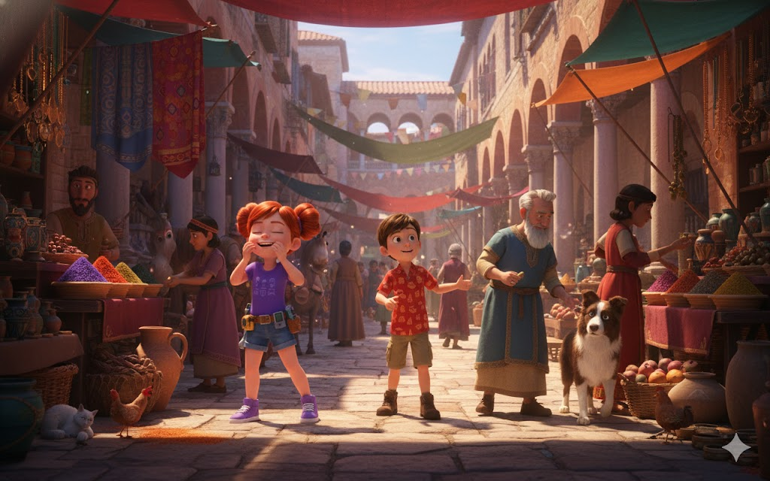
They found refuge in one of the secret safe houses that Thalass maintained - a small room above the scribe's workshop, hidden but comfortable.
As Theodora ate (voraciously, making Will realize how truly hungry she was), they explained the situation. Thalass left out details about time travel - too complex, too risky to reveal - but he explained about Atlantean crystals, about Niketas, about rifts that threatened not just Constantinople but ancient connections that held civilizations together.
Theodora took it all in with an intensity that reminded Will of Sophie when she was learning something crucial.
"So Councilor Niketas," she said slowly, "that man who is always whispering in the ears of important people, who walks in the shadows like a mouse - he wants to destroy crystals?"
"He wants to steal them," Mia corrected. "Using your power without understanding consequences."
"And if it succeeds," Sophie added, "Hagia Sophia may collapse prematurely. It will be a disaster."
Theodora chewed thoughtfully on a piece of cheese. "I saw him. Watching the cathedral from afar. He always seemed...hungry. The way you look at something you want but can't have."
"He's being manipulated," Thalass explained. "By a faction of my own people who disagree with contact with humans. They want it to fail, they want the connection severed."
"Your own people?" Theodora looked at Thalass with new understanding. "Are you... are you water people?"
Thalass tilted his head. "I am. And these children are allies from much further away than you realize."
Theodora processed this, then asked the more practical question: "What do you need me to do?"
"Do you know the chambers beneath the Hagia Sophia?" Mia asked.
"Some," admitted Theodora. "There are old tunnels, cisterns, passages that date back even before the cathedral. Grandmother showed me some before she died. She said that one day I would need to see them."
"She knew," Thalass said softly. "Your grandmother was guardian. And you are becoming what she was."
Tears glistened in Theodora's eyes, but she blinked them away determinedly. "Then tell me what to do."
Will looked at his friends, saw determination reflected in every face (and Jimmy's snout). "We need to get into the Hagia Sophia. Find the chamber where crystals are hidden. Find out exactly what Niketas plans and when."
"And then," said Leo, snapping his fingers, "stop him."
"Without revealing Atlantean secrets to the general population," Sophie added. "Without drastically changing history."
"No pressure," Max murmured, and Theodora surprisingly laughed - a clear, bell-like sound.
"You guys are funny," she said. "Mysterious travelers from far away trying to save the city with the help of an orphaned street girl. Sounds like a story a grandmother would tell."
"The best stories," Will said with a smile, "are the ones we live, not just hear."
Theodora nodded decisively. "So when do we start?"
Thalass looked out the window, measuring the sun's position. "Hagia Sophia construction site opens to workers in two hours. If they want to enter without suspicion, they will have to look like apprentices."
"Apprentices," Mia repeated, already thinking. "We can do this. My engineering is advanced, but I can pretend to be a beginner."
"And I," said Leo, flexing, "can carry rocks with the best of them."
Sophie was taking notes. "We need to memorize basic layout, worker hierarchy, main architects..."
"Isidore of Miletus and Anthemius of Trales," Theodora supplied. "They are geniuses. But they are also... peculiar. They speak in a language of numbers and angles that most people don't understand."
"Perfect," smiled Mia. "I speak this language fluently."
Jimmy barked, and Theodora petted him. "And you, brave companion? What is your role?"
Max translated (partially): "Jimmy is our explorer. His nose is better than any map."
"So we have a plan," said Will, feeling that familiar feeling of adventure about to truly begin. "We entered as apprentices, found the secret chamber, assessed damage to the crystals, and discovered Niketas' timeline."
"Simple," said Theodora with irony that made Will like her even more.
"Simple," he agreed. "Except for the part where it's completely impossible."
"Impossible," said Theodora, unconsciously echoing Will from moments before, "it's just difficult that we haven't done yet."
Will reached out his hand again. "Officially part of the gang now?"
Theodora pressed without hesitation. "Officially."

• • •

The next two hours were spent in frantic preparation.
Thalass arranged for appropriate apprentice clothing—simple tunics, worn sandals, hair scarves (in the case of girls). Theodora guided them about worker slang, about showing respect to master craftsmen, about shortcuts through the construction site.
Mia studied basic construction diagrams that Thalass had (legitimately acquired through his role as an advisor). Sophie memorized names and faces. Leo practiced lifting heavy objects with Byzantine technique. Max taught Jimmy not to react to commands in English - only Greek.
And through it all, Will felt that distant pulse - the Atlantean crystals beneath the Hagia Sophia, calling, their irregular beats like a sick heart in need of healing.
"Do you guys feel it?" he asked at one point.
Mia nodded. "Like vibrating wrongness. The crystals are in pain."
"Then let's heal them," said Theodora decisively. "Grandmother always said that crystals are living things. If they are alive and suffering, they deserve help."
Finally, as the sun rose at noon, they were ready.
Thalass led them to a final viewpoint before descending into the flowerbed. From there, they could see Hagia Sophia in all its splendor under construction - scaffolding covering the massive dome, workers looking like ants against the impossible scale of the structure.
"Remember," said Thalass, "you are quantum observers. You can interact, but you are not truly 'part' of this timeline. This protects you from paradoxes, but it also means you must be careful. Very large changes can break the protective bubble."
"Understood," said Will. "Subtlety is key."
"What if they find Niketas?" Thalass asked.
"We watched," Sophie replied. "We've learned. We haven't confronted yet."
"Wise," approved Thalass. Then he looked at each of them. "Fifteen centuries apart, and you are still the bravest people I know. Your era has created something special."
"Our era?" said Max. "We just met some amazing people from your era too."
He pointed to Theodora, who blushed but smiled.
"Then let's go," said Will, looking at the Hagia Sophia. "History is waiting."
"Not just waiting," Theodora corrected, starting down the hill. "Happening. And let's be part of it."
And so, with the midday sun shining over Constantinople in all its golden glory, the Adventure Gang - now with an added member - descended into the impossible.
Towards the gravity-defying cathedral.
Towards the crystals that pulsed sickly beneath ancient stone.
Toward a conspiracy that threatened not just a city, but the fabric of time itself.
Above them, the Hagia Sophia waited.
And beneath it, in the forgotten depths, Atlantean secrets waited to be discovered.
The real adventure was just beginning.

CHAPTER 5
THE SECRET OF HAGIA SOPHIA
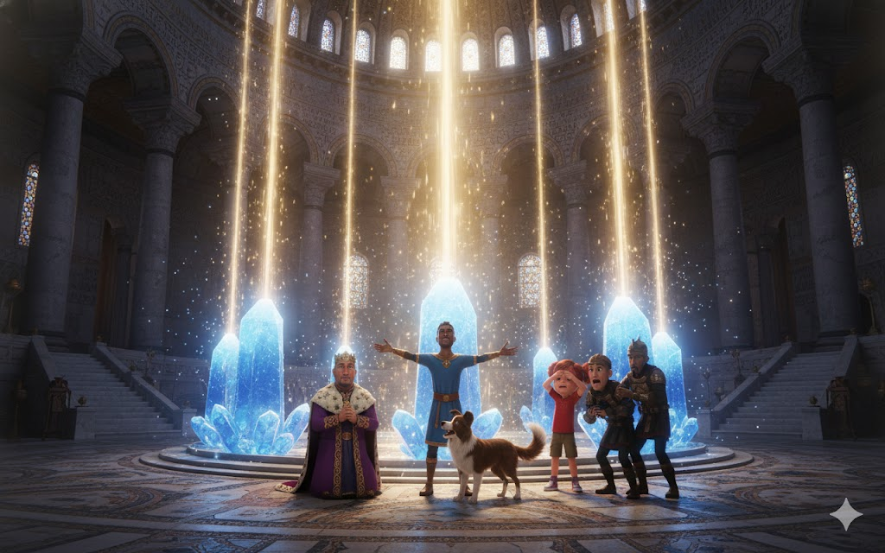
The Hagia Sophia construction site was a human anthill of impossible activity. Will, disguised in a simple apprentice's robe, looked up and felt dizzy - the partially constructed dome seemed to float, defying all logic of physics he knew.
"Amazing," whispered Mia beside him, her inventor's eyes shining as she analyzed the construction techniques. "The pendentives - spherical triangles allowing a circular dome on a square base. And that..." she pointed discreetly, "that is temporary support that shouldn't support half the weight it's holding."
"Unless," muttered Will, "there's a little Atlantean help."
Theodora guided them through the organized chaos - hundreds of workers carrying blocks of marble, artisans creating elaborate mosaics, engineers shouting instructions intechnical Greek. Jimmy remained close to Max, behaving perfectly like an ordinary working dog.
"There," said Theodora discreetly, pointing to two men in more elaborate robes examining complex architectural drawings. "Isidore and Anthemius. The masters."
Isidore of Miletus was a man in his forties, thin, with intense eyes that seemed to see not what was, but what could be. Anthemius of Trales was younger, robust, hands stained with ink and clay. Both spoke quickly, gesturing to invisible angles and curves.
"...if we increase the radius by three spans," said Isidoro, "the pressure will distribute evenly across the arcs..."
"But the load," countered Anthemius, "will exceed structural capacity unless..."
Mia couldn't contain herself. He advanced, almost forgetting that he was supposed to be a beginner apprentice. "Unless they use counterforces at the bases, redistributing weight through a specific geometric pattern based on the golden ratio?"
Both architects stopped, looking at the eight-year-old girl who had just described an advanced engineering principle as if it were obvious.
"And you are?" asked Isidoro, eyebrows raised.
"Mia," she said, remembering to bow respectfully. "Apprentice, sir. My father was... an engineer. From distant lands."
"Really distant," Anthemius murmured, studying her. "No local engineers train girls. Your eyes... you see the invisible lines, don't you? The hidden geometries?"
Mia nodded, unable to lie about it.
Isidoro smiled, genuinely delighted. "Come then, young engineer from distant lands. Show us these counterforces you mention."
For the next hour, Mia worked with the sixth century's most brilliant architects, balancing apprentice humility with knowledge she shouldn't possess. Will, Sophie, Leo, Max, and Theodora watched in amazement as she subtly guided the masters to solutions, always making it seem like they were their ideas.
But through it all, Will felt it - that pulse of the crystals, stronger now. Calling from somewhere below them.
"Theodora," he whispered when the opportunity arose, "the tunnels you mentioned. How do we get there?"
She looked around, then gestured discreetly. "He follows."
Leaving Mia in engineering ecstasy with Isidoro and Antêmio, the rest of the class followed Theodora through less busy parts of the construction site. She led them to an almost invisible entrance hidden behind a pile of marble blocks - a stone staircase descending into darkness.
"Ancient cisterns," she explained softly. "Built before the cathedral. Grandmother showed them to me. She said that beneath them, even deeper, there is something even older."
Leo lit the small torch that Thalass had provided. The flickering light revealed a narrow passage of worn stone, damp, cold. They went down, Jimmy leading the way with a keen sense of smell.
The passage opened into a larger chamber—cistern indeed, stone columns supporting a vaulted ceiling, dark water reflecting torchlight in dancing patterns. It was beautiful in a strange, disturbing way.
But it was not the final destination.
Jimmy barked, pointing to a specific wall. Sophie approached, ran her hands over seemingly solid stones. "Here. There's empty space behind. Echo is different."
Leo pushed, then pushed harder. With the creak of ancient stone not moved in centuries, the section of wall slid aside, revealing the passage beyond.
And light.
Soft, pulsing, familiar blue light.
"Crystals," Will whispered, feeling resonance in his own bones.
They descended once more, the passage becoming narrower, older. The stones changed from Byzantine architecture to something more ancient—blocks perfectly fitted together without mortar, technology Will recognized from Blue Atlantis.
Finally emerging into the chamber that took everyone's breath away.
It was its own underground cathedral - high ceiling, elegant columns, and in the center, arranged in a precise geometric pattern, nine Atlantean crystals each the size of a person.
But where Blue Atlantis crystals shone with healthy, steady light, they pulsed irregularly. Some had visible cracks. One was completely out. And worse - Will could see, even without Mia's tools, that they were deliberately damaged. Precise cuts, calculated sabotage.
"Who would do that?" whispered Theodora, reverent and horrified.
"Someone who doesn't understand," said a voice behind them, making everyone turn around sharply, "that destroying the past destroys the future as well."
Counselor Niketas stood at the entrance to the chamber, accompanied by three guards with drawn swords.
But it wasn't guards that made Will freeze.
He was the second man next to Niketas - tall, eyes shining with an unmistakable blue-green hue. An Atlantean. But where Thalass radiated wisdom and compassion, this one radiated cold calculation.
"Temporal Restorers," said the rebel Atlantean, voice like ice. "Coral sent children to do guardian work? Atlantis is more desperate than I thought."
"Who are you?" Sophie asked, keeping her voice steady despite her fear.
"Kaelum. And unlike Thalass, human-embracing traitor, I understand truth - surface civilizations destroy everything they touch. This connection," he gestured to damaged crystals, "must end. It should have ended millennia ago."
Niketas looked confused, looking between Kaelum and the children. "You said they were just thieves trying to steal holy relics. You didn't mention...water people, whatever that was."
"Because you are a tool, Niketas," said Kaelum coldly. "Useful human, but tool nonetheless. After crystals are destroyed and cathedral collapses, you will have your political power. And I will have Atlantis isolated from surface contamination. Everyone wins."
"Except," said Max, his young but clear voice cutting through the tension, "for the part where hundreds die in the collapse. And where connection between peoples is severed forever. And where you become exactly the kind of isolationist who makes civilizations die."
Kaelum looked at Max with something like amusement. "Brave child. But foolish. Isolation is not death - it is protection."
That's when Jimmy attacked.
Not fiercely, not violently. The border collie just ran past the surprised guards, straight to Kaelum, and started... crying. Short, whiny barks, the sound he made when something was wrong, when someone was hurt.
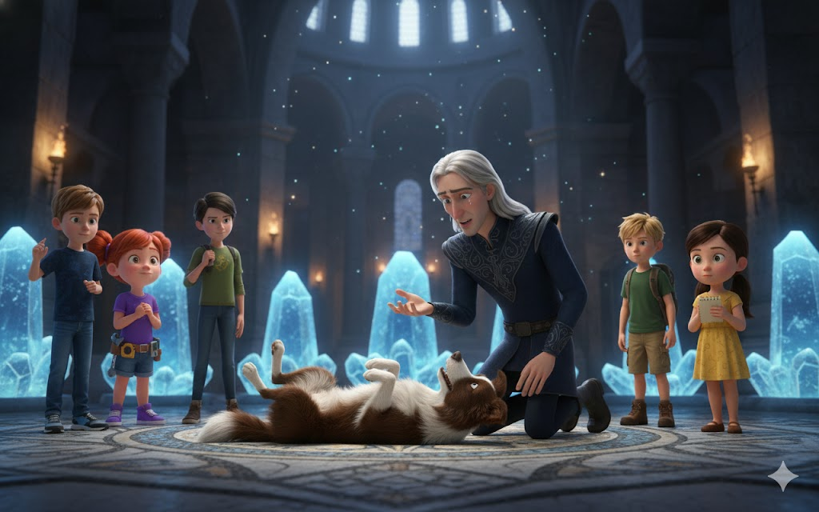
And to everyone's complete surprise, including Kaelum, the rebellious Atlantean automatically knelt down, hand reaching out to comfort the dog.
"I..." he began, confusion on his face, "why would you..."
"Because," Theodora said softly, stepping forward with a boldness that made Will's heart almost stop, "even you are not as isolated as you think. Humans and Atlanteans, we are not so different. We both love. We both fear. We both react to the creature suffering."
Jimmy groaned again, and Kaelum - a powerful Atlantean rebel bent on destroying civilizations - scratched the border collie behind the ears with surprising gentleness.
Niketas, seeing a moment of distraction, decided to act. He drew his dagger and advanced toward the nearest crystal, clearly planning to complete destruction.
But Leo was faster.
In a fluid movement that combined Byzantine training with modern reflexes, the ten-year-old picked up the torch and threw with perfect precision. It struck Niketas' dagger, sending it flying across the chamber.
"No!" shouted Niketas.
The guards advanced, but Sophie was ready. "Stop!" she shouted in impeccable Greek, voice filled with authority that should not belong to an eight-year-old girl. "By order of Emperor Justinian! These crystals are imperial property!"
It was a complete bluff. But it worked. Guards, trained to obey imperial authority above all else, hesitated.
And in that hesitation, everything changed.
A ray of sunlight penetrated through the opening in the chamber's ceiling - perfect alignment, perfect timing. It hit crystals, and even though they were damaged, they responded.
Blue light exploded through the chamber, not harmful but completely overwhelming. Will saw, just for a second, what it must be - the nine crystals working in perfect harmony, resonating with the structure above, not just supporting physical weight but aligning forces on a quantum level that made the impossible possible.
He saw the vision that Thalass had had - a future where Atlanteans and humans worked together, shared knowledge, advanced instead of warring.
And he saw the same recognition on Kaelum's face. The same possibility.
The rebellious Atlantean fell to his knees, not out of weakness but out of understanding. "I...I forgot," he whispered. "I was alone so long I forgot why Thalass believed."
Niketas, however, was beyond reason. He picked up the dagger again, eyes wild. "No! My plan! My power!"
It was Theodora who stopped him. Not with violence, but with words.
"Councillor Niketas," she said, little street orphan stopping powerful man with nothing but naked truth. "Grandmother once told me that power taken from others always crushes the taker. But power shared lifts all. These shining stones are not your path to greatness. To truly serve your emperor, your city, your people - that is greatness."
Niketas looked at her - orphaned, homeless, nameless child. And he saw something that broke any fanaticism that remained.
Maybe he saw it himself. What might have been before ambition consumed compassion.
Slowly, the dagger fell from his hand.
"I was so right," he whispered. "So sure he was saving the empire."
"You still can," Will said gently. "Save it by letting crystals work. Letting wonder be wonder."
The guards, finally understanding that they had witnessed something beyond common understanding, decided nonverbally that they had seen nothing. They retreated discreetly to pass.
Kaelum stood up, Jimmy still at his side. He looked at the crystals, then at the children. "You told us to keep going," he said, not defensively but with genuine admiration. "So young, but so determined."
"As you were when you founded Atlantis," Mia added, finally reaching them - she had found her way through engineering instinct. "When they believed that knowledge should be shared."
Kaelum nodded slowly. "Thalass was right. And I... I really need to rethink."
"But these crystals," Mia said, already approaching with makeshift tools, "still need repairing. And we don't have much time."
Niketas, suddenly looking much smaller and older, asked, "What do you want from me?"
"Let us fix it," Will said simply. "And when the cathedral is consecrated tomorrow, celebrate with everyone else. Not as a conspirator, but as a citizen of Constantinople who helped protect something precious."
Niketas hesitated, then nodded. "I... will. But how will I explain to my..."
"Say you had a vision," Sophie suggested. "That God showed error. Byzantines believe in visions."
A sad smile crossed Niketas' face. "They really believe it. And who's to say this wasn't the case?"
He left, followed by his guards. Kaelum remained for the moment.
"Surface children," he said finally. "You have given me much to contemplate. I will return to Atlantis and... talk to elders again. Perhaps I will listen this time."
"That," said Theodora with wisdom beyond her years, "is all we can ask."
Kaelum left, and the gang was left alone in the underground chamber with nine Atlantean crystals in desperate need of help.
"So," said Mia, rolling up her metaphorical sleeves, "who's ready to save the future?"
Everyone raised their hands.
And work began.

CHAPTER 6
THE THREAT OCULTA

Mia's work on the crystals lasted hours.
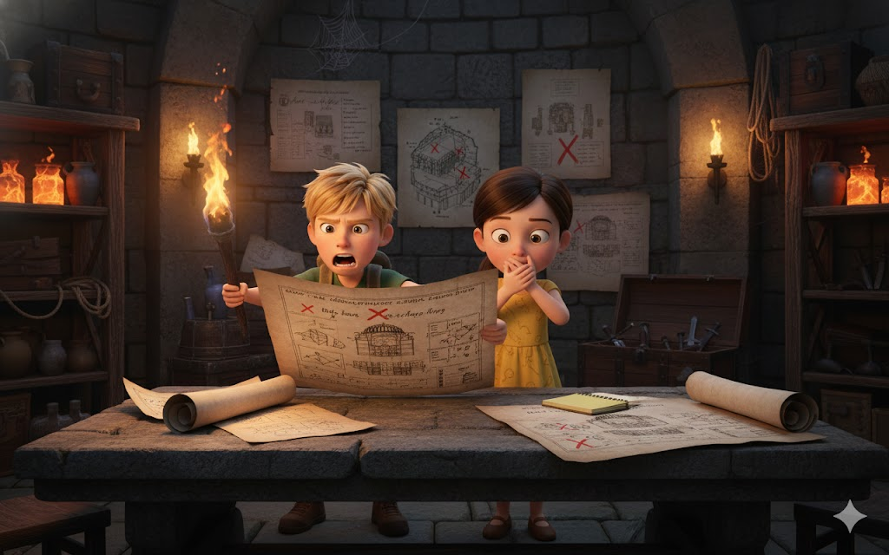
Will watched, fascinated, as she used Atlantean tools that Thalass had provided, combining them with improvised Byzantine materials in ways only a genius inventor could imagine. Theodora held torch, angled light exactly where Mia needed it. Leo and Max stood guard at the entrances. Sophie documented everything in her mind, her photographic memory capturing every detail.
And Jimmy... Jimmy just sat, focused on the crystals with an intensity that Will couldn't fully explain. As if the border collie could feel not only the presence of the crystals, but their pain.
"This one," Mia murmured, hands shaking slightly as she adjusted the molecular structure of a cracked crystal, "was damaged months ago. Slow, methodical sabotage. Whoever did this... understood Atlantean crystals. Very well."
"Kaelum?" suggested Sophie.
"Maybe. But..." Mia frowned, "there's something about the cuts. Multiple angles, multiple tools. Like more than one person worked on it at different times."
Will felt a chill down his spine. "Are you saying Kaelum wasn't working alone?"
"I'm saying," Mia replied slowly, "that even if Kaelum changed his mind, there may be others who haven't."
Theodora lowered the torch slightly, face worried. "Councillor Niketas had... associates. Men who always whispered to him in the corners of the palace. Grandmother used to warn me to avoid them when wandering near the imperial areas."
"Men loyal to Niketas specifically," said Sophie, "or loyal to his cause?"
"To the cause," replied Theodora with certainty. "Niketas was just face. There is an entire faction that believes that ancient magic is dangerous, that the Empire should reject everything it doesn't understand."
Max appeared at the entrance, out of breath. "Guys, we have a problem."
Everyone turned.
"Leo found something," Max continued. "You guys need to see it."

• • •

The discovery was in a small office that Leo had explored while on security patrol - a forgotten room attached to the ancient cisterns, probably used by some administrator centuries ago.
It now contained a table, chair, and - crucially - documents.
Sophie was already hunched over them when Will and the others arrived, her eyes moving quickly as she read ancient Greek as if it were her native language.
"It's a plan of attack," she said without looking up. "Thorough, detailed, frighteningly well thought out."
"Let me guess," said Mia, "it's not just from Niketas."
"Niketas is referred to as 'public tool' - exactly as Kaelum called him. But there are at least three other conspirators identified by code names: 'The Scholar', 'The Soldier', and 'The Merchant'."
Will felt his stomach sink. "And their plan is...?"
Sophie took a deep breath. "During the consecration ceremony tomorrow - December 27th - when Emperor Justinian and the entire court are present, when thousands of citizens fill the Hagia Sophia..." she paused, "crystals will be completely destroyed. Not just damaged. Destroyed."
"As?" Leo asked.
"Greek fire," Sophie replied, voice tense. "Byzantine incendiary that burns even underwater. A sufficient amount, placed precisely where crystals are fragile, and..." she didn't finish the sentence.
It didn't need to. Everyone understood.
"The dome would fall," muttered Will.
"Not right away," Sophie corrected. "The crystals aren't just holding physical weight - they're aligning forces at a quantum level, remember? Without them, Hagia Sophia couldlast days, maybe weeks. But during the opening ceremony..." she looked at each of them, "structural stresses would be at their highest. Thousands of people inside. And when it started to collapse..."
Theodora turned pale. "It would be a massacre."
"And Niketas – or any surviving conspirators – could blame 'dangerous pagan magic,' sweep away any Atlantean evidence, and consolidate political power," Mia added. "Perfect for them."
"Except," said Max with determination that Will recognized from previous adventures, "for the part where we won't let it happen."
Jimmy lative I remember.
Will looked at documents, then at his friends. "We have less than..." he glanced at the position of the shadows, calculating time of day, "twelve hours until ceremony. We need a plan."
"First," said Sophie, still reading, "we need to identify who 'The Scholar', 'The Soldier', and 'The Merchant' are. The documents mention meeting points, times..."
"I can track them," Leo offered immediately. "I know surveillance techniques."
"Not alone," said Theodora. "This is my city. I can take you anywhere without being noticed. And I have... friends. Street kids who see everything, hear everything."
"Intelligence network," Sophie muttered, impressed. "Smart."
"I stay here finishing crystals," said Mia. "If the conspirators attack, healthy crystals have a better chance of surviving the sabotage."
"But you can't do it alone in twelve hours," Will pointed out.
"Then I need an assistant," Mia looked at Theodora. "Someone with steady hands and a quick mind."
Theodora looked torn. "I wanted to help Leo track down..."
"We can split up," Max suggested. "Theodora stays here helping Mia for the first few hours, teaches me routes and contacts. Then Jimmy and I track while she works on the crystals. Border collies," he petted Jimmy, "are excellent at following people."
"And me?" Sophie asked.
"You," Will said, plan forming in his mind, "come with me. We need to talk to Thalass. If there are more rogue Atlanteans involved, he needs to know. And perhaps he can give us information about who 'The Scholar' could be - someone who understands crystals as well as Kaelum."
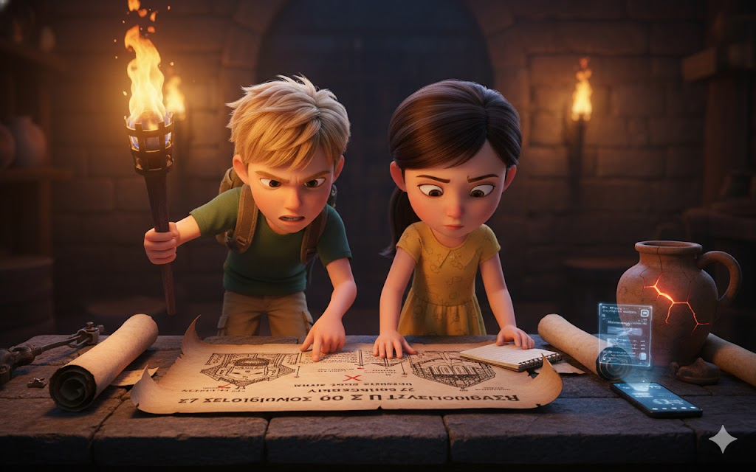
Sophie nodded. "Iris can help. If I photograph these documents with her cell phone, she can analyze them, look for patterns."
Will took out his smartphone, feeling the familiar presence of Iris activating it.
"I detected conspiracy talk," said the AI's synthesized but curiously emotional voice. "I suppose you need my brilliant analytical skills?"
"Always so modest," Max murmured with a smile.
"Modesty is for less capable AIs," replied Iris. "Photograph documents. I will begin linguistic pattern analysis, cross-references with Byzantine historical data that Sophie downloaded before the time travel."
For the next few minutes, Sophie methodically photographed each document. Iris processed in real time, occasionally chiming in with sarcastic remarks that made even the tense situation seem slightly less scary.
"Interesting," muttered Iris after analyzing the last document. "Writing pattern in three separate documents shows distinct characteristics. 'The Scholar' uses formal academic Greek with technical engineering terms. 'The Soldier' ​​employs straightforward military vocabulary. 'The Merchant' demonstrates a flowery style common to educated merchants trying to impress patrons."
"So it's definitely three different people," Will confirmed.
"Four, including Niketas," corrected Sophie. "Although based on these documents, Niketas is a pawn, not a true conspirator."
"It means that even with him giving up, three others still plan to continue," Leo said darkly.
Theodora was studying a partial map that was among the documents - a diagram showing escape routes through tunnels beneath the city. "I recognize some of these paths. Grandmother showed me. But others..." she frowned, "are deeper. Older. Atlantean?"
Mia looked over her shoulder. "Yes. Definitely Atlantean architecture. Which means..."
"It means 'The Scholar' has access to significant Atlantean knowledge," Will added. "Not just crystals. Entire underground network."
"Kaelum could have shared information before changing his mind," Max suggested.
"Or," Sophie said slowly, "there's another Atlantean involved. One who hasn't had a change of heart like Kaelum."
Heavy silence fell on the group.
Jimmy broke stillness with a low bark, then trotted to the entrance and barked again—his warning signal.
"Someone's coming," Max translated.
Everyone got ready - Leo took the torch as a potential weapon, Mia hid smaller crystals in her bag, Sophie quickly gathered documents.
But it was only Thalass who appeared at the entrance, his expression worried.
"They were taking their time," he said. "I was worried." Then he saw documents in Sophie's hands. "What did you find?"
Will explained quickly - the conspiracy, the three unidentified conspirators, the plan to use Greek fire during the ceremony.
With each detail, Thalass's face became darker.
"Times something like this happened," he said finally. "Kaelum was not the only rebellious Atlantean. There is an entire faction in Atlantis that believes that the connection with the surface was a mistake. But I thought they would not act so...drastically."
"Do you know another Atlantean here in Constantinople?" Sophie asked.
Thalass hesitated. "There were rumors of a second observer. Someone who arrived years ago, well before Kaelum. Integrated into Byzantine society so completely that even I never discovered his identity."
"'The Scholar'," said Will with certainty.
"Possibly," agreed Thalass. "Atlantean living among humans for years, studying culture, architecture, gaining confidence... would have access and knowledge to orchestrate something of this magnitude."
"So how do we find it?" Leo asked.
Thalass thought. "Documents mention meeting points?"
Sophie consulted her mental notes. "Three locations: cisterns under the Hippodrome, private garden near the Grand Palace, and..." she paused, "scribal quarters near the manuscript market."
"Scribes," repeated Thalass. "Interesting. Profession that would allow Atlanteans to study ancient texts without suspicion. Access to historical knowledge, imperial documents..."
"'The Scholar' could be a scribe," concluded Mia.
"And 'The Soldier' ​​is obviously in the military or imperial guard," Leo added. "'The Merchant' in the shopping district."
"So we have targets," said Will. "We need coordinated surveillance, identification of conspirators, and a way to stop them without causing massive unrest that could ruin the timeline."
"Quantum observers," Sophie reminded. “We can interact, but not create too much historical change.”
"Saving Hagia Sophia and thousands of lives doesn't count as too much change," argued Max. "The cathedral is SUPOSTA surviving. We're just making sure history happens as it should."
"He's right," Thalass agreed. "This isn't changing history. It's protecting history."
Will looked at each member of his class, saw determination, courage, and - crucially - mutual trust.
"So here's the plan," he said. "Theodora and Mia work on the crystals. We need them as healthy as possible before tomorrow. Leo, you and Theodora - after she teaches Max routes - track the meeting points, identify conspirators."
"Max and Jimmy," he continued, "you are our mobile intelligence network. Children and dogs can go anywhere without suspicion. Establish surveillance, report movements."
"Sophie and I," Will concluded, "work with Thalass. We need Atlantean backup in case 'The Scholar' is actually one of yours. And we need to understand exactly how Greek fire could damage crystals in order to plan countermeasures."
"What if we find the conspirators?" Leo asked. "What do we do?"
"Observe. Learn. Report," said Will. "Don't confront them alone. We wait until we understand their full plan, then we all act together."
"Less than twelve hours," Sophie recalled, looking at the burning candle that marked time. "The sun is setting. Ceremony is tomorrow at noon."
"So," said Theodora, rolling up her sleeves with determination that reminded Will why she fit in so perfectly with the class, "we stopped talking and got to work."
Jimmy barked approval.
And so, as the last light of day faded over Constantinople, as the city prepared for the biggest celebration in its history, the Adventure Gang split off on an even more important mission.
Mission to save not just a cathedral.
But the very possibility of connection between worlds, between eras, between peoples.
Will looked one last time at the crystals - still damaged, still fragile, but pulsing with determination that mirrored his own.
"Twelve hours," he murmured.
"Twelve hours," echoed Sophie.
And a race against time - against a conspiracy that spanned centuries - began.

CHAPTER 7
RACE AGAINST DESTINY

Night fell over Constantinople like a dark blue velvet curtain dotted with stars. But for Turma da Aventura, there was no time to appreciate beauty. They had a mission.
And less than twelve hours to complete it.
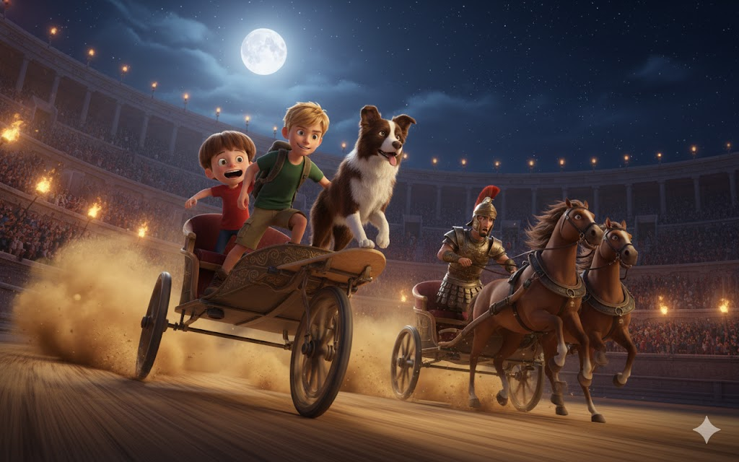
• • •

Chamber of Secrets under the Hagia Sophia - Two hours before midnight
Mia's hands were covered in sweat, muscles trembling with concentrated effort. The sixth crystal finally began to pulse regularly - not perfect yet, but improving.
"Water," she murmured, not looking up from her work.
Theodora placed gourd on her lips gently, letting her drink without needing to stop. They had developed a rhythm over the last few hours - Theodora anticipating what Mia needed before she even asked.
"You would be an amazing inventor," Mia said, finally pausing to stretch out aching fingers. "He has a natural instinct for mechanics."
Theodora blushed slightly. "Grandmother always said I fixed broken things. Toys, tools, once even a wagon wheel." She looked at the giant crystals pulsing. "But never anything like this."
"Principle is the same," Mia explained, picking up a different tool - something hybrid she had improvised from Byzantine bronze and Atlantean technology. "Everything has a pattern, frequency, purpose. When something breaks, you identify where the pattern was interrupted and restore flow."
"Like music?" suggested Theodora.
Mia blinked, then smiled. "Just like music. You understand."
They worked in silence for more minutes. Then Theodora asked quietly: "When you return... to your time... will I forget this? About you?"
Mia stopped, looked at the Byzantine girl who had become friends so quickly. "I don't know. Thalass says quantum observers leave... echoes. Impressions. Maybe you remember it as a dream. Maybe just as a strange sensation."
"I want to remember," said Theodora fiercely. "I want to remember everything."
"Then write it down," Mia suggested. "When we leave, write everything down. Hide it in writing. And maybe..." she hesitated, "maybe your descendants will find it. Maybe history will survive."
Theodora nodded determinedly. "I'll do it. I promise."
The seventh crystal began to glow under Mia's hands.
Two to go.
And seven hours left.

• • •
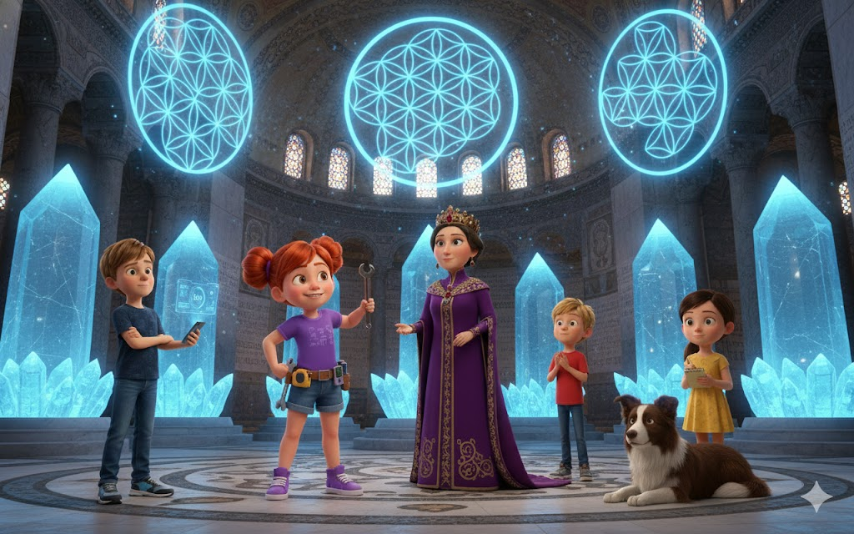
Hippodrome of Constantinople - Midnight
Leo had never seen anything like the empty Hippodrome. The arena was massive - three hundred meters long, capable of holding one hundred thousand spectators. Under the moonlight, obelisks and statues cast dramatic shadows.
And right in the center, preparing for the secret torchlit chariot race, were 'The Soldier' ​​and his associates.
"It's not exactly subtle," muttered Max from their hiding place behind the spina - the hippodrome's central barrier decorated with ancient monuments.
"Soldiers rarely are," replied Leo. "But look - unofficial night chariot racing. Testing horses? Practicing for competition? Or..."
"Checking escape routes," Max added, understanding. "If conspiracy fails, you'll need to leave Constantinople quickly. Trained horses, knowledge of which gate to use, exact timing..."
Jimmy barked softly - a warning sign.
Figure emerged from the shadows near the chariots. Tall, muscular, wearing imperial guard armor but no rank insignia. The man spoke to waiting charioteers, gesturing to different gates.
"'The Soldier'," Leo whispered. "It has to be."
"We need positive identification," said Max. "Name, rank... something Thalass can use."
Leo thought quickly. Then he smiled. "Or... we create a situation where he reveals himself."
"I'm listening," said Max, recognizing the gleam of plan in his friend's eyes.
"You," said Leo, "are the best narrator I know. And I coach running and athletics. So..."
Max started to smile too. "Chariot racing?! Are you crazy?"
"Completely," agreed Leo. "But think - if we defeat his charioteers, 'The Soldier' ​​will be furious. Professional soldiers hate losing to amateurs. Especially children. He'll reveal something useful."
"Or," said Max, "he will kill us."
"Details," Leo said with courage he didn't fully feel. "Are you in?"
Max looked at Jimmy, who tilted his head as if considering, then barked approval.
"Jimmy says yes. So yes."
Fifteen minutes later, Leo was in a "borrowed" chariot, holding the reins of two horses that seemed as confused as he was about the situation. Max was standing next to him, holding Jimmy (who had insisted on participating).
And he shouted to surprised charioteers in perfect Greek thanks to the perception bubble:
"I heard that the best drivers in Constantinople practice here at night! I came to challenge them!"
Shocked silence. Then laughs.
'The Soldier' ​​advanced, expression between amused and irritated. "Child," he said, voice deep as thunder, "this is no game."
"No," agreed Leo. "It's racing. Seven laps around the spina. I win, you admit you're not even that good. You win..." he thought, "I clean stables for a month."
More laughter. But something changed in the eyes of 'The Soldier'. Curiosity. Maybe respect for the audacity.
"Your funeral, boy," he said. Then, to charioteers: "Prepare chariot. Let's teach this young dog a lesson."
"Technically," Max said loud enough for everyone to hear, "Jimmy is the dog. Leo is human. Common to be confused in the dark."
Even 'The Soldier' ​​laughed at this.
The race was... chaotic.
Leo had trained in many things. Parkour, martial arts, gymnastics. But driving a horse-drawn chariot at high speed around an ancient arena while a professional charioteer tried to force him into the marble spina?
Completely new.
"ESQUERDA!" shouted Max, narrate
I walk as if it were a sporting event. "LEO VAI PELA ESQUERDA! MOVIMENTO OUSADO! The horses seem confused as to why the child is screaming but are cooperating out of politeness!"
Jimmy barked encouragement, tail wagging in perfect balance that only a border collie could maintain.
On the third lap, Leo noticed something. 'The Soldier' ​​wasn't just running - he was watching gates, timing how long it took to get around, where guards would be positioned.
I was using running as recognition.
"MAX!" shouted Leo over the sound of thundering hooves. "PRESTA ATTENTION NOS GATES QUE ELE OLHA!"
"ALREADY ESTOU!" shouted Max back. "GATE NORDESTE! MARCA THREE VEZES!"
Fifth lap. Leo was losing - the professional charioteer's horses were faster, better trained. But he didn't surrender.
Sixth lap. 'The Soldier' ​​was almost parallel now, forcing Leo closer and closer to the marble spina. Dangerously close.
"Give it up, boy!" shouted the soldier. "Before you get hurt!"
"JAMAIS!" replied Leo, and in a movement that was pure instinct plus adrenaline, he pulled the reins firmly.
Horses reacted, turning sharply. Biga tilted on two wheels per terrible second. Max shouted. Jimmy barked. Leo held his breath.
And then, miraculously, wheels touched the ground again.
Directly in front of 'The Soldier', forcing him to brake to avoid collision.
Seventh lap. Leo overtook by a tiny margin, crossed the improvised finish line...
And he fell from the chariot directly onto a pile of hay that was providentially there.
Max disembarked more gracefully. Jimmy jumped up and started licking Leo's face.
Silence. Then, surprisingly, applause.
'The Soldier' ​​got out of his chariot, approached Leo still lying on the hay. For a terrible moment, Will thought they were going to attack.
Then the soldier extended his hand.
"Nikephoros Strategos," he said. "Captain of the Imperial Guard. And you, brave young fool, have just performed a maneuver I have only seen once before - when the Emperor himself was young and foolish."
Leo shook his hand, mind recording the name. Nikephoros. Identity confirmed.
"Just luck," said Leo modestly.
"Luck doesn't turn into a chariot on two wheels and survive," said Nikephoros. Then, quieter: "Why are you really here?"
Leo felt his heart accelerate. Did the soldier suspect?
"Because," said Max, thinking quickly, "we wanted to see if stories about night racing were true. And because Leo here likes to prove that he can do the impossible."
Nikephoros studied them. "Go home. Now. Tomorrow is an important day. Consecration of the great cathedral. City will be crazy. Children in the streets will be trampled."
"We promise," Leo said.
As they walked away - Leo limping slightly, Max supporting Jimmy - they heard Nikephoros speaking quietly to charioteers:
"Tomorrow. Noon. Northeast gate. Have horses ready."
Max and Leo exchanged looks.
Confirmation.
Mission accomplished.

• • •

Quarteira de Escribas - One hour after midnight
Sophie had a gift for becoming invisible. Not literally - but moving quietly, staying in the shadows, seeming to belong wherever he was.
Now, disguised as an apprentice scribe carrying parchment, she circulated around workshops close to the manuscript market.
Thalass accompanied her disguised as a wealthy customer buying rare texts.
"Three scribes work so late," muttered Sophie, passing the third brightly lit workshop. "Unusual?"
"Very," confirmed Thalass. "Tomorrow is a holiday. Most artisans would rest."
They stopped outside the most isolated workshop. Through the window, Sophie saw a man bent over an elaborate manuscript. Even from a distance, he could see that the writing was incredibly precise. Geometric. Almost... non-human in its perfection.
"There," whispered Thalass, suddenly tense. "The way fingers hold stylus. Angle. It's Atlantean technique."
"'The Scholar'," said Sophie.
They needed a name. Identity.
Sophie thought quickly, then knocked on the workshop door.
The scribe looked up, irritated. "We're closed."
"Pardon me, sir," Sophie said in perfectly respectful apprentice Greek. "Master Thalass sent it to me. He urgently needs a copy of the text for tomorrow's ceremony. He said that only the best scribe in Constantinople could do it with the necessary quality."
Direct flattery. But it worked surprisingly well.
The scribe - middle-aged man with eyes that had that characteristic blue-green glow seen in certain light - softened slightly.
"Thalass, you say?" He looked at 'customer' on the street. Recognition passed between Atlanteans.
Thalass entered, bowing his head respectfully. "Theodoros, I didn't expect to find you working so late."
Theodoros. Name confirmed.
"Important work," said Theodoros, putting away the manuscript he was writing. But not before Sophie saw a partial diagram - a structure she recognized from Mia's drawings.
Atlantean crystals.
"The consecration tomorrow," continued Theodoros conversationally, "will mark the end of an era. And the beginning of another."
"Certainly," agreed Thalass neutrally. "Hagia Sophia is marvelous."
"Wonder built on a foundation of lies," said Theodoros, voice suddenly bitter. "Our technology used without permission, without understanding. Humans always take, never say thank you."
"Some appreciate it," Sophie said quietly.
Theodoros looked at her as if truly seeing her for the first time. "Wise child. But wisdom without power is useless."
"And power without wisdom," countered Sophie, "is destructive."
Tense silence.
Then Theodoros smiled - without humor. "Tomorrow," he said, "we will see which prevails."
It was a clear threat.
Thalass placed a gentle but firm hand on Sophie's shoulder. "We should go. Thank you for your time, Theodoros."
When they were safely away, Thalass said quietly, "He knows we know."
"And he doesn't care," Sophie concluded. "Because you believe there's nothing we can do to stop it."
"Then," Thalass said with determination that Sophie rarely heard in the normally calm Atlantean's voice, "we will need to prove him wrong."

• • •

Mercantile District - Three hours before dawn
Jimmy had the best nose in the class. Technically, he had a better nose than any human in any class. It was a border collie.
And now he followed the trail of 'The Merchant' through a maze of warehouses and closed shops.
Will, who was holding a loose leash, let Jimmy lead. The dog had found scent on one of the documents - whoever had touched the paper had left a unique chemical trace.
Greek fire had a characteristic smell. Whoever planned to use it inevitably had waste.
Jimmy stopped outside the private warehouse, growling low.
Will felt Iris vibrate in his pocket - smartphone in silent mode but detecting something.
"Suspicious activity," murmured Iris through the tiny earpiece Mia had made. "Movement inside. Multiple heat sources. Arson storage likely."
"Can you see how many people?" Will whispered.
"Three. No, four. One seems to be... mixing something."
Greek fire.
Will had two options: observe or act.
Observing was safer.
Taking action could prevent tragedy.
He made a second decision.
"Iris, can you cause a distraction?"
"Define 'distraction'."
"Something that makes people leave the warehouse without suspecting a direct attack."
Pause while AI processed. "I can access nearby church bells via time connection. Make them ring out of turn. Byzantines are superstitious - will take it as omen."
"Do."
Thirty seconds later, bells began to ring. Non-regular pattern - erratic, strange, disturbing sequence.
Warehouse doors opened. Men came out, looking at church steeples in confusion.
Will saw their faces clearly. Especially one - rich merchant judging by elaborate clothes, expensive rings. But eyes were calculating, cold.
'The Merchant'. Name still unknown, but face memorized.
While men were distracted, Jimmy silently entered the warehouse through the broken window.
"Jimmy, no!" Will whispered, but it was too late.
Sixty tense seconds.
Then Jimmy emerged, holding something delicately in his jaw.
Small bottle. Sealed. Containing golden-green liquid that seemed to glow.
Greek fire.
Evidence.
Will carefully took the bottle and wrapped it in cloth. "Good boy," he whispered. "Let's go."

• • •

Chamber of Secrets - First light of dawn
When everyone gathered - exhausted, dirty, but triumphant - Mia was finishing the ninth crystal.
All nine were pulsing now. Not perfectly synchronized yet, but alive, healthy, fortified.
"Did they?" Mia asked without looking up from her work.
"Nikephoros Strategos, Captain of the Imperial Guard - 'The Soldier'," Leo reported. "Plans to escape through the northeast gate at noon."
"Theodoros, master scribe - 'The Scholar'," Sophie added. "Atlantean confirmed. Though perhaps less of action, more of planning."
"It's 'The Merchant,'" said Will, placing jar of Greek fire carefully on the stone table. "Name unknown yet, but Jimmy got evidence."
Thalass examined the vial, face dark. "Enough to severely damage crystals. Perhaps destroy them if placed precisely."
"You can still try during the ceremony," said Mia, finally stopping work and turning to the group. "Even with healthy crystals."
"So we stopped it," said Theodora simply. As if it were obvious.
"Against captain of the imperial guard, Atlantean scribe, and rich merchant?" questioned Sophie. "As?"
Will looked around at each member of his class. They saw night work reflected in tired but determined faces. They saw courage, intelligence, loyalty.
They saw family.
"We do what we always do," Will said with a slow smile. "The impossible."
Mia returned a smile. "In style."
Leo snapped his fingers. "And precision."
Sophie adjusted her glasses. "And extremely well thought out plan."
Max hugged Jimmy. "And furry help."
Theodora looked at each one, then nodded decisively. "Then tell me the plan."
As the first rays of sunlight touched the partial dome of the Hagia Sophia above them, as the city began to awaken to the greatest day in its history, Turma da Aventura planned their last move.
Six hours until ceremony.
Enough time?
They would have to be.
Because failure was not an option.
Not when thousands of lives depended on it.
Not when his own future was at stake.
"Let's save a cathedral," said Will.
"And make history," Sophie added.
"No changing the story," corrected Mia with an ironic smile.
"Technical detail," said Max.
And finally, after the longest night of their lives, the gang rested.
Just for the moment.
Because in six hours, final race would begin.
And this time, only victory would be acceptable.

CHAPTER 8
THE DIA OF CONSECRATION

December 27, 537 AD
The day that would change history.
Will woke up to the sound of bells - not alarming this time, but celebratory. All of Constantinople was awakening to the greatest event in generations: the consecration of the Hagia Sophia.
The cathedral that would defy gravity for over a thousand years.
If they could keep her standing today.
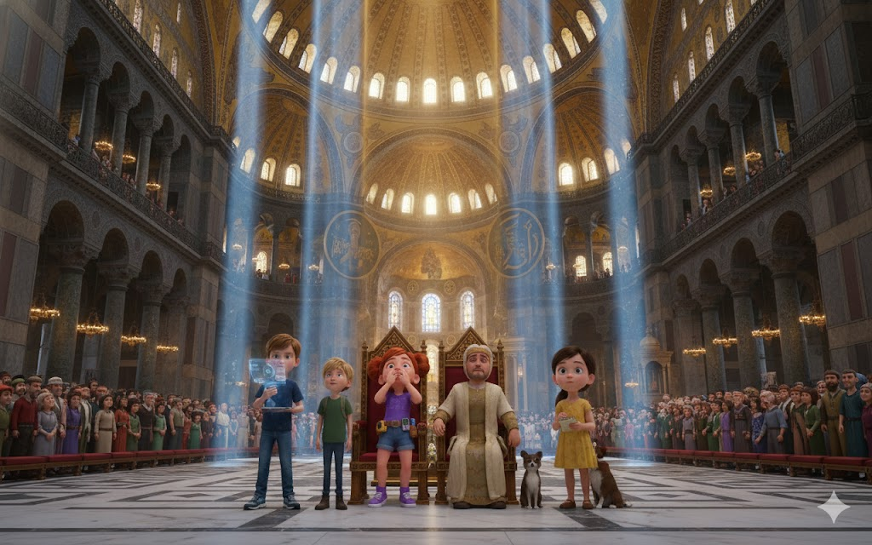

• • •

Dawn - Final Preparations
The gang gathered in the secret chamber one last time. The nine Atlantean crystals pulsed in almost perfect harmony - Mia and Theodora's work had been miraculous.
"Status?" Will asked, automatically falling into leadership mode.
"Crystals are at ninety-five percent," Mia reported, dark circles under her eyes but firm voice. "They will resist sabotage if we can intervene quickly enough."
"Iris is synchronized with ceremony timers," Sophie added. "Main blessing happens at exact noon, when sun is directly overhead. This is when conspirators are likely to act - time of greatest symbolism."
"Nikephoros will have horses ready at the northeast gate," Leo said. "But I alerted loyal guards through... indirect channels. Theodora introduced me to a few."
Theodora nodded. "Street children have access to places adults ignore. Message has been delivered to the commander who hates Nikephoros. He will be watching."
"And Theodoros?" Will asked.
Thalass, who had arrived a few minutes earlier, responded. "I confronted him directly this morning. Atlantean to Atlantean. He knows that Kaelum repented. He knows that Atlantean elders themselves sent us help." Pause. "But he is... conflicted. He may still act, or he may retreat. I'm not sure."
"Then we assume you will act," Will decided. “We plan for the worst-case scenario.”
Max raised his hand. "What about 'The Merchant'?"
"Unknown yet," Sophie admitted. "But you will be at the ceremony. Rich merchants always participate in imperial events. When we act, we will reveal it."
Jimmy barked softly, as if saying, "I'll smell him."
"So," Will said, looking around at each member - his gang, his family, "the plan. Mia and Theodora stay here with the crystals. First line of defense."
"Leo and Max move through the crowd above. They watch Nikephoros and look for 'The Merchant'."
"Sophie and I stayed close to Justinian and Theodora - Thalass got passes for us as young scholars. We will be ready to alert emperor if necessary."
"And Jimmy?" Max asked.
"Jimmy," Will said with a smile, "does what he does best. Being in the right place, right time, being adorable. No one suspects a border collie."
Jimmy shook his tail proudly.
"Six o'clock," Sophie said, checking the sun's position through an opening in the ceiling. "Ceremony begins."
Theodora abruptly hugged each member of the class. "In case you don't get another chance," she said, voice breaking. "Thank you. For everything. For showing me that magic still exists in the world."
Will hugged her back. "Magic has always existed, Theodora. You just needed people to do it with."

• • •
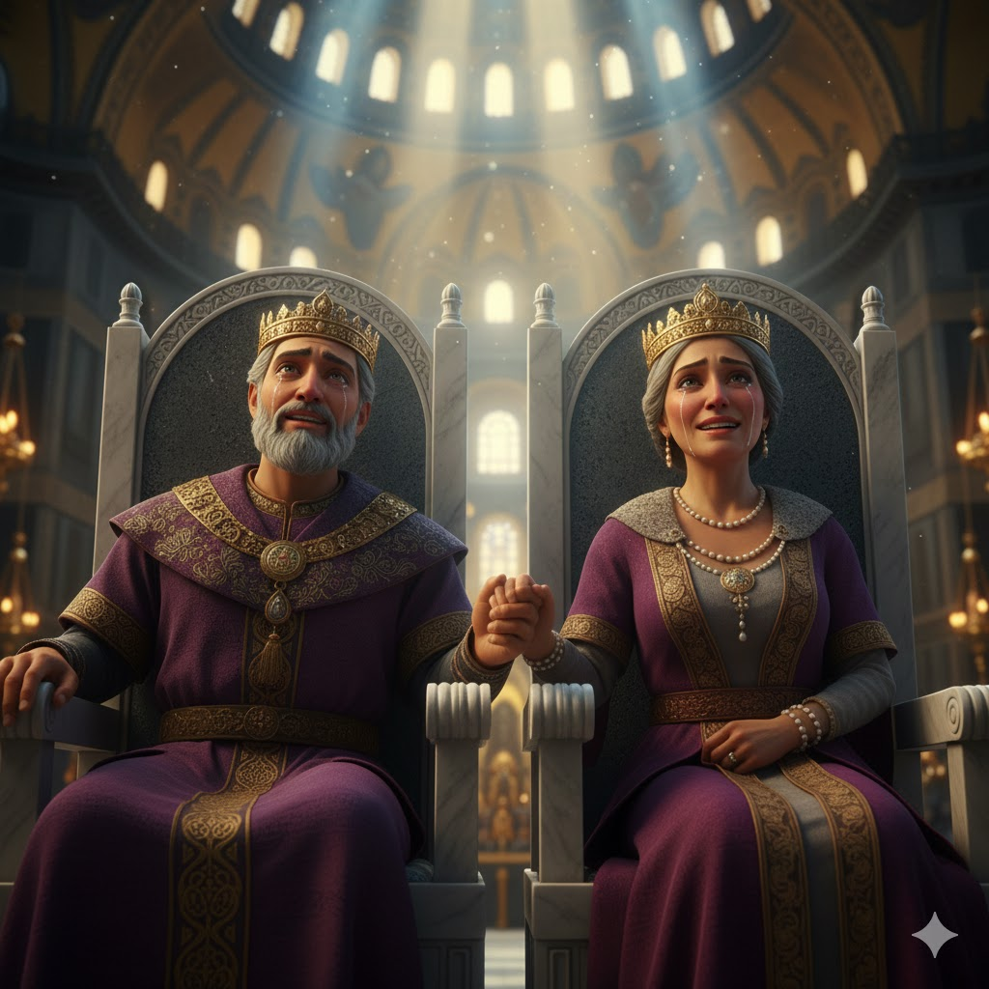
Noon - The Consecration
The complete Hagia Sophia took your breath away.
Will had seen images, read descriptions. Nothing prepared for reality.
The dome seemed to float—impossible, physics-defying, held up by light and sacred geometry as much as by stone and mortar. Circular windows around the base created agolden halo. Mosaics sparkled. Marble in every color of the empire - green from Thessaly, white from Paros, red from Egypt - created hypnotic patterns.
And inside, crowd of thousands.
Nobles in elaborate silks. Soldiers in polished armor. Merchants displaying wealth. Ordinary citizens in simple but clean clothes for the occasion. Priests in ceremonial vestments.
And in the center, on a raised platform near the altar, Emperor Justinian I and Empress Theodora.
Justinian was a man of fifty, with gray hair but a regal posture. He wore an imperial crown and purple robes, but his eyes - Will noticed - were intelligent, calculating. This was a man who had codified Roman laws, reconquered lost territories, built architectural marvels.
And at his side, Theodora - former actress who became empress, beautiful and formidable, looking over the crowd with an expression that combined grace and absolute power.
Will and Sophie, disguised as young scholars with parchment and respectful appearance, positioned themselves where they could see both the altar and stairs leading to the lower chambers.
Leo and Max circulated through the crowd, Jimmy trotting innocently between people's legs, his nose keen.
Patriarch Menas began ceremony - blessing sung in liturgical Greek, incense filling the air, choirs singing heavenly harmonies.
It was nice.
It was perfect.
It was the exact moment the conspirators would choose.

• • •

Noon and Fifteen Minutes - The Moment
Will saw it first: Nikephoros moving through the crowd with haste unusual for a ceremonial guard. Direction: stairs to lower chambers.
"Sophie," he whispered, touching her arm.
She saw it too. "Thalass," he murmured to the Atlantean discreetly positioned near them.
Thalass nodded, began to move. But then he stopped, expression changing.
Because Theodoros - the Atlantean scribe - had emerged from the shadows near the altar. He carried a small bag. Moving with purpose.
To the same stairs.
"Two of them," said Will. "At the same time."
"Coordinated," agreed Sophie. "What it means..."
"It means that 'The Merchant' is making a third part," added Thalass. "Divide our attention."
As if in confirmation, Iris fluttered in Will's pocket. The AI's voice came through the earpiece:
"I detected unusual thermal signature near the crystals. Someone is already underneath."
The Merchant had arrived first.
"We need to split," Will decided quickly. "Sophie, you and Thalass are going after Theodoros. I'm going after Nikephoros. And someone needs..."
Jimmy barked, already running towards the stairs.
"Jimmy goes first," said Max, following the border collie. "And I'm going with him."
It wasn't a perfect plan.
But it was a plan they had.

• • •

Chamber of Secrets - Final Showdown
Mia felt a presence before she saw it.
The crystals reacted - pulse changing, light flickering. Someone was interfering.
"Theodora," she whispered. "We have a visitor."
Theodora took the torch and raised it as an improvised weapon. "Show yourself."
Man came out of the shadows. Rich, well dressed - merchant, clearly. But he carried a familiar flask of green-gold liquid.
Greek fire.
"Children," he said in a surprisingly gentle voice. "You don't need to be here. Get out. Forget you saw me."
"We can't do this," Mia said firmly.
"So," he said, genuine sadness on his face, "I'm sorry." He lifted the bottle.
That's when Jimmy came in like a furry missile, barking ferociously, interrupting the man's throwing line.
The Merchant stumbled, vial falling - but not breaking, thanks to careful packaging.
Max arrived seconds later, out of breath. "You," he panted, "are going to need to get past a very angry border collie first."
Behind him, footsteps - Nikephoros descending stairs, sword drawn.
"Stay away from the crystals," commanded the captain.
"YOU move away," countered the new voice.
Theodoros had arrived from another entrance, closely followed by Sophie and Thalass.
The chamber was suddenly crowded.
Four conspirators (including Niketas if he had appeared).
Five children.
A border collie.
Two Atlanteans.
And nine crystals pulsating tensely.
"This is madness," said Theodoros, but his voice sounded tired rather than convinced. "Just destroy crystals and be done."
"No," said the new voice, and Will entered, having followed Nikephoros. "They will not destroy."
"Arrogant child," said Nikephoros, "this is a matter of empire. You don't understand politics, power..."
"I understand," interrupted Will calmly, "that killing thousands of innocent people is not politics. It is murder."
"Ends justify means," argued The Merchant, retrieving vial.
"No," said Theodora—the Byzantine, not the empress—stepping forward with courage that made Will feel immense pride. "Ends become means. If they use murder to gain power, they rule through murder. If they use lies to achieve truth, they destroy truth in the process."
"Orphan child philosophy," sneered Nikephoros.
"Wisdom," corrected Thalass, "from someone who lived on the streets and saw humanity in its rawest form. She understands it better than you."
Theodoros looked at Thalass. "Traitor to our species."
"No," said Thalass. "Believe in our species. Atlanteans were not made to live in isolation. We were made to explore, teach, learn. You want to trap us in fear."
"Fear keeps us alive," said Theodoros.
"Fear keeps us existing," Mia corrected. "But not living. Big difference."
The Merchant looked between the determined children and the pulsing crystals. "Even if they stop us today, others will come. Movement does not end with us."
"Maybe," agreed Will. "But today, here, now - you will not win."
"Against captain of the imperial guard?" Nikephoros raised his sword.
That's when Emperor Justinian came down the stairs, accompanied by his personal guards.
Everyone froze.
"Captain Nikephoros," said the emperor, voice calm but charged with absolute authority. "Put the gun down."
Nikephoros looked between emperor and crystals. Obvious choice.
He lowered his sword.
"Thalass informed me of this conspiracy yesterday," continued Justinian. “I allowed it to unfold to identify everyone involved.” Sweep eyes were camera. "Now I know."
The Merchant dropped the bottle, defeated.
Theodoros simply closed his eyes.
"Guards," said Justinian, "escort these men to detention. Judgment will come later."
As conspirators were led away, Justinian turned to the children.
"Thalass said they were...travelers from far away. Even further than I can imagine."
Will nodded respectfully. "Yes, Your Majesty."
"And they came to protect my cathedral. My people."
"Not just yours," Sophie said. "Of everyone. For fifteen hundred years."
Justinian seemed intrigued. "So specific. Do you... know future?"
"We know," said Will carefully, "that Hagia Sophia will endure. Through empires, invasions, earthquakes, transformations. It will be church, mosque, museum. But it will always remain wonder."
Tears - genuine ones - shone in the emperor's eyes. "So we build something eternal."
"They built it," Mia confirmed.
"With help," Thalass added, gesturing to crystals.
Justinian looked at the Atlantean crystals, then at Thalass. "I knew I had an unusual advisor. I never asked where he came from. Maybe it's better to remain a mystery."
"Wisdom of a true ruler," said Thalass with a respectful bow.
Justiniano started climbing stairs, then stopped. "Children. What are their names?"
They introduced themselves - Will, Mia, Leo, Sophie, Max, Jimmy, and finally Theodora.
Upon hearing the last name, the emperor stopped. "Theodora. As my beloved wife."
"In her honor, Your Majesty," said Theodora without hesitation. "Grandmother always said that a strong woman could change the world."
"Wise grandmother," said Justinian. "And you - street child who defended empire - deserve reward. Come see me after the ceremony."
Theodora paled, but nodded.
The emperor left.
And silence fell on the chamber.
Until Leo said, "Did we just save Hagia Sophia?"
"We saved it," Will confirmed.
"With Emperor knowing," Sophie added.
"And thanking us," Mia added.
Max hugged Jimmy. "You're a hero, boy. Officer."
Jimmy hummed modestly.
It was Theodora who noticed it first. "The crystals..."
Everyone looked.
The nine Atlantean crystals were pulsing in perfect synchronization now. Not just healthy - magnificent. Singing harmonies you could almost hear, radiant blue light matching sunlight descending through the dome above.
"They feel it," Mia murmured. "They feel that the danger has passed. That they are safe. That they can do the work they were created to do."
And then it happened.
Divine Light
It was exactly noon.
Sun was directly above Constantinople.
And through the forty windows surrounding the base of the dome, sunlight penetrated in geometrically perfect rays.
Not by chance. By design.
Isidoro and Antêmio had calculated every angle, every curve, every window to create this exact moment.
But they didn't know about the Atlantean crystals below.
Crystals that now responded to sunlight, amplifying it, resonating it, transforming it.
In the secret chamber, blue light exploded.
Above, in the main shrine, crowds of thousands saw golden rays of sunlight transform into an impossible blue-gold glow.
Menas, in the middle of blessing, stopped.
Justinian looked up, amazed.
Teodora held her husband's hand, tears running down her face.
And for a moment - brief, perfect, eternal - everyone in Hagia Sophia felt the presence of the divine.
Not Atlantean crystals.
Not technology.
But connection between peoples, between eras, between earth and sky that technology facilitated but love created.
Will felt it in the chambers below.
He felt each person above - their hopes, fears, joys.
He felt Theodora beside him, squeezing his hand.
He felt a gang around him - his family through time.
And I knew, with absolute certainty, that they had done more than save the cathedral.
They had protected the possibility.
Possibility of connection that would span centuries.
Light gradually dimmed.
Crowd above erupted in cheers.
"Miracle!" they shouted. "God has blessed Hagia Sophia!"
Technically, Atlantean crystals blessed.
But Will wouldn't correct it.
Sometimes magic and science are the same thing.
Just seen from different angles.
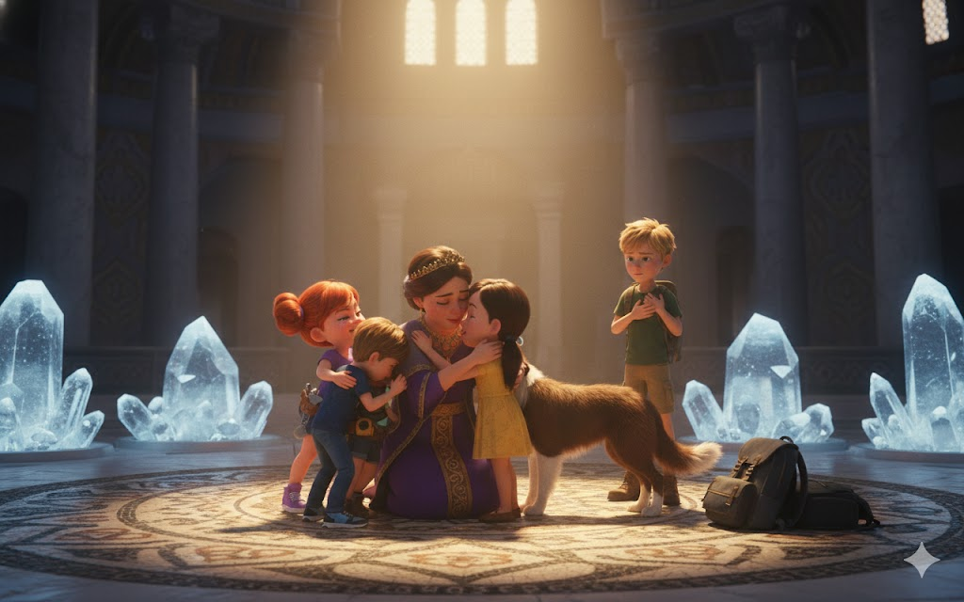
Theodora was crying, smiling simultaneously. "I'll remember," she whispered. "I promise I'll remember this forever."
"We hope so," said Will gently. "Because you need to tell your children. And their children. And so on."
"Guardian," said Thalass, placing a hand on the girl's shoulder. "First of the new line."
Theodora looked at crystals still gently pulsing, then at each member of the class.
"First," she agreed. "But not last."
Never last.
Because stories like this don't end.
They just echo through time.
Waiting for next guardians.
Next heroes.
Next adventure.

CHAPTER 9
FAREWELLS AND ECHOES

The celebration lasted for hours.
But everything that lasts comes to an end.
Will felt it first - that familiar tug in the Atlantean communicator crystals he carried. Not urgent yet, but insistent. Like tide starting to change.
"How long do we have?" Sophie asked softly, seeing the expression on his face.
"Hours," said Will. "Maybe until tomorrow morning. But no longer."
Theodora, who had remained beside them since the ceremony, turned pale. "Already?"
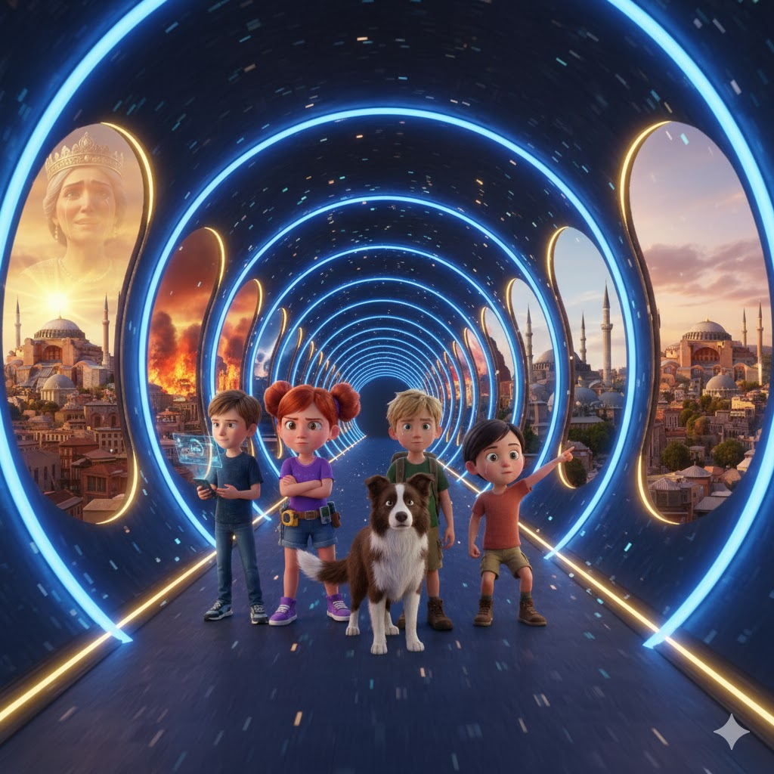
"Temporal dip," Mia explained gently. "The longer we spend here, the harder it becomes to return. It's like... depth pressure. Eventually, the protective bubble can't handle it."
"Then you really leave." It wasn't a question.
"We have to leave," Will confirmed.

• • •

Sunset over Constantinople
Thalass took them to one of the highest points in the city - a hill close to the old walls. From there, they could see all of Constantinople spread out below like a living map.
Hagia Sophia dominated the skyline, its dome capturing the sun's last rays and turning them into liquid gold.
"She will stand," said Theodora, more to herself than to them. "You said so. For fifteen centuries."
"It will fall once," Sophie corrected, ever honest. "In 558. Earthquake. But Justinian will rebuild it. Bigger. Stronger."
"And then?"
Sophie hesitated, looked at Will.
He nodded permission.
"In 1453," Sophie said softly, "Constantinople will fall. Byzantine Empire will end. But not Hagia Sophia. Ottoman Turks will turn it into a mosque. Add minarets, preserve structure. For another five hundred years, it will serve new purpose."
"And after that?" Theodora was brave, always brave.
"Museum," said Mia. "In the twentieth century. Place where all people - Byzantine, Turkish, Christian, Muslim, of any faith or none - can come to appreciate beauty. Testimony that art and wonder transcend conquest."
Theodora processed this in silence for a long moment.
"So we don't build for empire," she said finally. "We build for humanity."
"It's always been that way," Thalass agreed. "Justiniano just didn't know yet."
The sun continued to descend. Constantinople began lighting torches and lamps - thousands of them, transforming the city into a mirror of the stars above.
"I have something for you," said Theodora abruptly. She took a small piece of cloth from her bag - fine silk, imperial red, embroidered with gold thread.
"Empress Theodora gave it to me," she explained. "When Justinian offered me a reward, I asked to meet her. And she..." voice broke slightly, "she hugged me. Said that street girl who defended empire deserved honor. Gave me this - piece of her own ceremonial robe."
He handed it to Will.
"But I want you to have it. To remember. To... prove that it was real. That it wasn't just a dream."
Will gently picked up silk. It was real. Ancient, precious, impossible.
"Theodora," he said, "you don't have to give us..."
"I have to," she insisted. "Because... because when you leave, I'm going to feel like I've lost family. And families share gifts. That's what they do."
Max started crying first - the seven-year-old who always hid emotions under humor finally breaking down.
Then Sophie, silent tears flowing as she hugged Theodora.
Leo, who never cried, turned to hide his face but his shoulders were shaking.
Mia simply held Theodora's hand, squeezing as if she could physically stop her from disappearing through the centuries.
And Jimmy... Jimmy did something remarkable.
The border collie approached Theodora, placed his head on her lap, and moaned - not bark, not cry, but purely empathetic sound that said, "I understand. I feel it too."
Theodora collapsed.
She hugged Jimmy, buried her face in soft fur, and finally - after two years of living alone on the streets, defending herself, being strong - she let herself cry.
Will looked at Thalass, saw the Atlantean also with tears in his eyes.
"Fifteen centuries will separate them," muttered Thalass. "But right now, they're family. Time can't change that."
They stayed like that while the sun finished setting.
Constantinople shining below.
Stars emerging above.
And between earth and sky, a group of children - some from the past, some from the future - sharing love that transcended time.

• • •

Imperial Audience - Night
Justinian received them in a private chamber, not a formal audience room. Theodora was there too, still wearing ceremonial robes but a soft expression.
"Then depart," said the emperor without preamble.
"Yes, Your Majesty," confirmed Will.
"And they can't stay. Nor can they tell us more about the future that awaits."
"It would be…dangerous," Sophie said. "Knowledge of the future can change decisions. And changes can..."
"Break the world," added Justiniano. He looked at each of them. "Thalass explained concept to me. Quantum observers. Minimal interference." He smiled without humor. "Although saving cathedral from collapse is hardly 'minimal'."
"Cathedral was supposed to survive," Mia argued. "We just made sure history took the right course."
"Ah, 'correct' course," said Theodora - the empress - with some irony. "As if history only has one path. But I understand. And I appreciate it."
Justiniano advanced, took off his finger ring. Simple gold, engraved with imperial eagle.
"Normally," he said, "I give this to advisors who have served the empire extraordinarily. But you... have no use for a ring that won't exist in your time. So instead, I give word."
“Word, Your Majesty?” Will asked.
"Promise," Justinian corrected. "That as long as I live, I will protect the secret of the Atlantean crystals. That your lineage, Thalass, will be honored. And that young Theodora - who defended empire at my side - will have a place in my court if she wishes. Education. Protection."
Theodora - his Theodora - gasped.
“Your Majesty, I…”
"It is your choice," said Theodora, the empress. "Streets or palace. But know that doors are open."
Will saw Theodora processing - street child being offered a life he never dreamed of.
"Can I... think?" she asked.
"Of course," said Justinian gently. "Important decisions deserve contemplation."
Then he turned to Thalass. "And you, my strange friend. Stay?"
Thalass considered. "For time. There is still work. But eventually, I return to my people. We have much to discuss regarding...future interaction with the surface."
"I see," said Justinian. "So when you leave, do so with my gratitude."
There were final exchanges—formal words, respectful bows.
But when they left the imperial chamber, it was with a feeling of closure.
Chapter finished.
Complete story.
Only final farewell remained.

• • •

Blue Atlantis - Temporal Return Chamber
They went down to the chambers one last time.
The nine crystals pulsed peacefully - work complete, purpose fulfilled.
Thalass prepared smaller communicator crystals - the ones that Will and the gang had brought from the future.
"When you activate," he explained, "you will feel a pull. Don't resist. Let the temporal current carry you back to where you belong."
"Will it hurt?" asked Max pragmatically.
"No," assured Thalass. "But it will be... disorienting. You will see history pass by. Centuries in seconds. Keep your minds focused on your own time. On Coral. On Blue Atlantis as you know it. It will guide you home."
Theodora was quiet, holding Jimmy.
"So," she said finally, "it's real. They really leave. And I...stay."
"Stay," agreed Will. "But not alone. Never alone again. There are emperor and empress who value you. There is Thalass for time. And there is..." he gestured to the crystals, "legacy. Responsibility."
"Guardian," said Theodora, testing the word. "First of the line."
"First," Thalass confirmed. "Your children, and their children, will protect the secret. Through Byzantium, through Ottomans, through ages I cannot foresee. And perhaps..." he looked at Will, "perhaps one day, your descendant will meet their descendants again."
"It's like full circle," muttered Sophie.
The moment has come.
Will placed his hand on the communicator crystal. Felt immediate vibration - recognition, preparation.
One by one, the class touched crystals.
Theodora hugged each one - quickly, tightly, desperately.
When he reached Jimmy, he simply knelt down, held the border collie's face in his hands, and whispered something that only he heard.
Jimmy licked her tears one last time.
Then Theodora retreated, staying next to Thalass.
"Thank you," she said. Simple words, but loaded with fifteen centuries of meaning. "For showing me magic. For making me part of something bigger."
"Thank you," replied Will, "for showing us courage. And for protecting a future we will never see."
Light began to grow in the crystals.
Blue, pulsating, growing in intensity.
"Remember," Thalass said, voice beginning to distort as time prepared to shift, "you are echoes now. Our memories of you will persist. And your memories of us..."
Light exploded.

• • •
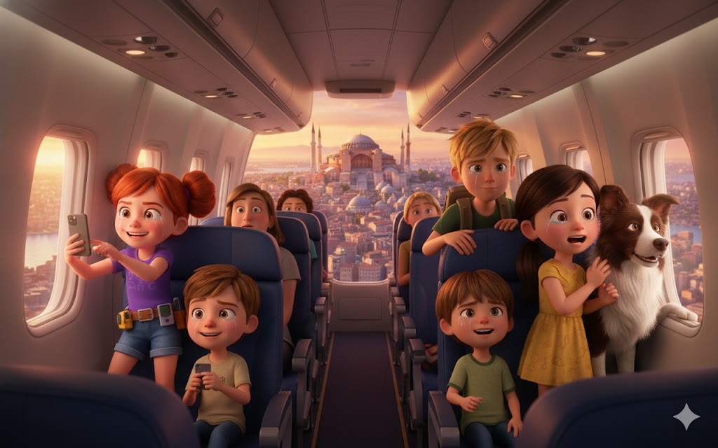
Through the Ages
It wasn't like traveling here - falling through time.
It was ascension.
Will felt centuries passing like layers of light - each a different color, texture, history.
He saw Hagia Sophia in snowy winter, scorching summer, flowery spring.
He saw Justinian grow old, die, be succeeded.
He saw earthquakes shake the city, the dome fell and was rebuilt bigger.
He saw Byzantium in golden glory.
He saw Muslim armies at the gates.
Saw 1453 - Constantinople falling, empire dying, but Hagia Sophia remaining.
Saw minarets being added. Mosaics covered but not destroyed. Transformation but not obliteration.
Saw century after century - wars, peace, constant change.
Saw 1935 - museum opening. People of all faiths entering together.
And through it all, he saw something else.
He saw a figure - familiar but older. Theodora at thirty, forty, elderly. Always with a small book. Always writing.
Keeping record.
Keeping promise.
Will tried to reach across time, but it was already dissolving into the next age.
Then vision changed.
Blue Atlantis.
Coral smiling.
Elders applauding.
And the feeling of cold water, pulsing crystals, home.

• • •

Back - Blue Atlantis, Present Time
Will gasped, hands leaving communicator crystal.
All around, the gang was doing the same - disoriented, amazed, marked.
Coral swam forward, expression beaming. "Welcome back, Temporal Restorers."
"We achieved?" asked Leo, still processing the trip.
"They did it," confirmed the oldest Elder - the Atlantean sage who had sent them. "Timelines are stable. Hagia Sophia is safe in all ages. And connection..." he touched crystals, "stronger than ever."
"Theodora?" Will asked abruptly. "What happened to her?"
Coral smiled - secret, knowing. "They'll find out. But I can say this: She kept her promise. Founded lineage of Guardians. Through Byzantines, Ottomans, modern Turks. Protecting secret, keeping faith, hoping."
"Waiting for what?" Sophie asked.
"You guys," Coral said simply. "She always knew they would come back. Maybe not in her lifetime. But what a story it would loop. And she was right."
Mia took the piece of imperial silk she was still holding - a gift from Theodora. "It survived time travel."
"Love survives time," said Coral. "Always survive."
Will looked at the class - exhausted, emotional, but triumphant.
They had plunged fifteen centuries into the past.
Saved cathedral.
Made a friend that would transcend eras.
And returned transformed.
"Next adventure?" asked Max with a tired smile.
"Eventually," said Will. "But first..."
"First we rest," Sophie added.
"And we remember," Mia added.
"And we honor it," concluded Leo.
Jimmy lative I remember.
Because some journeys don't end with a return home.
They end with the understanding that home can exist in multiple times.
In multiple places.
In multiple hearts.
And Theodora - street orphan who became guardian through the centuries - would live forever in this.
Forever in their memories.
Forever in the echoes of Constantinople.

CHAPTER 10
ECHOES IN THE PRESENT

A week later.
It felt like both more time and less time - a temporal paradox that still made Will's head hurt when he thought about it too much.
They had returned to the surface days ago. Professor Marino had found them exactly where he left them - rocky pier on the Greek coast, sun rising, as if only minutes had passed.
But Will knew the truth.
They had lived for days in Constantinople. Made friend. Saved cathedral. Changed history by not changing it.
And now they carried a secret that spanned fifteen centuries.
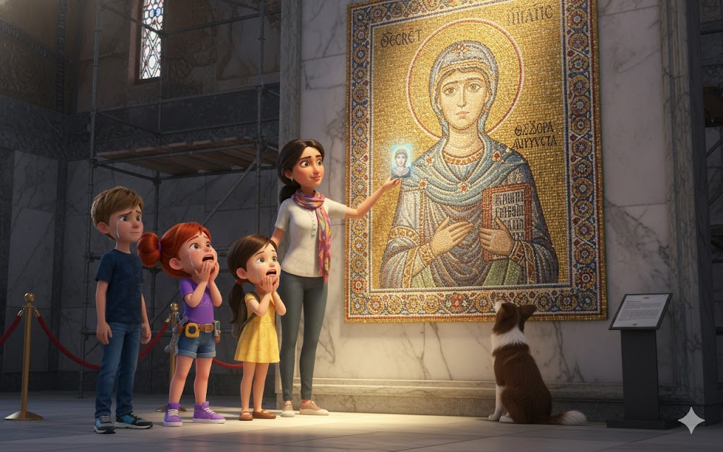
"You look different," Professor Marino had said immediately, studying them with the discerning eyes of an archaeologist accustomed to reading truths in fragments.
"We are," Will had agreed simply.
"Did you make it?"
"We achieved."
And the smile that lit up the old professor's face was worth every moment of danger, every second of fear.
Now, a week and many (carefully edited) explanations later, they were on a plane to Istanbul.
All of them - Will, Mia, Leo, Sophie, Max, Jimmy (with a special canine passport that Marino had provided), and the professor himself.
Iris slept in battery saver mode in Will's pocket, having processed every second of time travel in a memory cache that she swore would take "decades to completely sort out."
"So," said Max as the plane began its descent, "are we really going to see where we've been?"
"Where have we been," Sophie corrected, "fifteen hundred years in the future from where we have been."
"Temporal paradoxes make me dizzy," Leo complained.
Mia smiled. "Everything makes you dizzy. You get sick in elevators."
"Elevators aren't supposed to move that fast," Leo defended himself.
Jimmy barked which clearly meant "I agree with Leo."
Will looked out the window as Istanbul appeared below.
And breathing stopped.
Because there she was.
Hagia Sophia.
Not golden and new as they had seen in 537 AD.
But still magnificent. Still impossible. Still defying gravity and time with a dome that seemed to float between earth and sky.
Minarets rose in the corners—Ottoman additions that Sophie had mentioned.
But the central structure—the cathedral that Isidore and Anthemius designed, that Justinian ordered, that Atlanteans secretly supported—remained.
"It's there," Mia whispered, pressing her face against the window. "It's really there."
"Fifteen centuries," muttered Sophie. "Wars. Earthquakes. Falling empires. And it's still there."
"Because we saved it," Leo said with simple pride.
"Because Theodora protected it," Will corrected gently.

• • •

Ayasofya - Hagia Sophia in the Present
Walking in for the first time was... surreal.
Will stepped through doors they had seen being built. He looked up and saw the dome they had seen glowing with impossible blue light.
But it was different too.
Christian mosaics - some revealed, others still covered from period as mosque. Huge Islamic calligraphy on hanging medallions. Marble floors polished by millions of feet through the centuries.
It was a palimpsest of faiths. Witness of transformation without destruction.
And it was packed with tourists - people from every country, every religion, marveling together.
"This," said Professor Marino quietly, "is what Justinian dreamed of. Not cathedral for Christians only. But wonder for humanity."
Sophie was reading an information board. "It says here that during the original consecration in 537, witnesses reported 'divine light' filling the cathedral at noon. Historians assume it was poetic exaggeration or a planned optical effect."
Will and Mia exchanged looks.
It was neither one nor the other.
They were Atlantean crystals.
But that secret died with them.
Max and Jimmy had split off from the group, exploring. Suddenly Max screamed - not alarmed, excited.
"PESSOAL! You need to see this!"
They ran - as much as allowed in a sacred museum - to where Max was pointing.
Section of wall partially obscured by restoration scaffolding. But through the gap, Sophie could see a small, incredibly detailed mosaic.
Girl figure. Curly dark hair. Brown eyes that seemed to follow the observer. Holding small book.
And around it, in ancient Greek written in a style Sophie instantly recognized, words:
"THEODORA - KEEPER OF THE MYSTERIES"
Theodora - Guardian of Mysteries.
"It's her," Mia whispered. "It's really her."
Professor Marino frowned. "Strange. There is no record of a mosaic like this in official cat inventories."
"Because," said Sophie, already studying the inscription more closely, "it's hidden. On purpose. Look - angle of the wall, positioning... it's only visible from a specific perspective. And with scaffolding usually covering it..."
"Nobody knows it exists," added Will.
"Except," muttered Leo, "who was supposed to know."
Sophie was tracing Greek letters with her finger, not touching but memorizing. "There is more. Smaller text below. Code."
"Can you read it?" Will asked.
Sophie closed her eyes, visualizing. "It's... list. No. Coordinates. Places."
She opened her eyes, took out her ever-present notebook, and began to write:
*Egypt - Egito*
*Greece - Grécia*
*Italy - Itália*
*Scandinavia - Escandinávia*
*Peru - Peru*
"Places where there are... problems," Sophie read, carefully decrypting. "Anomalies. Crooked echoes. Guardians waiting."
"Guardians," Mia repeated. "Plural. So Theodora wasn't alone."
"Never been," said a familiar voice behind them.
Everyone turned.
Woman of perhaps thirty, olive skin, brown eyes that Will recognized instantly. Same eyes as the mosaic.
Same eyes that Theodora had had.
"You're..." Will began.
"Descendant," said woman with a light Turkish accent. "Forty-seventh generation. My name is Ayşe. And I have been waiting for you."

• • •

Revelation of the Guardians
Ayşe took them to a nearby cafe - small, discreet, clearly owned by someone who knew how to keep secrets.
"Grandmother told me," she began without preamble. "And her grandmother told her. Back and forth through the centuries. Story of the Adventure Gang that came from the future, saved Hagia Sophia, and left promising that echoes would remain."
"Theodora wrote everything," continued Ayşe, taking a small book out of her bag. Antique leather, yellowed pages, but lovingly preserved through the ages.
"Can I?" asked Sophie reverently.
Ayşe delivered the book.
Sophie gently opened it. First page, in Byzantine Greek written in childish but careful handwriting:
*"For those who come after. For those who will come again. This is the story of Will, Mia, Leo, Sophie, Max, Jimmy and Iris. Time travelers. My family through the centuries."*
Tears began to stream down Sophie's face as she turned pages.
Stories they had lived, written from Theodora's perspective. Moments they had shared. Jokes Max had told. Inventions that Mia had explained. Leo's courage. Sophie's wisdom. Will leadership.
And Jimmy - pages and pages about the border collie who had comforted the orphan through the darkest night.
"She remembered," Will said, voice breaking. "He promised he would remember and he did."
“More than that,” said Ayşe. "She built. Each generation, guardians. Protecting not just secrets from Hagia Sophia but from other places as well. Because," she gestured to the list Sophie had copied, "Theodora wasn't the only child Atlanteans helped. It wasn't the only civilization with hidden crystals."
"The anomalies," Mia said, understanding. "Egypt, Greece, Italy, Scandinavia, Peru..."
“Pyramids of Giza,” enumerated Ayşe. "Parthenon. Vatican. Viking Temples. Machu Picchu. All have... echoes. Atlantean technology integrated into ancient construction. And all have guardians, descendants of children that Atlanteans trusted."
"Network," Sophie whispered. "Global network of guardians through the centuries."
"Waiting," said Ayşe with a smile, "for Temporal Restorers to return."
Will felt the weight of it. They didn't just save a cathedral.
They started moving.
Legacy.
Family through time.

• • •

Last View
They returned to Hagia Sophia at sunset.
Tourists had left. Museum was closing. But Ayşe had connections (forty-seven generation guardian descendant tended to).
They stood on the upper balcony, looking down at the vast expanse of marble and light.
"Theodora stayed here," Ayşe said softly. "Her notes mention it. After they came back, she came every sunset a year. She looked at the dome. She remembered."
"Did she have a good life?" asked Max, always practical but caring.
"He accepted Justinian's offer," said Ayşe. "Education. Protection. But she never became a courtesan. Instead, she became... librarian. Copyist. Preserver of knowledge. Married at twenty-five to a kindly scribe. Had three children. Lived to eighty-one - a remarkable age for the time."
"And he always kept it a secret," Ayşe added.
"Always," confirmed Will.
Iris chose the exact moment to reactivate the economy mode.
"Sorry to interrupt the emotional moment," said AI, "but I detected an anomaly."
Everyone looked at Will's smartphone.
"What kind of anomaly?" Will asked.
"Temporal. Similar to cracks in Constantinople but... different. Older. Location..." he paused as he processed. "Giza Plateau. Egypt. Proximity: Pyramids."
Silence.
Then Sophie began to laugh—not humor, but recognition.
"Of course," she said. "Of course it would be Egypt next."
"First on Theodora's list," Mia pointed out.
"Coral mentioned it," Leo recalled. "Other exiled Atlanteans helped ancient civilizations. Some created problems."
Will looked around at the gang - exhausted from Byzantium but already feeling the familiar pull of adventure.
"So," he said. "Pyramids?"
"Eventually," said Professor Marino, appearing from the shadows where he had been giving them privacy. "But first, children rest. Process. Write reports for school about 'educational trip to Türkiye'." Eyes shone with knowledge of unspoken truth.
"But when you're ready," he continued, "when the next adventure calls... I'll be there. Because someone has to keep you alive."
"And because," Ayşe added, "guardians must work together. I have a cousin in Cairo. She is also a guardian. She has also been waiting."
Will looked one last time at Hagia Sophia.
Dome capturing last rays of sun, turning them into gold that slowly faded to blue at night.
The same dome they had seen consecrated fifteen centuries ago.
Same wonder that Theodora had protected.
Same promise they now carried.
"We'll go back," he said - no question, promise. "Not here. But to other places. Other times. Other echoes in need of protection."
"Temporal Restorers," Sophie said, testing the title Coral had given her.
"It's got a good ring," Max agreed.
Jimmy barked approval.
And there, on the balcony of a cathedral that spanned centuries, between empress mosaics and orphan memories, past and future met.
Because time is not a line.
It's web.
And each thread connects to others.
And sometimes - just sometimes - brave kids with super-smart dog and snarky AI can fix broken wires.
They can protect wonders.
They can make friends through the ages.
They can save not just cathedrals.
But possibilities.
Connections.
Love that transcends centuries.
Will took out his smartphone and looked at the message from Coral that had arrived during the conversation:
*"Well done, Restorers. Rest. Afterwards... Egypt awaits. And other adventures. Endless adventures. Because time is vast, and wonders are many, and you... you are exactly the ones who need to protect them."*
He showed it to the class.
Everyone smiled - tired, happy, ready.
Not now.
But soon.
Because some stories don't end.
They just echo.
They echo through time.
They echo through space.
They echo through the hearts of anyone brave enough to listen.
And for Turma da Aventura, echoes were just the beginning.
Of something wonderful.
Of something impossible.
Of something that Theodora - a street orphan from Constantinople who became a guardian through the centuries - had known from day one:
That true families are not limited by time.
They are connected by love.
And love, like wonder, like Hagia Sophia, like Atlantean crystals pulsing beneath ancient land...
It lasts forever.

SOBRE ESTE LIVRO

When ancient Atlantean crystals begin to fail beneath the Hagia Sophia, the Adventure Gang must delve fifteen centuries into the past to save one of the world's greatest architectural wonders. In Constantinople in 537 AD, Will, Mia, Leo, Sophie, Max, Jimmy and Iris meet Theodora - a street-smart orphan who will become a guardian over the centuries.
But forces conspire to destroy the cathedral before it is even consecrated. In a race against time across the imperial city, facing complex villains and impossible dilemmas, the gang must use intelligence, courage and teamwork to protect not just a building, but the very possibility of connecting past and future.
An epic adventure of friendship through time, where every choice can change history - or preserve it forever.

NEXT ADVENTURE
The Secrets of the Pyramids
Ancient Egypt awaits the Temporal Restorers!

