Red Team Attack!

nmap 192.168.1.1/24

ip found 192.168.1.105

open ports 22 and 80

dirb 192.168.1.105 /usr/share/wordlists/dirb/common.txt

found secret folder. Based off the meet_our_team folder I decided to attack ashton’s user



This is my attack command

This is the password that I found!

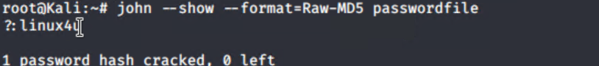

Used john to crack the hash and got ryan’s password of linux4u

Went to webdav and entered Ryan’s credentials. Now we can open a webdav folder.



Then made a payload.php file through msfvenom and dropped it into the webdav file folder.

After the payload was in the proper place, I started msfconsole on my terminal. I set the payload and set the LHOST and was able to open meterpreter on their system.

Once there I went to the root directory and used the ls command and found the file for the flag.



Here is the flag!

We then downloaded the flag to our system.



This completes the Red Team attack on a vulnerable system.

Analysis