Exercise 2 – Memory training machine

1. Definition of interfaces
// Interface for Button to access Bus,and for bus to access Control
template < class T >
class Control4Bus_if : public sc_interface {
public:
virtual void write (T) = 0;
};
template < class T >
class Bus4Control_if : public sc_interface {
public:
virtual void LightControl (T) = 0;
};
template < class T >
class Bus4Button_if : public sc_interface {
public:
virtual void write (T) = 0;
};
// interface for bus to access button
template < class T >
class Light_if : public sc_interface {
public:
virtual void SetLight( T ) = 0;// forget to add "=0", so undefined reference to `Light_if<bool>::SetLight(bool)'
//collect2: error: ld returned 1 exit status
};
// interface for testbed to access button's push and signal
class Push_if : public sc_interface {
public:
virtual void Push(void) = 0;
virtual bool Checklight(void) = 0;
};

2. Definition and realization of the bus system
// The Bus system
class Bus : public sc_channel, public Bus4Button_if<int>, public Bus4Control_if<int>
{
public:
void write(int);// method for BUtton
void LightControl(int);//method for Control
sc_port< Control4Bus_if<int> > port2control;//access to control's interfaces
sc_port< Light_if<bool> > port2button[10];// access to button's interfaces,but 10 port!!! 10!!,if the number of port and button module instances donot match, systemc will stop at elaboration phase.

Bus (sc_module_name name) : sc_channel (name) {}

};

3. Realization of the module class Button
// Our beloved button class (changes are required)

class Button: public sc_module, public Light_if<bool>, public Push_if{

public:
//to access Bus
sc_port< Bus4Button_if<int> > writep;
Button (sc_module_name, int);

void Push(void);//method for simulate "push",accessed by testbed
bool Checklight(void);// returns the light status
void Button_process();// why should basic thread functions declaration be placed in public? how to hide them.
void SetLight ( bool bl );//setting the sc_signal cur_val.

private:
int button_id;
sc_signal<bool> light;//represents the on/off status

};

At primary test on which timing issues haven't been taken into consideration, the testbench's process tends to check/read button's status, sc_signal light ,instantly after every write. It fails to read the correct signals since the signals won't be updated their value until at least a delta cycle passes. So , I add some wait statement at the signal accessing method: Checklight and SetLight.

void Button::SetLight(bool bl) {
wait(SC_ZERO_TIME);//FOR SAFE WRITE. WRITE after IT'S UPDATED
if(bl) {
light.write(true);
} else {
light.write(false);
}
}

bool Button::Checklight(void){
bool bl_temp;
wait(SC_ZERO_TIME);//MAKE SURE IT'S GET UPDATED. SAFE READ.
bl_temp = light.read();
return(bl_temp);
}

4. Realization of the Control module class
// Our beloved control class (changes required)
class Controller : public sc_module, public Control4Bus_if <int>
{
public:
sc_port< Bus4Control_if<int> > writep;// to access Bus
Controller (sc_module_name);
void write(int);
void Control_process(void);

private:
static const int X[9];// Secrete code

};

5. Testbed and simulation

First version of testbench.
Draw backs: didn't separate the input and output operations into two processes. Because in the primary model, the response from “push the button” to “get the light results” all by method calls between objects in the same delta cycle. So the sc_signal type object won't get updated until the next delta cycle arrives. It takes long time to realize this bug.

As mentioned in “3. Realization of the module class Button”, I modify the methods to make the button more “robust” to avoid proceeding situation. But I also wanna improve the testbench design by dividing it into two processes, “resource process” and “sink process”, and hence make it more flexible and more realistic in concurrency.
#ifndef TEST_BED_H
#define TEST_BED_H

#include "if.h"
#include "iostream"

//basic ideas: random generagtes some "push", once the light on, push the next one, restore the current correct push order and number.
//if all off, then repeat the correct orders restored
//print each tests.
// sc_stop() here.
class testbed : public sc_module {
public:
sc_port < Push_if > port2Button[10];///10!!!!

void testbed_process(void);

testbed (sc_module_name nm): sc_module(nm){

SC_HAS_PROCESS(testbed);

SC_THREAD(testbed_process);
}

};

void testbed::testbed_process(void){
int successful_rounds = 0;
int successful_counts = 0;
int try_times = 0;
int correct[10];// restore the successful tests.
cout << "TestBench launched, test is running !" << endl;

while(true){

int i = 1 + rand() % 9; // 1 <= i <= 9, IS % 9!!!!! 0 - 8
//int i = 3;
port2Button[i]->Push();
try_times++; // to show how many times have been tried
cout << try_times <<"-th try: ";
//wait(1,SC_MS);////WAIT THE SIGNAL GET UPDATED!!!!
bool bl_temp;
bl_temp = port2Button[i]->Checklight();
if(bl_temp) {
cout << i << " successful " << endl;
correct[successful_counts]=i;
cout << "Current get secrete code order : " ;
for( int j = 0; j <= successful_counts; j++ ){
cout << correct[j] << ", ";
}
cout << endl;
successful_counts++;

}
else {
cout << "fail " << i << endl;
int j;

for ( j = 0; j < successful_counts; j++){// successful counts = 0 should be careful
port2Button[correct[j]]->Push();// once failed , try the restored correct ones from beginning
}

}

if( successful_counts == 9){
successful_counts = 0;
successful_rounds++;
}

if((successful_rounds == 1)||(try_times == 130)){
cout<<endl;
cout<< "overall try "<< try_times <<" times to achieve the results." << endl;
sc_stop();
}
//wait(10,SC_PS);
//

}
}

#endif

And also, I designed the input “push” tests in a way that which button ID number generated randomly other than using a constant array. And use this
array to restore the successful tries in order.

Here comes the terminal running results:
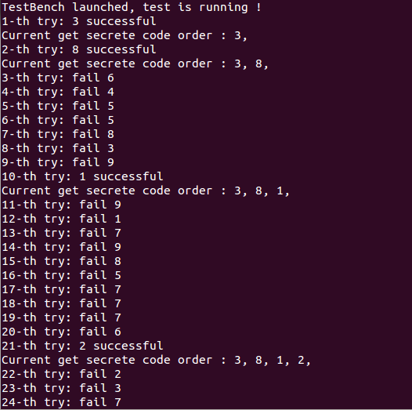

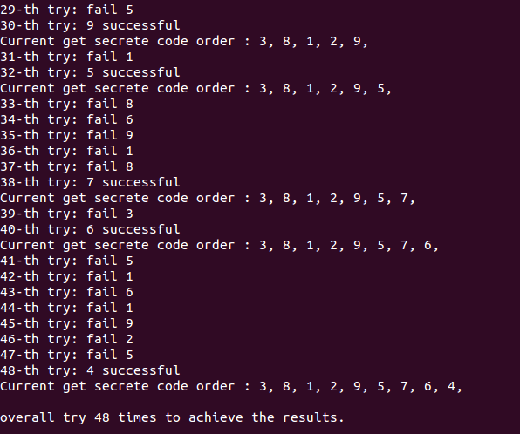

Second version of testbench design.
1. Dividing the test process into two separate “resource” and “sink” processes.
2. Redesign the interactive interfaces at the terminal, make it more interesting and intuitive.
Using some code string to change the default secrete code array.
And make all necessary arguments and parameters configurable: like delay time, keys' number.
Make inputs generated interval times configurable.
Add some timestamps in the output to analyze the simultaneous push.
Add the manual “push” ways by pressing the corresponding keys.
Etc.

3. 2nd version design will also include the mutex and time delay simulation.

4. make several pushing process in the testbench at the same time may be a good idea to simulate the simultaneous push

