NUIST Dynamic Web Design and Development Experiment Report

Experiment name: jQuery events and animation effects Date: Score:

Instructor: Xiaolong Xu Department: Major:

Grade: Class: Name: Student number:

**1、Experimental purpose**

(1)、Understand the basic syntax format of jQuery events

(2)、Master the usage of common jQuery document/window events

(3)、Master the usage of common jQuery keyboard events

(4)、Master the usage of common jQuery mouse events

(5)、Master the usage of jQuery event binding and release

(6)、Master the usage of jQuery hide/show related functions hide(), show() and toggle()

(7)、Grasp the usage of jQuery fade-in/fade-out related functions fadeIn(), fadeOut(), fadeToggle(), fadeTo()

(8)、Grasp the usage of jQuery sliding related functions slideDown(), slideUp(), slideToggle()

(9)、Master the usage of jQuery animation (Animation)

(10)、Grasp the usage of jQuery stop animation related function stop()

**2、Experimental content**

(1)、Create Dangdang special effects

Use mouseover() method and mouseout() method to make navigation page, as shown in the figure

When the mouse pointer moves over, change the background of the current navigation item

When the mouse pointer moves out, restore the background style of the current navigation item

Examples of experimental results:



(2)、Make the fixed layer on the right side of the JD homepage

Make a fixed layer on the right side of the JD homepage, with 6 icons: JD members, shopping cart, my attention, my footprint, my message and consulting JIMI

By default, only the icon is displayed, and the background color is dark gray; when the mouse is moved over the icon, the background color is dark red and the text is displayed

Examples of experimental results:

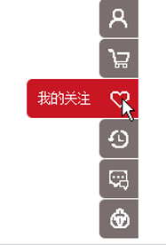

(3)、Imitation of the left side menu of Jingdong

Use hover() to display the secondary menu when the mouse is moved to the menu, and hide the secondary menu when moving out of the current menu

Use toggleClass() to realize that the background color becomes orange when the mouse is moved to the menu, and the background color is restored to the original color when the mouse moves out of the current menu

Examples of experimental results:

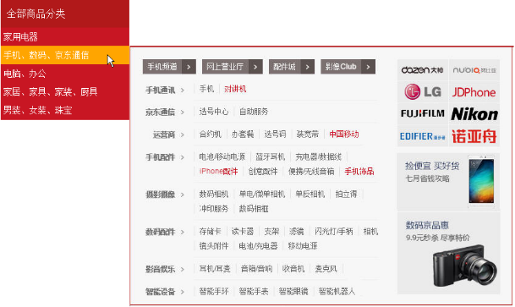

(4)、Create Jingdong FAQ classification page

Move the mouse to "Contact Customer Service", the secondary menu will be displayed at the speed of "slow"; when the mouse is left, the secondary menu will be hidden at the speed of "fast"

Use slideDown() to display the second-level menu at the "slow" speed when the single-mouse "common problem classification" first-level menu; when the mouse clicks the first-level menu again, use slideUp() to achieve the second-level menu at the "slow" speed hide

Examples of experimental results:



**3、Experimental results** (given the code and result diagram)

**4、Summary and experience**