NUIST Dynamic Web Design and Development Experiment Report
Experiment name: Use jQuery to manipulate the DOM Date: Score:
Instructor: Xiaolong Xu Department: Major:
Grade: Class: Name: Student number:
1、Experimental purpose
(1)、Use jQuery to manipulate web page elements
(2)、Use jQuery to manipulate CSS styles
(3)、Use jQuery to manipulate text and attribute value content
(4)、Use jQuery to manipulate DOM nodes
(5)、Use jQuery to manipulate CSS-DOM
(6)、Use jQuery to traverse DOM nodes
2、Experimental content
(1)、Make FAQ module
Next, make the page as shown in the figure, click the title "FAQ", and use the html() method to add a list of questions on the page, as shown in the figure.
Click the "×" button, use the html() method to cancel the question list and return to the interface as shown in the figure.
Examples of experimental results:
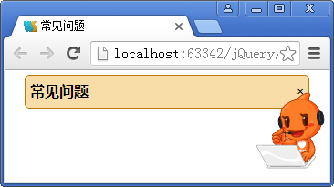
(2)、Make search box special effects
Make the search box special effect as shown in the picture.
When the text box gets the focus, the initial value "electric fan" disappears, as shown in the figure,
This initial value appears if the content of the text box is empty when the focus is lost.
Examples of experimental results:
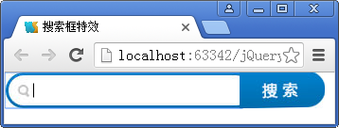
(3)、Side floating folding hidden pop-up window effect
On service websites, the customer service phone number is generally displayed on the left or right side of the website, which is convenient for interested visitors to contact the customer service to inquire about the situation.
Realize the effect of side floating folding hidden pop-up window
Examples of experimental results:
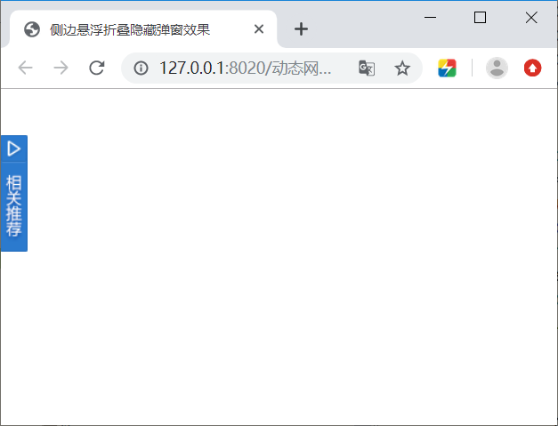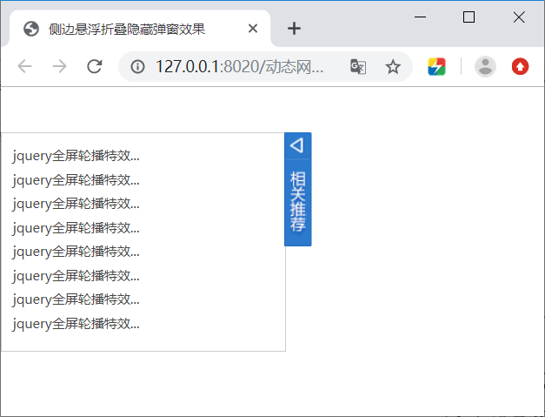
(4)、Single line text scroll
On news websites, in order to save page area, the automatic scrolling of one-line news is generally displayed on the website to inform people of the content of the news.
This case will achieve the scrolling effect of a single line of text
The effect is shown in the figure, and the text content in the rectangular box is automatically changed.
Examples of experimental results:
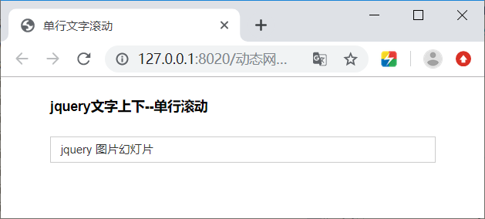
3、Experimental results (given the code and result diagram)
4、Summary and experience

