Investigating Sending Methods by Remote Method Invocation (RMI) and User Datagram Protocol(UDP)

Calvin Chan(cc6815)
Yuxuan Chen(yc4416)

Introduction:
Sending messages between client and server, by Remote Method Invocation (RMI) and User Datagram Protocol (UDP), investigated by coding in Java, is introduced in this report. Different number of messages are sent between client and server by two different computers, and this report will analyse the performance, efficiency and ease of set-up of each type of system.

UDP:

UDP is based on a connectionless communication model, and there is no guarantee of delivering or ordering, especially in unreliable network.
There are several ways of causing the package loss.

Firstly, congestion could take place easily. UDP lacks overhead, so it can send packets very quickly. Especially in an overloaded router, it receives data in a faster rate than sending. Also， many other users are using the school computers and Internet at the same time, the loading pressure is very high.
Secondly, UDP does not retransmit the lost messages, so this causes the loss rate to increase.

RMI:

Instead of sending messages locally, RMI calls a remote method implementation using stub and skeleton to transmit data between client and server.
The stub acts as a local proxy for a remote object, and it carries out method calls when a method is invoked from a caller(client). The skeleton then receives the call from network, and it dispatches the call to the actual remote object.
Server binds the service with the RMI Registry, and Security Manager should work for both server and client when skeleton catches the calls sent by the stub.
UDP against RMI (By observation of our testing):
We can easily spot the characteristics in the screen shots below. For UDP, when the distance increases, the loss rate will also increase, but for the RMI, it does not have any lost packages, which means that UDP has a high rate of loss of messages compared to RMI, but it serves quickly.
It is suitable for applications that need fast and efficient transmission such as games.

When we are sending packages by RMI, the time waiting is longer.
Although RMI is reliable, it is not suitable for the system requiring lots of exchanging of message such as funds transfer.

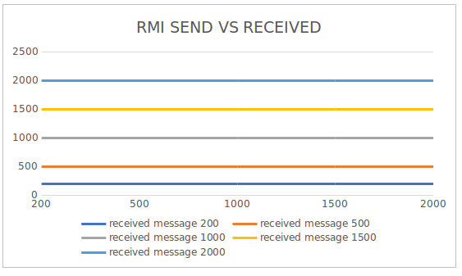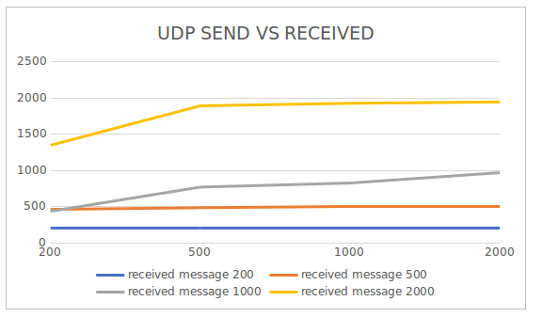

RMI screen shots:

RMI Client:
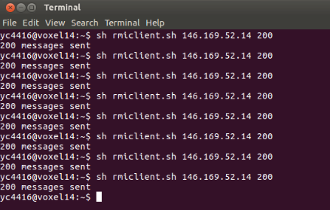

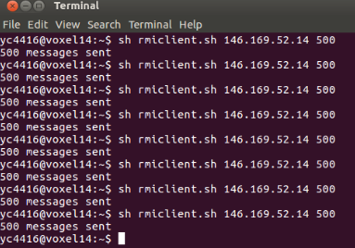

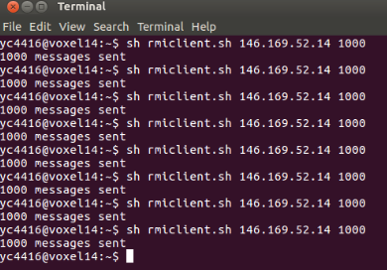

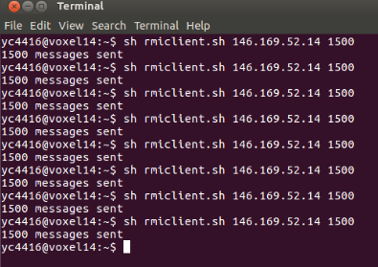

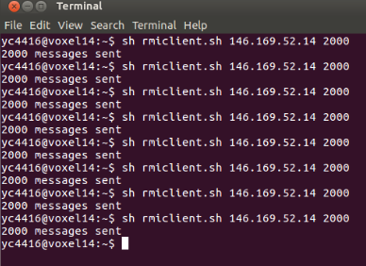

RMI Server:

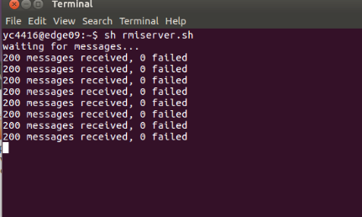
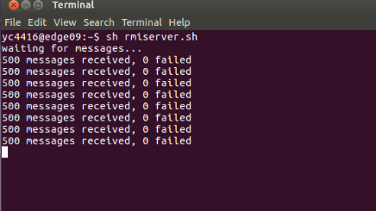

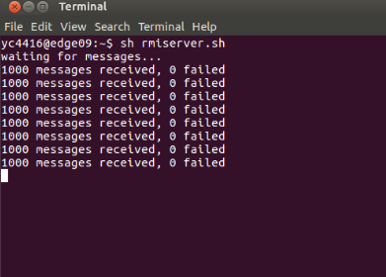

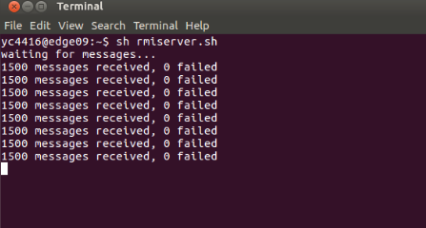

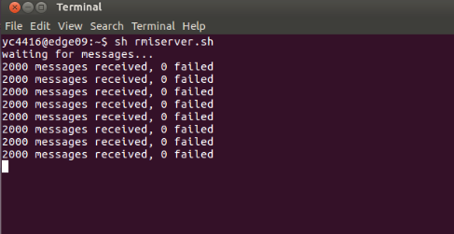

RMI Client code:
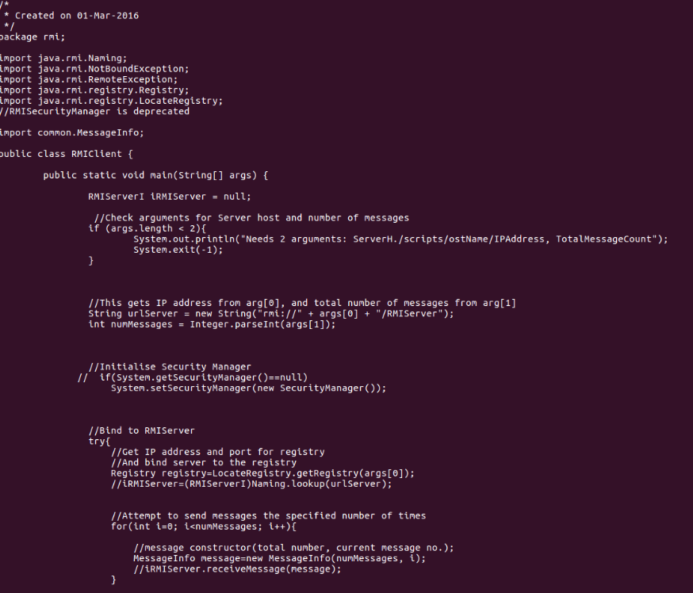
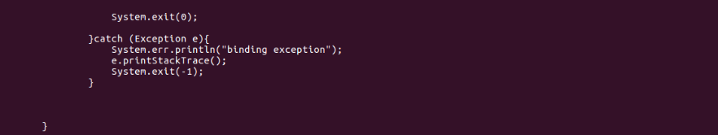
RMI Server code:
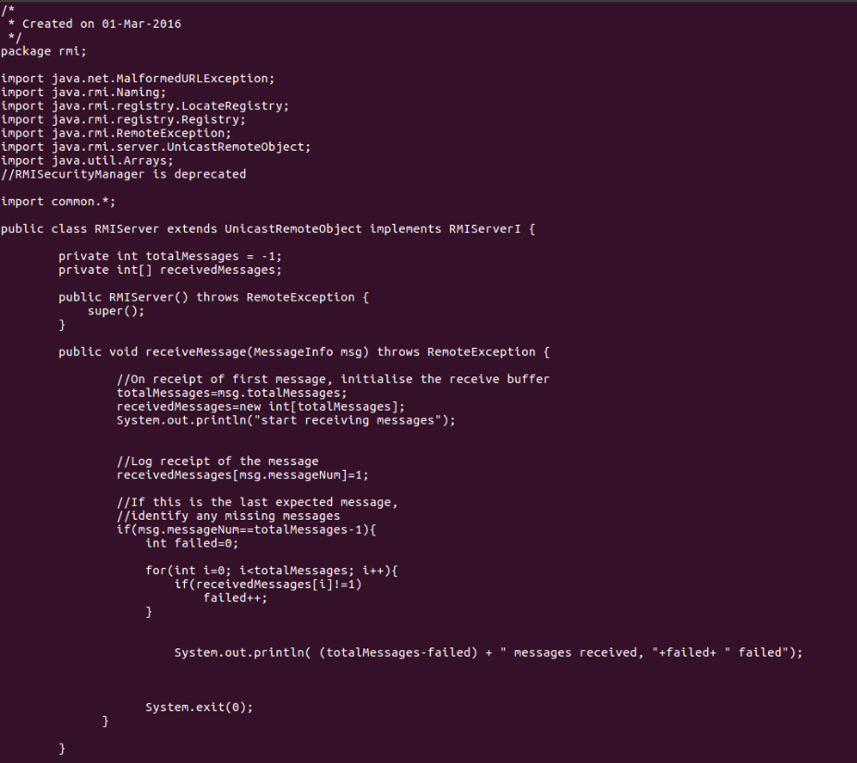
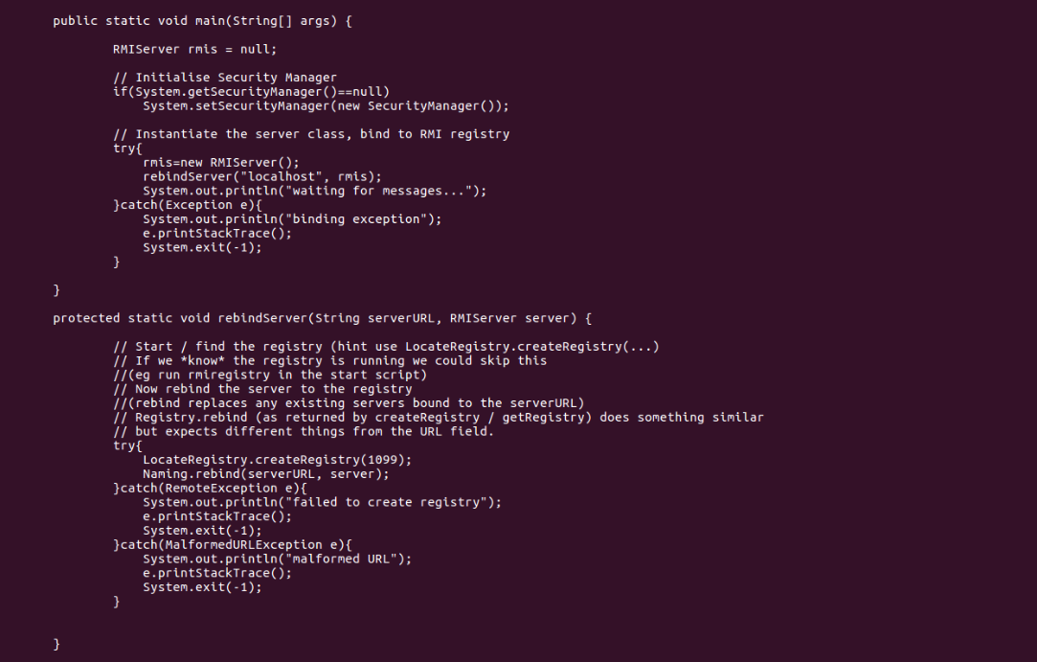

UDP screen shots:

UDP client:

UDP server:
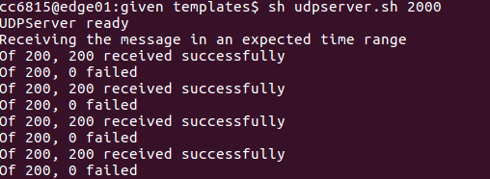

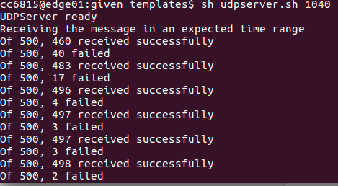

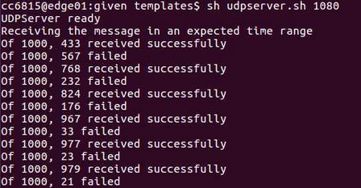
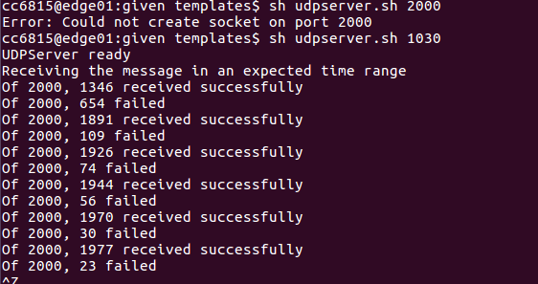

UDP client code:
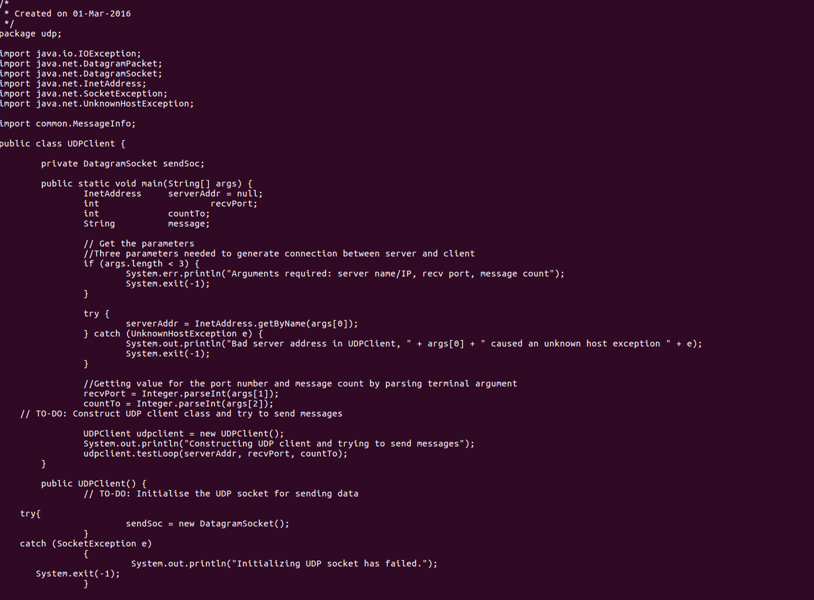

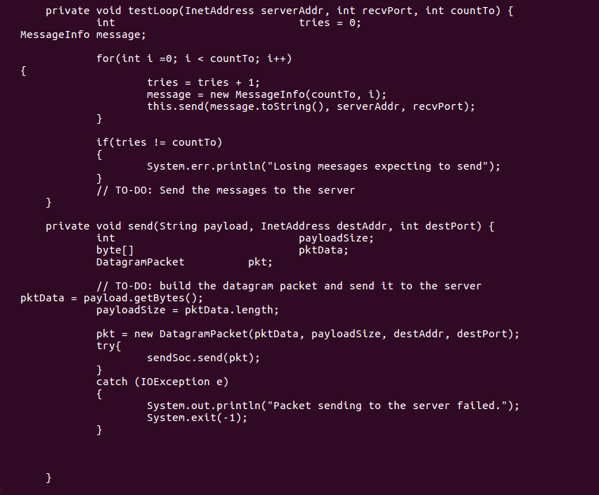

UDP Server Code:
