武汉大学计算机学院
本科生课程设计报告

Category analysis of daily hotspots

专 业 名 称 ：软件工程
课 程 名 称 ：商务智能与数据挖掘
指 导 教 师 ：朱卫平 副教授
学 生 学 号 ：2017302580067
学 生 姓 名 ：黄伟豪

二○一九年十二月

郑 重 声 明

本人呈交的设计报告，是在指导老师的指导下，独立进行实验工作所取得的成果，所有数据、图片资料真实可靠。尽我所知，除文中已经注明引用的内容外，本设计报告不包含他人享有著作权的内容。对本设计报告做出贡献的其他个人和集体，均已在文中以明确的方式标明。本设计报告的知识产权归属于培养单位。

本人签名： 黄伟豪 日期： 2019.12.15

Abstraction

The main purpose of this experiment is to find the news type by its title and then use this model to get everyday hot point’s type.

The main content of the experiment is to obtain data from the news website to form a training and test set, then select a deep learning model for training, and then use the reptile to obtain daily hotspots to predict the type.

Keyword：news, type, deep learning

Directory

1 Background of the experiment………………………………..5
2 Demand analysis………………………………………………….5
3 Solution of the problem……………………………………….5
4 Key code implementation……………………………………….6
4.1Key code…………………………………………………………………………… 6
4.2Configuration instructions………………………………………………… 9
4.2Data Source………………………………………………………………………… 10
5 Discussion…………………………………………………………10

1 Background of the experiment

There are new hot spots everyday, however hot spots are just listed in the table and are not classified. So if you want to see one specific hot spot, you actually need to skim all of them which is time wasting.

2 Demand analysis

If you want achieve what has been mentioned above, you have to get the hot point classified. But the hot point data is actually not classified, you have to find data for the model to train .What’s more, you need write reptile to get data and everyday hot point.

3 Solution of the problem

First of all, for the labeled data used to train and test, I choose to obtain the classified news data from the website. As for deep learning model , this is Text Categorization problem so I choose Convolutional Neural Networks. I obtain the data and hot point from the website by using BS4 reptile. That is solution to the problem.

4 Key code implementation

4.1 Key cord
First, you have to collect all the character in the data’s title as a dictionary.
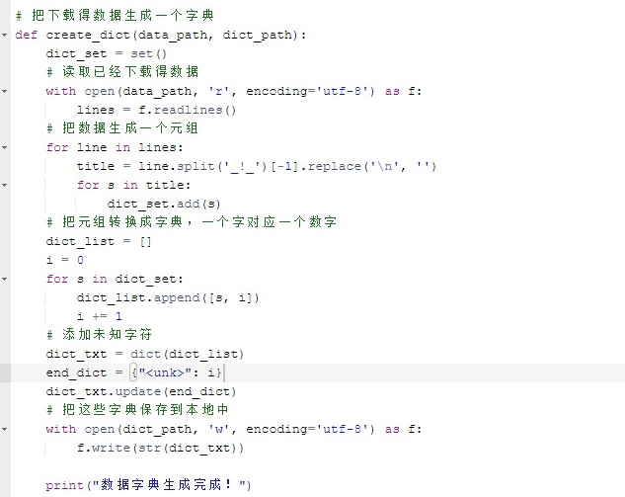
Picture4.1the funtion of producing a dic

Second, you have to process the data and divide them into two files as train and test data. And one of every ten data is divided into test data. 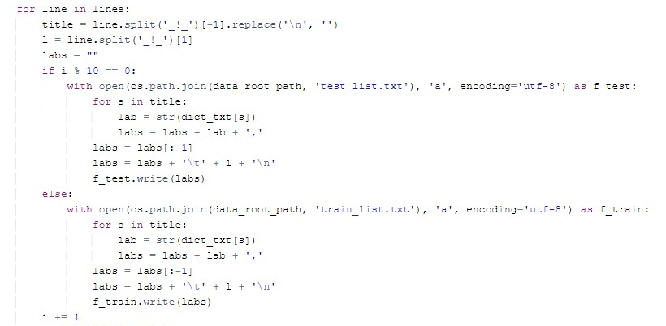
Picture 4.2 production of train data and test data

Next, you can define the function for the learning model to get train and test data.
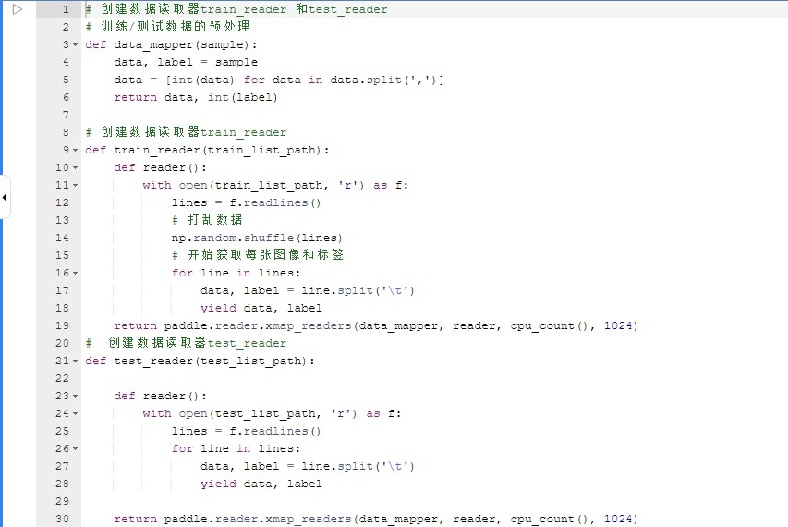
Picture 4.3 function of train_reader and test_reader

Enter a sequence of word vectors to generate a feature map, and use the max pooling over time operation on the feature map to obtain the features of the entire sentence corresponding to this convolution kernel. The features obtained from the kernel are stitched together to form a fixed-length vector representation of the text. For text classification problems, they are connected to softmax to build a complete model.
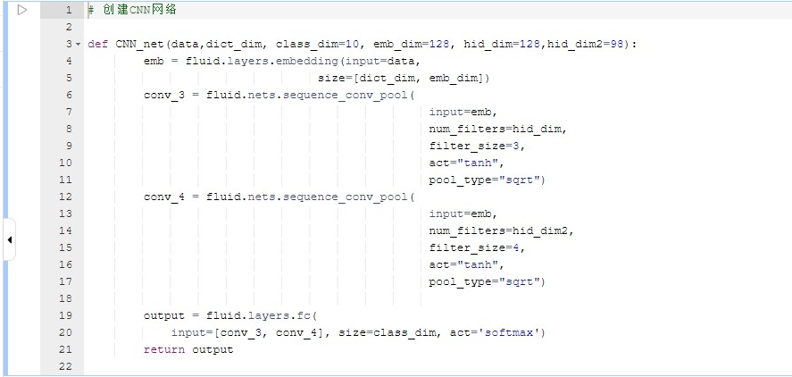
Picture 4.4 creation of the CNN
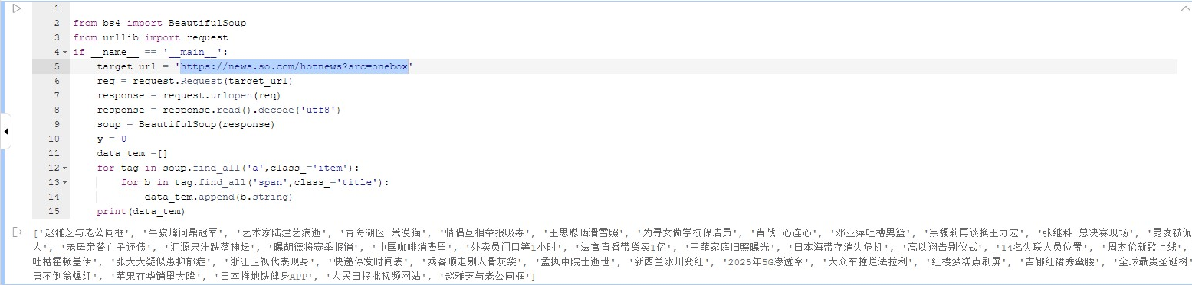
Picture 4.5 reptile to obtain the hot point
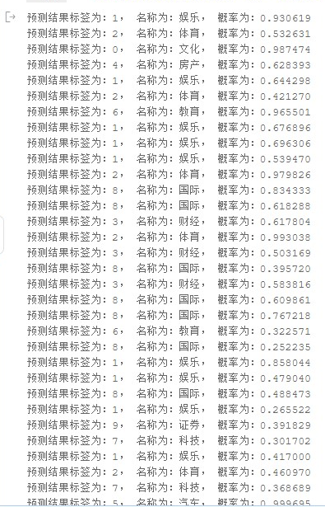
Picture 4.6 prediction result
4.2 Configuration instructions
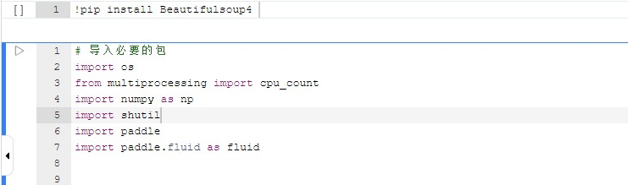
Picture 4.7 Import package
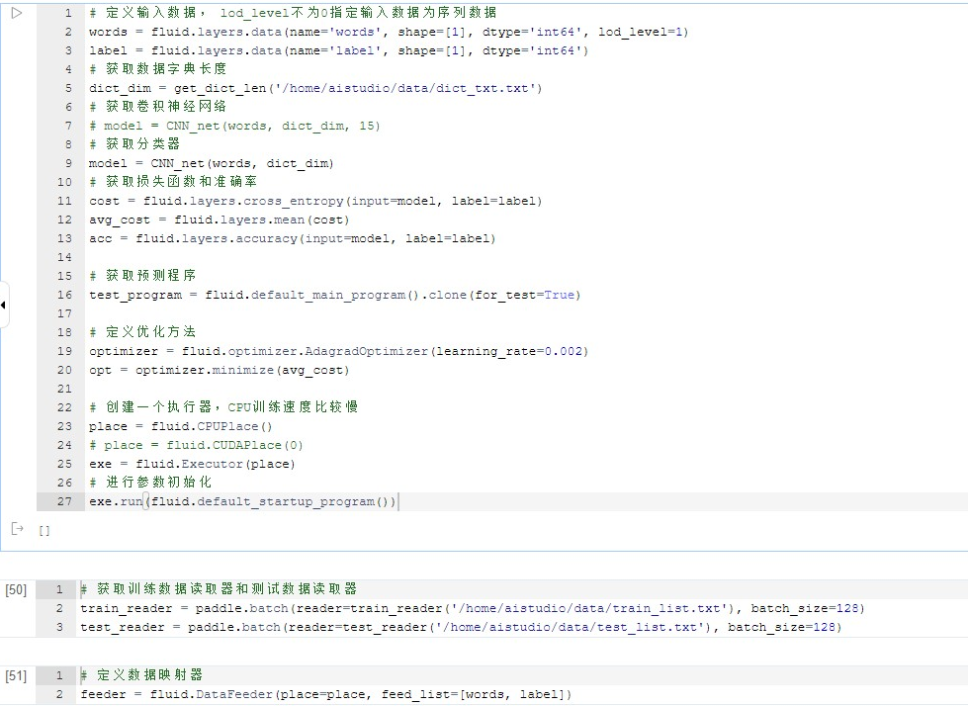
Picture 4.8 Neural network configuration
4.3Data Source
The train and test data are obtained from the Internet by reptile and the hot spot is gained from https://news.so.com/hotnews?src=onebox

5 Discussion

It can be seen from the experimental results that the classification accuracy for many hotspots is still low. The possible reason is that the number of categories of training data is still too narrow. So if I want to improve the model, I think I can do from the following parts. First, get more kinds of the data. Next, output the result not just one class but into multi classes.

