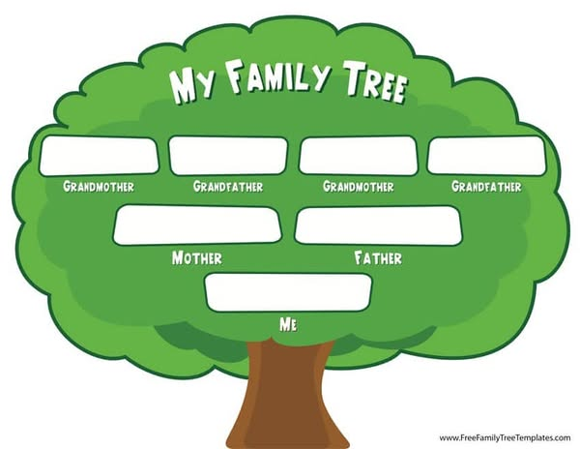

MINING ABRIL CERVANA
RONALD DE TORRES WILBA

NATIVIDAD WELBA
JEROME A. WILBA
GERALDINE A. WILBA
# The Welba Family
The Welba family is a loving and close-knit family with a rich history and cultural heritage. They originated from the province of San Pablo City, Philippines, where their ancestors were known for their resilience, hard work, and warm hospitality.
# Family Members
- Parents: Geraldine and Ronald both in their late 50s, are the pillars of the family. My father is a security guard at quickloan jewelry shop in san pablo, while my mother is a homemaker and an optomologist personnel.
- Children: The Welba family has 2 children: I am eldest, and my younger sister is also 21y/old
# Family Values
The Welba family values tradition, respect, and unity. They place great importance on family gatherings, celebrations, and storytelling. They are also known for their generosity, kindness, and strong sense of community.
# Family Traditions
- Sunday Lunch: The Welba family gathers every Sunday for a grand lunch,
- Storytelling: My family loves to share stories about their ancestors, their struggles, and their triumphs.
# Family Legacy
The Welba family is proud of their heritage and their contributions to their community. They strive to pass on their values, traditions, and stories to future generations, ensuring that their family legacy continues to thrive.

