1. Make sure your DB is running

PS D:\> docker start mysql1

mysql1

PS D:\>

PS D:\> docker ps -a

CONTAINER ID IMAGE COMMAND CREATED STATUS PORTS NAMES

83c6492cfe22 mysql/mysql-cluster "/entrypoint.sh mysq…" 2 weeks ago Exited (0) 2 weeks ago mysql11

c90dacd63e0e mysql/mysql-cluster "/entrypoint.sh ndbd" 2 weeks ago Exited (137) 2 weeks ago ndb2

f5df46ee80d2 mysql/mysql-cluster "/entrypoint.sh ndbd" 2 weeks ago Exited (137) 2 weeks ago ndb1

9d339f00c575 mysql/mysql-cluster "/entrypoint.sh ndb_…" 2 weeks ago Exited (137) 2 weeks ago management1

de80c5fb5135 neo4j:latest "/sbin/tini -g -- /d…" 2 weeks ago Exited (0) 12 days ago myneo4j

e159eab5e555 mongo:latest "docker-entrypoint.s…" 3 weeks ago Exited (255) 2 weeks ago 127.0.0.1:27017->27017/tcp mymongo

a1f412b3e094 mysql:latest "docker-entrypoint.s…" 2 months ago Up 9 minutes 0.0.0.0:3306->3306/tcp mysql1

cb21284a0b14 microsoft/azureiotedge-agent:1.0-preview "/usr/bin/dotnet Mic…" 3 months ago Exited (0) 3 months ago edgeAgent

54a224910330 redis "docker-entrypoint.s…" 3 months ago Exited (0) 3 months ago myredis

PS D:\>

1. Connect your DB and create your interview1 DB,

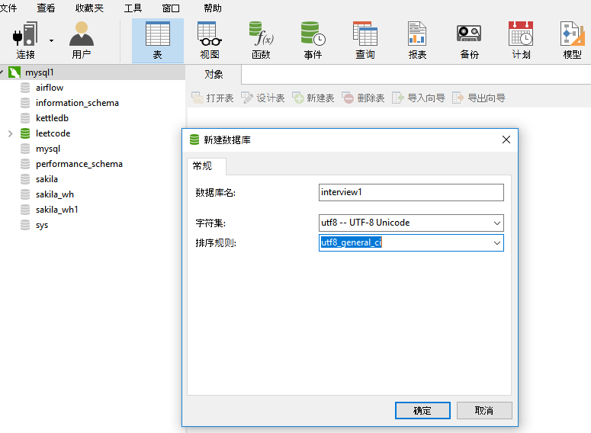

1. Run the following interview.sql by file

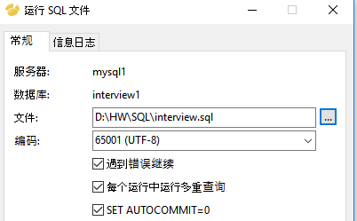

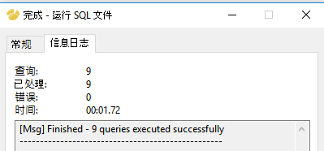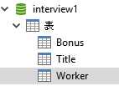

Do your interview questions by the file answer1.sql