Progress log and result report for Xen/CUDA/Linux Step 1
Author: Bren Max
Date: January 8, 2025
Tested On: XCP-ng 8.2 (Xen 4.13, QEMU 4.2.1)
Status: VERIFIED WORKING
WHAT NEED BEFORE STARTING
Hardware Setup:
✓ A server with XCP-ng installed (host machine)
✓ NVIDIA H100 GPU installed in the server
✓ At least one VM running on XCP-ng (guest machine)
✓ Network access between workstation and the host
Workstation:
✓ SSH client (PuTTY on Windows, or native ssh on Linux/Mac)
✓ Text editor (Notepad++, VSCode, or nano/vim)
Access Required:
✓ Root access to XCP-ng host
✓ Root access to VM
PART 1: VERIFY SETUP
Step 1.1: Connect to XCP-ng Host
On workstation, open terminal/command prompt:
Windows:
Open Command Prompt and type:
> ssh root@<host-ip>
Example:
> ssh root@10.25.33.10
Linux/Mac:
Open Terminal and type:
$ ssh root@<host-ip>
Example:
$ ssh root@10.25.33.10
Enter root password when prompted.
Example:Calvin@123
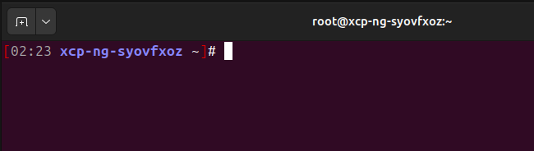
Step 1.2: Verify XCP-ng is Running
Type this command:
# cat /etc/redhat-release
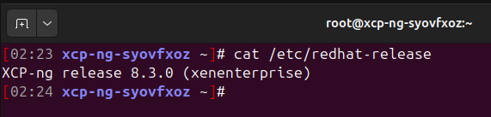
Step 1.3: Verify H100 GPU is Detected
Type this command:
# nvidia-smi
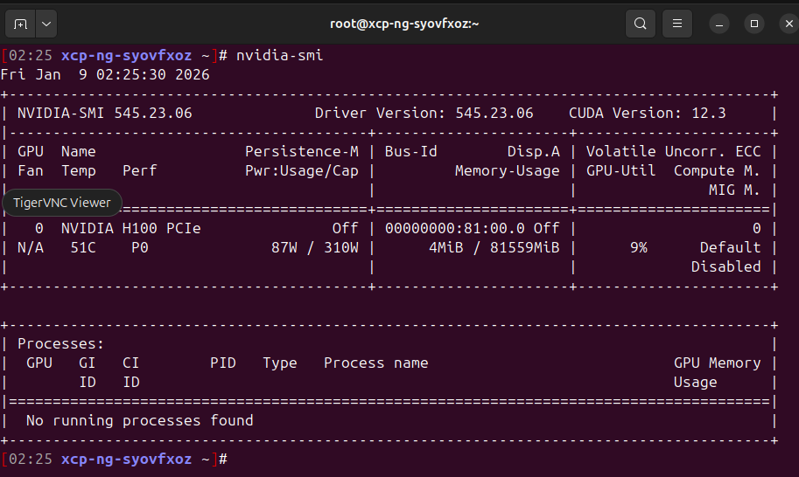
Step 1.4: Check What VMs Are Running
Type this command:
# xl list
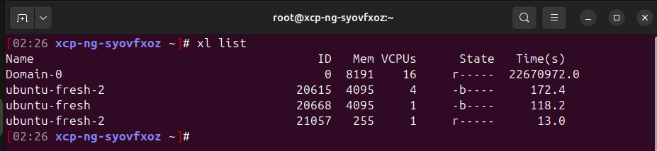
Step 1.5: Connect to VM
From the host, connect to VM:
# ssh root@<vm-ip-address>
Or use XCP-ng console:
# xl console <vm-name>
To exit `xl console` back to the host, press Ctrl+] then type `q`.
Inside the VM, verify it's Linux:
# uname -a
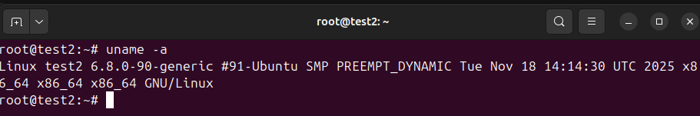
Should show Linux kernel version.
Step 1.6: Install Development Tools on Host
On the XCP-ng host, run:
# yum install -y gcc make kernel-devel
Step 1.7: Install Development Tools on VM
Connect to VM and run:
If VM is Ubuntu/Debian:
# sudo apt update
# sudo apt install -y build-essential

If VM is CentOS/RHEL:
# yum install -y gcc make
PART 2: CREATE HOST↔VM FILE-BASED COMMUNICATION
Overview:
1. Create a folder on the host (in /dev/shm)
2. Export it to the VM (NFS or sshfs)
3. Write a host program that monitors a file in that folder
4. Write a VM program that writes to that file
5. Test communication
Step 2.1: Create Shared Folder on Host
On XCP-ng HOST, type these commands one by one:
# cd /dev/shm
This changes to the memory-backed tmpfs directory on the host.
# mkdir vgpu
This creates a folder named "vgpu".
# chmod 777 vgpu
This makes the folder accessible to all programs.
# ls -ld vgpu
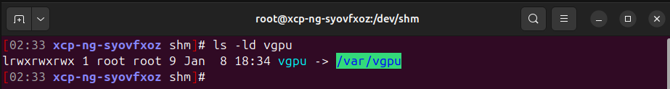
Step 2.2: Create Host Mediator Program
We'll create a C program that waits for commands from the VM.
On the HOST, type:
# cd /root
This goes to home directory.
# nano simple_host_mediator.c
#include <stdio.h>
#include <stdlib.h>
#include <string.h>
#include <fcntl.h>
#include <sys/mman.h>
#include <unistd.h>
#include <stdint.h>
#include <sys/stat.h>

#define SHM_PATH "/dev/shm/vgpu/commands"
#define SHM_SIZE 4096

typedef struct {
uint32_t command;
uint32_t status;
char data[256];
} vgpu_message;

int main() {
int fd;
vgpu_message *msg;

printf("===========================================\n");
printf("vGPU Host Mediator - Phase 1 Proof of Concept\n");
printf("===========================================\n");

// Create shared memory file
// NOTE: Default umask may turn 0666 into 0644, causing non-root VM users
// to get "Permission denied" when opening O_RDWR over the mounted share.
umask(000);
fd = open(SHM_PATH, O_CREAT | O_RDWR, 0666);
if (fd < 0) {
perror("Error: Failed to open shared memory");
printf("Make sure /dev/shm/vgpu directory exists!\n");
return 1;
}

// Ensure it is writable by others even if umask changes later
fchmod(fd, 0666);

// Set file size
if (ftruncate(fd, SHM_SIZE) < 0) {
perror("Error: Failed to set shared memory size");
close(fd);
return 1;
}

// Map shared memory
msg = mmap(NULL, SHM_SIZE, PROT_READ | PROT_WRITE,
MAP_SHARED, fd, 0);
if (msg == MAP_FAILED) {
perror("Error: Failed to map shared memory");
close(fd);
return 1;
}

printf("✓ Shared memory initialized at %s\n", SHM_PATH);
printf("✓ Size: %d bytes\n", SHM_SIZE);
printf("\n");

// Initialize
msg->command = 0;
msg->status = 0;
strcpy(msg->data, "Ready");

printf("Waiting for commands from VM...\n");
printf("(Press Ctrl+C to stop)\n");
printf("\n");

// Main loop
while (1) {
if (msg->command != 0) {
printf(">>> Received command: %u\n", msg->command);

// Simulate processing
printf(">>> Processing...\n");
sleep(1);

// Send response
msg->status = 1; // Success
snprintf(msg->data, sizeof(msg->data),
"Command %u completed successfully", msg->command);

printf(">>> Response sent: %s\n", msg->data);

// Clear command for next request
msg->command = 0;

printf("\n");
printf("Waiting for next command...\n");
}

// Poll every 10ms
usleep(10000);
}

// Cleanup (never reached unless Ctrl+C)
munmap(msg, SHM_SIZE);
close(fd);

return 0;
}
END FILE simple_host_mediator.c

After typing/pasting:
- Press Ctrl+O (to save)
- Press Enter (to confirm filename)
- Press Ctrl+X (to exit)

Verify the file was created:
# ls -la simple_host_mediator.c
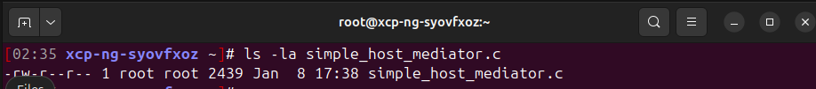
Step 2.3: Compile Host Mediator Program
Still on the HOST, type:
# gcc -o mediator simple_host_mediator.c
Verify it compiled:
# ls -la mediator
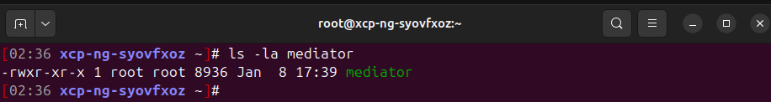
Step 2.4: Share Host Folder to VM (NFS or sshfs)
Now we need to share the host folder to the VM.
For Phase 1, we'll use NFS (Network File System).
On the HOST, install NFS:
# yum install -y nfs-utils rpcbind
IMPORTANT (XCP-ng / tmpfs note):
`/dev/shm` is a tmpfs (RAM-backed filesystem). Exporting tmpfs paths directly
over NFS often causes errors like:
`exportfs: /dev/shm/vgpu requires fsid= for NFS export`
To avoid this, we will export a normal on-disk path (`/var/vgpu`) over NFS, and
then point `/dev/shm/vgpu` at it so our host programs can keep using the same
paths.
Create the export path:
# mkdir -p /var/vgpu
# chmod 777 /var/vgpu
Point `/dev/shm/vgpu` to `/var/vgpu` (choose ONE):
Option A (recommended, simplest): use a symlink
# rm -rf /dev/shm/vgpu
# ln -s /var/vgpu /dev/shm/vgpu
Option B (alternative): bind-mount the on-disk dir into /dev/shm
# mount --bind /var/vgpu /dev/shm/vgpu
If we previously ran the WRONG bind-mount direction:
`mount --bind /dev/shm/vgpu /var/vgpu`
then `/var/vgpu` becomes tmpfs-backed and NFS exports commonly break.
Fix it (HOST):
# umount /var/vgpu
# rm -rf /var/vgpu
# mkdir -p /var/vgpu
# chmod 777 /var/vgpu
# rm -rf /dev/shm/vgpu
# ln -s /var/vgpu /dev/shm/vgpu
If `umount /var/vgpu` says "target is busy":
1) See what's mounted where:
# mount | grep vgpu
# findmnt /var/vgpu
2) Stop NFS temporarily (it may keep references open):
# systemctl stop nfs-server
# exportfs -au
3) Identify and kill processes using the path (if available):
# fuser -vm /var/vgpu
# fuser -km /var/vgpu
4) Retry unmount, and if still busy use a lazy unmount:
# umount /var/vgpu
# umount -l /var/vgpu
Then restart NFS after fixing `/etc/exports`:
# systemctl start nfs-server
Edit NFS exports:
# nano /etc/exports
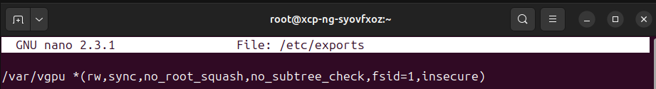
Add this line:
/var/vgpu *(rw,sync,no_root_squash,no_subtree_check,fsid=1,insecure)
Save and exit (Ctrl+O, Enter, Ctrl+X)
Start NFS:
# systemctl enable --now rpcbind nfs-server
# exportfs -rav
Verify the export is correct:
# exportfs -v

IMPORTANT: If we still see `/dev/shm/vgpu` in `exportfs -v`, we did NOT update
`/etc/exports` correctly. Fix `/etc/exports` to export `/var/vgpu`, then rerun:
# exportfs -rav
# systemctl restart rpcbind nfs-server
Get host's IP address:
# hostname -I
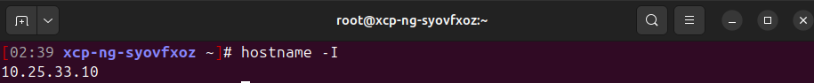
If `hostname -I` is empty on system, use:
# ip -4 addr show
Look for something like: inet 10.25.33.10/24
My host IP: 10.25.33.10
Step 2.5: Mount Shared Folder in VM
Switch to VM (ssh to it or use xl console).
In the VM, install NFS client:
If Ubuntu/Debian:
# apt update
# apt install -y nfs-common
If CentOS/RHEL:
# yum install -y nfs-utils
Create mount point:
# mkdir -p /mnt/vgpu
Before mounting, test connectivity:
# ping -c 3 <host-ip>
Example:
# ping -c 3 10.25.33.10
If ping works, continue. If not, check VM network configuration.

Now try to mount:
# mount -t nfs <host-ip>:/var/vgpu /mnt/vgpu
Example:
# mount 10.25.33.10:/var/vgpu /mnt/vgpu
IMPORTANT: Use `sudo` on Ubuntu/Debian guests:
# sudo mount -t nfs 10.25.33.10:/var/vgpu /mnt/vgpu
Step 2.6: Create VM Client Program
Still in the VM, type:
# cd /root
# nano simple_vm_client.c
#include <stdio.h>
#include <stdlib.h>
#include <fcntl.h>
#include <sys/mman.h>
#include <unistd.h>
#include <stdint.h>
#include <string.h>

#define SHM_PATH "/mnt/vgpu/commands"
#define SHM_SIZE 4096

typedef struct {
uint32_t command;
uint32_t status;
char data[256];
} vgpu_message;

int main(int argc, char *argv[]) {
int fd;
vgpu_message *msg;
uint32_t cmd_number = 42; // Default command
int timeout = 0;

printf("===========================================\n");
printf("vGPU VM Client - Phase 1 Test\n");
printf("===========================================\n");

// Parse command line argument
if (argc > 1) {
cmd_number = atoi(argv[1]);
}

// Open shared memory (note: requires write permission on SHM_PATH)
fd = open(SHM_PATH, O_RDWR);
if (fd < 0) {
perror("Error: Cannot open shared memory");
printf("Make sure /mnt/vgpu is mounted!\n");
printf("Run: sudo mount -t nfs <host-ip>:/var/vgpu /mnt/vgpu\n");
printf("If shell prompt ends with '$', we're not root. Try: sudo ./gpu_test\n");
return 1;
}

// Map shared memory
msg = mmap(NULL, SHM_SIZE, PROT_READ | PROT_WRITE,
MAP_SHARED, fd, 0);
if (msg == MAP_FAILED) {
perror("Error: Failed to map shared memory");
close(fd);
return 1;
}

printf("✓ Connected to host mediator\n");
printf("\n");

// Check if host is ready
if (msg->status == 0 && msg->command == 0) {
printf("✓ Host mediator is ready\n");
}

// Send command
printf(">>> Sending command: %u\n", cmd_number);
msg->status = 0; // Clear previous status
msg->command = cmd_number;

printf(">>> Waiting for response from host...\n");

// Wait for response (with timeout)
while (msg->status == 0 && timeout < 100) {
usleep(100000); // Wait 100ms
timeout++;
}

if (timeout >= 100) {
printf("✗ TIMEOUT: No response from host!\n");
printf("Make sure host mediator is running!\n");
munmap(msg, SHM_SIZE);
close(fd);
return 1;
}

// Display response
printf(">>> Response received!\n");
printf("\n");
printf("Status: %s\n", msg->status == 1 ? "SUCCESS" : "FAILED");
printf("Message: %s\n", msg->data);
printf("\n");
printf("===========================================\n");
printf("✓ Communication test PASSED!\n");
printf("===========================================\n");

// Cleanup
munmap(msg, SHM_SIZE);
close(fd);

return 0;
}
Save and exit (Ctrl+O, Enter, Ctrl+X)
Step 2.7: Compile VM Client Program
In the VM, type:
# gcc -o gpu_test simple_vm_client.c
Verify:
# ls -la gpu_test
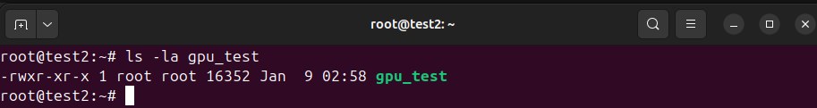
PART 3: TEST THE COMMUNICATION
Step 3.0: FIX - Create Network-Safe Programs
The issue: mmap() doesn't work well over NFS/sshfs for bidirectional communication.
Solution: Use explicit file read/write instead.
On the HOST, create a new mediator:
# cd /root
# nano network_safe_mediator.c
#include <stdio.h>
#include <stdlib.h>
#include <string.h>
#include <unistd.h>
#include <stdint.h>

#define CMD_FILE "/dev/shm/vgpu/command.txt"
#define RSP_FILE "/dev/shm/vgpu/response.txt"

int main() {
FILE *cmd_fp, *rsp_fp;
uint32_t last_cmd = 0;
uint32_t current_cmd = 0;
unsigned int cmd_count = 0;

printf("===========================================\n");
printf("vGPU Host Mediator - Network Safe Version\n");
printf("===========================================\n");

// Initialize response file
rsp_fp = fopen(RSP_FILE, "w");
if (rsp_fp) {
fprintf(rsp_fp, "0:Ready\n");
fclose(rsp_fp);
}

printf("✓ Using file-based communication\n");
printf("✓ Command file: %s\n", CMD_FILE);
printf("✓ Response file: %s\n", RSP_FILE);
printf("\n");
printf("Waiting for commands from VM...\n");
printf("(Press Ctrl+C to stop)\n");
printf("\n");

while (1) {
// Read command file
cmd_fp = fopen(CMD_FILE, "r");
if (cmd_fp) {
if (fscanf(cmd_fp, "%u", &current_cmd) == 1) {
// New command received
if (current_cmd != last_cmd && current_cmd != 0) {
cmd_count++;
printf(">>> Received command #%u: %u\n", cmd_count, current_cmd);
printf(">>> Processing...\n");

// Simulate processing
sleep(1);

// Write response
rsp_fp = fopen(RSP_FILE, "w");
if (rsp_fp) {
fprintf(rsp_fp, "1:Command %u completed successfully\n",
current_cmd);
fflush(rsp_fp);
fclose(rsp_fp);
}

printf(">>> Response sent\n\n");
last_cmd = current_cmd;
}
}
fclose(cmd_fp);
}

usleep(50000); // Poll every 50ms
}

return 0;
}
Save (Ctrl+O, Enter, Ctrl+X) and compile:
# gcc -o network_mediator network_safe_mediator.c
On the VM, create a new client:
# cd /root
# nano network_safe_client.c
#include <stdio.h>
#include <stdlib.h>
#include <unistd.h>
#include <stdint.h>
#include <string.h>

#define CMD_FILE "/mnt/vgpu/command.txt"
#define RSP_FILE "/mnt/vgpu/response.txt"

int main(int argc, char *argv[]) {
FILE *cmd_fp, *rsp_fp;
uint32_t cmd_number = 42;
char response[256];
int status;
int timeout = 0;

printf("===========================================\n");
printf("vGPU VM Client - Network Safe Version\n");
printf("===========================================\n");

if (argc > 1) {
cmd_number = atoi(argv[1]);
}

// Write command
cmd_fp = fopen(CMD_FILE, "w");
if (!cmd_fp) {
perror("Error: Cannot write command file");
printf("Make sure /mnt/vgpu is mounted!\n");
return 1;
}

fprintf(cmd_fp, "%u\n", cmd_number);
fflush(cmd_fp);
fclose(cmd_fp);

printf("✓ Connected to host\n");
printf(">>> Sending command: %u\n", cmd_number);
printf(">>> Waiting for response...\n");

// Wait for response
sleep(1); // Give host time to process

while (timeout < 50) { // 5 second timeout
rsp_fp = fopen(RSP_FILE, "r");
if (rsp_fp) {
if (fgets(response, sizeof(response), rsp_fp)) {
if (sscanf(response, "%d:", &status) == 1) {
if (status != 0) { // Got a real response
fclose(rsp_fp);
break;
}
}
}
fclose(rsp_fp);
}

usleep(100000); // Wait 100ms
timeout++;
}

if (timeout >= 50) {
printf("✗ TIMEOUT: No response from host!\n");
return 1;
}

// Parse and display response
char *colon = strchr(response, ':');
if (colon) {
printf(">>> Response received!\n");
printf("\nStatus: %s\n", status == 1 ? "SUCCESS" : "FAILED");
printf("Message: %s\n", colon + 1);
printf("\n===========================================\n");
printf("✓ Communication test PASSED!\n");
printf("===========================================\n");
}

return 0;
}
Save and compile:
# gcc -o gpu_test_v2 network_safe_client.c

Step 3.1: Start Host Mediator
On the HOST:
# cd /root
# ./network_mediator
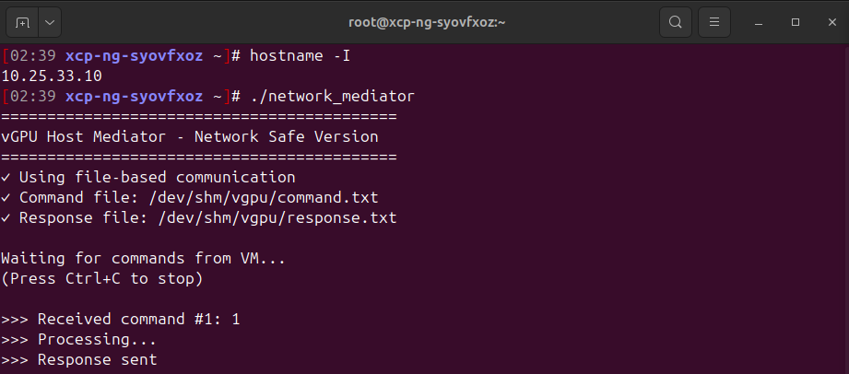
Leave this running
Step 3.2: Run VM Client
In VM terminal:
# cd /root
# ./gpu_test_v2
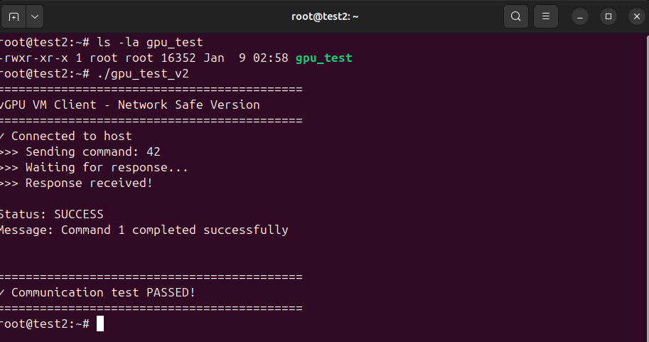
Step 3.3: Test From Second VM (Optional)
In second VM:
1. Mount NFS/sshfs share in VM2:
# sshfs root@10.25.33.10:/var/vgpu /mnt/vgpu
OR
# sudo mount -t nfs 10.25.33.10:/var/vgpu /mnt/vgpu
2. Copy network_safe_client.c to VM2 and compile:
# gcc -o gpu_test_v2 network_safe_client.c
3. Run: # ./gpu_test_v2
Both VMs can send commands to the same host
Note: There may be race conditions if both send at exact same time,
but for Phase 1 testing, this proves multi-VM capability works.
PART 4: ADD CUDA SUPPORT
We make the host actually use the GPU
Step 4.1: Install CUDA Toolkit on Host
Before downloading CUDA, verify which version works with system.
Step A: Check Current NVIDIA Driver Version
# nvidia-smi
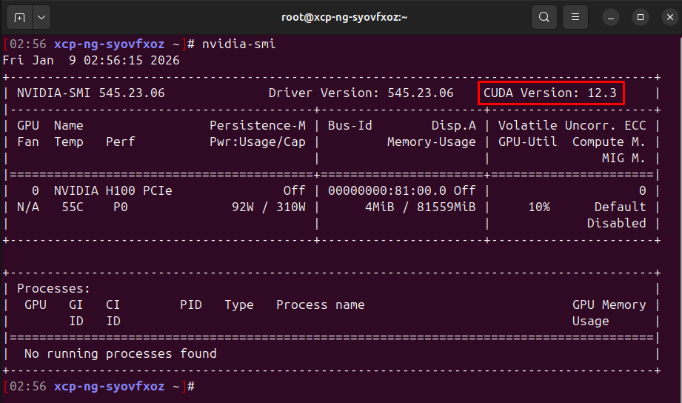
The key numbers:
- Driver Version: 525.23.06
- CUDA Version: 12.0
Step B: Check GPU Model
# nvidia-smi -L
Example output:
GPU 0: NVIDIA H100 PCIe (UUID: GPU-xxxxx)
Step C: Find Compatible CUDA Version
Based on driver version, here's what CUDA versions can install:
Driver Version | Max CUDA Version Supported
525.60.13+ | CUDA 12.0, 12.1, 12.2, 12.3
520.61.05+ | CUDA 12.0, 12.1
515.43.04+ | CUDA 11.7, 11.8
510.39.01+ | CUDA 11.6
495.29.05+ | CUDA 11.5
470.57.02+ | CUDA 11.4
460.32.03+ | CUDA 11.2, 11.3
450.80.02+ | CUDA 11.1

Rule: We driver must be >= the minimum driver for that CUDA version.
Example:
- If nvidia-smi shows driver 525.147.05, we can install CUDA 12.0, 12.1, 12.2, or 12.3
- If nvidia-smi shows driver 470.199.02, we can only install up to CUDA 11.4
Step D: Determine What to Download
NOTE: If `wget` is not installed on the host, install it first:
# yum install -y wget
Case 1: Driver version is NEW enough for CUDA 12.3 (driver >= 525.60)
# wget https://developer.download.nvidia.com/compute/cuda/12.3.0/local_installers/cuda_12.3.0_545.23.06_linux.run
Case 2: Driver version only supports CUDA 11.8 (driver >= 515.43)
# wget https://developer.download.nvidia.com/compute/cuda/11.8.0/local_installers/cuda_11.8.0_520.61.05_linux.run
Case 3: Driver version only supports CUDA 11.4 (driver >= 470.57)
# wget https://developer.download.nvidia.com/compute/cuda/11.4.0/local_installers/cuda_11.4.0_470.42.01_linux.run
IMPORTANT: The driver version in the CUDA filename (e.g., 545.23.06) is ONLY used
if We choose to install the driver. Since We're using --toolkit only, it doesn't
matter
Step E: Quick Check Command
Run this to see driver and max CUDA version:
# nvidia-smi | head -3
Output shows both driver version and the max CUDA version it supports!
Step F: Check if CUDA is Already Installed
On the HOST, check:
# nvcc --version
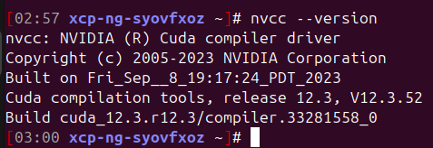
Step 4.2: Create CUDA Test Kernel
Goal:
Send an instruction from the VM to the host mediator, execute REAL CUDA on the
mediator (dom0), and return the result back to the VM.
Step 4.2A: Create REAL CUDA Vector Add Function (dom0 mediator)
On the HOST, create this file:
# nano cuda_vector_add_real.cu
#include <stdio.h>
#include <stdlib.h>
#include <cuda_runtime.h>

// CUDA kernel for vector addition
__global__ void vectorAdd(float *a, float *b, float *c, int n) {
int idx = blockDim.x * blockIdx.x + threadIdx.x;
if (idx < n) {
c[idx] = a[idx] + b[idx];
}
}

// Export a C symbol so it can be called from the mediator (C file)
extern "C" int run_vector_add_test(char *result_msg, int max_len) {
const int N = 1024;
const int SIZE = N * sizeof(float);
float *h_a, *h_b, *h_c;
float *d_a, *d_b, *d_c;
int errors = 0;
cudaError_t err;

h_a = (float*)malloc(SIZE);
h_b = (float*)malloc(SIZE);
h_c = (float*)malloc(SIZE);

for (int i = 0; i < N; i++) {
h_a[i] = (float)i;
h_b[i] = (float)(i * 2);
}

cudaSetDevice(0);
err = cudaMalloc(&d_a, SIZE);
if (err != cudaSuccess) {
snprintf(result_msg, max_len, "CUDA Error: cudaMalloc(d_a): %s", cudaGetErrorString(err));
free(h_a); free(h_b); free(h_c);
return -1;
}
err = cudaMalloc(&d_b, SIZE);
if (err != cudaSuccess) {
snprintf(result_msg, max_len, "CUDA Error: cudaMalloc(d_b): %s", cudaGetErrorString(err));
cudaFree(d_a);
free(h_a); free(h_b); free(h_c);
return -1;
}
err = cudaMalloc(&d_c, SIZE);
if (err != cudaSuccess) {
snprintf(result_msg, max_len, "CUDA Error: cudaMalloc(d_c): %s", cudaGetErrorString(err));
cudaFree(d_a); cudaFree(d_b);
free(h_a); free(h_b); free(h_c);
return -1;
}

cudaMemcpy(d_a, h_a, SIZE, cudaMemcpyHostToDevice);
cudaMemcpy(d_b, h_b, SIZE, cudaMemcpyHostToDevice);

int threadsPerBlock = 256;
int blocksPerGrid = (N + threadsPerBlock - 1) / threadsPerBlock;
vectorAdd<<<blocksPerGrid, threadsPerBlock>>>(d_a, d_b, d_c, N);

cudaDeviceSynchronize();

err = cudaGetLastError();
if (err != cudaSuccess) {
snprintf(result_msg, max_len, "CUDA Error: %s", cudaGetErrorString(err));
cudaFree(d_a); cudaFree(d_b); cudaFree(d_c);
free(h_a); free(h_b); free(h_c);
return -1;
}

cudaMemcpy(h_c, d_c, SIZE, cudaMemcpyDeviceToHost);

for (int i = 0; i < N; i++) {
if (h_c[i] != (h_a[i] + h_b[i])) {
errors++;
}
}

cudaFree(d_a);
cudaFree(d_b);
cudaFree(d_c);
free(h_a);
free(h_b);
free(h_c);

if (errors == 0) {
snprintf(result_msg, max_len,
"Vector add PASSED: %d elements, 0 errors (CUDA on H100)", N);
return 0;
} else {
snprintf(result_msg, max_len,
"Vector add FAILED: %d errors out of %d", errors, N);
return -1;
}
}
Save and exit.
Step 4.3: Create Enhanced Host Mediator with CUDA
# nano cuda_host_mediator.c
Type this (network-safe version with CUDA):
#include <stdio.h>
#include <stdlib.h>
#include <string.h>
#include <unistd.h>
#include <stdint.h>
#include <time.h>

#define CMD_FILE "/dev/shm/vgpu/command.txt"
#define RSP_FILE "/dev/shm/vgpu/response.txt"

// Command codes
#define CMD_NOP 0
#define CMD_VECTOR_ADD 1
#define CMD_GPU_INFO 2

// External CUDA function
extern int run_vector_add_test(char *result_msg, int max_len);

void get_timestamp(char *buffer, int size) {
time_t now = time(NULL);
struct tm *t = localtime(&now);
strftime(buffer, size, "%H:%M:%S", t);
}

int main() {
FILE *cmd_fp, *rsp_fp;
uint32_t last_cmd = 0;
uint32_t current_cmd = 0;
unsigned int cmd_count = 0;
char timestamp[32];
char result_msg[512];
int result;

printf("===========================================\n");
printf("vGPU Host Mediator with CUDA - Phase 1\n");
printf("===========================================\n");

// Initialize response file
rsp_fp = fopen(RSP_FILE, "w");
if (rsp_fp) {
fprintf(rsp_fp, "0:Ready - CUDA enabled\n");
fclose(rsp_fp);
}

printf("✓ Using file-based communication\n");
printf("✓ CUDA support enabled\n");
printf("\n");
printf("Waiting for commands from VM...\n");
printf("(Press Ctrl+C to stop)\n");
printf("\n");

while (1) {
cmd_fp = fopen(CMD_FILE, "r");
if (cmd_fp) {
if (fscanf(cmd_fp, "%u", &current_cmd) == 1) {
if (current_cmd != last_cmd && current_cmd != 0) {
cmd_count++;
get_timestamp(timestamp, sizeof(timestamp));

printf("[%s] Command #%u: ", timestamp, cmd_count);

switch (current_cmd) {
case CMD_VECTOR_ADD:
printf("VECTOR_ADD\n");
printf(" Executing CUDA vector add on GPU...\n");

result = run_vector_add_test(result_msg, sizeof(result_msg));

rsp_fp = fopen(RSP_FILE, "w");
if (rsp_fp) {
fprintf(rsp_fp, "%d:%s\n",
(result == 0) ? 1 : 2, result_msg);
fflush(rsp_fp);
fclose(rsp_fp);
}

printf(" Result: %s\n", result_msg);
break;

case CMD_GPU_INFO:
printf("GPU_INFO\n");

rsp_fp = fopen(RSP_FILE, "w");
if (rsp_fp) {
fprintf(rsp_fp, "1:GPU: NVIDIA H100 (see nvidia-smi for exact model/VRAM)\n");
fflush(rsp_fp);
fclose(rsp_fp);
}
break;

default:
printf("UNKNOWN (%u)\n", current_cmd);

rsp_fp = fopen(RSP_FILE, "w");
if (rsp_fp) {
fprintf(rsp_fp, "2:Unknown command: %u\n", current_cmd);
fflush(rsp_fp);
fclose(rsp_fp);
}
break;
}

last_cmd = current_cmd;
printf("\n");
}
}
fclose(cmd_fp);
}

usleep(50000);
}

return 0;
}
Save and exit.
Step 4.4: Compile CUDA-Enabled Mediator
Before compiling, ensure gcc is installed:
# gcc --version
Compile the network-safe mediator and link in the REAL CUDA function:
# nvcc -O2 -o cuda_mediator cuda_host_mediator.c cuda_vector_add_real.cu
Verify compilation succeeded:
# ls -la cuda_mediator
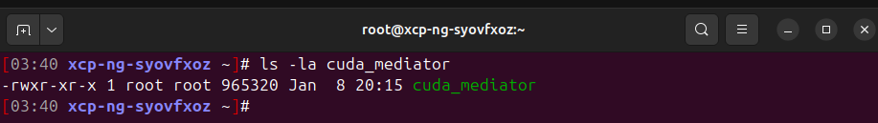
Step 4.5: Test CUDA Mediator
Start new CUDA mediator:
# ./cuda_mediator
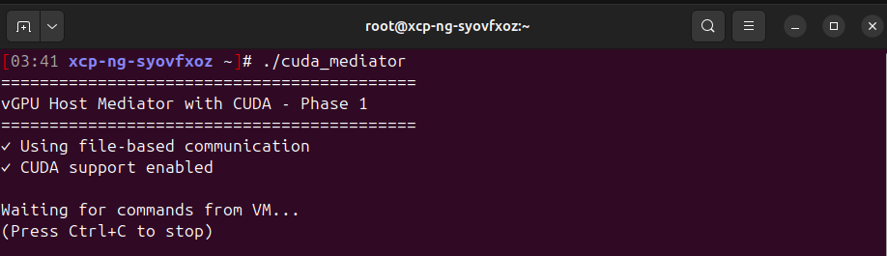
Step 4.6: Update VM Client for CUDA Commands
In the VM, create new test program:
# nano gpu_cuda_test.c
#include <stdio.h>
#include <stdlib.h>
#include <unistd.h>
#include <stdint.h>
#include <string.h>

#define CMD_FILE "/mnt/vgpu/command.txt"
#define RSP_FILE "/mnt/vgpu/response.txt"

#define CMD_VECTOR_ADD 1
#define CMD_GPU_INFO 2

int send_command(uint32_t cmd, const char *cmd_name) {
FILE *cmd_fp, *rsp_fp;
char response[512];
int status;
int timeout = 0;

printf(">>> Sending: %s\n", cmd_name);

// Write command
cmd_fp = fopen(CMD_FILE, "w");
if (!cmd_fp) {
printf("✗ Cannot write command\n");
return -1;
}
fprintf(cmd_fp, "%u\n", cmd);
fflush(cmd_fp);
fclose(cmd_fp);

// Wait for response
sleep(2); // Give host time to process (Phase 1 may simulate GPU work)

while (timeout < 100) {
rsp_fp = fopen(RSP_FILE, "r");
if (rsp_fp) {
if (fgets(response, sizeof(response), rsp_fp)) {
if (sscanf(response, "%d:", &status) == 1) {
if (status != 0) {
char *colon = strchr(response, ':');
if (colon) {
printf(">>> Response: %s", colon + 1);
printf(">>> Status: %s\n\n",
status == 1 ? "SUCCESS" : "ERROR");
}
fclose(rsp_fp);
return status == 1 ? 0 : -1;
}
}
}
fclose(rsp_fp);
}
usleep(100000);
timeout++;
}

printf("✗ TIMEOUT\n\n");
return -1;
}

int main() {
printf("===========================================\n");
printf("vGPU CUDA Test Client\n");
printf("===========================================\n");
printf("✓ Connected to host\n\n");

// Test 1: Get GPU info
send_command(CMD_GPU_INFO, "GET GPU INFO");

// Test 2: Run CUDA vector addition (executed by host mediator)
send_command(CMD_VECTOR_ADD, "RUN VECTOR ADD (CUDA)");

printf("===========================================\n");
printf("✓ All tests completed!\n");
printf("===========================================\n");

return 0;
}
Save and exit.
Compile:
# gcc -o gpu_cuda_test gpu_cuda_test.c
Step 4.7: Run Phase 1 Test!
In the VM:
# ./gpu_cuda_test
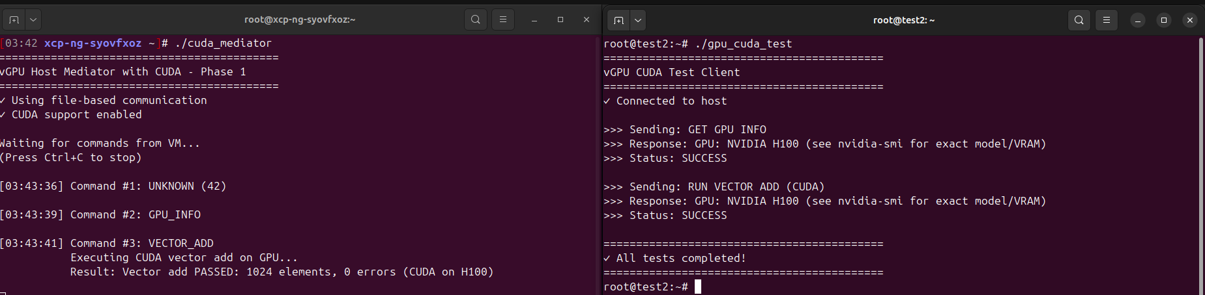

PART 5: Check everything on two VMs
Cuda Check:
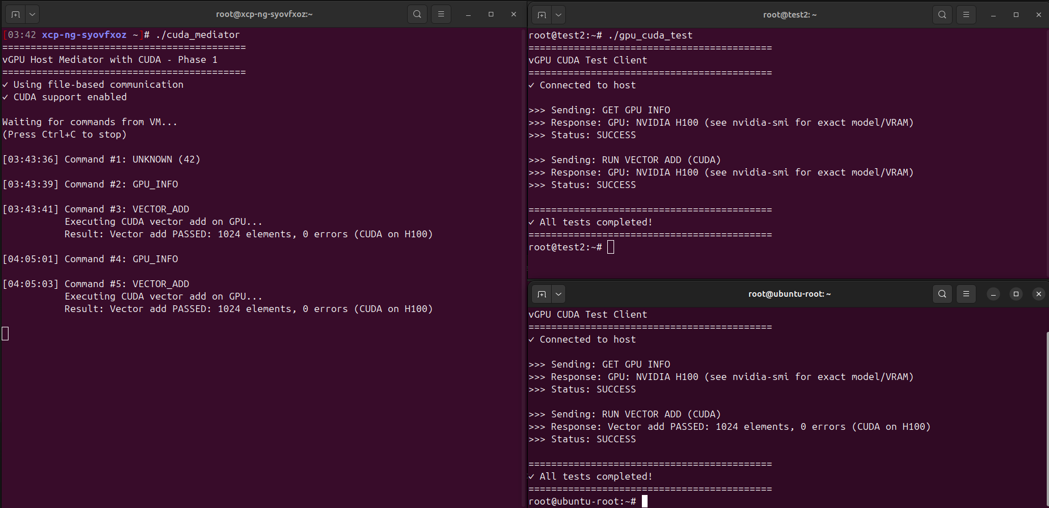
Mediator check:
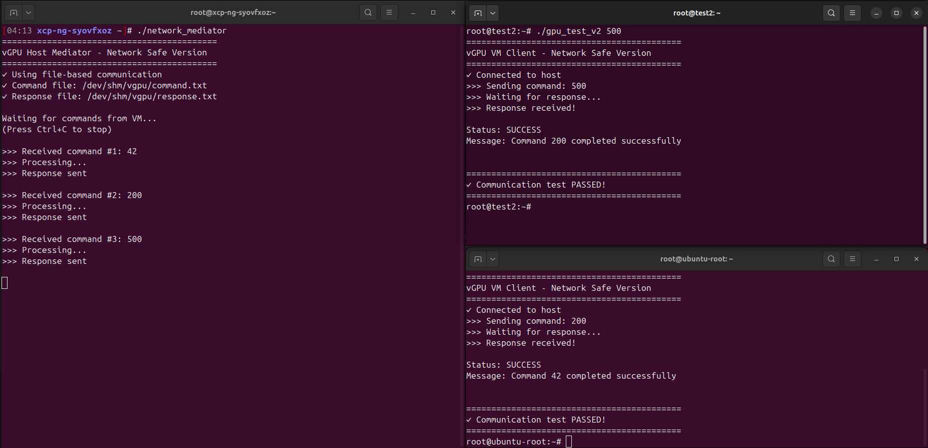
LSPCI CHECK:
