COMPLETE GUIDE: Building QEMU 4.2.1 with vGPU Stub Device for XCP-ng

Author: Bren Max
Date: January 8, 2025
Tested On: XCP-ng 8.2 (Xen 4.13, QEMU 4.2.1)
Status: VERIFIED WORKING ✓

This guide provides the EXACT steps used to successfully build QEMU with a
custom vGPU stub device that appears as a PCI device in guest VMs.

IMPORTANT: These steps have been tested and work. Follow them exactly.

SECTION 1: WHAT We'LL BUILD

A custom PCI device that:
- Shows up in guest VMs as: "Processing accelerator: Red Hat, Inc. Device 1111"
- Can be detected with lspci
- Has a 4KB MMIO region for future communication
- Is a foundation for more complex vGPU implementations

Device Details:
Vendor ID: 0x1AF4 (Red Hat, Inc.)
Device ID: 0x1111 (Custom)
Class: Processing Accelerator (Co-processor)
BAR0: 4KB memory-mapped I/O region

SECTION 2: PREREQUISITES

System Requirements:
- XCP-ng 8.2 or compatible Xen system
- At least 2GB free disk space
- Internet connection for downloads
- Root access

Required Packages:
yum install -y gcc gcc-c++ make python2 glib2-devel pixman-devel
zlib-devel bzip2 wget git centos-release-scl

Enable Developer Toolset (for modern GCC):
yum install -y devtoolset-11
scl enable devtoolset-11 bash

Verify GCC version:
gcc --version
# Should show GCC 11.x or higher

SECTION 3: DOWNLOAD AND EXTRACT QEMU

Step 1: Create Clean Working Directory
We start fresh to avoid issues with previous build attempts.

mkdir -p ~/qemu-clean-build
cd ~/qemu-clean-build

Step 2: Download QEMU 4.2.1 (exact version XCP-ng uses)
wget https://download.qemu.org/qemu-4.2.1.tar.xz

Verify download:
ls -lh qemu-4.2.1.tar.xz
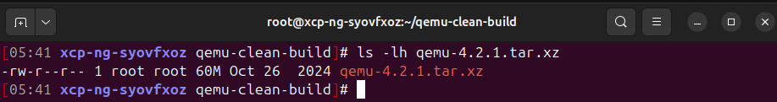
# Should show ~60MB file

Step 3: Extract
tar xf qemu-4.2.1.tar.xz
cd qemu-4.2.1

Current directory should be:
/root/qemu-clean-build/qemu-4.2.1

SECTION 4: CREATE THE VGPU-STUB DEVICE CODE

Step 1: Create the Device Source File
We create a QEMU 4.2.1-compatible device using the older QOM API.

IMPORTANT: The code below is for QEMU 4.2.1. Do NOT use QEMU 7.x code

cat > hw/misc/vgpu-stub.c << 'VGPU_CODE'
/*
* VGPU Stub Device for XCP-ng
*
* Simple PCI device that appears as a GPU in guest VMs
* Compatible with QEMU 4.2.1 API
*/

#include "qemu/osdep.h"
#include "hw/pci/pci.h"
#include "hw/hw.h"
#include "hw/pci/msi.h"
#include "qemu/timer.h"
#include "qom/object.h"
#include "qemu/module.h"
#include "sysemu/kvm.h"

#define TYPE_VGPU_STUB "vgpu-stub"
#define VGPU_STUB(obj) OBJECT_CHECK(VGPUStubState, (obj), TYPE_VGPU_STUB)

typedef struct VGPUStubState {
PCIDevice parent_obj;

/* Memory-mapped I/O region */
MemoryRegion mmio;

/* Device state */
uint32_t command_reg;
uint32_t status_reg;
} VGPUStubState;

/* MMIO read handler */
static uint64_t vgpu_mmio_read(void *opaque, hwaddr addr, unsigned size)
{
VGPUStubState *s = opaque;
uint64_t val = 0;

switch (addr) {
case 0x00: /* Command register */
val = s->command_reg;
break;
case 0x04: /* Status register */
val = s->status_reg;
break;
default:
val = 0;
break;
}

return val;
}

/* MMIO write handler */
static void vgpu_mmio_write(void *opaque, hwaddr addr, uint64_t val, unsigned size)
{
VGPUStubState *s = opaque;

switch (addr) {
case 0x00: /* Command register */
s->command_reg = val;
/* Set status to indicate command received */
s->status_reg = 0x1;
break;
case 0x04: /* Status register (read-only in real device) */
/* Ignore writes */
break;
default:
break;
}
}

static const MemoryRegionOps vgpu_mmio_ops = {
.read = vgpu_mmio_read,
.write = vgpu_mmio_write,
.endianness = DEVICE_LITTLE_ENDIAN,
.impl = {
.min_access_size = 4,
.max_access_size = 4,
},
};

/* Device realization */
static void vgpu_realize(PCIDevice *pci_dev, Error **errp)
{
VGPUStubState *s = VGPU_STUB(pci_dev);

/* Set up PCI config space */
pci_dev->config[PCI_INTERRUPT_PIN] = 1; /* Interrupt pin A */

/* Initialize MMIO region (4KB) */
memory_region_init_io(&s->mmio, OBJECT(s), &vgpu_mmio_ops, s,
"vgpu-stub-mmio", 4096);
pci_register_bar(pci_dev, 0, PCI_BASE_ADDRESS_SPACE_MEMORY, &s->mmio);

/* Initialize device state */
s->command_reg = 0;
s->status_reg = 0;
}

/* Device exit */
static void vgpu_exit(PCIDevice *pci_dev)
{
/* Cleanup if needed */
}

static void vgpu_class_init(ObjectClass *klass, void *data)
{
DeviceClass *dc = DEVICE_CLASS(klass);
PCIDeviceClass *k = PCI_DEVICE_CLASS(klass);

k->realize = vgpu_realize;
k->exit = vgpu_exit;
k->vendor_id = 0x1AF4; /* Red Hat */
k->device_id = 0x1111; /* Custom device ID */
k->revision = 0x01;
k->class_id = PCI_CLASS_PROCESSOR_CO; /* Co-processor */

set_bit(DEVICE_CATEGORY_MISC, dc->categories);
dc->desc = "Virtual GPU Stub Device";
}

static const TypeInfo vgpu_info = {
.name = TYPE_VGPU_STUB,
.parent = TYPE_PCI_DEVICE,
.instance_size = sizeof(VGPUStubState),
.class_init = vgpu_class_init,
.interfaces = (InterfaceInfo[]) {
{ INTERFACE_CONVENTIONAL_PCI_DEVICE },
{ },
},
};

static void vgpu_register_types(void)
{
type_register_static(&vgpu_info);
}

type_init(vgpu_register_types)
VGPU_CODE
Step 2: Verify File Created
ls -lh hw/misc/vgpu-stub.c
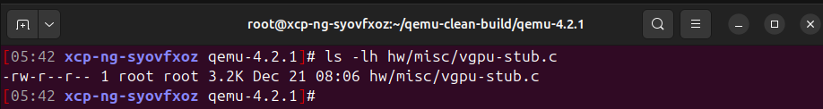

wc -l hw/misc/vgpu-stub.c
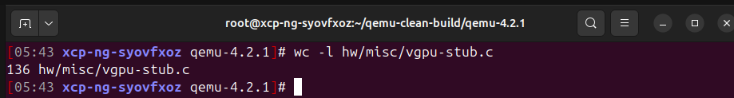
Step 3: Update Build System (Makefile.objs)

Add vgpu-stub to the build by editing hw/misc/Makefile.objs

sed -i '/common-obj-$(CONFIG_EDU) += edu.o/a common-obj-y += vgpu-stub.o' \
hw/misc/Makefile.objs

Verify it was added:
grep vgpu-stub hw/misc/Makefile.objs

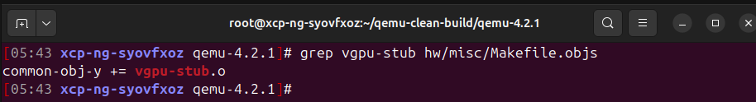
Check context (should be after edu.o):
sed -n '8,12p' hw/misc/Makefile.objs

Expected output:
common-obj-$(CONFIG_PCI_TESTDEV) += pci-testdev.o
common-obj-$(CONFIG_EDU) += edu.o
common-obj-y += vgpu-stub.o
common-obj-$(CONFIG_PCA9552) += pca9552.o

SECTION 5: CONFIGURE QEMU

CRITICAL Configuration Notes:
- We use --disable-xen because xen-devel headers may not be installed
- We use --disable-werror to avoid warnings blocking the build
- We use --python=/usr/bin/python2 because QEMU 4.2.1 needs Python 2
- We build x86_64-softmmu which can run both 32-bit and 64-bit VMs

Run Configure:
./configure \
--target-list=x86_64-softmmu \
--prefix=/usr \
--disable-xen \
--enable-kvm \
--disable-werror \
--python=/usr/bin/python2

Expected Output (check these lines):
Install prefix /usr
target list x86_64-softmmu
xen support no
KVM support yes
python /usr/bin/python2 -B (2.7.5)

If configure fails, check:
1. GCC version: gcc --version (should be 11.x)
2. Python2 exists: which python2
3. Required libraries: yum list installed | grep -E "glib2-devel|pixman-devel"

SECTION 6: BUILD QEMU

Step 1: Start Build
------------------------------------------------------------------------
make -j$(nproc) 2>&1 | tee build.log

This will take 10-20 minutes depending on wer system.
The tee command saves output to build.log for troubleshooting.

Expected Progress:
[Start] Generating configuration files
[Middle] Compiling hundreds of .c files
Look for: CC hw/misc/vgpu-stub.o (around line 1489 in our test)
[End] LINK x86_64-softmmu/qemu-system-x86_64

Step 2: Check Build Status
echo "Build exit code: $?"
# Should show: Build exit code: 0

If build failed:
1. Check build.log for errors: grep -i error build.log
2. Most common issue: Missing dependencies
3. Fix and run: make clean && make -j$(nproc)

Step 3: Verify Binary Exists
ls -lh x86_64-softmmu/qemu-system-x86_64

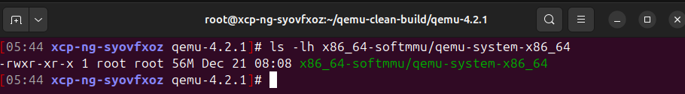
SECTION 7: VERIFY THE DEVICE

Step 1: Check Device is Available
./x86_64-softmmu/qemu-system-x86_64 -device help 2>&1 | grep vgpu-stub
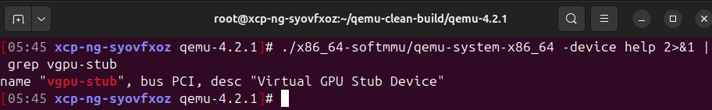
Step 2: Compare with Other Test Devices
./x86_64-softmmu/qemu-system-x86_64 -device help 2>&1 | grep -E "vgpu|edu|testdev"
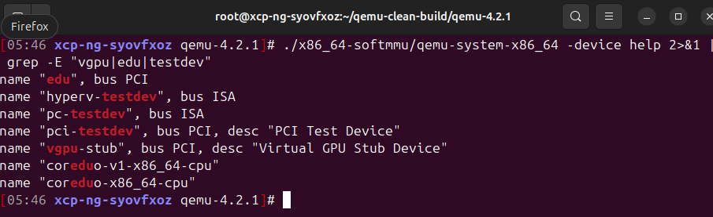

Step 3: Test Instantiation
Test that the device can actually be created:

./x86_64-softmmu/qemu-system-x86_64 \
-M q35 \
-device vgpu-stub \
-display none \
-serial stdio \
-S &

sleep 2

ps aux | grep qemu-system-x86_64 | grep vgpu-stub

We should see a running QEMU process. Kill it:
pkill -f "qemu-system-x86_64.*vgpu-stub"

If QEMU starts without errors, the device is working correctly!

SECTION 8: DEPLOYMENT TO XCP-NG

CRITICAL: XCP-ng uses /usr/lib64/xen/bin (note the lib64, not lib)

Step 1: Find XCP-ng QEMU Binary
rpm -ql qemu | grep bin/qemu-system

Output should show:
/usr/lib64/xen/bin/qemu-system-i386

Step 2: Verify Current QEMU Version
/usr/lib64/xen/bin/qemu-system-i386 --version
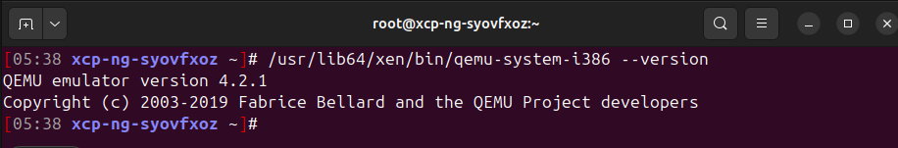
Should show:
QEMU emulator version 4.2.1

Step 3: Backup Original QEMU
IMPORTANT: Always backup before replacing!

cp /usr/lib64/xen/bin/qemu-system-i386 \
/usr/lib64/xen/bin/qemu-system-i386.backup-$(date +%Y%m%d-%H%M)

Verify backup:
ls -lh /usr/lib64/xen/bin/qemu-system-i386.backup-*

Step 4: Deploy New QEMU Binary
Copy our x86_64 binary to replace qemu-system-i386:
(The x86_64-softmmu target can run both 32-bit and 64-bit VMs)

cd ~/qemu-clean-build/qemu-4.2.1

cp x86_64-softmmu/qemu-system-x86_64 /usr/lib64/xen/bin/qemu-system-i386

When prompted "overwrite?", type: yes

Step 5: Verify Deployment
Check version still matches:
/usr/lib64/xen/bin/qemu-system-i386 --version

Check device is available:
/usr/lib64/xen/bin/qemu-system-i386 -device help 2>&1 | grep vgpu-stub
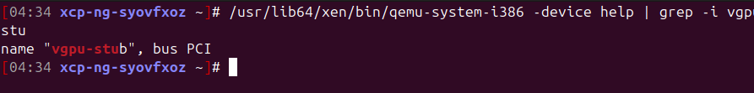
Check file size and permissions:
ls -lh /usr/lib64/xen/bin/qemu-system-i386

Expected:
-rwxr-xr-x 1 root root 56M Dec 21 08:21 /usr/lib64/xen/bin/qemu-system-i386

SUCCESS! QEMU with vgpu-stub is now deployed to XCP-ng!

SECTION 9: TESTING WITH A VM

Method 1: Create Test VM Configuration (Simple)
Create a minimal test config:

cat > /tmp/test-vgpu.cfg << 'EOF'
name = "test-vgpu-stub"
type = "hvm"
memory = 1024
vcpus = 1
builder = "hvm"
boot = "c"

# Add the vgpu-stub device
device_model_args = ["-device", "vgpu-stub"]
EOF

Create the VM:
xl create /tmp/test-vgpu.cfg

Check if running:
xl list | grep test-vgpu

Destroy test VM:
xl destroy test-vgpu-stub

Method 2: Add to Existing VM
For an existing Linux VM:

1. Power off the VM:
xl shutdown <vm-name>

2. Find the VM's config:
ls -lh /etc/xen/

3. Edit the VM's config file or add parameters:

For xl-based VMs, add to config:
device_model_args = ["-device", "vgpu-stub"]

For XAPI/XCP-ng Center VMs, use xe command:
xe vm-param-set uuid=<vm-uuid> \
other-config:device-model-args="-device vgpu-stub"

4. Start the VM:
xl create <config-file>
# or
xe vm-start uuid=<vm-uuid>

SECTION 10: VERIFY IN GUEST VM

Step 1: Access the VM
Via xl console:
xl console <vm-name>

Or via SSH if network is configured

Step 2: Check PCI Devices
Inside the guest VM, run:
lspci
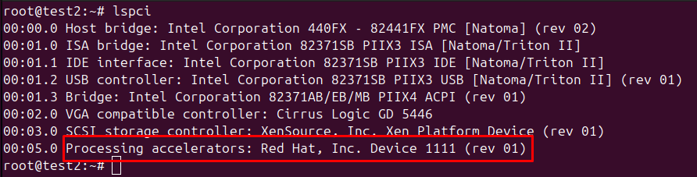

Step 3: Get Detailed Device Info
lspci -v -s 01:00.0

Expected output:
01:00.0 Processing accelerator: Red Hat, Inc. Device 1111
Subsystem: Red Hat, Inc Device 1100
Flags: fast devsel
Memory at <address> (32-bit, non-prefetchable) [size=4K]

Step 4: Check Device Node
ls -l /sys/bus/pci/devices/0000:01:00.0

This shows the sysfs entry for the device.

SECTION 11: TROUBLESHOOTING

Problem: Configure fails with "xen support requested but not found"
Solution: Add --disable-xen to configure command (already in our guide)

Problem: Build fails with "Python 3 required"
Solution: Add --python=/usr/bin/python2 (already in our guide)

Problem: Build fails with old GCC errors
Solution:
scl enable devtoolset-11 bash
gcc --version # Verify it shows 11.x

Then rebuild:
make clean
./configure [same options]
make -j$(nproc)

Problem: "common-obj-y += vgpu-stub.o" not found in Makefile.objs
Check:
grep -n vgpu hw/misc/Makefile.objs

If missing, add it manually:
nano hw/misc/Makefile.objs

Add after the edu.o line:
common-obj-y += vgpu-stub.o

Problem: Device doesn't appear in lspci in guest
Verify in sequence:
1. Check host QEMU has device:
/usr/lib64/xen/bin/qemu-system-i386 -device help 2>&1 | grep vgpu

2. Check VM is using device_model_args:
xl list -l <vm-name> | grep device_model_args

3. Check QEMU process has the device:
ps aux | grep qemu | grep <vm-name>

4. Check QEMU logs:
tail -f /var/log/xen/qemu-dm-<domain-id>.log

Problem: VM fails to start after deployment
Symptoms: VM won't boot, xen errors

Debugging:
1. Check Xen logs:
tail -100 /var/log/xen/xl-<vm>.log

2. Test with original QEMU:
cp /usr/lib64/xen/bin/qemu-system-i386.backup-* \
/usr/lib64/xen/bin/qemu-system-i386

3. Check QEMU permissions:
ls -l /usr/lib64/xen/bin/qemu-system-i386
# Should be: -rwxr-xr-x

4. Try without vgpu-stub first:
Remove device_model_args from VM config
If VM starts, QEMU is OK but device has issues

Problem: Wrong QEMU binary path
If we have /usr/lib/xen instead of /usr/lib64/xen:

Replace all instances of /usr/lib64/xen with /usr/lib/xen in deployment steps

To find the correct path:
rpm -ql qemu | grep bin/qemu-system

SECTION 12: ROLLBACK PROCEDURE

If We need to restore the original QEMU:

Step 1: List Available Backups
ls -lh /usr/lib64/xen/bin/qemu-system-i386.backup-*

Step 2: Restore Backup
# Replace TIMESTAMP with actual backup timestamp
cp /usr/lib64/xen/bin/qemu-system-i386.backup-TIMESTAMP /usr/lib64/xen/bin/qemu-system-i386

Step 3: Verify
/usr/lib64/xen/bin/qemu-system-i386 --version
/usr/lib64/xen/bin/qemu-system-i386 -device help 2>&1 | grep vgpu

The vgpu-stub should no longer appear.

