Barakar Valley Power Distribution Limited

Storm Restoration After-Action Report
August Monsoon Depression
Event period | 11 August 2026 09:15 to 13 August 2026 10:00
Consumers served | 342,000
This report keeps two kinds of statement apart.
Observed statements are traceable to a numbered event-log entry and carry that entry in square brackets.
Assessed statements are the response team's judgement and carry no log entry because none supports them.
Where the records cannot answer a question, the report says so rather than estimating.

1. Event Overview

Observed
August Monsoon Depression began affecting the Barakar Valley Power Distribution Limited network at 14:05 on 11 August 2026, when the first outages were recorded on feeder 11 kV JMR-07 [EL-0004]. Consumers without supply peaked at 33,400, which is 9.8 per cent of the 342,000 consumers served, at 17:00 on 11 August [EL-0008]. Full restoration took 36 hours 35 minutes from the first recorded outage to the final consumer restored at 02:40 on 13 August [EL-0004, EL-0019].

Assessed
The response is judged to have met its restoration objective, with no service interruption extending beyond the operating standard [assessed].

2. Timeline of Events

Observed
- At 09:15 on 11 August: IMD Kolkata warns of a deep depression over Gangetic West Bengal. Extremely heavy rainfall and gusty winds of 55 to 65 km/h expected over Paschim Bardhaman from 14:00 [EL-0001]
- At 10:00 on 11 August: Storm control room activated at the Asansol divisional office. Ten line gangs placed on standby [EL-0002]
- At 13:20 on 11 August: Sustained winds of 58 km/h recorded at the Burnpur monitoring mast. Rainfall of 84 mm in six hours reported at Asansol [EL-0003]
- At 14:05 on 11 August: First outages recorded on the 11 kV Jamuria feeder JMR-07 after a tree contact in the Nunia canal corridor [EL-0004]
- At 15:30 on 11 August: Outages spread across the Raniganj and Jamuria sections after waterlogging at a distribution substation [EL-0006]
- At 16:10 on 11 August: All standby line gangs dispatched. Tree-cutting gangs mobilised to the Nunia canal corridor [EL-0007]
- At 17:00 on 11 August: Peak consumers without supply recorded at 33,400 across 24 feeders [EL-0008]
- At 18:30 on 11 August: Water ingress reported at the 33/11 kV Raniganj substation. Affected equipment isolated as a precaution [EL-0009]
- At 22:00 on 11 August: Mutual aid requested from the Durgapur distribution circle [EL-0011]
- At 02:15 on 12 August: Durgapur circle gangs arrive on site [EL-0013]
- At 15:20 on 12 August: Remaining outages are individual service connections requiring separate gang visits [EL-0017]
- At 08:00 on 13 August: The outage management system link held for the duration of the event. The manual fallback capture procedure remains undeveloped and was not exercised [EL-0020]
- At 09:00 on 13 August: Post-event review: 14 poles, 22 spans and 5 distribution transformers replaced [EL-0021]

3. Crew Mobilisation

Observed
8 crews totalling 44 field personnel were mobilised for the event [EL-0002, EL-0007]. 1 mutual-aid crew totalling 10 personnel was requested from Durgapur Circle [EL-0011, EL-0013]. Crews worked approximately 1,050 personnel-hours on the event [EL-0002, EL-0007]. This figure covers 7 of 8 crews; the remaining 1 has incomplete records and is excluded [EL-0002, EL-0007].

Assessed
Mutual aid was requested at an appropriate point in the event, and earlier escalation would not have materially shortened the restoration [assessed].

What the records do not show
Crew CR-B08 (10 personnel from Durgapur Circle) has no mobilisation time in the records, so its hours cannot be computed and are excluded from the personnel-hours total. [no record]

4. Restoration Performance

Observed

Observed
- 50 per cent of affected consumers were restored within 13 hours of peak outage, by 06:00 on 12 August when 10,200 consumers remained without supply [EL-0008, EL-0014]
- 90 per cent of affected consumers were restored within 25 hours of peak outage, by 18:00 on 12 August when 1,340 consumers remained without supply [EL-0008, EL-0018]
- 9 consumer counts were recorded across the event, from 14:05 on 11 August to 02:40 on 13 August [EL-0004, EL-0019]

Assessed

Assessed
Restoration sequencing prioritised transmission-level faults and high-count feeders correctly, and the resulting curve is consistent with the damage sustained [assessed]

5. Consumer Communications

Observed
The first consumer notification was issued at 14:43 on 11 August, 38 minutes after the first recorded outage [EL-0004, EL-0005]. 5 consumer communications were issued across 5 channels (IVR, SMS, WhatsApp, email, web), reaching 59,860 recipients in total [EL-0005, EL-0015, EL-0022].

Assessed
Message cadence was appropriate to the restoration profile, and consumers received revised estimates at the points where the estimates materially changed [assessed].

6. Restoration Curve
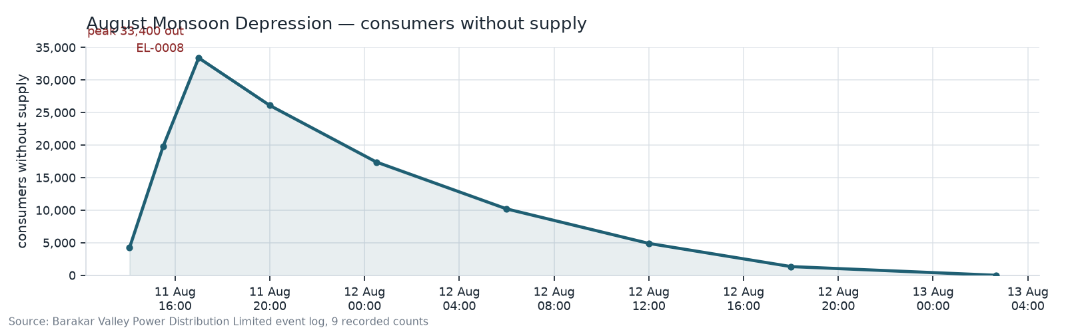
Consumers without supply over the course of August Monsoon Depression, peaking at 33,400 at 17:00 on 11 August 2026 [EL-0008].

7. Lessons Learned

Carried forward from previous events
Item | Raised in | Owner | Status | Note
LL-A1: Mutual-aid gang arrival times are not captured | storm-a | Distribution Operations, Asansol Division | Open | Mutual-aid gangs were requested and arrived again with no per-gang mobilisation time recorded. [storm-b/EL-0011, storm-b/EL-0013]
LL-A2: Time to first consumer notification exceeded the two-hour target | storm-a | Consumer Services Wing | Closed in storm-b | First consumer notification was issued 38 minutes after the first recorded outage, inside the two-hour target. [storm-b/EL-0004, storm-b/EL-0005]
LL-A3: Outage management system link was lost with no fallback capture | storm-a | SCADA and IT Wing | Open | The link held for this event, so the gap did not recur, but the manual fallback capture procedure remains undeveloped. [storm-b/EL-0020]

Raised by this event
LL-B1 — Tree contact in the Nunia canal corridor initiated the event. The first outage and the largest single outage cluster both originated from tree contact in the Nunia canal corridor, which was last cleared in 2023. Owner: Line Clearance Wing. [EL-0004, EL-0007]

