Barakar Valley Power Distribution Limited

Storm Restoration After-Action Report
Kalbaisakhi Squall
Event period | 24 April 2026 13:30 to 26 April 2026 16:00
Consumers served | 342,000
This report keeps two kinds of statement apart.
Observed statements are traceable to a numbered event-log entry and carry that entry in square brackets.
Assessed statements are the response team's judgement and carry no log entry because none supports them.
Where the records cannot answer a question, the report says so rather than estimating.

1. Event Overview

Observed
Kalbaisakhi Squall began affecting the Barakar Valley Power Distribution Limited network at 16:52 on 24 April 2026, when the first outages were recorded on feeder 11 kV BNP-04 [EL-0004]. Consumers without supply peaked at 74,600, which is 21.8 per cent of the 342,000 consumers served, at 20:15 on 24 April [EL-0008]. Full restoration took 43 hours 28 minutes from the first recorded outage to the final consumer restored at 12:20 on 26 April [EL-0004, EL-0030].

Assessed
The response is judged to have met its restoration objective, with no service interruption extending beyond the operating standard [assessed].

2. Timeline of Events

Observed
- At 13:30 on 24 April: IMD Kolkata issues a thunderstorm warning with squall for Paschim Bardhaman district, gusts of 70 to 90 km/h expected from 16:00 [EL-0001]
- At 14:15 on 24 April: Storm control room activated at the Asansol divisional office. Twelve line gangs placed on standby across the Hirapur, Kulti and Raniganj sections [EL-0002]
- At 16:40 on 24 April: Squall line reaches Asansol. Gusts of 96 km/h recorded at the Burnpur monitoring mast, with heavy rain and hail reported at Jamuria [EL-0003]
- At 16:52 on 24 April: First outages recorded on the 11 kV Burnpur feeder BNP-04 after a tree fell across the conductor near Burnpur bazaar [EL-0004]
- At 17:10 on 24 April: Line gangs 1 to 6 dispatched to the Hirapur and Burnpur sections [EL-0005]
- At 17:45 on 24 April: Cascading outages across the Kulti and Barakar sections after multiple poles tilted on the KLT-02 feeder [EL-0006]
- At 20:15 on 24 April: Peak consumers without supply recorded at 74,600 across 41 feeders [EL-0008]
- At 20:40 on 24 April: Snapped 11 kV conductor reported at Neamatpur More. Area cordoned and the section isolated [EL-0009]
- At 21:20 on 24 April: Mutual aid requested from the Durgapur and Purulia distribution circles [EL-0010]
- At 23:05 on 24 April: Damage assessment reports 34 poles snapped or tilted, 52 spans of conductor down and 9 distribution transformers damaged [EL-0011]
- At 01:15 on 25 April: Outage management system link to the Asansol data centre lost. Consumer counts are not recorded from this point [EL-0013]
- At 03:40 on 25 April: Mutual-aid gangs from the Durgapur circle arrive on site [EL-0014]
- At 04:45 on 25 April: Outage management system link restored after 3 hours 30 minutes. Counts resume [EL-0015]
- At 11:20 on 25 April: Lineman injured at Raniganj: minor laceration while clearing a fallen span, treated on site, no lost time [EL-0019]
- At 20:30 on 25 April: Tree-cutting gangs reassigned to the Barakar corridor to clear gang access along the feeder route [EL-0023]
- At 04:00 on 26 April: Remaining outages are individual service connections requiring separate gang visits [EL-0025]
- At 11:30 on 26 April: All snapped-conductor sites cleared and released for normal operation [EL-0029]
- At 15:00 on 26 April: Post-event review scheduled. 34 poles, 52 spans and 9 distribution transformers replaced [EL-0031]

What the records do not show
Consumer counting was interrupted from 01:15 on 25 April (EL-0013) until 04:45 on 25 April (EL-0015), a span of 3 hours 30 minutes; the restoration curve is broken across this window and the records do not support a figure inside it. [no record]

3. Crew Mobilisation

Observed
11 crews totalling 61 field personnel were mobilised for the event [EL-0002, EL-0005]. 2 mutual-aid crews totalling 18 personnel were requested from Durgapur Circle, Purulia Circle [EL-0010, EL-0014]. Crews worked approximately 1,521 personnel-hours on the event. This figure covers 9 of 11 crews; the remaining 2 have incomplete records and are excluded [EL-0002, EL-0005, EL-0011].

Assessed
Mutual aid was requested at an appropriate point in the event, and earlier escalation would not have materially shortened the restoration [assessed].

What the records do not show
- Crew CR-A10 (10 personnel from Durgapur Circle) has no mobilisation time in the records, so its hours cannot be computed and are excluded from the personnel-hours total. [no record]
- Crew CR-A11 (8 personnel from Purulia Circle) has no mobilisation time and no release time in the records, so its hours cannot be computed and are excluded from the personnel-hours total. [no record]

4. Restoration Performance

Observed
- 50 per cent of affected consumers were restored within 16 hours 45 minutes of peak outage, by 13:00 on 25 April when 31,500 consumers remained without supply [EL-0008, EL-0020]
- 90 per cent of affected consumers were restored within 37 hours 45 minutes of peak outage, by 10:00 on 26 April when 3,600 consumers remained without supply [EL-0008, EL-0028]
- 12 consumer counts were recorded across the event, from 16:52 on 24 April to 12:20 on 26 April [EL-0004, EL-0030]

Assessed
Restoration sequencing prioritised transmission-level faults and high-count feeders correctly, and the resulting curve is consistent with the damage sustained [assessed]

5. Consumer Communications

Observed
The first consumer notification was issued at 19:33 on 24 April, 2 hours 41 minutes after the first recorded outage [EL-0004, EL-0007]. 8 consumer communications were issued across 6 channels (IVR, SMS, WhatsApp, email, press, web), reaching 262,700 recipients in total [EL-0007, EL-0017, EL-0021].

Assessed
Message cadence was appropriate to the restoration profile, and consumers received revised estimates at the points where the estimates materially changed [assessed]

What the records do not show
Communication CC-A06 (press, 19:00 on 25 April, “Briefing to local media on restoration progress”) has no corresponding event-log entry, so its issue cannot be corroborated against the log. [no record]

6. Restoration Curve
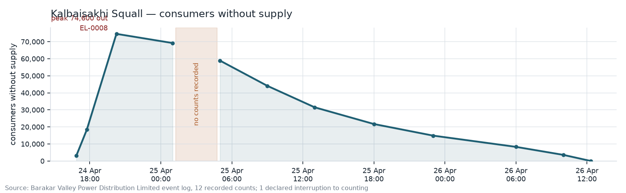
Consumers without supply over the course of Kalbaisakhi Squall, peaking at 74,600 at 20:15 on 24 April 2026 [EL-0008].

7. Lessons Learned

Raised by this event
Mutual-aid gang arrival times are not captured. Two mutual-aid gangs were requested from neighbouring circles and both worked the event, but neither crew record carries a mobilisation time, so mutual-aid gang-hours cannot be computed from the records. Owner: Distribution Operations, Asansol Division. [EL-0010, EL-0014]
Time to first consumer notification exceeded the two-hour target. The first outage was recorded at 16:52 and the first consumer notification was issued at 19:33, an interval of 2 hours 41 minutes against a two-hour internal target. Owner: Consumer Services Wing. [EL-0004, EL-0007]
Outage management system link was lost with no fallback capture. The link to the Asansol data centre was unavailable for 3 hours 30 minutes and no manual consumer counts were taken during the gap, leaving a hole in the restoration curve that cannot be reconstructed. Owner: SCADA and IT Wing. [EL-0013, EL-0015]

