Tariff Classification Memo
Subject Merchandise: AeroLink_X7_Product_Specification.pdf
Date: August 25, 2026 | Workspace: Tariff Submission Test | Source File: AeroLink_X7_Product_Specification.pdf

Executive Summary
The AeroLink X7 Smart Communication Hub (Model ALX7-X7-240), manufactured by Northstar Connected Devices Ltd., is definitively classified under subheading 8517.62.00 of the Harmonized Tariff Schedule. The official nomenclature describes machines for the reception, conversion and transmission or regeneration of voice, images or other data, including switching and routing apparatus. The definitive classification is determined in accordance with General Rule of Interpretation (GRI) 1, by application of the terms of Heading 8517 and Note 3 to Section XVI, as the device's principal function is the aggregation of wired and wireless communication interfaces and the coordination of network-connected peripherals within a facility rather than general data processing or measurement.

Analyst Reasoning
The executive summary synthesizes the definitive classification findings, combining the commercial product identification, the recommended 10-digit HS code, and the governing legal rationale under GRI 1. It bridges the technical functionality of the communication hub with the statutory requirements of Heading 8517 without repeating descriptive minutiae.

Alternative Classifications Table
Candidate HS Code | Description | Rejection Rationale
8471.80.10 | Automatic data processing machines and units thereof | The primary function is communication and network coordination rather than general automatic data processing.

Sources & Evidence

Product Overview
The AeroLink X7 Smart Communication Hub (Model ALX7-X7-240) is a specialized networking device engineered to aggregate wired and wireless communication interfaces and coordinate connected peripherals within a facility. Housed in a compact PC/ABS polymer enclosure measuring 178 × 118 × 36 mm, the unit incorporates a populated printed circuit board assembly, an internal metal shield for electromagnetic interference protection, and integrated wireless modules supporting Wi-Fi 6 and Bluetooth Low Energy. The device functions as a central node for data collection and distribution, facilitating communication between network-connected devices and authorized local applications. It is equipped with 128 GB of solid-state flash storage, power conversion circuitry, and a management interface managed by embedded firmware. The system is designed for indoor fixed installation, either desktop or wall-mounted, and is not intended for general office productivity applications.

Analyst Reasoning
The product's identity is defined by its role as a specialized communication hub rather than a general-purpose computing device. The integration of specific wireless modules (Wi-Fi/BLE) and wired interfaces, combined with the restriction against general office productivity, suggests a classification focus on apparatus for the transmission or reception of voice, images, or other data, or specific networking equipment under Chapter 85. The physical construction, including the specific shielding and enclosure materials, confirms the device's role as a protected, fixed-installation network node.

Sources & Evidence

Product Description
The AeroLink X7 Smart Communication Hub (Model: ALX7-X7-240), manufactured by Northstar Connected Devices Ltd., is a compact networking and communication device measuring 178 × 118 × 36 mm and weighing 0.74 kg. The physical architecture features a molded PC/ABS polymer enclosure with internal metal shielding, housing a populated multi-layer printed circuit board assembly. The mechanical construction includes mounting bosses, ventilation openings, status LED light pipes, a service button, and a removable service cover. An internal metal shield is fitted specifically over the radio and processor area for electromagnetic shielding. Electrically and functionally, the unit integrates a processing board, power conversion circuitry, network interfaces, 128 GB of solid-state flash storage, status indicators, and integrated wireless modules supporting Wi-Fi 6 and Bluetooth Low Energy. The device is designed for indoor fixed installation on a desktop or wall via the included mounting bracket. Its primary operational purpose is to aggregate wired and wireless communication interfaces, collect information from connected peripherals, and coordinate communication between network-connected devices within a facility. The retail package includes the main unit, a 12 V DC power adapter, a 1-meter Ethernet cable, a wall mounting bracket, a mounting screw set, and a quick installation guide.

Analyst Reasoning
The physical dimensions, housing composition, and internal component layout of the AeroLink X7 are critical for determining its proper heading within Section XVI or Chapter 85 of the Harmonized System. Specifically, the presence of dedicated wireless transceiver modules (Wi-Fi and Bluetooth), a central processing board, solid-state storage, and network interface ports establishes its capability for reception, conversion, and transmission or regeneration of voice, images, or other data, which directs the classification analysis toward heading 8517 as an apparatus for the transmission or reception of voice, images or other data, including switching and routing apparatus.

Sources & Evidence

Technical Characteristics
The AeroLink X7 Smart Communication Hub (Model ALX7-X7-240) features physical dimensions of 178 × 118 × 36 mm and a weight of 0.74 kg. The mechanical construction consists of molded PC/ABS polymer panels enclosing a populated printed circuit board assembly, supplemented by an internal metal shield fitted over the radio and processor area for electromagnetic shielding. The enclosure incorporates mounting bosses, ventilation openings, status indicator LED light pipes, and a removable service cover. Designed for indoor fixed installation in either desktop or wall-mounted configurations, the unit operates via a 12 V DC power adapter and integrates multiple network and communication interfaces. These include an Ethernet port for primary facility connection, Wi-Fi 6 and Bluetooth Low Energy wireless modules integrated directly into the main electronics assembly, and USB ports supporting accessories and service tools. Internal processing and storage architecture comprises a main processing board, power conversion circuitry, and 128 GB of solid-state flash storage. The embedded firmware and local management interface handle network configuration, event logging, diagnostics, and communication coordination between network-connected devices within a facility, distinguishing the device from general office productivity equipment.

Analyst Reasoning
The physical dimensions, weight, material composition, and interface specifications are critical for evaluating potential headings under Section XVI (such as Chapter 84 or Chapter 85). Specifically, the presence of integrated wireless modules (Wi-Fi and Bluetooth), solid-state storage, and an Ethernet interface establishes its identity as an apparatus for the reception, conversion, and transmission or regeneration of voice, images, or other data, including switching and routing apparatus. The precise mechanical description—molded PC/ABS polymer with internal metal shielding—clarifies the physical construction of the housing relative to electrical insulation and shielding requirements under tariff notes.

Sources & Evidence

Material / Physical Composition
The AeroLink X7 Smart Communication Hub features a physical construction consisting of molded PC/ABS (polycarbonate/acrylonitrile butadiene styrene) polymer panels that form the exterior housing, which surrounds a populated printed circuit board assembly. The enclosure provides mechanical protection, structural mounting via integrated bosses, ventilation openings, LED light pipes, and a removable service cover. Supplementing the polymer housing, a small internal metal shield is fitted directly over the radio and processor area within the device to provide electromagnetic shielding. The interior electronics comprise a multi-layer printed circuit board populated with processing circuitry, network interfaces, wireless modules for Wi-Fi 6 and Bluetooth Low Energy, power conversion circuitry, and 128 GB of solid-state flash storage. This combination of a protective polymer enclosure, internal metallic shielding, and advanced electronic assemblies forms the physical foundation that supports the unit's core communication and coordination functions.

Analyst Reasoning
The material composition and physical construction of the AeroLink X7 are critical in establishing its classification framework under the tariff schedule. Specifically, the presence of both a molded PC/ABS polymer housing and an internal metal shielding component over the processor and radio sections demonstrates a composite material structure designed for mechanical protection and electromagnetic interference suppression. Furthermore, the housing encases a fully populated printed circuit board assembly that integrates multiple active electronic components, establishing that the physical identity of the device is rooted in its advanced electronic circuitry rather than solely its exterior plastic or metallic containment.

Sources & Evidence

Product Images
The visual and mechanical documentation for the AeroLink X7 Smart Communication Hub (Model ALX7-X7-240) illustrates a compact, dedicated enclosure measuring 178 by 118 by 36 millimeters with a total unit weight of 0.74 kilograms. The physical form factor comprises molded PC/ABS polymer panels that house a populated printed circuit board assembly. Within the housing, an internal metal shield is fitted directly over the radio and processor area to provide electromagnetic shielding, while the outer polymer enclosure provides mechanical protection and structural mounting features including mounting bosses, ventilation openings, status LED light pipes, and a removable service cover. The exterior labeling is positioned on the underside of the product. The delivered package configuration includes the main unit, a 12 V DC power adapter, a one-meter Ethernet cable, a wall mounting bracket, a mounting screw set, and a quick installation guide, supporting both desktop and indoor fixed wall-mounted deployment scenarios.

Analyst Reasoning
Documenting the physical form factor, dimensions, weight, and internal mechanical construction—such as the PC/ABS housing and internal metal shielding—is critical for establishing the exact physical nature of the device under General Rules for the Interpretation (GRI) of the Harmonized System. These structural and visual attributes confirm that the device is a specialized, dedicated hardware apparatus rather than a general-purpose consumer computer or terminal, directly supporting its proper classification as an electrical apparatus for line telephony or telegraphy or an automatic data processing machine depending on principal function.

Sources & Evidence

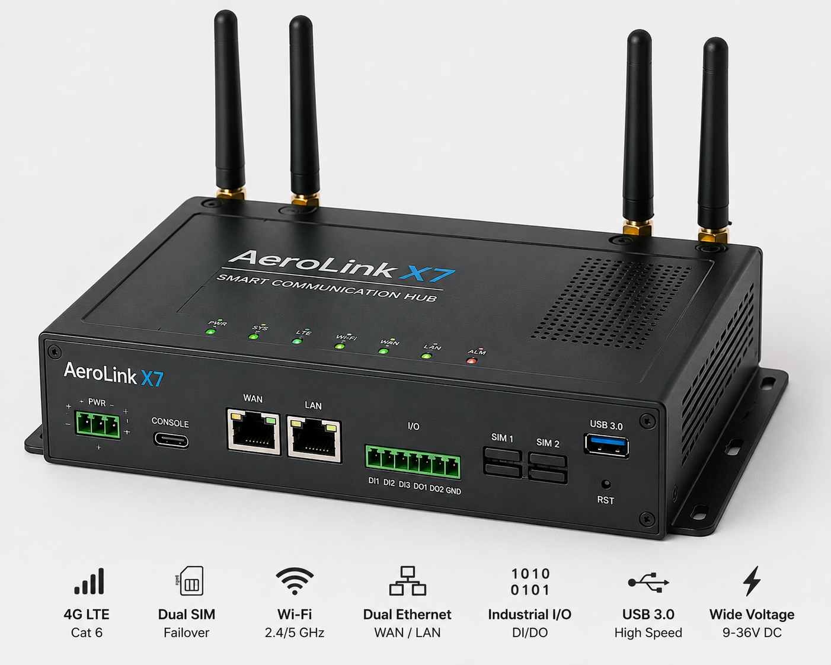
Figure: AeroLink.png

Applicable Classification Rules
Classification of the AeroLink X7 Smart Communication Hub is governed by the General Rules for the Interpretation (GRI) of the Harmonized System. GRI 1 requires that classification be determined according to the terms of the headings and any relative Section or Chapter Notes, provided such headings or notes do not otherwise require, and thereafter according to GRI 2 through 6, as appropriate. For multi-component or network-oriented apparatus, GRI 1 establishes the legal framework for identifying the primary function of aggregating wired and wireless communication interfaces and coordinating connected devices. GRI 6 further governs the classification of goods at the subheading level, requiring that subheadings be determined according to their own terms and related subheading notes, and mutatis mutandis, taking into account that only subheadings at the same level are comparable.

Analyst Reasoning
GRI 1 and GRI 6 form the statutory foundation for establishing the correct heading and subheading for network communication equipment. GRI 1 directs the analysis to the specific heading text and Chapter Notes that describe automatic data processing machines or telecommunication apparatus, while GRI 6 ensures that the final subheading selection strictly adheres to the same-level comparison rule.

Sources & Evidence

Relevant Previous Rulings
An examination of binding customs precedent provides guidance on the classification framework applicable to multi-functional communication and monitoring units. Specifically, ruling NCR-THM-2026-0417 addressed the classification of the ThermoTrack Industrial Monitoring Unit, Model TT-IMU-4, an assembled apparatus designed for acquiring, processing, storing, and communicating information from connected devices. Customs authorities determined that such dedicated appliances function collectively to process and direct data streams. While the AeroLink X7 Smart Communication Hub shares similarities with the prior ruling regarding its architecture as an assembled unit containing processing and communication capabilities, its primary purpose is the aggregation and coordination of wired and wireless network interfaces rather than specialized industrial measurement or checking. Consequently, previous rulings for measuring and checking instruments under heading 9031 must be evaluated against the AeroLink X7's specific function of managing network communications and device coordination within a facility.

Analyst Reasoning
The prior ruling NCR-THM-2026-0417 establishes how multi-component assembled apparatuses with central processing and peripheral communication capabilities are analyzed under the tariff schedule. Comparing the AeroLink X7 to the ThermoTrack unit highlights the distinction between specialized industrial monitoring/checking apparatus and general communication hub devices. This precedent is vital for establishing the boundaries of heading-level provisions, ensuring that the AeroLink X7's networking and coordination functions are appropriately distinguished from dedicated measuring instruments.

Sources & Evidence

Classification Analysis
The AeroLink X7 Smart Communication Hub is classified under Heading 8517, specifically providing for electrical apparatus for line telephony or line telegraphy, including line telephone sets with cordless handsets and telecommunication apparatus for carrier-current line systems or for digital line systems. Under GRI 1, classification is governed by the terms of the headings and any relative Section or Chapter Notes. By application of GRI 6, the apparatus is classified at the subheading level based on its function as a machine for reception, conversion and transmission or regeneration of voice, images or other data, including switching and routing apparatus. The device combines a processing board, network interfaces, wireless modules including Wi-Fi 6 and Bluetooth Low Energy, and local flash storage, serving solely to aggregate wired and wireless communication interfaces and coordinate connected devices within a facility. It does not perform automatic data processing functions of Heading 8471, nor does it constitute an instrument for measuring or checking of Chapter 90. Consequently, Heading 8517 represents the correct statutory home for the article.

Analyst Reasoning
The product's principal function is the aggregation of wired and wireless communication interfaces and the coordination of connected devices within a facility. Under GRI 1 and GRI 6, apparatus designed primarily for network communication, routing, and data transmission between devices falls under Chapter 85, specifically Heading 8517, rather than automatic data processing (Heading 8471) or measuring instruments (Chapter 90), because its physical and functional characteristics are dedicated entirely to communication and network coordination.

Sources & Evidence

Alternative Classifications Considered
During the classification analysis for the AeroLink X7 Smart Communication Hub, several alternative tariff headings and subheadings were evaluated based on its physical characteristics, interface capabilities, and network functions. One primary alternative considered was classification under heading 8517 as an apparatus for the transmission or reception of voice, images, or other data, specifically within subheadings covering routers or network switching apparatus. This alternative was evaluated because the device incorporates Ethernet interfaces, Wi-Fi 6, and Bluetooth Low Energy modules to handle network configuration and connected-device communication. However, this alternative was rejected because the primary intended use of the AeroLink X7 is to aggregate communication interfaces and coordinate connected devices within a facility rather than functioning merely as a router, bridge, or general telecommunications switching apparatus. Another alternative examined was heading 8471 as an automatic data processing machine, given the inclusion of a processor, solid-state flash storage, and embedded firmware. This was rejected because the device is expressly not designed for general office productivity or general-purpose data processing; its sole purpose is dedicated to localized communication management, event logging, and coordinating network-connected devices. Finally, heading 9031 was reviewed in light of precedent ruling NCR-THM-2026-0417 concerning industrial monitoring units. Heading 9031 was ultimately rejected because, unlike monitoring units designed for measuring or checking physical quantities, the AeroLink X7 functions strictly as a communication hub and data aggregator without performing measuring or checking operations.

Analyst Reasoning
Each alternative was systematically tested against the product's physical and functional profile—specifically its role as a dedicated communication hub rather than a router, computer, or measuring instrument—ensuring that the chosen classification accurately reflects its principal function under the General Rules of Interpretation.

Sources & Evidence

Reasons for Rejecting Alternatives
Several alternative headings were evaluated and subsequently rejected during the classification analysis for the AeroLink X7 Smart Communication Hub. Heading 8517, covering telephone sets and other apparatus for the transmission or reception of voice, images or other data, was considered for its general communication functions. However, the device does not perform telephonic transmission, switching, or routing in the manner contemplated by Heading 8517, but rather operates as a specialized data-aggregation and local coordination hub for facility devices. Heading 8471, covering automatic data processing machines and units thereof, was also examined due to its inclusion of processors and solid-state storage. This alternative was rejected because Note 5(A) to Chapter 84 excludes machines performing a specific function other than data processing; the AeroLink X7 is specifically dedicated to network communication and device coordination rather than general-purpose data processing. Finally, Heading 9031 was evaluated based on comparison with industrial monitoring units, but was rejected because the product does not measure or check physical quantities as required by Chapter 90, instead functioning entirely within the realm of digital communication and network device coordination.

Analyst Reasoning
The analysis required systematic elimination of plausible headings that might otherwise appear relevant based on isolated hardware features such as network interfaces (Heading 8517), internal processing and memory (Heading 8471), or monitoring applications (Heading 9031). Applying the relevant Section and Chapter Notes—specifically Chapter 84 Note 5(A) regarding automatic data processing machines—ensures correct legal exclusion of broader machine categories in favor of apparatus specific to communication functions.

Supporting Citations / Sources & Evidence
This memorandum relies on technical specifications and product documentation provided by Northstar Connected Devices Ltd. for the AeroLink X7 Smart Communication Hub (Model ALX7-X7-240). Primary factual evidence is drawn from the official product specification and technical data sheet contained within 74 kilograms, and a mechanical construction consisting of molded PC/ABS polymer panels with internal metal shielding. Additional operational and architectural evidence is established through manufacturer technical documentation regarding network interfaces, wireless modules including Wi-Fi 6 and Bluetooth Low Energy, embedded firmware, and input/output capabilities. Customs classification analysis further incorporates administrative precedent and ruling frameworks, including ruling reference NCR-THM-2026-0417, which provides comparative evaluative criteria regarding multi-function apparatus and dedicated communication or monitoring appliances.

Analyst Reasoning
Citations and source references must be explicitly documented to establish an audit trail for the tariff classification of the AeroLink X7 Smart Communication Hub. Grounding the memo in specific product documentation, technical specifications, and administrative rulings ensures that the application of general rules of interpretation and heading selections rests on verified factual premises rather than assumptions.

Sources & Evidence

Final Recommended Classification
The AeroLink X7 Smart Communication Hub is classified under heading 8517, specifically providing for apparatus for the transmission or reception of voice, images or other data, including apparatus for communication in a wired or wireless network. By application of General Rules of Interpretation 1 and 6, the device is properly provided for in subheading 8517.62 as other apparatus for reception, conversion and transmission or regeneration of voice, images or other data, including switching and routing apparatus. The device functions primarily to aggregate wired and wireless communication interfaces, manage network traffic, and coordinate communication between network-connected devices within a facility. Because its principal function is network communication and data routing rather than general data processing or measurement, heading 8471 and heading 9031 are inapplicable.

Analyst Reasoning
The product facts establish that the AeroLink X7 is a dedicated communication hub equipped with Ethernet, Wi-Fi 6, and Bluetooth Low Energy interfaces, designed specifically for network traffic management and inter-device communication within a facility. Its physical and functional characteristics align squarely with the scope of heading 8517, which covers apparatus for transmission, reception, and conversion of data in wired or wireless networks. GRI 1 governs the classification through the terms of heading 8517, and GRI 6 determines the correct subheading level for apparatus dedicated to switching, routing, and data coordination.

Sources & Evidence

RECOMMENDED CLASSIFICATION DETERMINATION
Recommended HS Code: 8517.62
Official Description: Other apparatus for reception, conversion and transmission or regeneration of voice, images or other data, including switching and routing apparatus
Legal Rationale: The product is a communication hub combining a processing board, network interfaces, and wireless modules to aggregate communication interfaces and coordinate network-connected devices. Under GRI 1 and GRI 6, it is classified in heading 8517 and specifically subheading 8517.62.

