Task:

Two Inventory locations to store finished inventory.

FGInventory & InventoryVault

On Page : <http://lostintech.com/walnut/holdingInventory>

Create a new drop down Sent to “Inventory Vault”

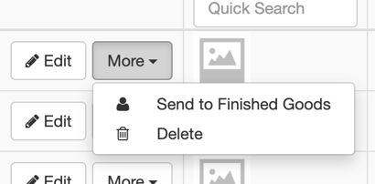

Inventory Vault will be a copy of the FGInventory, but with different inventory

Sales orders will be able to choose from FGInventory and InventoryVault.

Maybe on drop down in sales order, display FG-“item info” or IV-“Item info” so we can choose easily which inventory its pulling from.