2015-12-25 10:39:52

TASK:

* Trying to manage tools.
  + The current tool function has a problem: all the code is in task script.
  + I need to extract the tool function in a way of more independently...
  + Most important two functions for tools are : pickup and use.
* Creat a script --- *InteractiveTool* and attached to the tools.
* Use this script to control the tools.

2015-12-25 10:52:32

PROBLEM: The task manager (HTN) cannot recognize the object.

SOLUTION:

* Assign all the used game object with *InteractiveTool*
* Pick up now is called.... forget to call pick up in task manager.

2015-12-25 11:04:06

PROBLEM: Both firefighter picking up the same thing.. StableTool_1

GOAL: one firefighter picking up StableTool_1 and the other picking up StableTool_2

SOLUTION: the firefighter doing the job according to the #StableSill and #StableWheel. And they are managed with tags. So I need to initialize the object with the correct tag.

2015-12-25 11:20:52

Now animate the UseTool correctly.

2015-12-25 11:53:14

UseTool involved too much with in the task...

It is difficult to detach from task manager.

2015-12-25 16:20:59

The 3d model has a problem... not every 3d model has a render component so that I should use *CurrentStablePointSill.renderer.enabled = true;* to organize my models.

Solution: reorganize the 3dmodel.

2015-12-25 16:34:43 .. download 3ds max... meantime, read materials for next action(task)

2015-12-25 18:53:15

Next task: glass management

* Glass simulation

2015-12-25 20:43:09

Back to modeling... ref[2015-12-25 16:20:59]. The StableTool_2 has been modeled into one model and it can be deactivated via mesh render.

Still have a problem, when the first sill is stabled, error happened...

2015-12-25 21:12:44

There is a big problem in the HTN planner...

That is : sometimes when some precondition or effect are setted, the HTN is not working or stop working as it suppose to be..

E.g. when I set up the blackboard var task = stabilizevehicles to stable vehicle note, it will stop working.

E.g. When I set up hasTool = true to pickup_tool’s effect. The whole task is not working as well...

This can be the bug/problem of the system...

Solve this first tomorrow...

2015-12-26 11:18:22

See what I can do ...ref[2015-12-25 21:12:44]

Stable sills and stable wheels are two tasks... which is not suppost to be or???

Design problem? How to go to the sub tasks...

If I set the task(rather than subtasks), the firefighter don’t know which sub-task to do.

2015-12-26 17:33:03

Not fount out what cause the problem system bug???

Try tomorrow or later.

2015-12-28 09:43:51

Back to work... read the example. See what hint I can find...

hasTool: when this var set to true as an effect of pickUp(tool), the plan doesn’t work. But when it set to false... no problem.

Why???

hasTool: (in code)only initialized in the OnEnable(), not trying to modify at all... (in HTN planner) only make an condition in FindToolForSillsStable.

* TEST: remove the condition: hasTool = false in FindToolForSillsStable, but it doesn’t do ahnything at all anyway...
* TEST: create an testBool in blackboard variables, and this variable works in HTN planner..

What is the different from testBool to hasTool?

THOUGHT: Init?????Should delete blackboard var in init code????

Test when I come back from shopping......(2015-12-28 10:41:37)

2015-12-28 21:14:41

Continue---

THOUGHT: Sequence cannot work when there is a sub task(or primitive task) that condition not matching …test it.

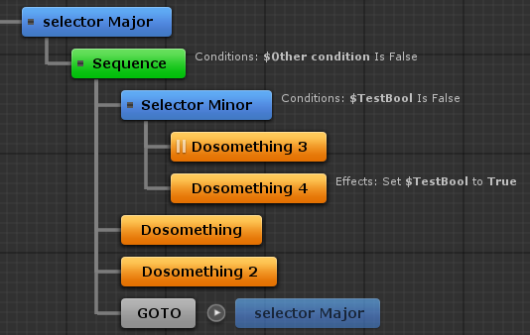

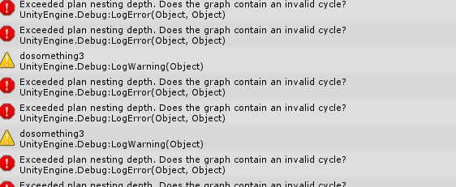

Test example above.

This is suppose to say that the circle of selector minor is not correct....

**THIS MUST BE THE PROBLEM!!!!!**

My firefighter model planner has the same problem..

I should make the logic correct.

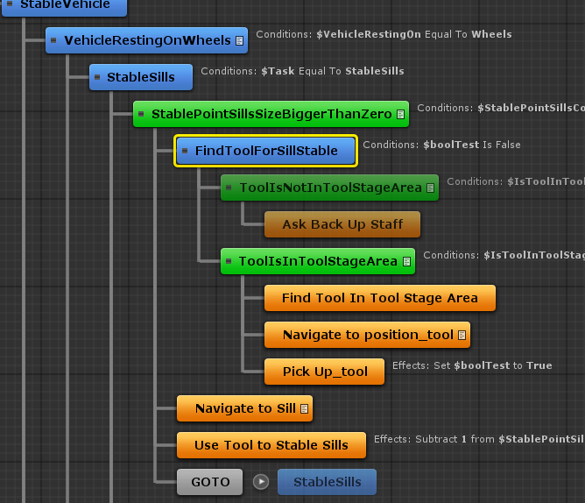

The wrong version.... above...

This should be the problem... and I finally fix it....

There are some continuesly problem... fix them one by one.continue tomorrow2015-12-28 23:09:49

2015-12-29 09:45:01

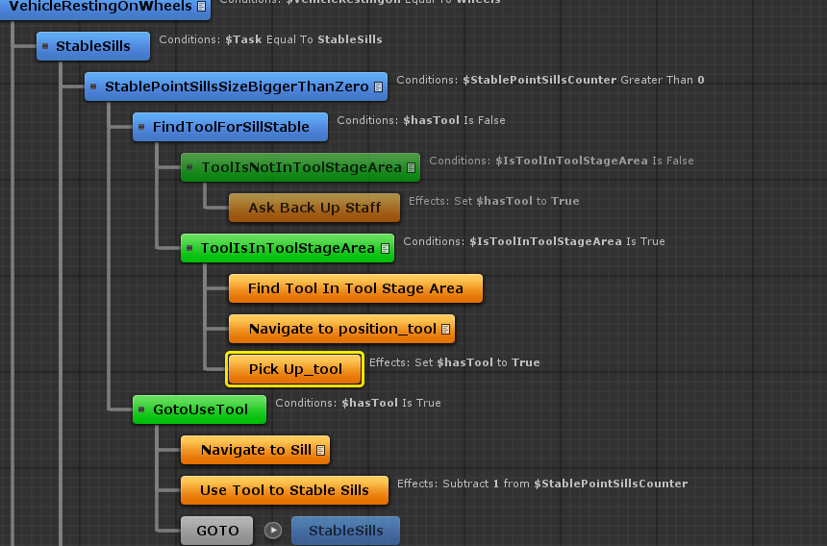

After fixing the logic, stable vehicle task works!

2015-12-29 09:53:58

TASK: glass management

Four status of glass: (side window)

* Original 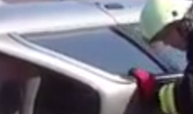
* Taped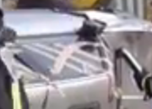
* Destroyed without tape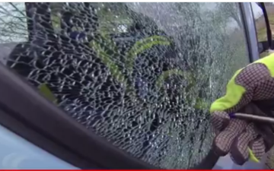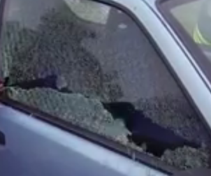
* Destroyed with tape 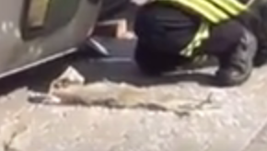

Need two models:

* Körner

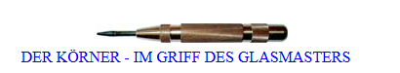

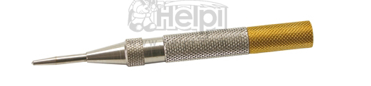

And Klebebandabroller:

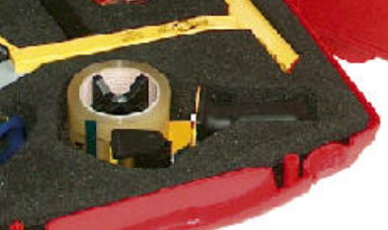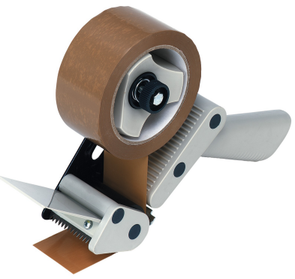

2015-12-29 13:26:48

Modeled: Klebebandabroller

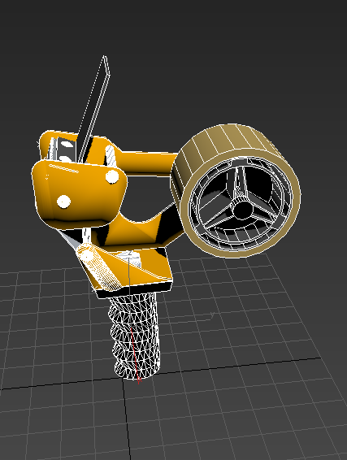

Unity

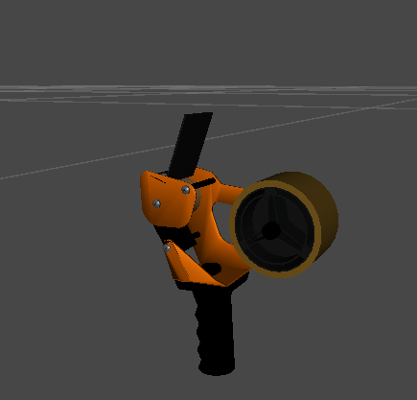

2015-12-29 15:57:08

How a center punch(FederKörner) work?

<https://en.wikipedia.org/wiki/Automatic_center_punch#/media/File:Operation_of_Sweet_patent_automatic_center_punch.gif>

2015-12-29 20:29:26

Modeled: Federkörner

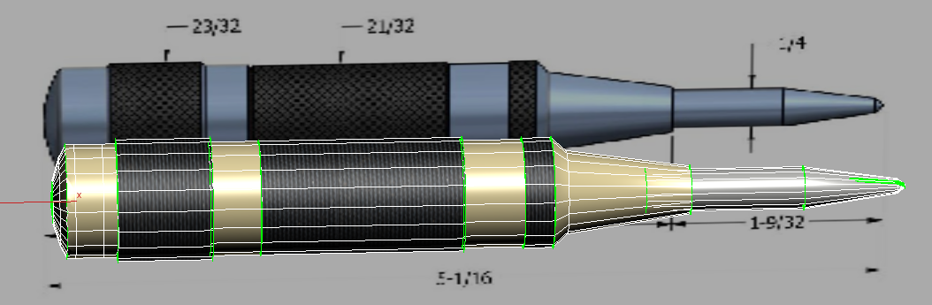

2015-12-29 21:03:52

Both models are added to the scene.

2015-12-29 21:28:56

Glass test in Unity.

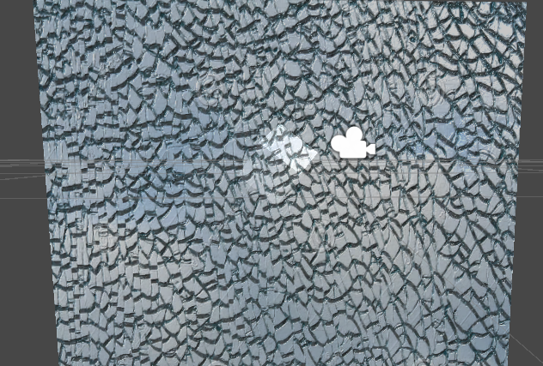

2015-12-30 11:09:03

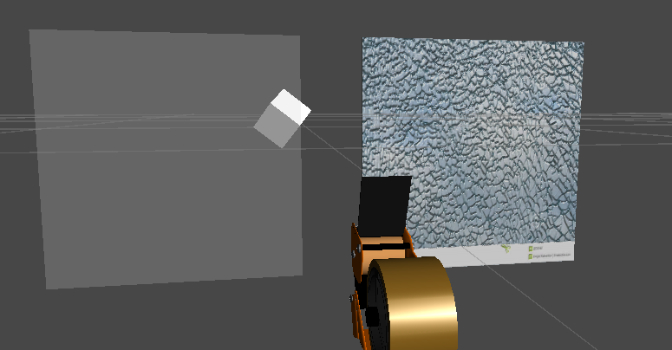

Two state of the window:

* Original
* Destroyed without tape

Has been set.

2015-12-30 11:20:14

Write a script that can control the material while runtime.

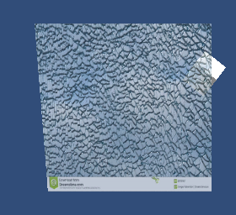

2015-12-30 11:34:32

Window for car ... ready

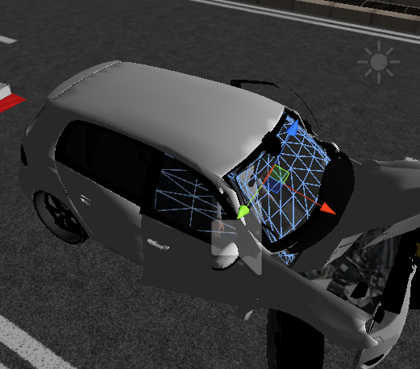

2015-12-30 15:11:09

Tape modeling

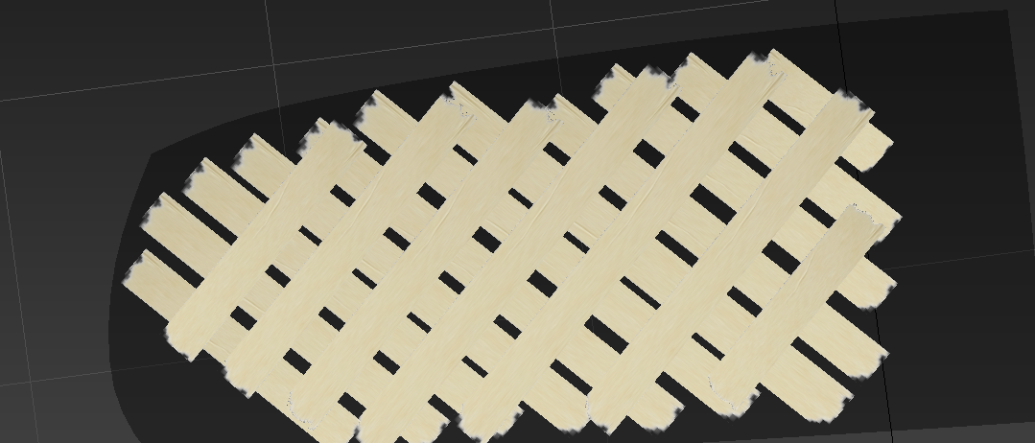

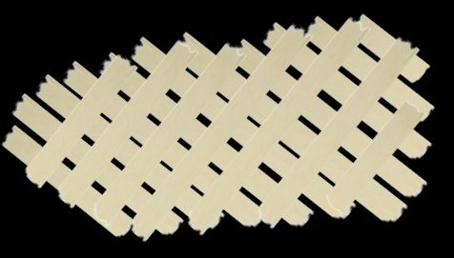

2015-12-30 15:22:32

Integrated the tape to the car

