2016-2-2 20:28:39
The book C# game programming for unity 3D is a very good book.
The introduced weapon system is quite a good workflow for tool system. I need to manage my tool system again and try to use this workflow.
Page 130

2016-2-3 09:02:42
LEARN: Layers in unity

Layers
Layers are most commonly used by Cameras to render only a part of the scene, and by Lights to illuminate only parts of the scene. But they can also be used by raycasting to selectively ignore colliders or to create collisions.

Casting Rays Selectively
Using layers you can cast rays and ignore colliders in specific layers. For example you might want to cast a ray only against the player layer and ignore all other colliders.

Most of the content have been read, and I need to implement the tool controller.

Before that I need to make the plan.

2016-2-3 10:58:29
Implementing tool operator.
Start from BaseToolScript:
This script will be attached to every tool.

2016-2-3 13:08:34
C# polymorphism

2016-2-3 15:28:34
First edition of ToolStates.cs and BaseToolScript.cs is implemented, ToolStates has all the states of the tool as well as the tool type. BaseToolScript.cs should attached to the tools and this will get the basic information of the tools.
Moreover, BaseToolScript is the base class of the tool script, more specific functions can be written in its derived classes.

Now I am working on ToolController that will be attached to the NPCs.

2016-2-3 20:32:54
About controller, I also need crashed car controller, dealing with window\glassmanagement, sill, wheel etc.
Many game objects can be active and deactive etc…

2016-2-3 21:05:35
Working with the basic script of tool controller.

2016-2-4 12:50:37
Warm up change the cursor of my application...
Cursor.SetCursor(cursorTexture, hotSpot, cursorMode);
For at least customized texture.

2016-2-4 13:03:19
Now continue with main project...
Tool controller..

2016-2-4 20:23:48
Integrating the tool controller...
Unit test, the FindToolByName function works, and this is integrated in to the task..

The task is not using parameter anymore but real value with tool name.
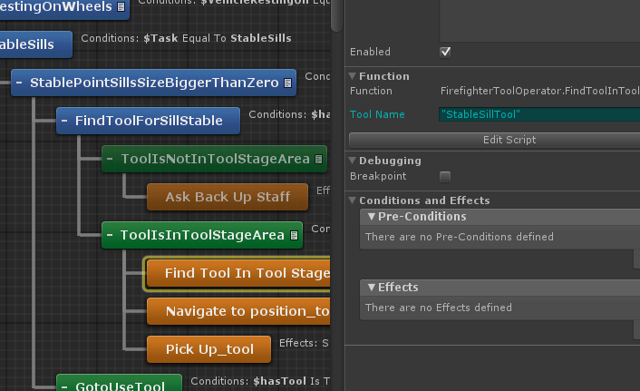

And this is the current tool list:
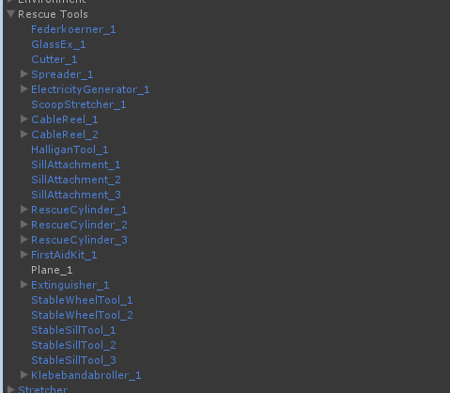

When I need a tool to do something, I can simply use the name without postfix.

Taks.. FindToolInToolStageArea works...
Now pickUp..

Set the toolscript to the tools...

Pickup works now...
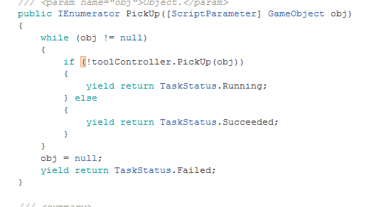
Only few lines of code.. really happy with it.

2016-2-5 09:09:53
There is a:
BUG: in the HTN system: when the primitive task node is created, the user should initialize the parameter, but when the parameter is initialized, it will not possible to be changed.... Only if you delete it and assign the parameter again...
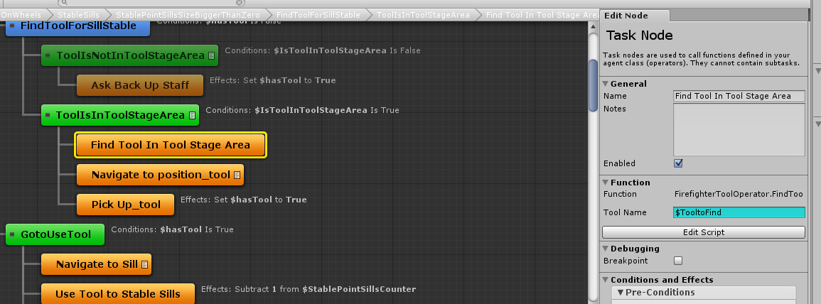
The image above is the one I used but now convert back to TooltoFind...rather than “StableSillTool”

2016-2-5 14:42:50
Now the current version is almost the same as before...

TODO now:
- Pickup should do it real, pick up enough tool to do the task.
- Firefighter should have a tool counter in his hand to do the task, not using the has tool
- Do not use has tool to judge weather the firefighter have tool.
- Add the use too status changing...
- Firefighter should finished the task complete...stable sill and then stable wheel. No matter one do it or two do it.

2016-2-9 08:47:38
Do the tasks above...

2016-2-9 09:14:51
Warm up... Gui info presentation...
Works atm

2016-2-9 09:53:18
- Firefighter should have a tool counter in his hand to do the task, not using the has tool
It is difficult to add multi tools in one firefighter’s hand using HTN planner....
ATM: I add the has---Tool as boolean operation, that can distinguish from different tools.
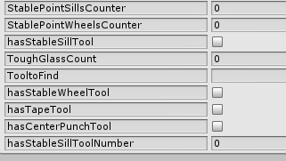

BUG: found a bug.. The last sill is stabled without animations...
Thought: try to find the problem in animator?? Logic of HTN?? Tool controller error??

I got it.... The last animation is not finished.. And the judging condition past...
-----Haven’t figure out how to easily fixed this problem..
TODO, come back later.
Fix the stable wheel problem first.. ... time2016-2-9 14:58:19
foreach(Renderer r in renderers) {
r.enabled = true;
}
Saved my day...
The stable sill and wheel work.... With the new system.

2016-2-9 16:28:39
TODO: 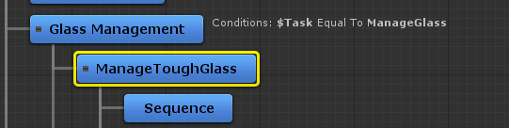
Sub tasks management...
Manage tough glass should be manage in the future...

Currently it will run always..

2016-2-10 09:19:49
Some parameters back up:
To solve the BUT in 2016-2-9 09:53:18

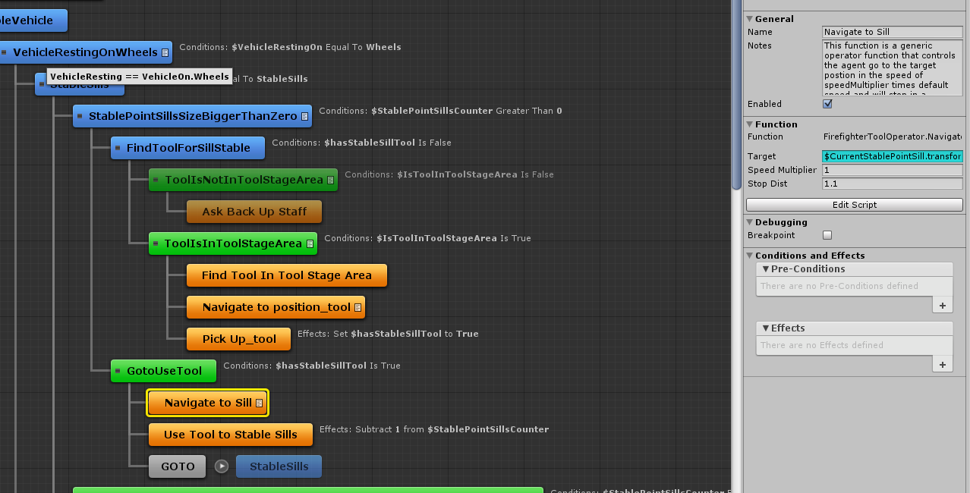
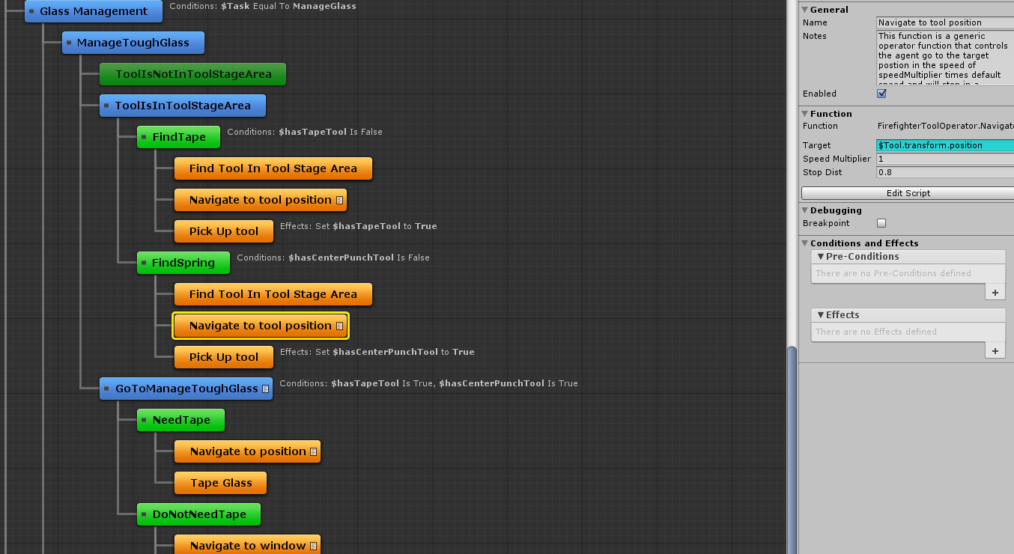

TODO:
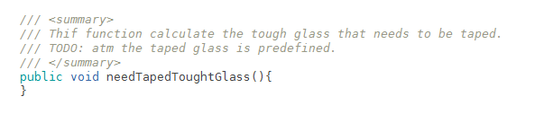
2016-2-10 10:05:39
This might have bug in the future that the firefighter tape the glass and not direct manage the glass.
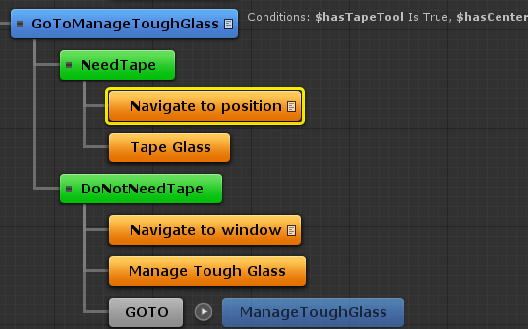

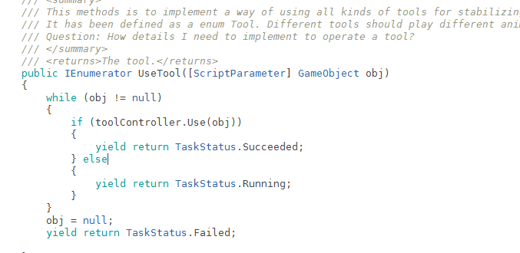should be changed to use tool to stable or ...

I need to tape glass
TapeGlass

A but here??? Cannot see..
Do not go further...

2016-2-10 16:43:25
After a lot test, the problem is from:
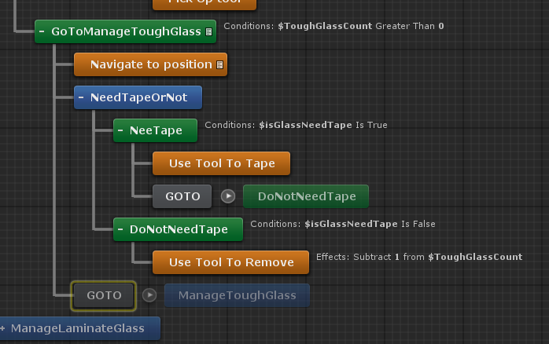
Goto ... this works in stable .... why this not working here...

2016-2-11 09:18:16
Tried to change the task logic..
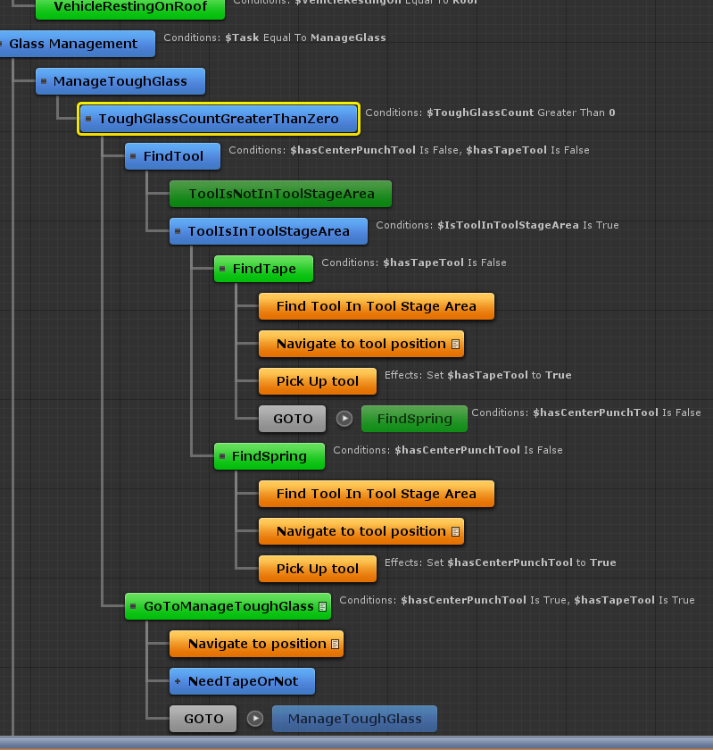

It is still not working ..
TEST:
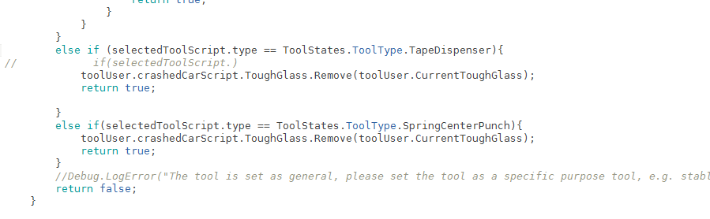
Return true added...
Not working ...

What else I can do...

2016-2-11 11:08:58
Atm, the AI logic is not working properly... Don’t know really why.. I decide to first work with the animation.. Game logic and so on.. And test this AI logic afterward...

!!!!
2016-2-11 11:46:06
After add the animation and further tasks ... It works ...
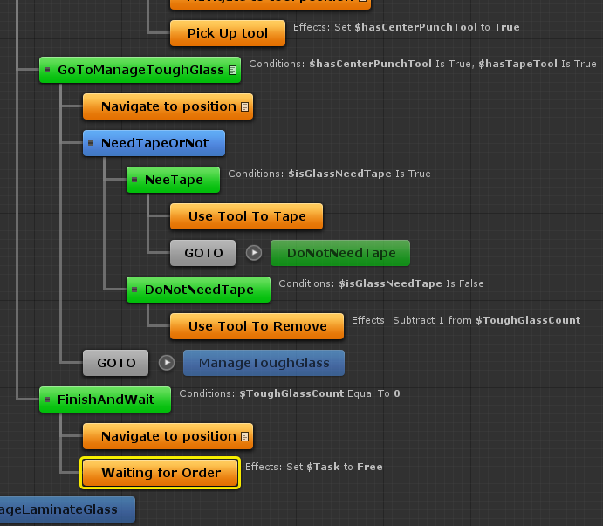

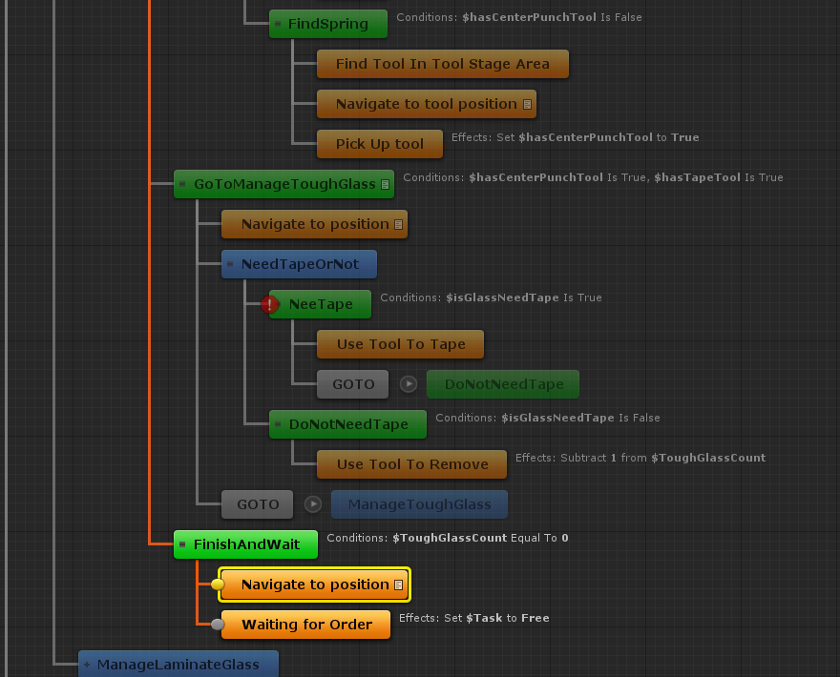

Still some error...

But it looks better..

Now trying to make it really work...
Problems found:
- Still have the problem that the firefighter not pickup correctly ... idea: the current judge is via the percentage of animation played, I should judge whether attached....

2016-2-15 10:27:37
Pick up problem and the tape problem are the same... That the animation is not played correctly...
Tow animations are played at the same time... Namely when the first animation is not finished played, e.g. 70% played, the second task is already on, and it has the same judge to evaluate whether it is running...

2016-2-15 12:27:40
Pick up bug fixed... 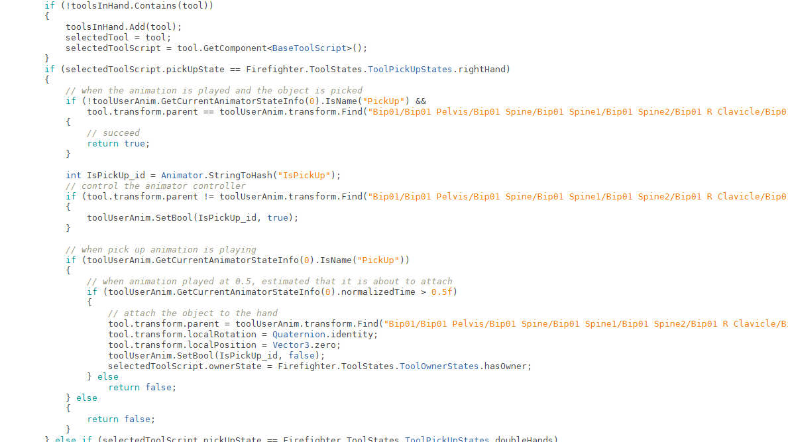
Fixed manymanymany bugs...

Keep working ...2016-2-15 17:49:11

2016-2-16 09:16:34
Trying to fix the mecanim problem when using svn yesterday night and today morning ...
Activate meta data and upload to svn, hope it works...

2016-2-16 09:17:26
Trying to fix:
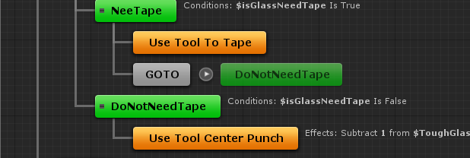
The goto seems not working properly..

Fixed...
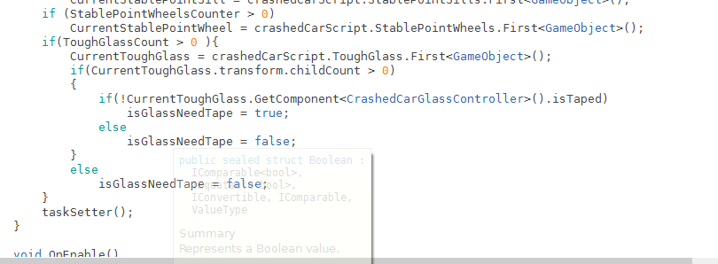
Add an additional Condition judgment in firefightertooloperator.cs update function...

Bug: don’t manage the last window..
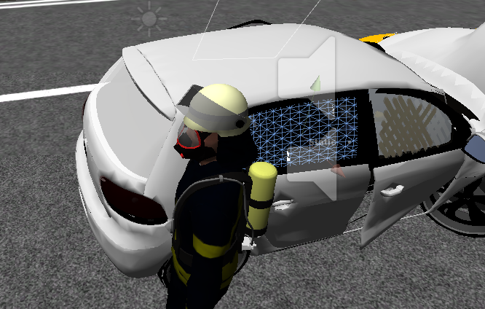

Fixed
Move finishandwait node out of rough glass bigger than 0 node
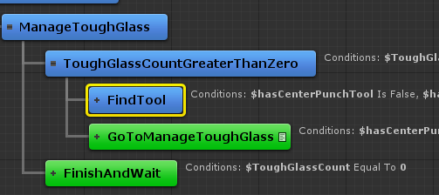

2016-2-16 09:49:02
Working on laminateglass...

2016-2-16 13:54:52
First version of game logic/AI logic is implemented..
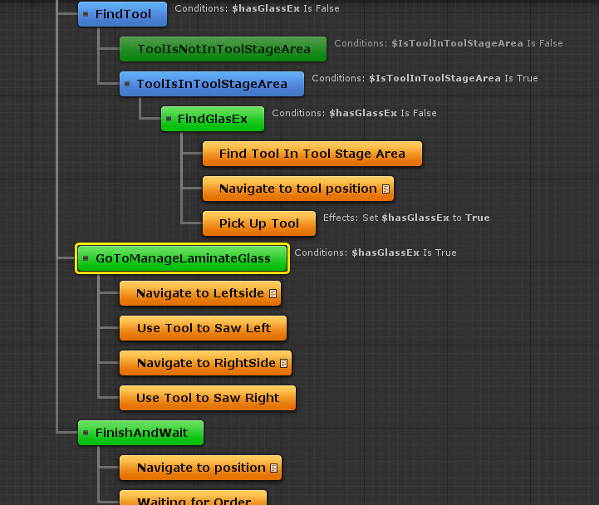
The find glasEx is implemented already
Now start with GoToManageLaninatedGlass node...

2016-2-17 14:56:00
Svn missing script and missing animations in mecanim system fixed... only libs can be ignored. Others must be synced.

2016-2-19 13:42:12
Working with
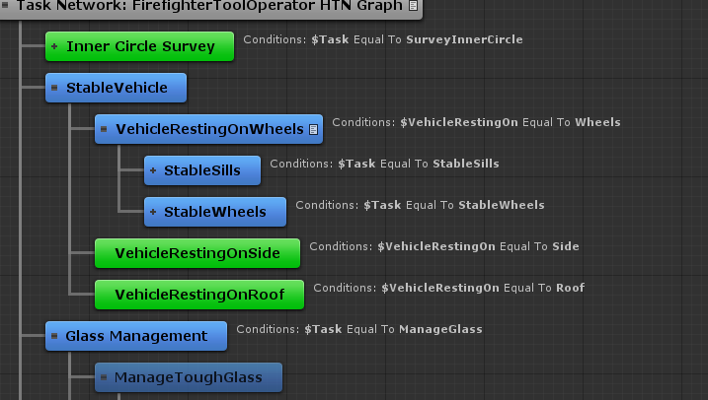

Convert to:
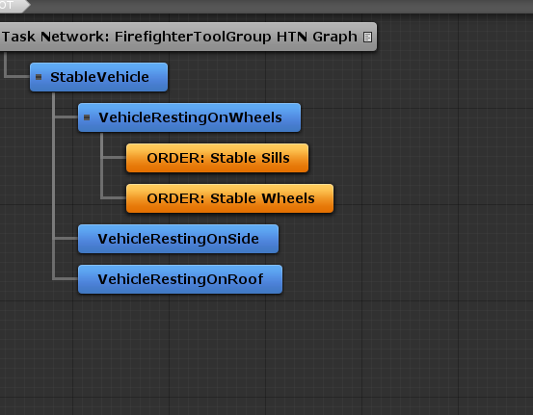 in tool group
and 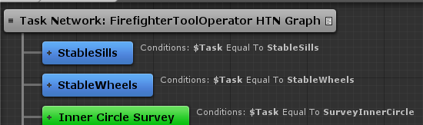 in tool member

2016-2-19 14:38:05
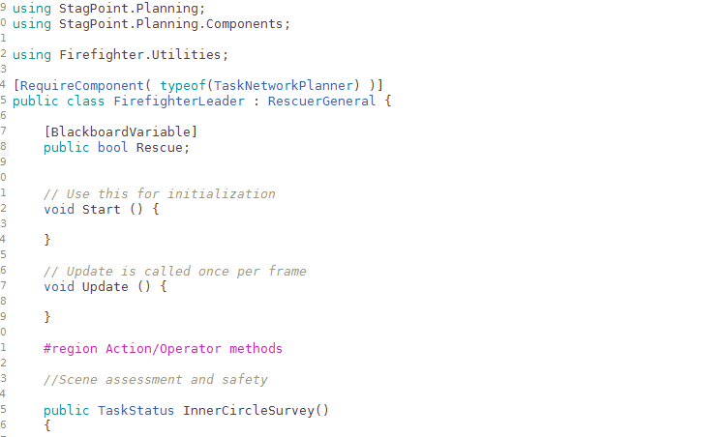
Black board variable changing runtime???

2016-2-23 10:32:37
Many problems solved...
Implement single task communication among firefighter leader--tool group--tool member.s

2016-2-23 11:19:45
Really big problem happens...
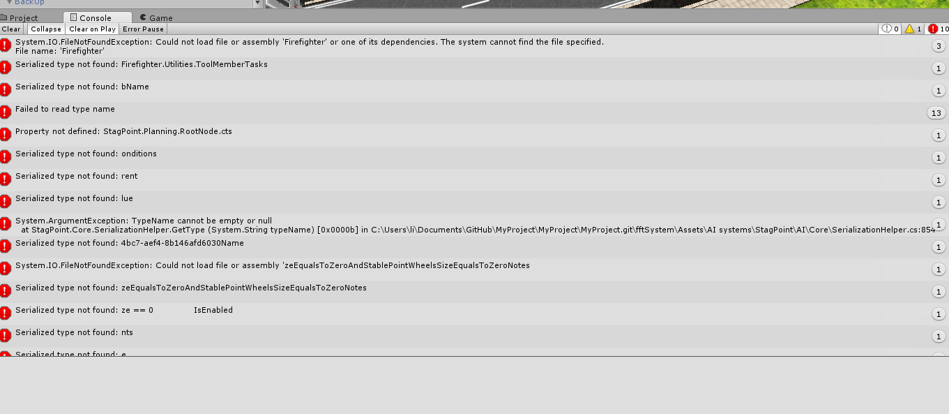
Many IO problems occurs.....
Graph for toolgroup is not presentable
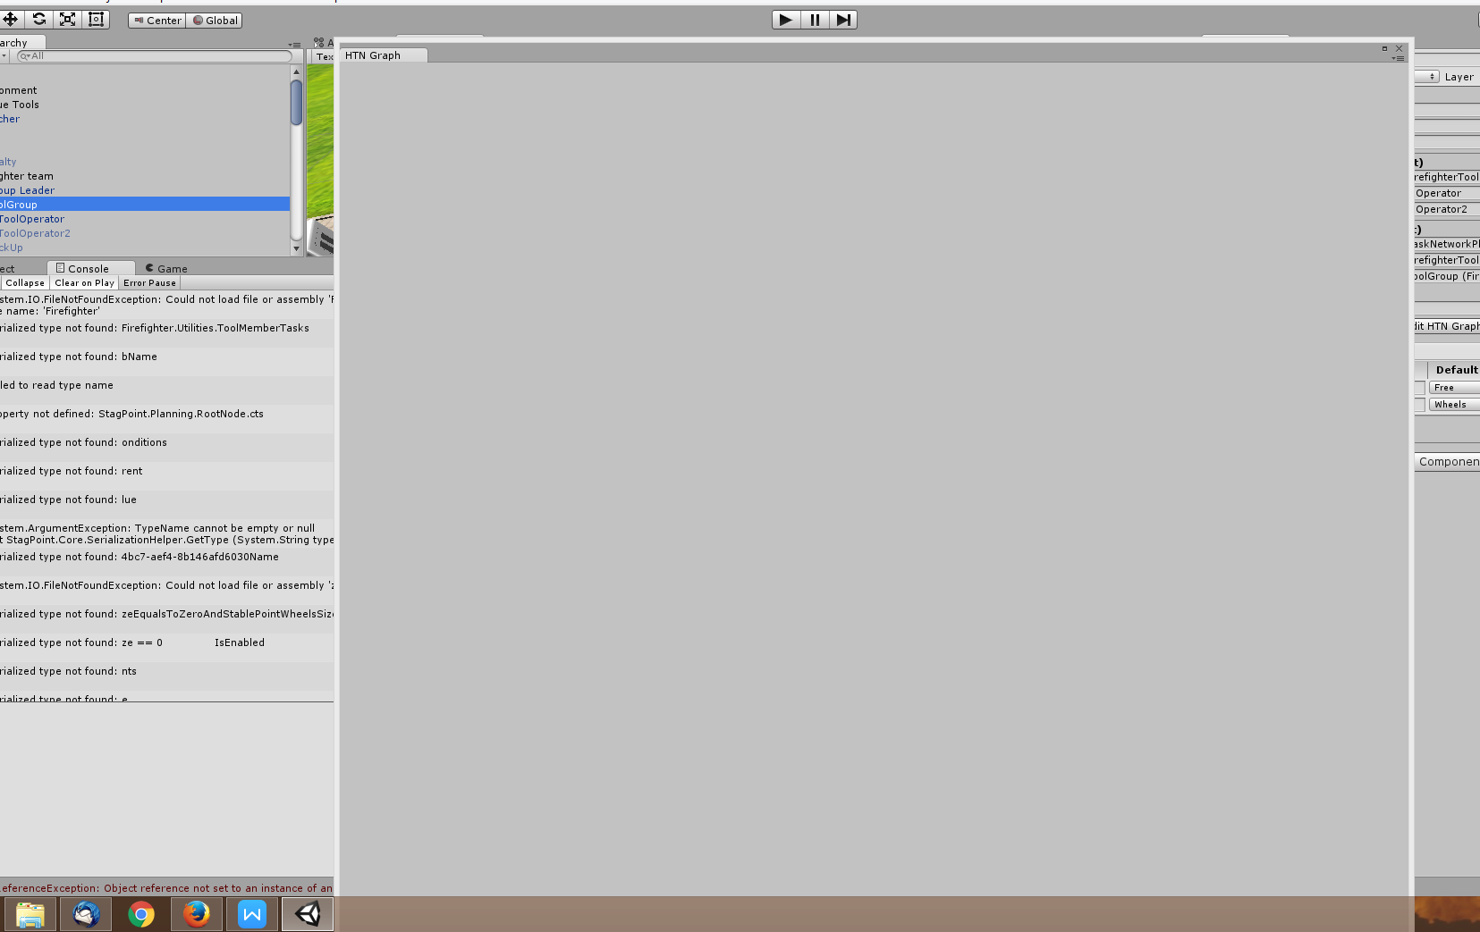
Tool operator contains nothing...

...... I have to revert my older version from yesterday...

The version from yesterday works... But I need to find out what is the problem for this...... May it happen again ???

It seems the saved file structure is changed.. And it is not possible to be fixed...

I have to rework with the older version again.

2016-2-23 11:26:15
Rework with the older version and implement the new features with care.

2016-2-23 13:59:16
Old version has been updated.. But I need to :
- Fix the one person not working all tasks problem (fixed)
- Add more information changes: down to up

2016-2-23 15:31:57
There is a bug
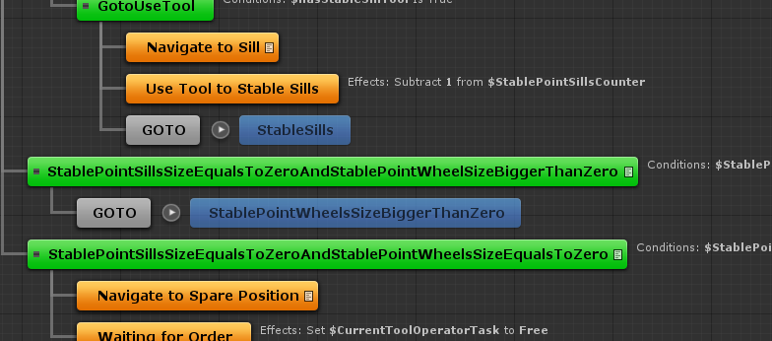
The second goto should go to the other task of stable: stableWheels.
But the planner don’t run at all...
So I have to use the subtask with works at the moment...

2016-2-23 15:33:40
There is another bug for my own testing.
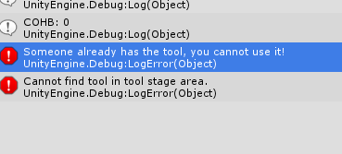
This can be fixed later...

2016-2-23 17:39:28
Report system has been implemented ... Now the tasks can be done one after another...

2016-2-24 11:14:28
Glass management is also integrated to the current hierarchical workflow...

2016-2-26 14:09:47
Basic GUI added:
- Intro
- Main gui
- Loading game scene

2016-2-29 11:57:10
Basic GUI added:
- Esc menu implemented
- Tab menu implemented
- Scrolling bar
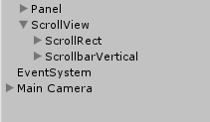
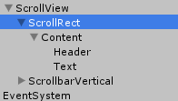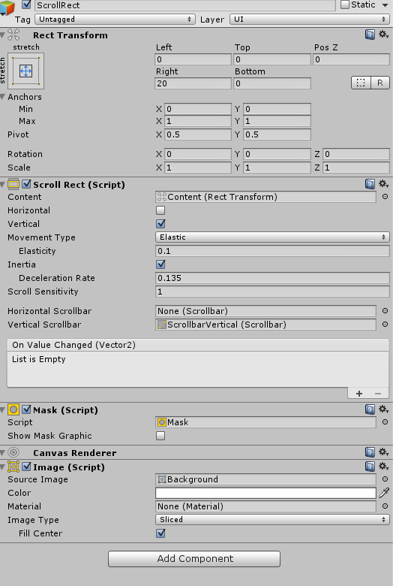

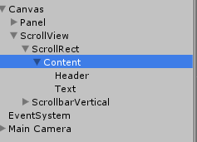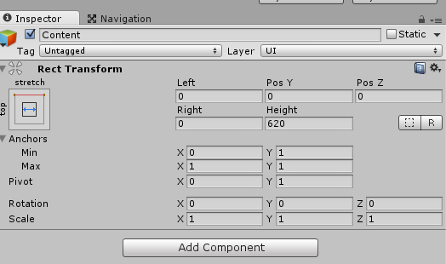

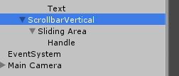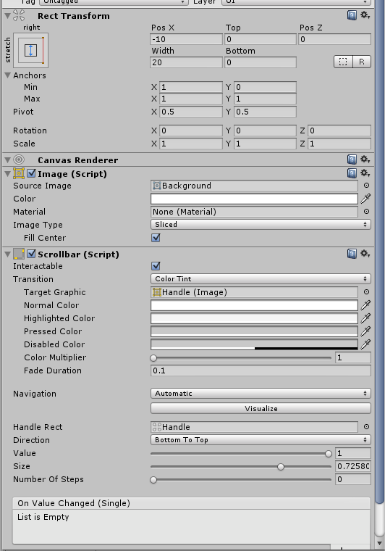

Scroll bar done..
BUG: some buttons or scroll bar is not easy to push...
