BUGS:
- Pickup bug: cannot play the animation of pickup when the second object is too close to the first one, namely only one animation and two objects has been picked up.
Reason: √
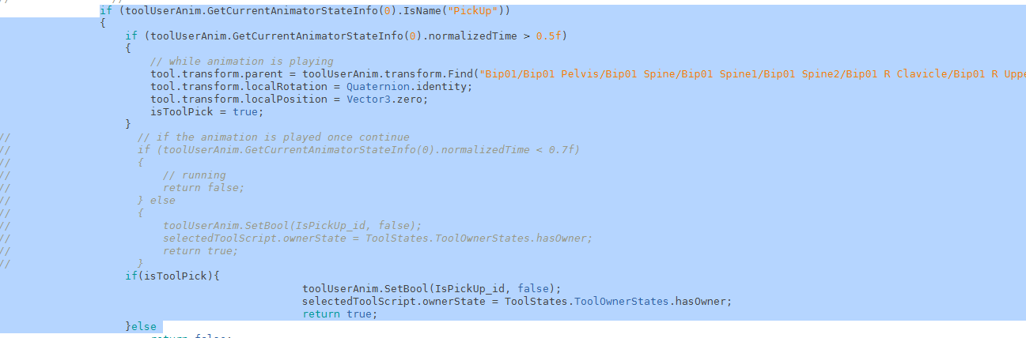
Because I judged the animation played via animation.normalizedTime...
When the time is not finished it the second is also considered as done.... So...

- Tool select: using GUI? Or at least using specific tool to do specific task.
- There is no UV in the car... If I want to add texture, I have to create one....
- Selected tool judge is also not a good idea... Problem is in when I try to use tape but the current tool is center punch.

TODOS:
- Integrate vision system
  - 2016-2-24 12:00:04 using vision
  - 2016-2-24 16:59:55: A basic vision is created in project Research test, however, I will not integrated to our project at the moment.
- Navigation ...animator controller
- Navigation ...add gameobject at runtime...
  - Do this at home with unity pro
- Animations and interactions with game objects
- Light
- Models: especially car models
- AI refine √
  - 2016-2-24 11:23:41 current works for the first three tasks singly and all together
- AI new hierarchy --- √
  - 2016-2-19 13:42:48 add group concept
  - 2016-2-24 11:24:35 Done for the first three tasks.
- GUI design √
  - Add buttons at GUI
  - A basic GUI logic has been implemented 2016-3-1 10:10:50
    - Intro, main gui button circle, in game exit.
    - Tab for debugging
- Editor
- Make the current scene as a story

