2016-1-5 16:10:00
Start with glass AI programming.
...First version... Draft... Could be changed a lot.
Tough Glass: side window and rare window
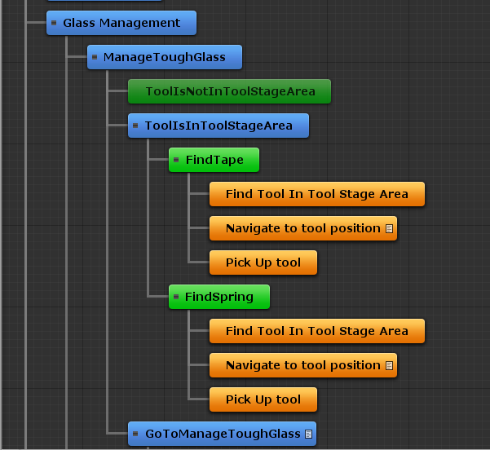
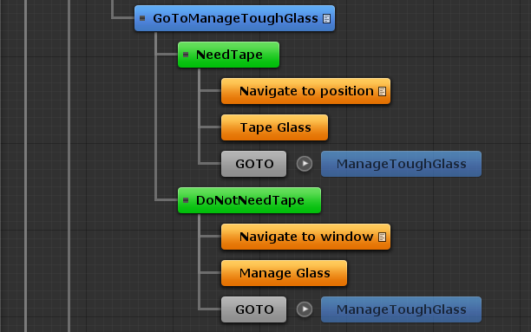

2016-1-5 17:02:15
Stable laminate glass
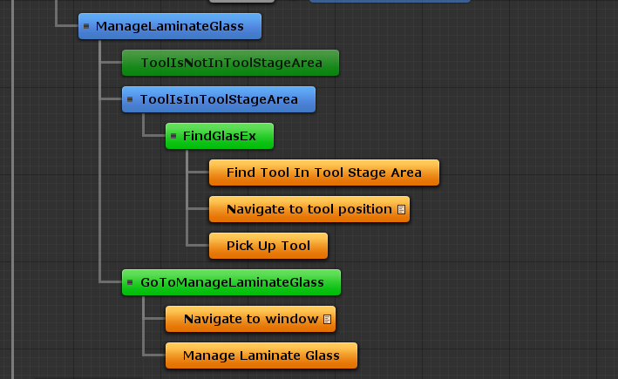

Integrate the glass management to the tool operation system

Car initialization
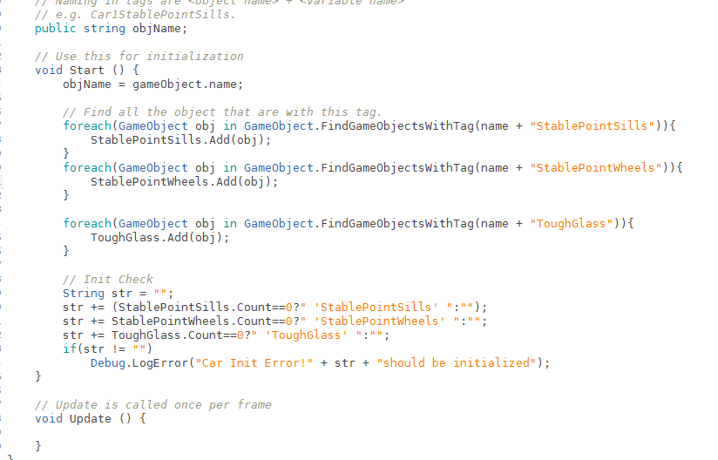
2016-1-6 08:48:03
Keep working but no report

2016-1-11 10:07:41
I found a BUG that should be fixed later, which is when I deactivate the tool operator 2, the tool operator 1 cannot fulfill all StableSill&StableWheel tasks: when he finished stabilizing the sills, he is not possible to navigate to the wheels.
This should be fixed later.

2016-1-11 10:19:47
Now continue with glass management!

PROBLEM: how to pick up two tools in our system

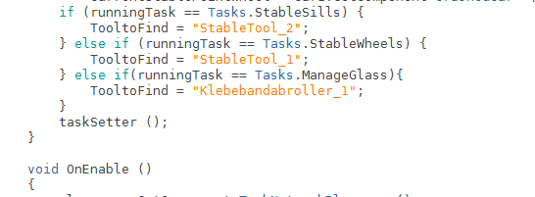
TODO: Tool is initialized. (I need to find a way to pick up two tools).

Button definition for glasmanagement
Create a new button in the screen:
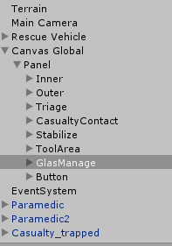
Event define
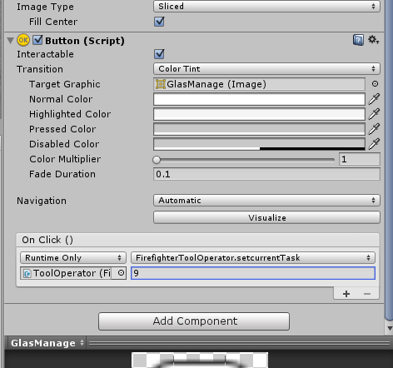
Firefighter goes to tool but don’t pick it up...
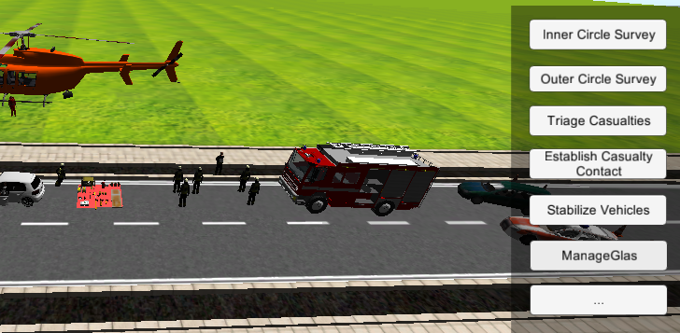

Forget to attach the script interactabletool to the script
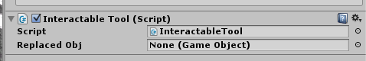

Tools can picked up...

Pick up the second one...
Condition is surely not work.
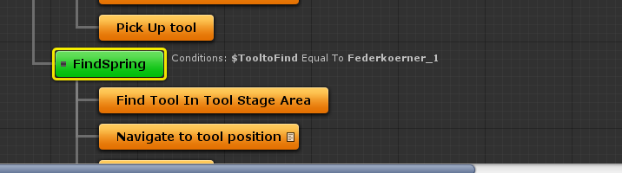

2016-1-12 20:01:36
ATM, I leave the pickup two tools problem for later implement.
I now implement the glass management.
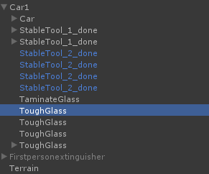
Update my Unity to pro version ... for some cased that I need to create nav mesh or ...

2016-1-25 12:13:23
After the long lecture, master thesis, project, vitos, tickets, .... I can finally work on my project!!!

2016-1-25 12:13:59
TASK: Glass management

THOUGHT:

DO I NEED TO REWORK THE FOLLOWING???????????????
Do I need to rethink about the workflow?
Do I need to rework with the whole work?
Unity version update to 5.x is possible?
Models rework, e.g. the car looks sucks....
Plan rework, e.g. think about squad AI

PLAN: first finish the glass management, and then think about the rest.

2016-1-25 20:16:29
Read book C#

2016-1-26 09:59:40
Start working on my project

PROBLEM: the error message „Actor::updateMassFromShapes: Compute mesh inertia tensor failed for one of the actor's mesh shapes! Please change mesh geometry or supply a tensor manually!“ in Unity always show up.
SOLUTION: the is because the rigidbody is attached to a game object that also contains mesh collider or its child mesh have mesh collider. This might also happen when the rigidbody is attached to a plain.

At the moment, I don’t consider the physics.

2016-1-26 16:30:54
TODO: hasTool variable is too generic, I need to make it more specific.
Now comes to the problem .... to know which window should be taped. and how to tape it.

Want to know some experience from example project about how to manage interactive objects.

Read book:
C# GaMe ProGraMMinG Cookbook for Unity 3D
LEARN: sometimes, if you have defined a more generic script, you can even use it to other games, even these games are totally in a different type. E.g. some manager script and some controller script.

LEARN:
Script communication:
1, Direct referencing manager scripts via variables set in the editor by the Inspector window.
public void aScript otherScript;
otherScript.DoSomething();
2, GameObject referencing using SendMessage.
SomeGameObject.SendMessage("DoSomething"); // DoSomething is a function from SomeGameObject, can add paramters
3. Static variables.
Make the whole class static???
1. In our gamecontroller.cs game controller script, we set up a public static:
public static GameController gateway;
2. When the game controller (gamecontroller.cs) runs its Start() function, it stores a reference to itself in a public static variable like this:
gateway = this;
3. In any other class, we can now access the game controller by referring to its type followed by that static variable (GameController.gateway) such as
GameController.gateway.GotBanana();
4. The singleton design pattern.

LEARN: Time.timeScale= 0f; is to stop time in Unity.
This is an amazing function!!! This helps me a lot with debug….. save my day.

LEARN: DataManager= gameObject.AddComponent<BaseUserManager>();
This code can add a script to a game object…. Can be used for initialization…

2016-1-27 15:55:00
The book is quite nice to read, and there is much to learn.
I decide to continue to read the book.

LEARN:
override
The override modifier is required to extend or modify the abstract or virtual implementation of an inherited method, property, indexer, or event.

CREASY IDEA!!!! What about combine clash of royale and lol!!!!!!!!!!!!!!

