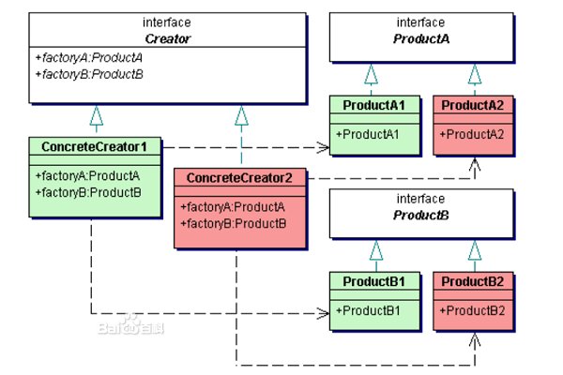

1.Every concrete factory only creates some products, but it doesn't combine them to a complete product???