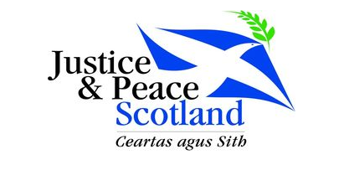
News from Justice and Peace
Motherwell May 2020

Pope Francis is inviting Catholic communities around the world to celebrate Laudato Si’ Week from 16 to 24 May 2020
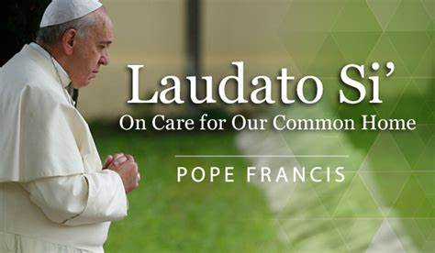
“By our actions, we can mitigate the effects of climate change stop the destruction of habitats and reverse the decline of species worldwide. The way we treat the earth today is already affecting the poorest and most vulnerable in the world and, in time, will affect us all. I urgently appeal, then, for a new dialogue about how we are shaping the future of our planet. We need a conversation which includes everyone, since the environmental challenge we are undergoing, and its human roots, concern and affect us all.” Pope Francis, Laudato’ Si

During the week we’re asking you to reflect on the world you hope to see post lockdown.
Laudato Si’ teaches us how to build a better world–together.
People everywhere are crying out for hope, and our faith is urgently needed to light the way. For Laudato Si’ Week, Catholics are uniting in solidarity for a more just and sustainable future.
Stand united with our brothers and sisters in faith as we grow through the crisis of this moment to build a better tomorrow.

Sign the Laudato Si Pledge http://livelaudatosi.org/


Answering Pope Francis’ urgent call in Laudato Si, I pledge to:
- Pray for and with creation
- Live more simply
- Advocate to protect our common home. Join the worldwide day of prayer, on May 24th.
- Put preparation into action during the Season of Creation, this September

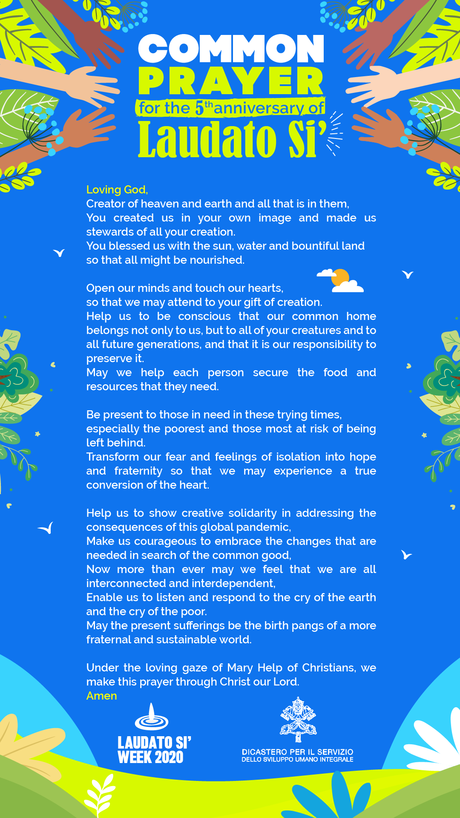
Let us also remember
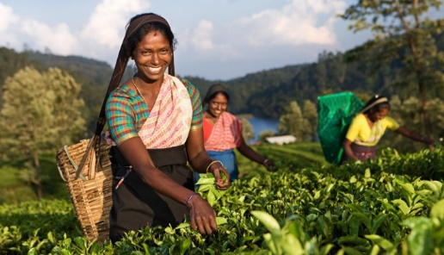

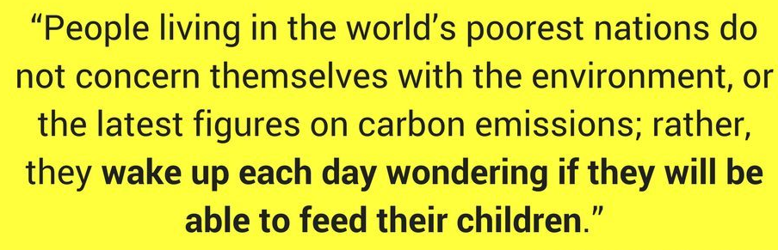
Many farmers and agricultural workers
are going to work each day to keep the world's food supply intact. By supporting Fairtrade farmers and workers during these times, and continuing to buy from Fairtrade co-operatives, we support them to protect the health and safety of their communities, to weather the economic challenges ahead, and to stand together in global solidarity.

There are many other resources online including -
- https://www.sciaf.org.uk/resources/76-laudato-si-study-guide
- https://laudatosi.com/watch
- https://www.youtube.com/watch?v=ssYIOWjG87k
- https://www.youtube.com/watch?v=KIVuISZGdug
Thank you for your continued support of Justice and Peace. We know that many parishes in our diocese continue to have a strong commitment to Justice and Peace.
You can contact Justice and Peace at 65 Bath Street, Glasgow, G2 2BX, 0141 3332O38 or email office@justiceandpeacescotland.org.uk

