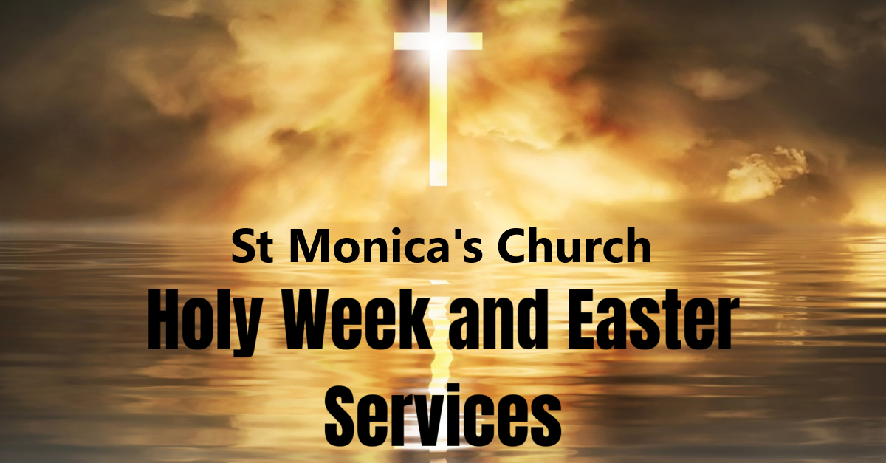
Friday 26th March | † 8am & 10am: Holy Mass  † 6pm: Stations of the Cross
Saturday 27th  Vigil Masses | † 10am: Holy Mass  † 4pm & 5.30pm: Vigil Mass
Palm Sunday | † 8.30am, 10am, 12Noon & 5pm: Holy Mass
Monday | † 8am & 10am: Holy Mass  † 6pm: Stations of the Cross
Tuesday | † 8am & 10am: Holy Mass  † 7pm: Penitential Service & Confession
Wednesday | † 8am &10am: Holy Mass  † 10.30am – 6pm: Exposition of the Holy  Sacrament & Confession
The Easter Triduum
Thursday | † 9.30am: Morning Prayer of the Church  † 7pm: Mass of the Last Supper  † 10pm: Night Prayer of the Church
Good Friday | † 9.30am: Morning Prayer of the Church  † The Passion of the Lord Services  12Noon, 3pm & 7pm  † 10pm: Night Prayers
Saturday | † 10am: Morning Payer of the Church  † 6pm & 8pm: Easter Vigil
Easter Sunday | † 9am,10.30am,12Noon & 5pm: Holy Mass

