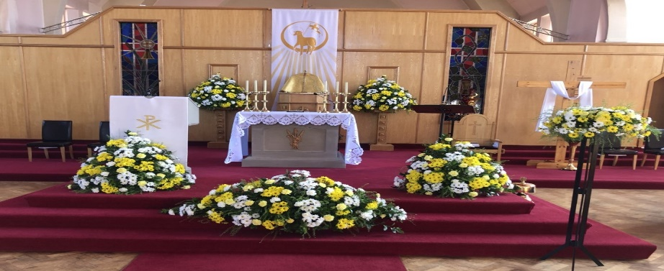
St Monica’s Parish
Diocese of Motherwell
Registered Charity SC011041
Sharp Avenue, Coatbridge ML5 5RP
Tel: 01236 421750 Mobile: 07747259800
Email: stmonica@rcdom.org.uk
Website: https://saint-monica.org.uk
Facebook: St. Monica’s Parish Coatbridge
You Tube: St. Monica's Parish Coatbridge
Twitter: @StMonicasParish

Parish Priest: Fr. Ghislain B. Mulumanzi.

SUNDAY MASSES: Vigils at 4pm & 5.30pm
9am,10am (livestream) 12 Noon & 5pm
WEEKDAY MASSES: 10am
NOVENA TO ST JOSEPH: Monday- Friday at 6pm
CONFESSIONS: Please contact Fr Ghislain
Baptisms: Speak to Fr Ghislain
Marriages: Please speak to Fr Ghislain. Please note 6 months’ notice is required.
_______________________________________________________

4th Sunday of Easter - B
First Reading: Acts 4:8-12
Responsorial Psalm: The stone which the builder rejected
has become the corner stone
Second Reading:Jn 3:1-2
Gospel: Jn: 10:11-18

Vocations Sunday letter from the Bishop

Dear Brothers and Sisters in Christ,

I hope this finds you well. I thank all who have been praying for my mother in her recent illness. She is recovering and appreciates your supportive prayers.

This coming Sunday, 4th Sunday of Easter, is Good Shepherd Sunday, which the Church keeps as our Day of Prayer for Vocations. I invite you all to offer your prayers on this day for Vocations to the ordained ministry and consecrated life. In his message for this Vocations Sunday, Pope Francis speaks of St Joseph, calling him protector of vocations:

“ I like to think, then, of Saint Joseph, the protector of Jesus and of the Church, as the protector of Vocations. In fact, from his willingness to serve comes his concern to protect. The Gospel tells us that “ Joseph got up, took the child and his mother by night” (Mt 2:14), thus revealing his prompt concern for the good of his family. He wasted no time over things he could not control, in order to give full attention to those entrusted to his care. Such thoughtful concern is the sign of a true vocation, the testimony of a life touched by The love of God. What a beautiful example of Christian life we give when we refuse to pursue our ambitions or indulge in our illusions, but instead care for what the Lord has entrusted to us through the Church! God then pours out his Spirit and creativity upon us; he works wonders in us as he did in Joseph.”

On this Vocations Sunday I ask the protection of St Joseph on those of Motherwell Diocese preparing for service in the Church as priests and permanent deacons. Two men will be ordained deacons this year - Christopher Morris, one of our seminarians in St Mary’s College, Oscott, will be ordained in Oscott on 6th June by Archbishop Bernard Longley; and Michael Meechan will be accepted as a candidate and ordained as a permanent deacon later in the year. I ask your prayers for them both as they prepare for ordination. Likewise I ask your prayers for our other seminarians in Rome (Christopher Furmage, Ronan McQuade and Kieran Burt) and in Oscott (Colum Martin), as well as Christopher Igwe who will go to Oscott in September, and three others who will hopefully join the Propaedeutic Period in January 2022. Along with Michael Meechan, the Diocese has two other men preparing for the permanent diaconate – Kevin Kirby and Stuart Dick, both of St Vincent’s in East Kilbride. If anyone reading this feels called to the priesthood or diaconate, and indeed to religious life, please make yourself known to your PP, who will assist you in your initial discernment and help you approach the Diocesan Vocations’ Directors or an appropriate Religious Congregation.

Having mentioned St Vincent’s, East Kilbride, I ask for your continued prayers also for its parish priest, Fr Ivan Boyle, who has been unwell in recent times. We wish him a speedy recovery

With my prayers and best wishes,

Yours in Christ,
+ Joseph Toal

Why don’t you join the VOLONTEERS to keep our church safer?
Whatever we do in our church, keeping things safe for all present remains the priority, especially as we have been made more aware of the infectious nature of the newer COVID 19 variants. We shouldn’t let our guard down and indeed we should all wish to demonstrate that the St Monica's Church is at the forefront in doing all that is required to prevent any possible spread of coronavirus.
From Monday, April 26th, the cap of 50 on the numbers attending our services (apart from weddings and funerals) will be lifted as the area and seating within our church permits this while respecting the two-metre distancing rule between people from different households. A risk assessment will be carried out by the PP, assisted by the Covid Coordinator and volunteers, and to agree upon a maximum number.
There is also a possibility to use the hall for mass. But this depends on the volunteers available to make this possible. Since the registration, supervision, and cleaning may well last beyond the period of restricted attendance, the amount of work expected of volunteers may increase and we will have to be careful not to make too many demands upon them, some of them being pensioners, and others have their jobs and families. I appeal on younger ones to join the volunteers' group to keep everyone safe. This is one of the best ways to show that you care and love your parish.

Enrolment Mass for First Communion and Confirmation
Monday 3rd May 2021 The Mass of Enrolment will take place in St Monica’s Church at 7pm mass for children who will celebrate the Sacrament of Holy Communion on 22nd and 23rd May 2021.

Tuesday 4th May 2021 The Mass of Enrolment will take place in St Monica’s Church at 7pm mass for children who will celebrate the Sacrament of Confirmation on 24th and 25th May 2021.
Please, come along with your child. This is a very important moment for your child and for parish community. Attending Each Sunday mass is important to help your child prepare well for the sacrament. The time of masses are Saturday 4pm, 5.30pm, Sunday 10am, 12 noon and 5pm.

This is a personal invitation for your family to join with your child in the Church each Sunday. Jesus would love you to take up this invitation with joy and not as a burden on you. When you presented your child for baptism you accepted the tremendous responsibility as your constant care to bring him/her in the practice of the faith in order that the divine life received from God grow always stronger in his/her heart. Keep your word.


Church Grounds
We are looking for help from our
parishioners to help maintain the parish grounds. If you have some spare time during the week, please come along and help to keep our parish grounds looking clean and tidy.

We would especially like to see some of our younger parishioners coming along to help and there are plenty of jobs around the parish suit all levels of fitness.

Church Stall
We have gifts and cards available for the First Communion and Confirmation

Weekly Collection
Offertory Collection: £848.57
Building Fund: £161.94

500 Club
1st Prize No 89 N Gallagher
2nd Prize No 193 A Carr
3rd Prize No. 279 M Kelly


Monday | 10am  6pm | Holy Mass  Novena to St Joseph
Tuesday | 10am  6pm | Holy Mass  Novena to St joseph
Wednesday | 10am  6pm | Holy Mass  Novena to St Joseph
Thursday | 10am  6pm | Holy Mass  Novena St Joseph
Friday | 10am  6pm | Holy Mass  Novena St Joseph
Saturday | 10am  4pm & 5.30pm | Holy Mass  Vigil Mass
Sunday | 10am, 12 Noon  & 5pm | 5th Sunday of Easter B

Please remember in your prayers
Sick: John Clenaghan, Jean Graham, James Carr, Linda Webb,James McLaughlin, Cecelia Greig, Ann & John McShane, Elizabeth McKenna, Mary Forsyth, Isabella Devine, Nicolas Hardy, Joan Violet Mitchell, Joe Cope, Mary Cope, John & Anne McShane, Jack Neeson, Michael McAdams

Months Mind:Sadie Slowey, Patsy Robertson Jenny & Jimmy Docherty, James Smith, Margaret Fallon, Peter, Mary, Henry Catherine & Madge Wallace, , Margaret & Peter McCann, George, Margaret, Henry & Charlie McAnally, Kathleen & Frank Coventry

Anniversaries: Margaret Smith, Danny Watson, Elizabeth McParland, Mary Kelly, Susanne McQuaker, Clare McMullen, Hugh Clark, Catherine McAnally, John Harkins

Please also remember the souls who have no one to pray for them



Fortnightly Garden Maintenance


Call 07504281030 or 07512092903

 Football Players Wanted 
Coatbridge Milan FC 2008’s are currently looking for players to trial for their team. If you were born in 2008 and are interested in coming along to a training session, please text either Mark on 07827 897 115 or Steph on 07944 045 405.


Sweaty Mama is a unique and effective way to exercise whilst you bond with your child. No need to organise childcare to get to the gym, Sweaty Mama allows you to spend quality time with your child whilst you undertake the workout. Exercises are adapted to suit all ages & development of the child as well as suit the fitness level of the Mama. Over the course of sessions, you gradually build up your fitness level and strengthen your core & posture to rehabilitate your body after having a child. A fab, fun workout to upbeat music both you and your child will love! With babies, toddlers and Preschoolers all joining in the fun!
Enquire @ catherine@sweatymama.com Tel: 07949397511

