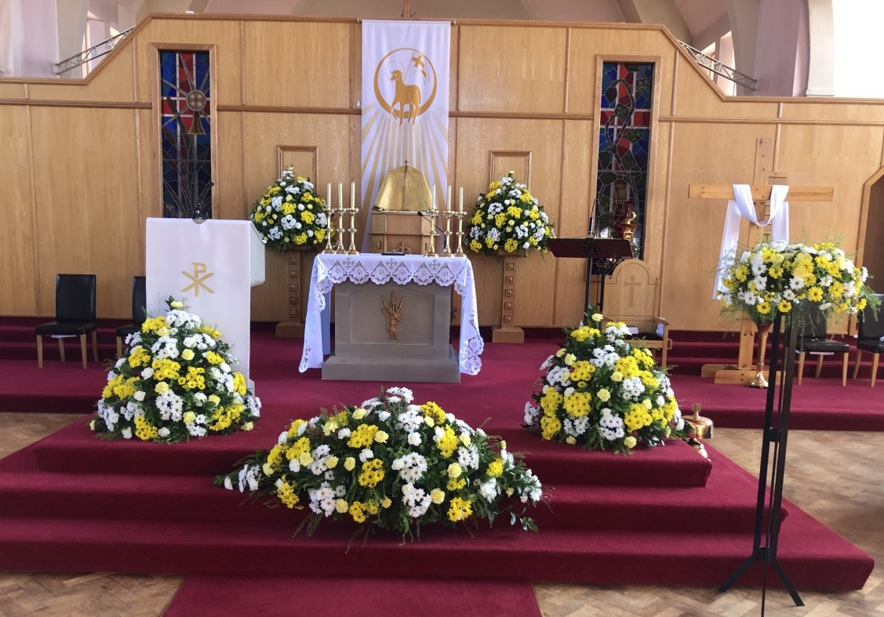
St Monica’s Parish
Diocese of Motherwell
Registered Charity SC011041
Sharp Avenue, Coatbridge ML5 5RP
Tel: 01236 421750 Mobile: 07747259800
Email: stmonica@rcdom.org.uk
Website: https://saint-monica.org.uk
Facebook: St. Monica’s Parish Coatbridge
You Tube: St. Monica's Parish Coatbridge
Twitter: @StMonicasParish

Parish Priest: Fr. Ghislain B. Mulumanzi.

SUNDAY MASSES: 9.00am, 10.30am (livestream) 12 Noon
(Please note there is no evening mass on Easter Sunday)
WEEKDAY MASSES: 10am
CONFESSIONS: Please contact Fr Ghislain
Baptisms: Speak to Fr Ghislain
Marriages: Please speak to Fr Ghislain. Please note 6 months’ notice is required.
_________________________________________________________

Easter Sunday of the Resurrection of the Lord - B

Vigil Mass
First Reading: Genesis 1.1.26-31
Second Reading: Exodus 14 15-15.1
Third Reading: Romans 6: 3-11
Gospel: Mk 16 1-7

Easter Sunday
First Reading: Acts 10: 34.37-43
Second Reading: Colossians 3: 1-4
Gospel: John 20:1-9

Easter message. The inevitable journey towards death leads to Easter

As we go through life we all experience little deaths. We get a foretaste of death when we live in bitterness, loneliness, sadness and despair. In times like these the world closes in on us and we seem to have one foot in the grave. We become increasingly conscious of our mortality and the inevitable journey toward death. Death constitutes a huge challenge to our faith. But we also experience little resurrections. When we know love, acceptance, and forgiveness, when we open our hearts to others and to life, then the world opens up and we emerge from the tomb. On this day we breathe the pure air of everlasting life. And we walk in radiant hope towards the Kingdom where there are no more shattered hopes or broken dreams, broken promises. To be a Christian is to be a person of hope, which is a deep trust in God. Good Friday, Day of darkness and death, comes to everyone. So does Holy Saturday, that day of emptiness and sorrow. On such day it is hard to believe. But Easter Sunday, day of life, will come as surely as the dawn. HAPPY EASTER EVERYONE.

Bulletin
If you have any information or mass intention to be shared on the bulletin Sunday, please hand it in before Friday of each week. You can also use the parish bulletin to advertise your business.

Gift Aid

Gift Aid Envelopes for year 2021/22 are now available at the back of the church for collection. Envelope numbers have changed this year so please check the name and address on your box and ensure you have uplifted the correct envelopes.

Diocesan Novena to St Joseph
All parishes and diocesan groups are invited to take part in a Diocese-wide Novena to St Joseph through the last nine days in April, leading to the Feast of St Joseph the Worker on Saturday May 1st. The intention of the Novena is to seek St Joseph’s protection in our present need, particularly for our families and young people.
Various prayers are available. https://yearofstjoseph.org/devotions/prayers/.

April – SCIAF Collection for Lenten Appeal for South Sudan
By raising money for the Wee Box Appeal, you can help children with disabilities in South Sudan to access the education and support they need to build a bright future. Boxes can be returned to the church commencing 28 March 2021, and before the end of April.

500Club
The 500 club resumes this weekend. Please consider joining the club and help fundraise for our church renovations.

Sacraments for Children
The parish has scheduled the celebration of sacraments for children as follows:

- First Reconciliation: Tuesday 27th & Wednesday 28th April 2021 at 6pm

- First Communion: Saturday 22nd May 2021 at 11am and 1pm
Sunday 23rd May 2021 at 2pm.

- Confirmation: Monday 24th May & Tuesday 25th May 2021 at 7pm

To enrol your child for these sacraments, parents are advised to download the application form on the parish website www.saint-monica.org.uk, contact Fr Ghislain or St Monica’s Primary School.



I wish to thank everyone who has helped during the Easter Triduum
& Easter Celebration especially the stewards, readers, the ladies that clean the church, the streaming team and Catriona Arbuckle for making the
beautiful flowers.

Your contribution is much appreciated.

Community News



Fortnightly Garden Maintenance
Call 07504281030 or 07512092903

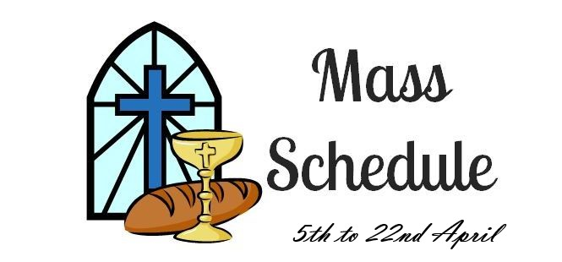
Monday | 10am | Holy Mass
Tuesday | 10am | Holy Mass
Wednesday | 10am | Holy Mass
Thursday | 10am | Holy Mass
Friday | 10am | Holy Mass
Saturday | 10am  4pm &  5.30pm | Holy Mass  Vigil Mass
Sunday | 10am  12 Noon  5pm | 2nd Sunday of Easter B  (Divine Mercy)  Holy Mass

Please remember in your prayers
Recently Dead: Agnes Cecelia Brennan

Sick: John Clenaghan, Jean Graham, James Carr, Linda Webb, James McLaughlin, Mrs Cecelia Greig, Ann & John McShane, Elizabeth McKenna, Mary Forsyth, Isabella Devine, Nicolas Hardy, Joan Violet Mitchell

Months Mind:, William, Margaret, Patrick, Agnes & Helen Dochety, Joseph, Elizabeth, James & Peter Silvestro, Alex & David Thain, Anna & Joseph Pearson, Jenny Wright, Margaret & Andrew McKinlay, Anna, Brian & Joseph Tierney, Agnes & William McAuley, Rab Bannen, John, Jim, Michael & Teresa McAlinden, John Catherine, John & Pat Rennie, Margaret Diamond, Helen Diamond, John Wallace, Margaret Deigan, John Deigan, Anne Marie Deigan, James Deigan, Mr & Mrs Peter Deigan & Brian, Mr & Mrs Deigan Snr & Jnr, Mr & Mrs Tommy Deigan, Mr & Mrs John Fagan, Mr & Mrs Andy Prost, Mr &Mrs Frank Grank & Marie, Mr Jack Gill, Lawrence, William & Mary Brankin, William, Ellen & Annie Brankin, Joseph, Agnes & Joe Mina, Patricia & Brian Sharkey Jnr, John McGrath, David Hayton, Kathleen Smith, Frank & Agnes Wilson, Elizabeth & Sadie Prunty Jimmy McLaughlin, Kathleen & Peter Dolan, Tilly & Marie Clarke, Mattie, Tommy & Thomas Collins

Anniversaries: James Prunty Catherine McAlinden, John Trower, John Diamond, Marion Henderson, Eddie Mina, Kevin McGrath, Bill Paul, Lawrence Molloy, May McLaughlin, Danny Watson,Snr, Danny Watson Jnr, Annie Duffy, John Slevin, Catherine Mooney, Joseph Tobin, Richard & Catherine Tobin

Easter Remembrance: Bernard, Lily, Liam, John & Brian Loney, James, Elizabeth & Sadie Prunty, James, Catherine, Joe, John & Robert Smith, Jean Robertson.

