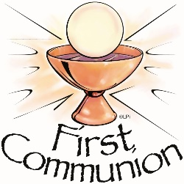

Please complete the attached track and trace form and bring this with you on the day of your child’s First Holy Communion.
Please note only the people listed will be able to attend the service.

Child making their First Holy Communion:

 | Name | Contact Telephone Number
1
2
3
4
5
6
7

